Dennis Tikhomirov (Dzianis Tsikhamirau)

Task 0

1. Install Virtual Box. Install one of Linux distributions (CentOS or Debian) on virtual machine (for details see vm.pdf, centos.pdf, debian.pdf). During installation, specify login name as your EPAM account(if you have one) without epam.com.
2. Login to your installed OS as root user via terminal session.

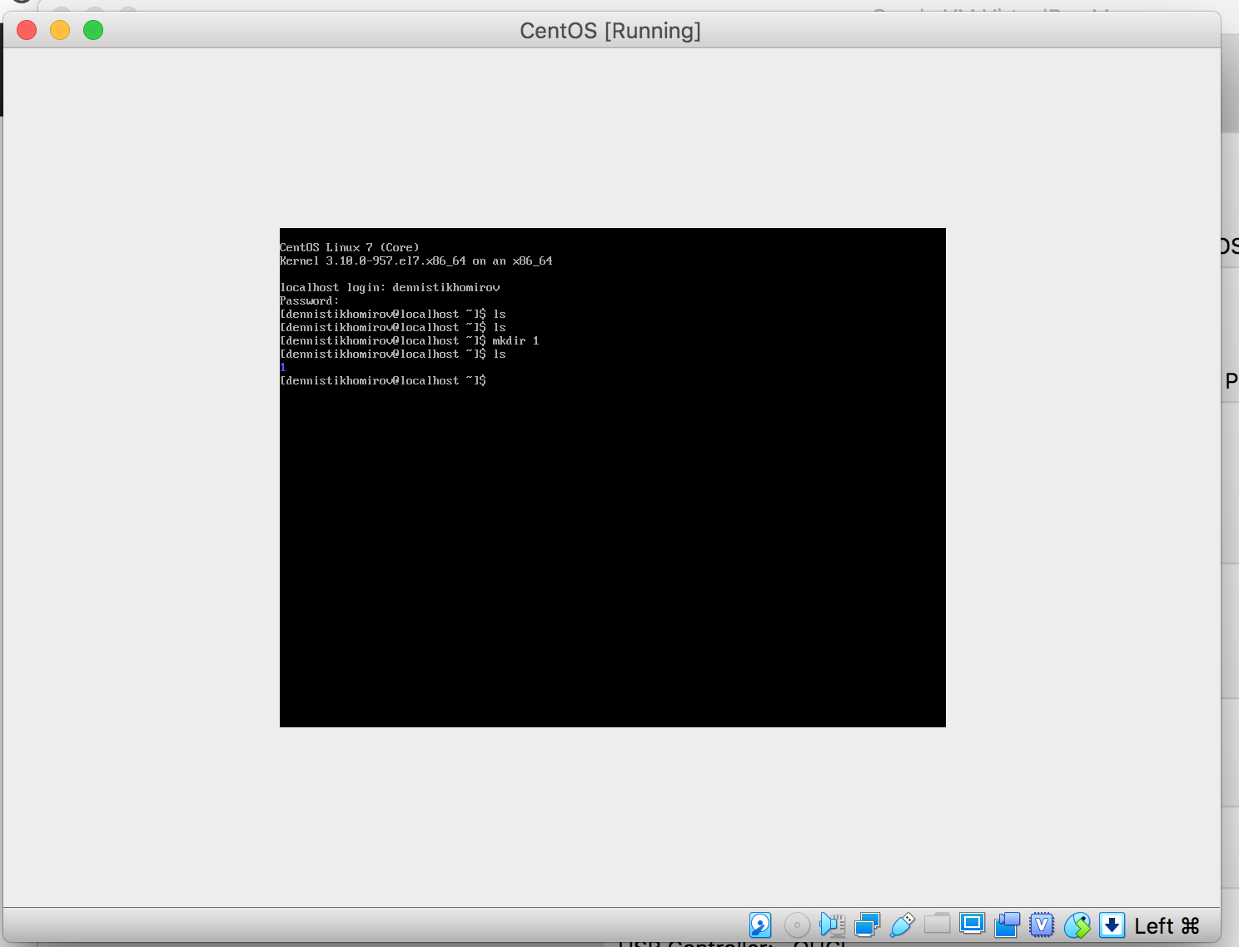

1. Recognize IP-address of your OS. In command line enter “ip addr”. This command shows all network interfaces in virtual machine. For example: 1: eth1: , 2: enp0s3 – this is network interface number and its name. To assign IP address run command “dhclient eth1 enp0s3”. Check that IP addresses assigned correctly with “ip addr”. One interface should be 10.0.2.15 (NAT interface) and second 192.168.x.x (Host Only interface. This IP will be used in next steps).

Note: for network configuration in CentOS you can try to run “nmtui” command.

