Dennis Tikhomirov

**Task 2**

2.1 File system tree exploration.

1. Describe 5 first directories from the root file system. Fill results in the table

below.

**Linux version 3.10.0-957.12.2.eI7.x86_64 (**[**mockbuild@builder.bsys.centos.org**](mailto:mockbuild@builder.bsys.centos.org)**) (gcc version 4.8.5 20150623 (Red Hat 4.8.5-36) (GCC) ) #1 SMP Tue May 14 21:24:32 UTC 2019**

|  |  |
| --- | --- |
| Directory  name | Purpose |
| **/bin/** | **Essential command binaries** (for use by all users). It may also contain commands which are used indirectly by scripts. There must be no subdirectories in **/bin.** 33 commands are required in **/bin** |
| **/boot/** | **This directory contains everything required for the boot process**  except configuration files not needed at boot time and the map  installer. Thus **/boot** stores data that is used before the kernel begins  executing user-mode programs. |
| **/dev/** | **Device file**s. It is the location of special or device files. Must contain a command named MAKEDEV |
| **/etc/** | **Host-specific system configuration**.  Contains configuration files. A "configuration file" is a local file used to control the operation of a program; it must be static and cannot be an executable binary. |
| **/etc/opt/** | Host-specific configuration files for add-on application software packages must be installed within the directory/etc/opt/<subdir>, where <subdir> is the name of the subtree in /opt where the static data from that package is stored. |
| **/home/** | User home directories (optional). |
| **/lib/** | **Essential shared libraries and kernel modules. C**ontains shared library images needed to boot the system and run the commands in the root filesystem, ie. by binaries in /bin and /sbin. |
| **/lib64/** | **Variant of /lib/.** This is commonly used for 64-bit or 32-bit support on systems which support multiple binary formats, but require libraries of the same name |
| **/media/** | Mount point for removable media. This directory contains subdirectories which are used as mount points for removable media such as floppy disks, cdroms and zip disks. |
| **/mnt/** | **Mount point for a temporarily mounted filesystem.** This directory is provided so that the system administrator may temporarily mount a filesystem as needed. The content of this directory is a local issue and should not affect the manner in which any program is run. |
| **/opt/** | Add-on application software packages. /opt is reserved for the installation of add-on application software packages. |
| **/proc/** | **Kernel and process information virtual filesystem.** |
| **/root/** | Home directory for the root user (optional) |
| **/run/** | **Run-time variable data.** This directory contains system information data describing the system since it was booted. Files under this directory must be cleared (removed or truncated as appropriate) at the beginning of the boot process. |
| **/sbin/** | **System binaries.** Utilities used for system administration (and other root-only commands) are stored in /sbin, /usr/sbin, and/usr/local/sbin. /sbin contains binaries essential for booting, restoring, recovering, and/or repairing the system in addition to the binaries in /bin. |
| **/srv/** | **Data for services provided by this system.** /**srv**contains site-specific data which is served by this system. |
| **/sys/** | **Kernel and process information virtual filesystem.**  The sys filesystem is the location where information about devices, drivers, and some kernel features is exposed. Its underlying structure is determined by the particular Linux kernel being used at the moment, and is otherwise unspecified |
| **/tmp/** | Temporary files. Must be made available for programs that required temporary files. |
| **/usr/** | **/usr i**s shareable, read-only data. That means that /usrshould be shareable between various FHS-compliant hosts and must not be written to. Any information that is host-specific or varies with time is stored elsewhere. |
| **/var/** | **/var** contains variable data files. This includes spool directories and files, administrative and logging data, and transient and temporary files. |

1. Detect file type.

/dev/null: character special  
/dev/zero: character special  
/dev/sda: block special  
/dev/tty: character special  
/root: directory  
/etc/passwd: ASCII text  
/proc/mounts: symbolic link to `self/mounts'  
/proc/mounts: empty  
/bin/ls: ELF 64-bit LSB executable, x86-64, version 1 (SYSV), dynamically linked (uses shared libs), for GNU/Linux 2.6.32, BuildID[sha1]=ceaf496f3aec08afced234f4f36330d3d13a657b, stripped  
/bin/zcat: POSIX shell script, ASCII text executable

<https://github.com/dennis00010011b/epam-devops-training/blob/master/Task2/file_types.txt>

* 1. Processes, file attributes, user rights

2.2.1 Create empty file in your home directory (file name == your

FirstName_LastName), set the following permissions for this file:

User: read, write

Group: read, execute

Other: read

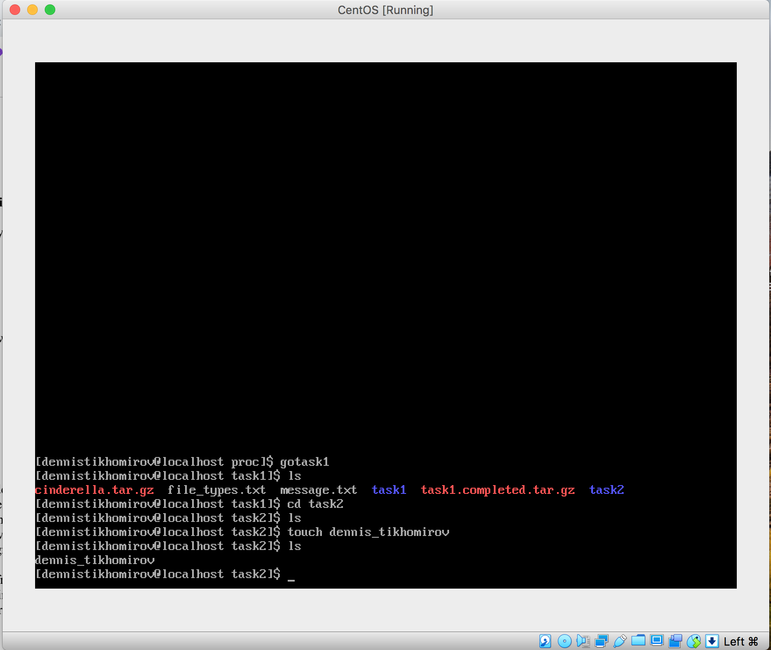

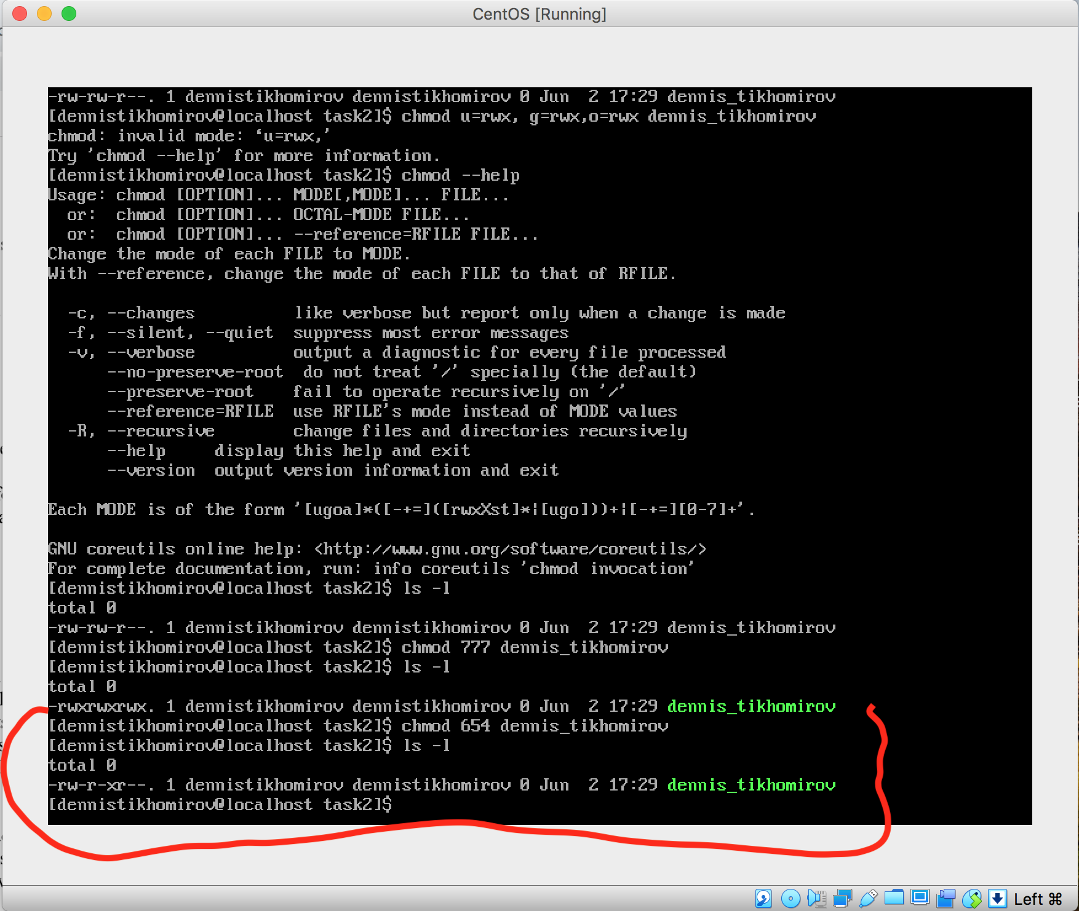

* + 1. Create alias for the following command: *ping tut.by*

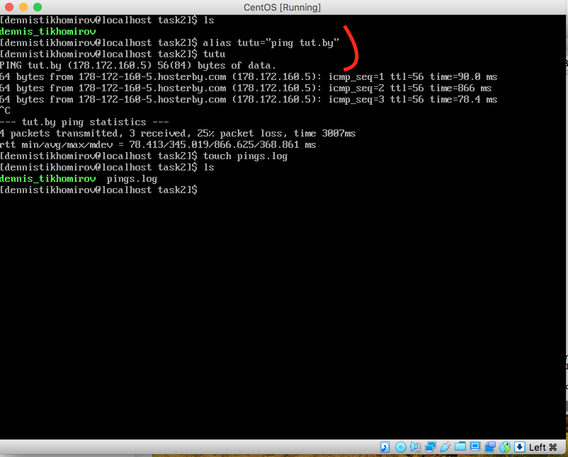

2.2.3 Run command “ping tut.by”(use alias from the previous task) with

redirect output in any file. Run this command in background

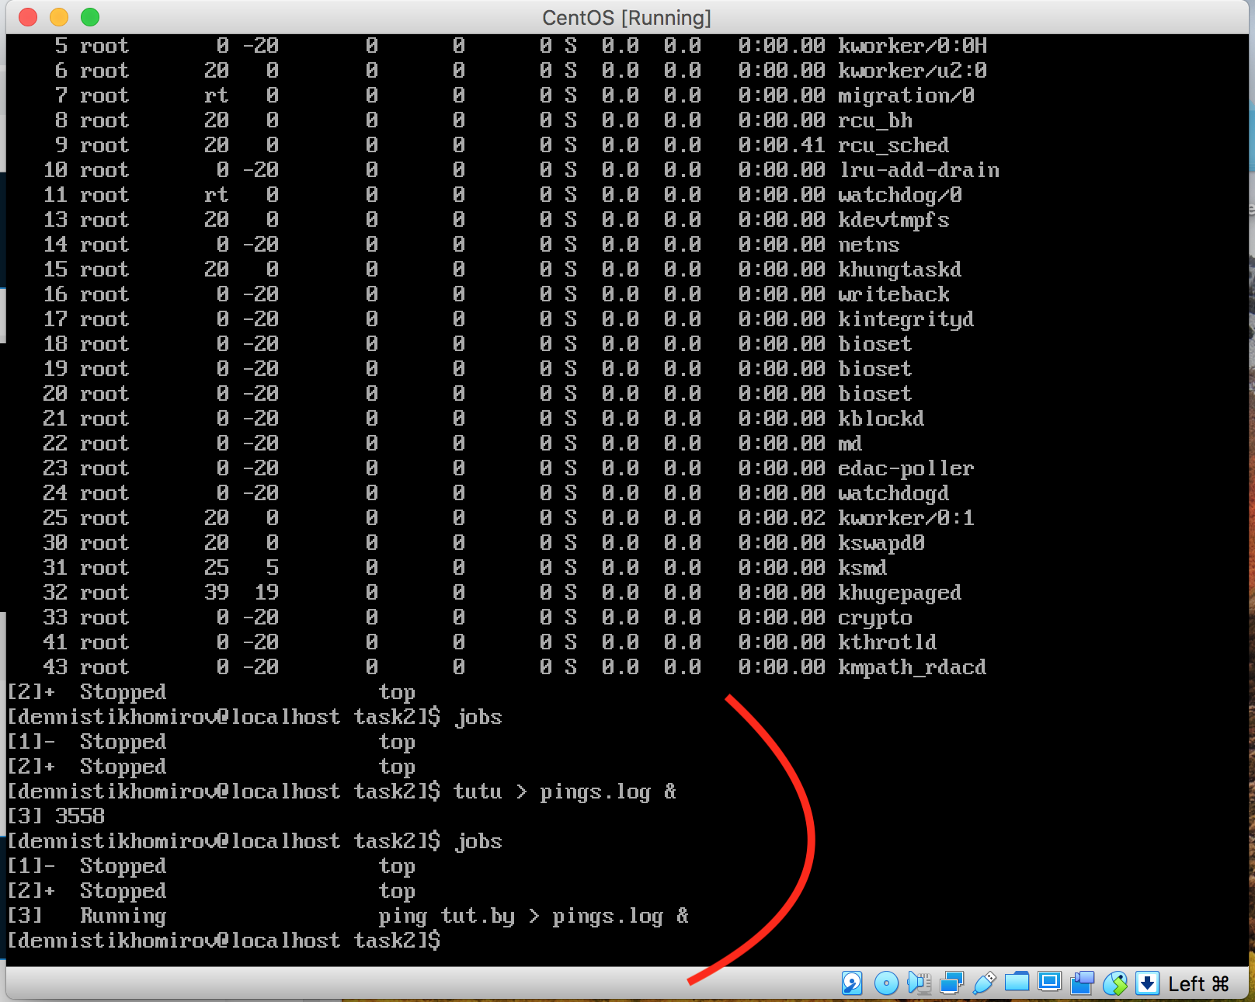

2.2.4 Put the previous command from background to foreground

2.2.5 Put the previous command from foreground to background

2.2.6 Find and kill process of the previous command

Make sure the process was really killed

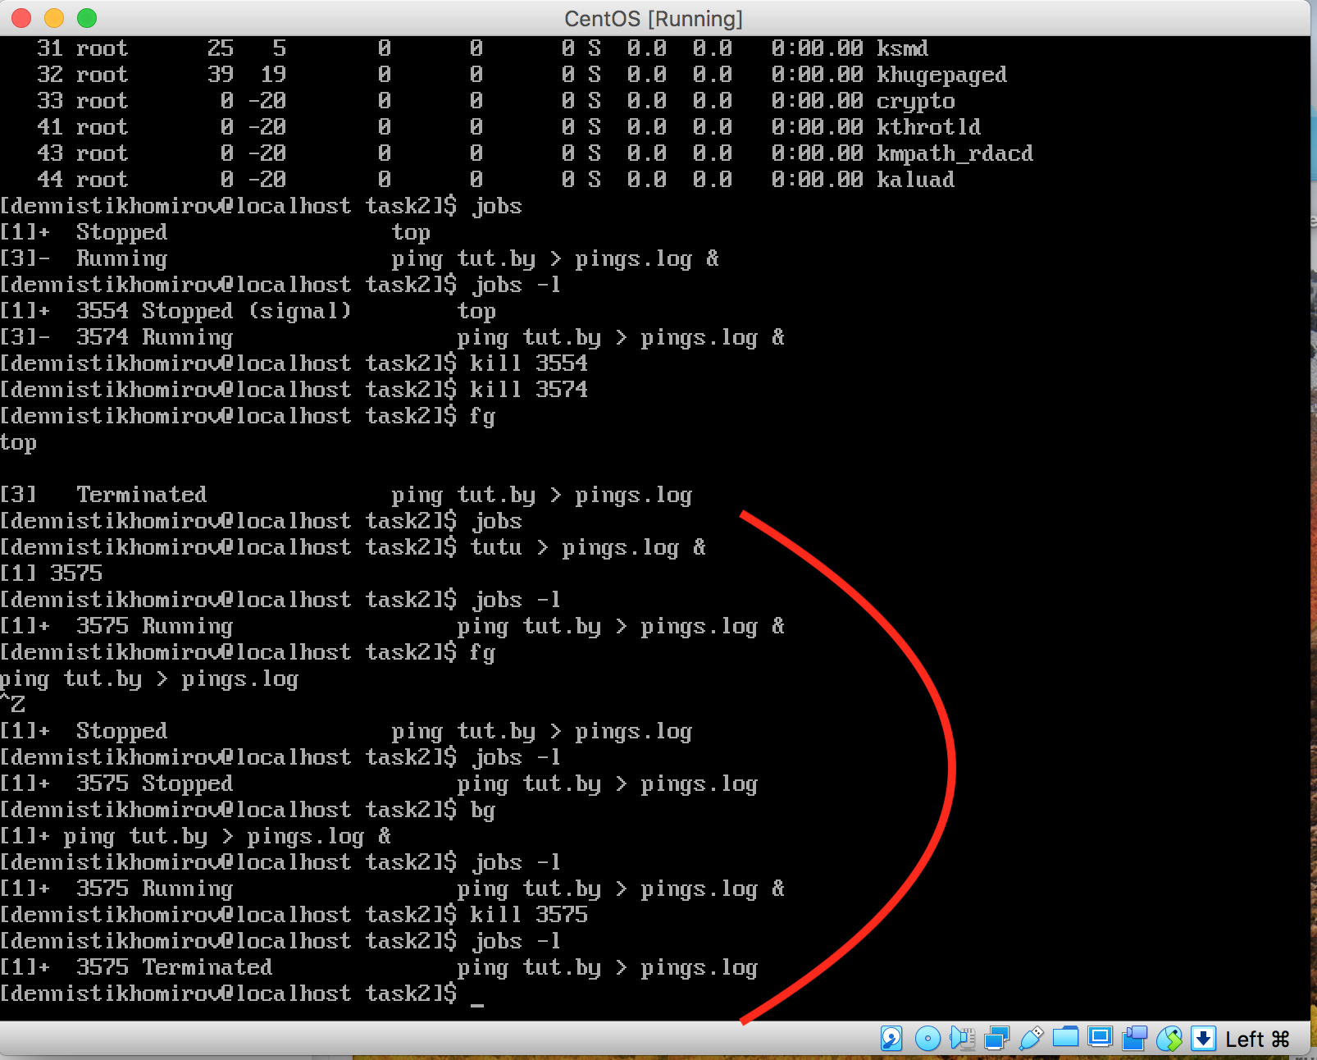

2.2.7. Find all files which names starts from “test”

Command find / test*

