3.1 «if else if»

I’ve created script for validation login/password

<https://github.com/dennis00010011b/epam-devops-training/blob/master/Task3/task31.sh>

#! bin/bash  
# This script provides simple login validation using if and case statements  
# I know the realization could be more simpler with for-each loop  
incorrect_pass () {  
echo "Incorrect password"  
exit  
}  
  
incorrect_name () {  
echo "Incorrect login name"  
exit  
}  
  
declare -A logins  
logins[0]='user1'  
logins[1]='user2'  
logins[2]='user3'  
declare -A passwords  
passwords[0]='pass1'  
passwords[1]='pass2'  
passwords[2]='pass3'  
  
echo "Enter login:"  
read login  
if [ $login = 'exit' ];  
then   
exit  
elif [ $login = ${logins[0]} ] || [ $login = ${logins[1]} ] || [ $login = ${logins[2]} ];  
then   
echo "Enter password:"  
read passwd  
else  
incorrect_name  
fi  
case $login in  
 ${logins[0]} )  
 if [ $passwd != ${passwords[0]} ];   
 then   
 incorrect_pass  
 fi  
 ;;  
 ${logins[1]} )  
 if [ $passwd != ${passwords[1]} ];  
 then   
 incorrect_pass  
 fi  
 ;;  
 ${logins[2]} )  
 if [ $passwd != ${passwords[2]} ];  
 then   
 incorrect_pass  
 fi  
 ;;  
 *)   
 incorrect_name  
 ;;  
esac  
echo "SUCCESS! You logged in."

3.2 «for, while..»

1. It is required to develop a script that implements output to the screen from the file name specified by the parameter of the subdirectory with the indication of their type.

<https://github.com/dennis00010011b/epam-devops-training/blob/master/Task3/task321.sh>

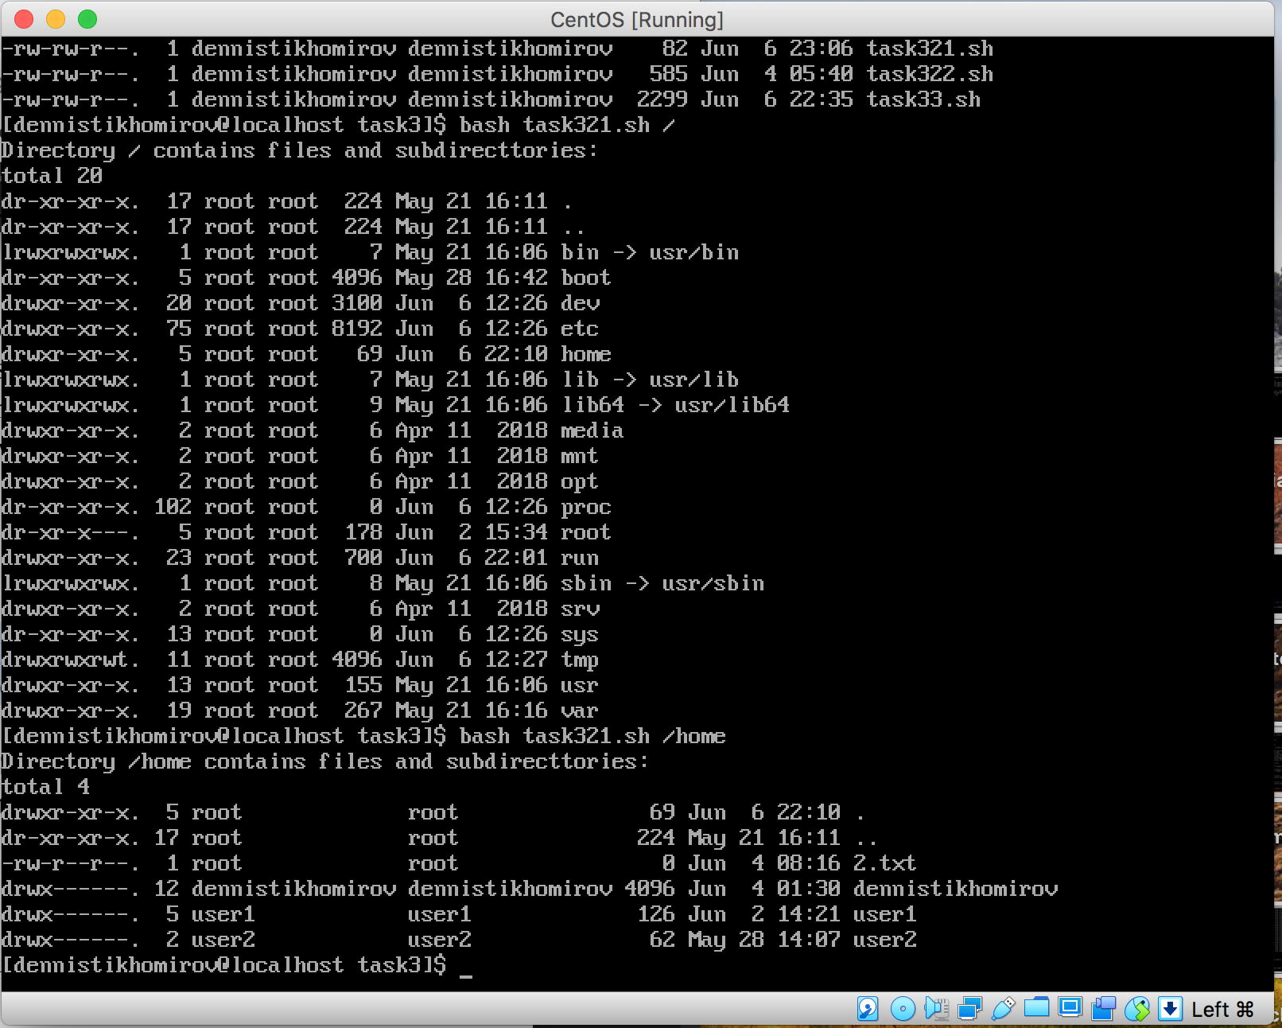

2. Try to complete the task from TASK 1 (Cinderella) by means of an executable file (bash shell). Compare the results.

<https://github.com/dennis00010011b/epam-devops-training/blob/master/Task3/task322.sh>

# Script organizes files from directory specified by parameter   
# to directory ./cinderella (wiil be created if doesn't exist)  
#!/bin/bash  
function ensure () {  
if [ ! -d $1 ]  
then mkdir $1  
fi  
}   
d="cinderella"  
ensure "$d"  
  
ensure $d/video  
ensure $d/audio  
ensure $d/books  
cp "$1"/*.pdf ./"$d"/books  
cp "$1"/*.chm ./"$d"/books  
cp "$1"/*.djvu ./"$d"/books  
cp "$1"/*.mp3 ./"$d"/audio  
  
ensure "$d"/video/80x  
ensure "$d"/video/200x  
ensure "$d"/video/latest  
  
  
cp "$1"/*198* ./"$d"/video/80x  
cp "$1"/*200* ./"$d"/video/200x  
for i in 2014 2015 2016  
do   
cp "$1"/*"$i"* ./"$d"/video/latest  
done

3.3 It is required to develop a script that implements a dialogue with the user in the form of a menu in the console mode. The script should be executed in a cyclic mode until the "Exit" item is selected. The first menu item should display information about the developer (full name). The following menu items should perform tasks according to the options in the table.

Variant 2

a. Delete files of the specified extension (specified in the parameter) in the specified folder (specified in the parameter) (* check the existence of paths / disks, etc.)

b. In the specified folder (specified in the parameter) find the file with the longest name

<https://github.com/dennis00010011b/epam-devops-training/blob/master/Task3/task33.sh>

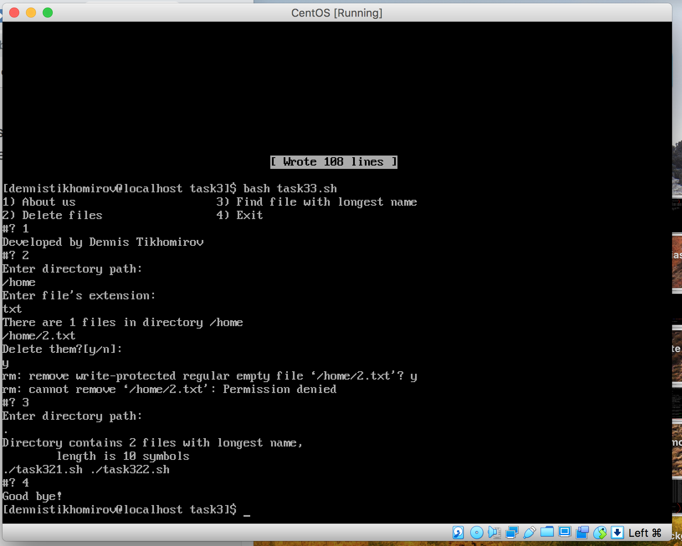

#!/bin/bash

###############################

# get number of files with given extension

#Input: $1=path, $2=extension

function amount_files () {

AMOUNT=$(ls -1p $1/*.$2 | wc -l)

}

###############################

#read a path name from console

function read_dir() {

echo "Enter directory path:"

read DIR

if [ ! -d $DIR ];

then echo "Directory dosn't exist"

fi

}

###############################

# Menu

select VAR in "About us" "Delete files" "Find file with longest name" "Exit"

do

case $VAR in

##############################

# Info about developer

"About us")

echo "Developed by Dennis Tikhomirov"

;;

##############################

# Exit from programm

"Exit")

echo "Good bye!"

exit

;;

##############################

# Delete files with given extension

"Delete files")

read_dir

echo "Enter file's extension:"

read EXT

amount_files $DIR $EXT

if [ $AMOUNT != "0" ];

then

echo "There are $AMOUNT files in directory $DIR"

ls -p $DIR/*.$EXT

echo "Delete them?[y/n]:"

read CONFIRMATION

if [ $CONFIRMATION = "y" ];

then

rm $DIR/*.$EXT

fi

else

echo "Can't find files with extension $ext in directory $DIR"

fi

;;

###############################

# Find in given directory the file/files witn longest name

"Find file with longest name")

read_dir

MAX=0

LENGTH=0

NAMES=()

# Find max length of file's name in directory $DIR

for F in $DIR/*.*

do

LENGTH=${#F}

if [ $LENGTH -gt $MAX ];

then

MAX=$LENGTH

fi

done

if [ $MAX -eq 0 ];

then

echo "Directory $DIR is empty"

else

# Find all files with longest name

for F in $DIR/*.*

do

LENGTH=${#F}

if [ $LENGTH -eq $MAX ];

then

NAMES+=($F)

fi

done

echo "Directory contains ${#NAMES[@]} files with longest name,

length is $(($MAX-${#DIR}-1)) symbols"

#print array of file's names

echo "${NAMES[@]}"

fi

;;

#####################################

# Incorrect choice

*)

echo "Incorrect choice. Please try again"

;;

esac

done