We can simulate by the stocks

It will shows your equity, how many stocks do you have, how many profit do you earn and the annualized rate or profit

The data is caught from the Realtime stock of Chinese securities company "hua tai zhen juan"

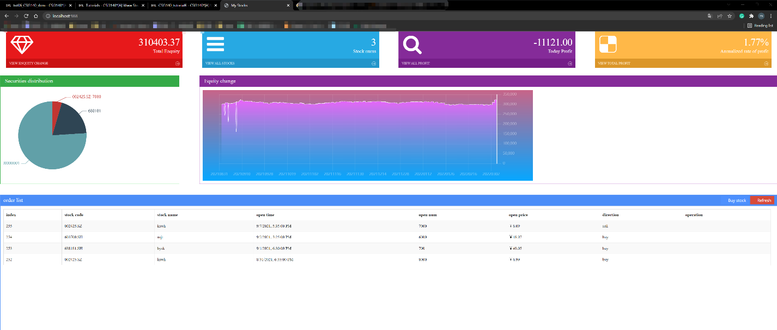

1. Try buy/sell stock

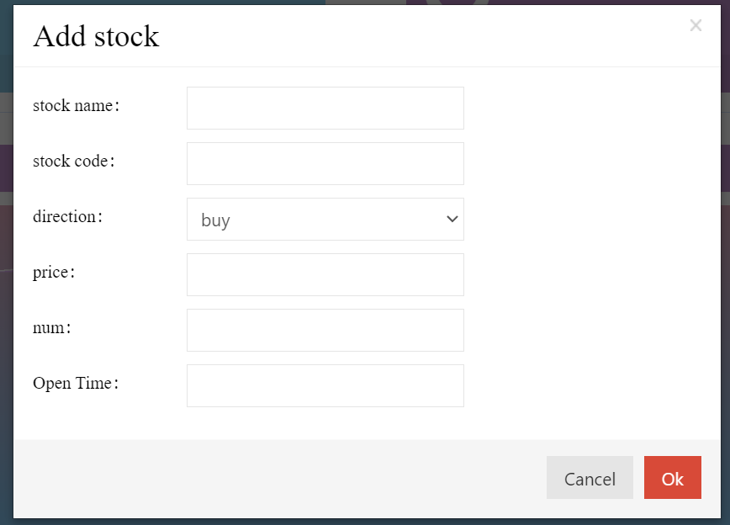

1. Add/sell stock information

It will identify did you buy the stock, do you have enough to sell

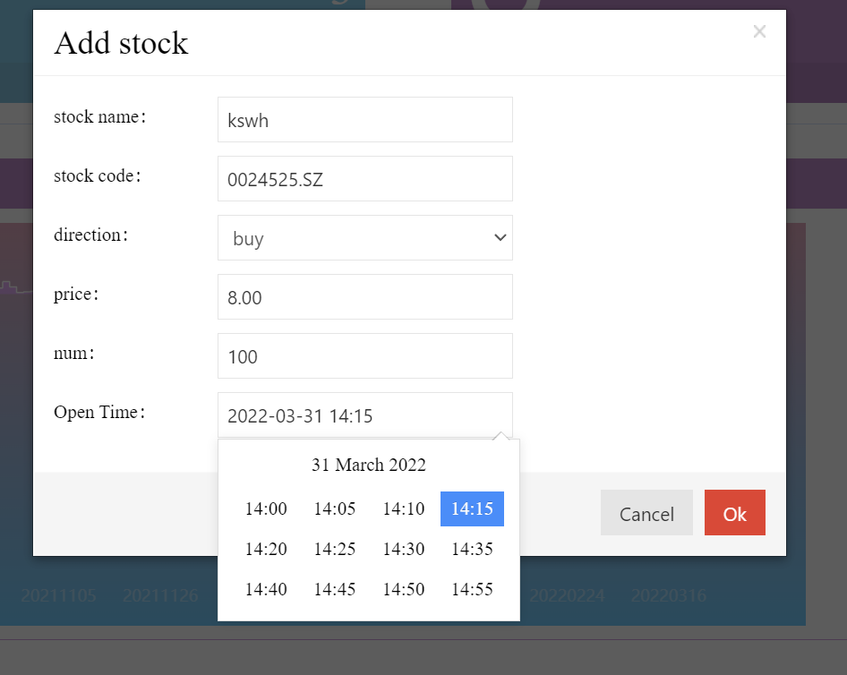

1. If we by the stock successful, we will get a new record below

Sell is same as buy, it will record all buy/sell record then refresh the Securities distribution

