React components go through three main phases: Mounting, Updating, and Unmounting. Here's how it works in both class components (the original way) and function components with hooks (the modern way).
The Three Phases
1. Mounting — component is being created and inserted into the DOM for the first time.
2. Updating — component re-renders due to changed props, state, or a parent re-rendering.
3. Unmounting — component is being removed from the DOM.
Let me show this visually first, then walk through each phase.

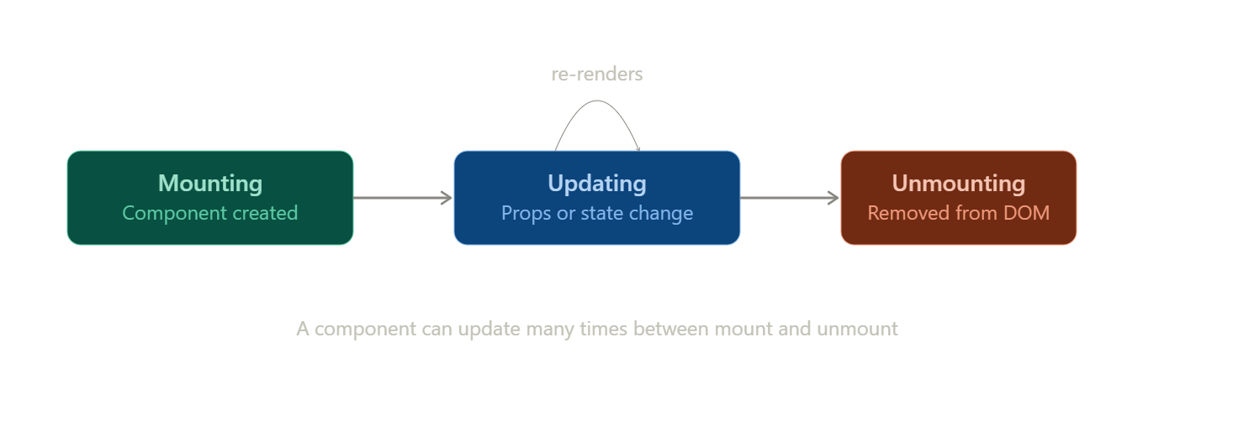
visualize show_widget
Mounting — component is born
This happens once, when the component first appears on screen.
Class components, in order:
- constructor() — set up initial state, bind methods.
- render() — returns the JSX to display.
- componentDidMount() — runs right after the component is in the DOM. This is where you fetch initial data, set up subscriptions, or interact with the DOM directly.
Function components (hooks):
- The function body itself runs (equivalent to render()).
- useEffect(() => { ... }, []) with an empty dependency array runs once, right after mount — the hook equivalent of componentDidMount.
Updating — component reacts to change
This happens whenever props change, state changes, or a parent re-renders. It can happen many times over a component's life.
Class components:
- render() runs again with the new props/state.
- componentDidUpdate(prevProps, prevState) runs after the update, letting you compare old vs. new values and respond (e.g. re-fetch data if a prop changed).
Function components (hooks):
- The function body re-runs.
- useEffect(() => { ... }, [someValue]) re-runs whenever someValue changes — this is the hook equivalent of componentDidUpdate, scoped to exactly the values you care about.
Unmounting — component is removed
This happens once, when the component is taken out of the DOM (e.g. navigating away, or a parent stops rendering it).
Class components:
- componentWillUnmount() — clean up: clear timers, cancel subscriptions, remove event listeners.
Function components (hooks):
- The cleanup function returned from useEffect runs — the function you return inside the effect:
jsx
useEffect(() => {
const timer = setInterval(tick, 1000);
return () => clearInterval(timer); // cleanup on unmount (or before next effect run)
}, []);
The key mental model for hooks
useEffect actually unifies all three phases depending on its dependency array:
- No array → runs after every render (mount + every update)
- [] → runs once (mount only)
- [a, b] → runs on mount, then again whenever a or b changes (update)
- The returned cleanup function runs before the effect re-runs, and one final time on unmount
That's why interviewers love asking about the dependency array — it's really asking whether you understand how the old three-phase class lifecycle maps onto this one hook.

