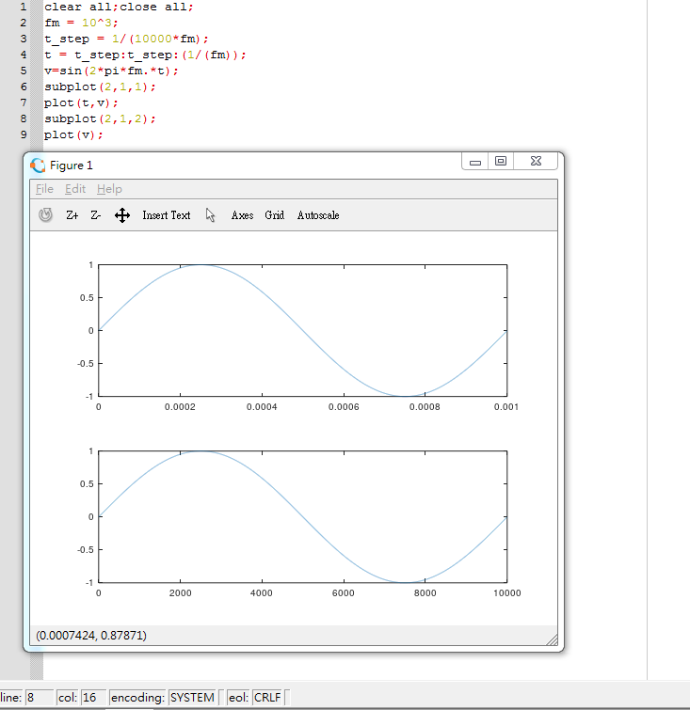

close all;

clear all;

fm=10^3;

t_step=1/(1000*fm);

t_step1=1/(3*fm);

t1=t_step1:t_step1:(1/(fm))

t=t_step:t_step:(1/(fm))

v=sin(2*pi*fm.*t);

v1=sin(2*pi*fm.*t1);

subplot(3,1,1);

plot(t,v);

subplot(3,1,2);

plot(v);

subplot(3,1,3);

plot(v1)

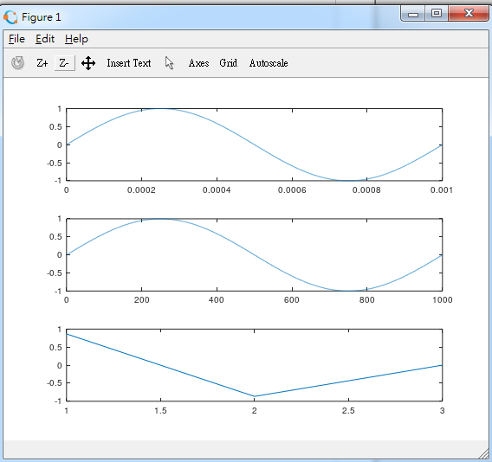

close all;

clear all;

fm=10^3;

t_step=1/(10^5*fm);

t=t_step:t_step:(1/fm);

v=sin(2*pi*fm.*t);

sample_rate=50;

fs=sample_rate*fm;

pw=10^3;

size_vv=size(v,2);

p=[];

for i=1:1:round(fs/fm)

p=[p zeros(1,round(size_vv/sample_rate)-round(pw)) ones(1,round(pw))];

end

vp=v.*p;

subplot(3,1,1);

plot(t,v);

subplot(3,1,2);

plot(t,p);

subplot(3,1,3);

plot(t,vp);

