電通二乙微處理器實驗 實驗結報

實驗名稱 | Lab06-音樂教室
組別 |  | 組員 | 陳詩元

- 實驗目的
如何使 Arduino 發出特定旋律的聲音?
  - Arduino 接喇叭如何接線?
  - 如何使用 tone library?
  - 如何演奏一段音樂?
  - 如何使用 4x4 鍵盤演奏音樂?
  - 如何發報摩斯電碼?

- 實驗步驟
Arduino 演奏一段特定的音樂, 旋律不得是小蜜蜂
4x4 鍵盤演奏音樂
發報摩斯電碼

- 程式碼
Lab06-1
int speakerPin = 9;
char notes[] = "ggagCb ggagDC ggGECba FFECDC";
unsigned long beats[] = {1, 1, 2, 2, 2, 2, 2, 1, 1, 2, 2, 2, 2, 2, 1, 1, 2, 2, 2, 2, 2, 1, 1, 2, 2, 2, 2, 2, 2};
int length = sizeof(notes);
int tempo = 300;
void setup()
{
pinMode(speakerPin, OUTPUT);
}

void loop()
{
for (int i = 0; i < length; i++)
{
if (notes[i] == ' ')
{
delay(beats[i] * tempo); // rest
}
else
{
playNote(speakerPin, notes[i], beats[i] * tempo);
}
delay(tempo / 10);
}
}

void playNote(int OutputPin, char note, unsigned long duration)
{
char names[] = { 'c', 'd', 'e', 'f', 'g', 'a', 'b', 'C', 'D', 'E', 'F', 'G' };
int tones[] = { 261, 294, 330, 349, 392, 440, 494, 523, 587, 659, 698, 784 };
for (int i = 0; i < 12; i++)
{
if (names[i] == note)
{
tone(OutputPin, tones[i], duration);
delay(duration);
noTone(OutputPin);
}
}
}
Lab06-2
#include<Keypad.h>
#define beat 500
#define pin 12
#define NOTE_C3 131
#define NOTE_CS3 139
#define NOTE_D3 147
#define NOTE_DS3 156
#define NOTE_E3 165
#define NOTE_F3 175
#define NOTE_FS3 185
#define NOTE_G3 196
#define NOTE_GS3 208
#define NOTE_A3 220
#define NOTE_AS3 233
#define NOTE_B3 247
#define NOTE_C4 262
#define NOTE_CS4 277
#define NOTE_D4 294
#define NOTE_DS4 311
#define NOTE_E4 330
#define NOTE_F4 349
#define NOTE_FS4 370
#define NOTE_G4 392
#define NOTE_GS4 415
#define NOTE_A4 440
#define NOTE_AS4 466
#define NOTE_B4 494
#define WHOLE 1 //全分符
#define HALF 0.5 //半分符
#define QUARTER 0.25
#define EIGHTH 0.125
#define SIXTEENTH 0.0625

const byte ROWS = 4, COLS = 4;

char keys[ROWS][COLS] = {{'F', 'E', 'D', 'C'}, {'B', 'A', '9', '8'}, {'7', '6', '5', '4'}, {'3', '2', '1', '0'}};

byte rowPins[ROWS] = {8, 9, 10, 11};
byte colPins[COLS] = {2, 3, 4, 5};
Keypad keypad = Keypad(makeKeymap(keys), rowPins, colPins, ROWS, COLS);

void setup()
{
pinMode(12, OUTPUT);
Serial.begin(9600);
}

void aa(int a, int b, int c)
{
tone(a, b, c);
delay(c);
noTone(a);
}

void loop()
{
char key = keypad.getKey();

if (key != NO_KEY)
{
if (key == '0')
{
aa(pin, NOTE_C3, 500);
}

else if (key == '1')
{
aa(pin, NOTE_CS3, 500);
}

else if (key == '2')
{
aa(pin, NOTE_D3, 500);
}

else if (key == '3')
{
aa(pin, NOTE_DS3, 500);
}

else if (key == '4')
{
aa(pin, NOTE_E3, 500);
}

else if (key == '5')
{
aa(pin, NOTE_F3, 500);
}

else if (key == '6')
{
aa(pin, NOTE_FS3, 500);
}

else if (key == '7')
{
aa(pin, NOTE_G3, 500);
}

else if (key == '8')
{
aa(pin, NOTE_GS3, 500);
}

else if (key == '9')
{
aa(pin, NOTE_A3, 500);
}
}

}
Lab06-3
char a = 0;
void setup()
{
Serial.begin(9600);
}
void loop()
{
if (Serial.available() > 0)
{
a = Serial.read();
Serial.println(a);
GetChar(a);
delay(300);
}
}
void x()
{
tone(8 , 440 , 150);
delay(300);
}
void y()
{
tone(8 , 440 , 500);
delay(300);
}
void GetChar(char tmpChar)
{
switch (tmpChar)
{
case'a':
x();
y();
break;
case'b':
y();
x();
x();
x();
break;
case'c':
y();
x();
y();
x();
break;
case'd':
y();
x();
x();
break;
case'e':
x();
break;
case'f':
x();
x();
y();
x();
break;
case'g':
y();
y();
x();
break;
case'h':
x();
x();
x();
x();
break;
case'i':
x();
x();
break;
case'j':
x();
y();
y();
y();
break;
case'k':
y();
x();
y();
break;
case'l':
x();
y();
x();
x();
break;
case'm':
y();
y();
break;
case'n':
y();
x();
break;
case'o':
y();
y();
y();
break;
case'p':
x();
y();
y();
x();
break;
case'q':
y();
y();
x();
y();
break;
case'r':
x();
y();
x();
break;
case's':
x();
x();
x();
break;
case't':
y();
break;
}
}
- 實驗結果及分析
能夠以4*4鍵盤透過喇叭發出聲音及以PC發出聲音
- 心得討論
這次的實驗有點久才做完，要努力認真。

- 修正電路圖
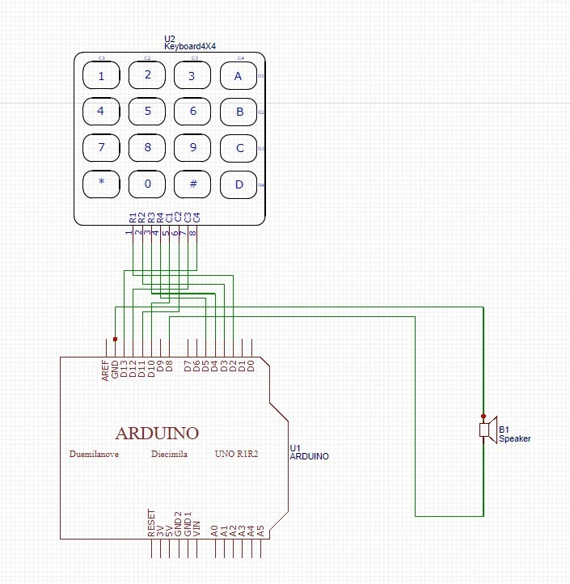
- 修正程式碼

