

IONITY GLOBAL
(Pty) Ltd

ESP32-MCP Fleet Platform
Ionity System EDGE Computing
Revamp Phase 3 – Node Firmware 3
ESP-IDF · MCPServer · read_telemetry on a FreeRTOS worker · ionity-prov/2

DOC-2026-10-ESP32MCP-FW-P3 | Version 1.0 | 11 October 2026
PUBLIC

www.ionity.today | ai@ionity.today

Index – Table of Contents
Phase 3 of the ESP32-MCP revamp delivers node firmware 3 on ESP-IDF for the ESP32-S3 (primary) and ESP32-C6 (secondary): the on-device MCP server, the read_telemetry tool routed from the network core to a FreeRTOS worker without ever blocking the network loop, and the board side of the ionity-prov/2 provisioning protocol.
Section | Topic | Page
1 | Executive summary | 3
2 | Decisions in force | 3
3 | Task topology and request routing | 4
4 | Registering read_telemetry | 7
5 | Memory and safety rules | 8
6 | ionity-prov/2 obligations and implementation | 9
7 | Build variants | 9
8 | Verification log | 10
9 | Production hardening | 10
10 | Known limits, running it and next steps | 11
A | Appendix A – Document control | 12

Page numbers are indicative and may shift slightly between Word versions. Use View > Navigation Pane for live navigation. The engineering source of this document is docs/architecture/PHASE-3-FIRMWARE.md in the repository.

1. Executive summary
A large language model calls a tool through the gateway; the gateway sends one small binary frame over MQTT; the board answers with a result. Phase 3 is the board side. The radio and the MQTT connection live on one CPU core, the tools on the other, and the network side never waits for a tool: when the board is busy it says so at once and tells the gateway when to retry. Memory is reserved at boot, so a flood of requests cannot fragment or exhaust it.
Deliverable | Result
main.cpp – boot order and task topology | Networking on Core 0, tools on Core 1 (S3); priorities decide on the single-core C6
MCPServer.h / .cpp – registry and router | Every hand-over from Core 0 uses a zero timeout; back-pressure becomes ERR BUSY with a retry hint
read_telemetry (0x02), get_device_info (0x01), identify (0x06) | Registered at boot, run on mcp_worker, results encoded straight into the uplink frame
EWP/1 codec | 16-byte header, bounded CBOR subset, CRC-32; constants generated from the TypeScript contract
MQTT 5 link and Wi-Fi | net_task is the only publisher; retained OFFLINE last will; TLS via ca_pem or the IDF certificate bundle
ionity-prov/2 board side | All 12 obligations of Phase 2; firmware 2.x settings read as-is and migrated once
Builds | 4 variants (S3/C6 × UART/USB console) with PlatformIO or idf.py; merged images and a manifest for the portal
Verification | 76 host unit tests under sanitizers, race tests, fuzzing, 5 interop tests against the TypeScript packages

Phase 3 is additive: it adds firmware/esp32-node/ and this document. The Arduino firmware 2.x tree keeps building until the restructure.

2. Decisions in force
# | Decision | Effect on Phase 3
D1 | Gateway in Node/TypeScript | The firmware includes the generated ewp_protocol.h by path – never a copy – so gateway and board cannot drift.
D9 | Mosquitto now, a cluster later | MQTT 5, clean start, session expiry 0; nothing broker-specific in the firmware.
D10 | Confirm every risky command. | Factory reset only through the portal's confirmed action. NVS encryption and eFuse burning are documented, not enabled (irreversible).
D11 | Restructure after Phase 3 | Phase 3 adds firmware/esp32-node/ only.
E1 | *Engineering choice, open for review:* ESP-IDF 5.5, PlatformIO-compatible | pioarduino (framework = espidf, src_dir = main) and plain idf.py; prepared for IDF 6 (managed mqtt / cjson components, not yet built).

3. Task topology and request routing
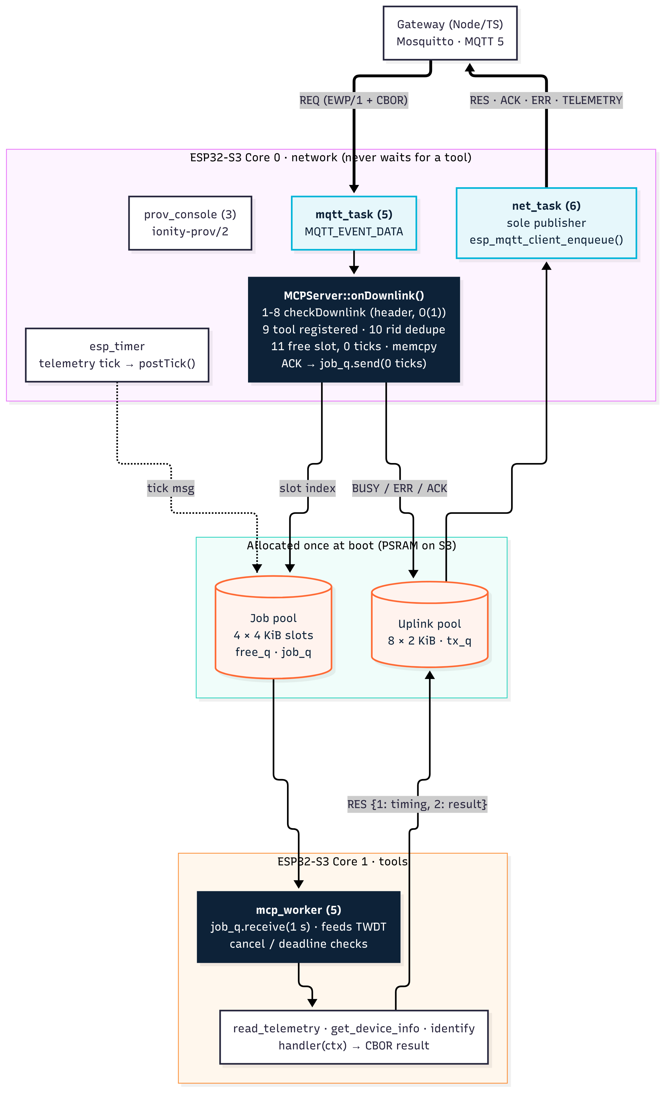
Source: docs/architecture/firmware_tasks.mmd.
Task | Core (S3) | Priority | Stack | Role
Wi-Fi, lwIP, sys_evt | 0 | 23 / 18 / 20 | IDF | Radio and IP stack
mqtt_task (esp-mqtt) | 0 | 5 | 6 KiB | Receives frames; calls MCPServer::onDownlink()
net_task | 0 | 6 | 5 KiB | Sole publisher: drains tx_q; HELLO / STATUS on connect
prov_console | 0 | 3 | 6 KiB | Serial lines → ionity-prov/2
prov_worker | any | 2 | 4 KiB | Slow provisioning ops (scan, test)
esp_timer | 0 | 22 | IDF | Telemetry tick → postTick() (0 ticks, coalesced)
mcp_worker | 1 | 5 (C6: 4) | 6 KiB | Runs tool handlers one at a time; feeds the task watchdog

On the ESP32-C6 every task is unpinned and mcp_worker runs at priority 4, below net_task, so a long tool can never starve publishing.

3.1 Why the network loop never blocks
onDownlink() runs in the esp-mqtt task, does only constant-time work and uses a zero timeout for every queue operation:
- Steps 1–8 checkDownlink(): magic, version, type, flags, length, topic, size ≤ 4096 – header only; the CBOR body is never parsed on Core 0.
- Step 9 tool registered, else ERR UNKNOWN_TOOL.
- Step 10 request id not in the 16-entry dedupe window (QoS 1 redelivery), else ERR DUPLICATE.
- Step 11 a free job slot with 0 ticks, else ERR BUSY with retryAfterMs 250.
- memcpy the frame into the slot – esp-mqtt reuses its buffer after the callback, so the job never points into it.
- ACK (if requested) into tx_q before the job becomes visible, so the gateway always sees ACK before RES.
- job_q.send(slot, 0) – sendToFront for PRIORITY – and return.
The worker checks cancel and deadline, takes an uplink buffer (≤ 200 ms), runs the handler – which writes its CBOR result straight into that buffer – wraps it as {1: timing, 2: result}, validates it, frees the slot and submits the frame. Failures become ERR frames with status, detail, argKey and retryAfterMs.

3.2 read_telemetry end to end
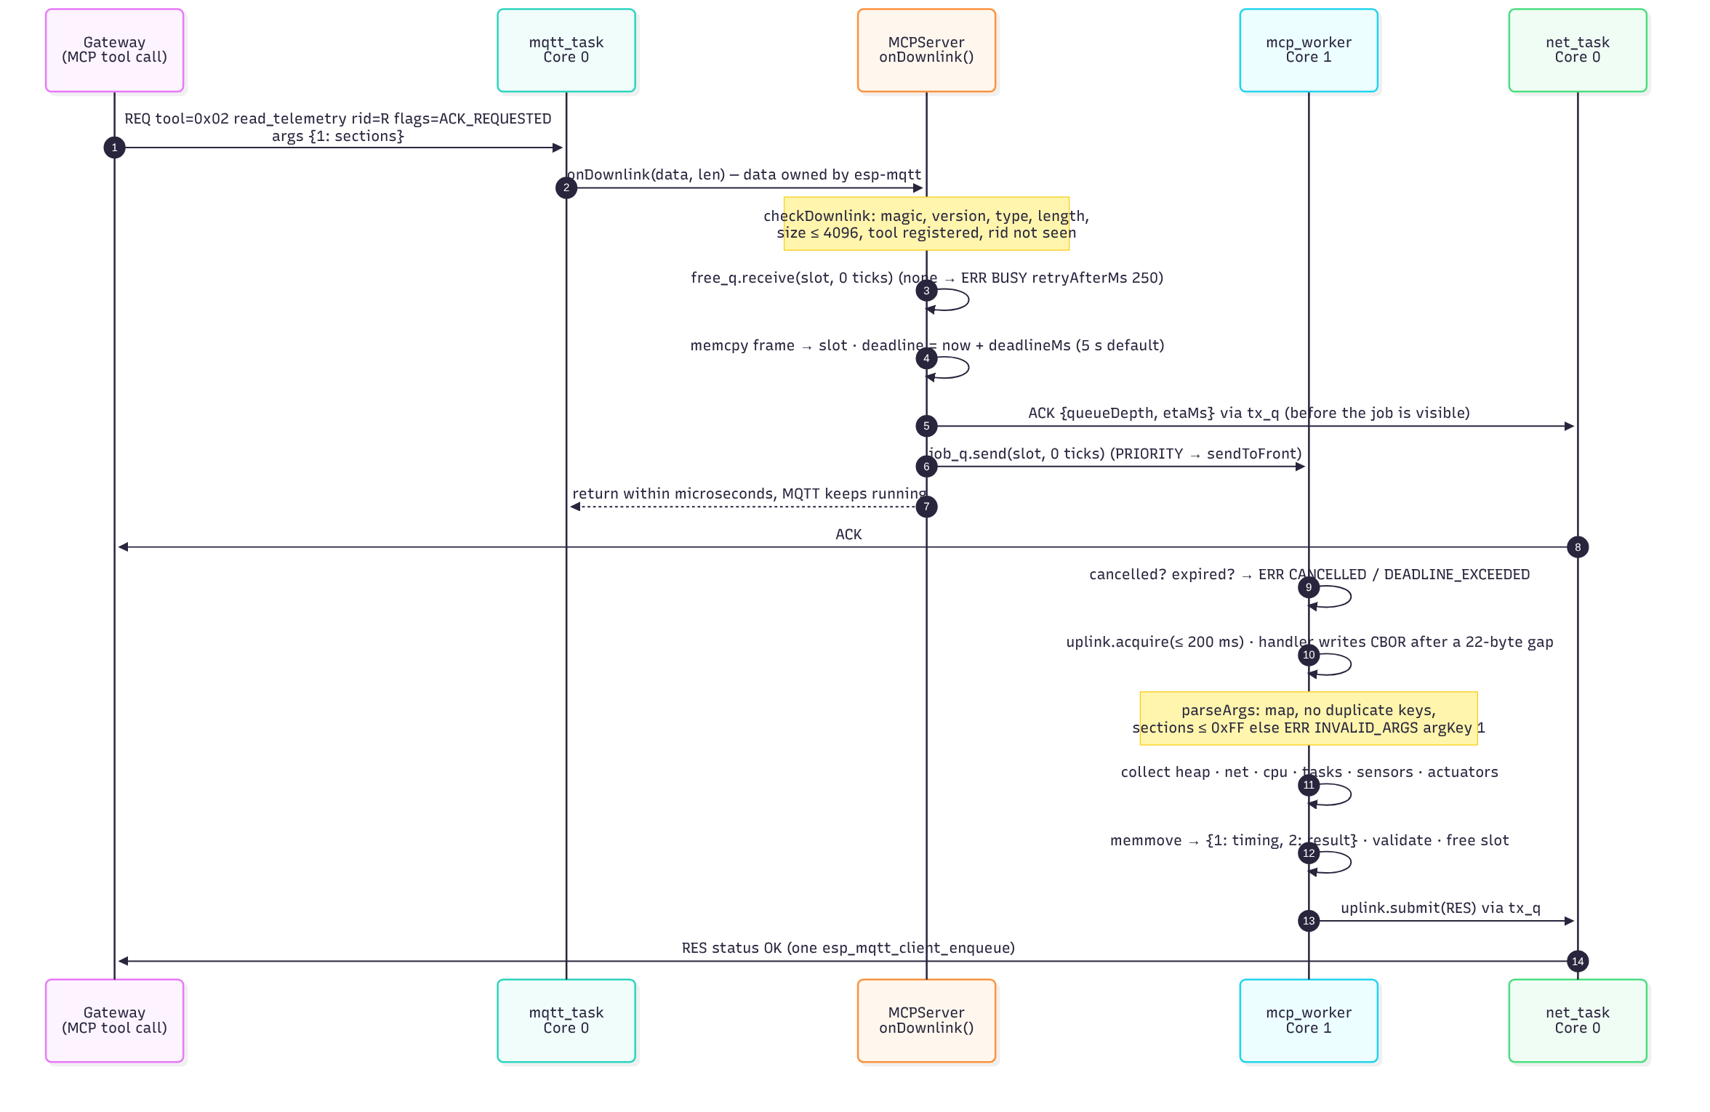
Source: docs/architecture/read_telemetry_sequence.mmd.

4. Registering read_telemetry
// components/tools/src/EdgeTools.cpp - registration (boot, before the network starts)
bool ok = server.registerTool({EWP_TOOL_READ_TELEMETRY, 1,
EWP_TOOL_FLAG_READ_ONLY | EWP_TOOL_FLAG_IDEMPOTENT,
EWP_TOOL_NAME_READ_TELEMETRY, &EdgeTools::readTelemetry, this});

// The handler - runs on mcp_worker (Core 1), never on the network core.
void EdgeTools::readTelemetry(mcp::ToolContext& ctx) {
EdgeTools* self = static_cast<EdgeTools*>(ctx.user());
uint8_t sections = kDefaultSections; // HEAP | NET | CPU | ACTUATORS (< 300 B)
const bool ok = parseArgs(ctx, [&](uint64_t key, ewp::CborReader& r) {
if (key == EWP_K_READ_TELEMETRY_ARGS_SECTIONS) {
uint64_t v = 0;
if (!r.readUint(v) || v > 0xFF) {
ctx.fail(EWP_ST_INVALID_ARGS, "sections must be a TelemetrySection bitmask (0-255)",
EWP_K_READ_TELEMETRY_ARGS_SECTIONS);
return false;
}
sections = static_cast<uint8_t>(v);
return true;
}
return skipUnknownArg(r); // forward compatible
});
if (!ok) return;
sections &= kSupportedSections; // INFERENCE / EXT arrive with run_inference
TelemetrySnapshot& s = self->snap_; // static, reused: no allocation per call
s = TelemetrySnapshot{};
self->cfg_.source->collect(s, sections);
s.seq = self->telemetrySeq();
s.mode = self->mode();
encodeTelemetryBody(ctx.out(), s, sections); // exactly one CBOR map = the result
}

// main.cpp - the server starts the worker on the tool core
mcp::ServerConfig sc;
sc.slots = CONFIG_IONITY_JOB_SLOTS; // 4 x 4 KiB, PSRAM when present
sc.workerCore = kToolCore; // 1 on S3, -1 (unpinned) on C6
sc.workerPriority = kWorkerPrio; // 5 on S3, 4 on C6 (below net_task)
s_server.begin(sc, s_uplink);
Handler rules (also in MCPServer.h): write exactly one CBOR item or call ctx.fail(); for long work poll ctx.cancelled() / ctx.expired() and call ctx.keepAlive() at least every second; never keep pointers into ctx.args(); never publish; never allocate per call.

5. Memory and safety rules
Rule | How it is enforced
No allocation on the request path | Job pool (4 × 4 KiB) and uplink pool (8 × 2 KiB) allocated once at boot (PSRAM on S3); every long-lived object has static storage
Bounded input | CBOR reader bounds-checked, depth ≤ 8, indefinite lengths rejected, UTF-8 validated; duplicate argument keys and trailing bytes rejected
Bounded output | CBOR writer with a sticky error; a result larger than the uplink buffer becomes ERR INTERNAL, never an overflow
Oversized MQTT messages | maximum_packet_size = 4096 + 512; a fragmented message is answered ERR TOO_LARGE
Concurrency | Single publisher (net_task); relaxed atomics only for counters; recursive console mutex; uplink frames kept in FIFO order
Watchdog | Task watchdog 10 s; the worker waits at most 1 s per receive and feeds it
Diagnostics | Stack canaries, heap poisoning (light), core dump to flash (ELF), run-time stats; task high-water marks in TELEMETRY
Secrets | Never logged or echoed: a log hook scrubs known secrets from every line; replies report has_* flags only

6. ionity-prov/2 obligations and implementation
# | Obligation (Phase 2 §5) | Implementation
1 | Announce at boot | prov.announce() after NVS load
2 | Accept prov/1 and prov/2 | Detected per line from v, id and the CRC suffix
3 | CRC both ways, echo id | Table CRC-32 (check value 0xCBF43926 tested); mismatch → error, not executed
4 | Line buffer ≥ 4096, RX ≥ 2 × | Line assembler 4096, driver RX 8192; overlong → "line too long"
5 | Atomic replies | One write under the recursive console mutex shared with the log hook
6 | Validate, then write | All fields validated first; one NVS handle, one commit; unknown fields rejected
7 | Never echo a secret | Scrubber on the log hook; has_* flags in replies
8 | test without reboot | prov_worker: Wi-Fi join (fails fast on authentication errors) and MQTT connect, bounded by timeout_ms
9 | reboot / factory_reset | Reply, flush, 150 ms, restart; reset erases namespace ionity and the Wi-Fi config, not PHY calibration
10 | Migrate firmware 2.x | server + mqtt_port → host_url once; site/group sanitised; keys and types unchanged
11 | Latency | hello answered from RAM; set is one NVS commit
12 | NVS encryption in production | Documented (section 9), not enabled – it burns eFuses and needs explicit approval

7. Build variants
Variant | Console | PlatformIO env | Notes
esp32s3_usb | USB-Serial-JTAG | s3_usb | Primary; native USB re-enumerates on reset (the portal handles it)
esp32s3_uart | UART0 (CH340 / CP210x) | s3_uart
esp32c6_usb | USB-Serial-JTAG | c6_usb | Single core
esp32c6_uart | UART0 | c6_uart

The partition table is firmware 2.x's min_spiffs layout (checked against the 2.1.1 images), so installing with Keep board settings preserves NVS. release.py checks the bootloader magic and the exact partition table of every merged image and writes dist/manifest.json in the portal's format.

8. Verification log
Check (11 October 2026) | Result
Host unit tests (ASan + UBSan): EWP codec, CBOR, MCPServer routing incl. stress, tools, provisioning | 76 / 76
ThreadSanitizer, MCPServer tests (Core 0 / Core 1 hand-over, cancel, BUSY, uplink ordering) | Clean, 3 runs
Fuzzing (CBOR reader, frames, provisioning lines, host URLs) | 40 000 iterations, no findings
Interop with the TypeScript packages (provisioning client end to end, firmware 2.x migration, cbor-x decode of HELLO / STATUS / TELEMETRY, TS-encoded request through the C++ server) | 5 / 5
idf.py release build, ESP-IDF 5.5.5, all four variants | Pass, 0 warnings – S3 app 1.01 MB (48–49 %), C6 1.13 MB (53–54 %)
PlatformIO (pioarduino, IDF 5.5.5), s3_usb | Success, flash 47.5 %
Configuration audit: every sdkconfig.defaults symbol applied | Fixed – core dump was silently off (section 10)

9. Production hardening
Flash encryption and NVS encryption protect Wi-Fi passwords and tokens at rest. Both burn eFuses and cannot be undone; a mistake can make a board unusable. They stay off in Phase 3 (D10). Enabling them is a separate, confirmed step: test on sacrificial boards, then a release variant with NVS encryption, flash encryption in release mode and Secure Boot v2.

10. Known limits, running it and next steps
- No hardware run yet. Everything above ran on the host or in the build. First bench test: S3 native USB, S3 via CH340, C6 dev kit – provision with the portal, then read_telemetry through the gateway.
- Core dump fix: the build was trimmed to the main component's dependencies, which left out espcoredump, so the core-dump settings were ignored. main now requires it.
- ws://, wss:// and http:// host URLs are accepted by the portal but rejected by this firmware (MQTT over TCP/TLS only); MQTT over WebSocket follows with the gateway.
- site, group and label apply on the next reboot.
- Octal PSRAM is the S3 default; boards without PSRAM still boot and use internal RAM.
- Uplink frames are 2 KiB; larger run_inference results get a larger pool in that phase (contract limit 8 KiB).
- Next: the restructure (D11), then run_inference, set_actuator, set_state_mode and Datadog.
cd firmware/esp32-node && pio run -e s3_usb -t upload && pio device monitor # PlatformIO
idf.py set-target esp32s3 && idf.py build flash monitor # ESP-IDF
python release.py # all four variants -> dist/*.bin + manifest.json
npm run test:firmware # host tests, sanitizers, fuzz, interop (IDF_PATH for cJSON)

Appendix A – Document control
Field | Value
Document ID | DOC-2026-10-ESP32MCP-FW-P3
Title | ESP32-MCP revamp – Phase 3: Node Firmware 3 (ESP-IDF)
Version / date | 1.0 – 11 October 2026 (SAST)
Status | Delivered – awaiting PROCEED to the restructure
Classification | PUBLIC
Owner | Johan Wilhelm van Antwerp | Ionity (Pty) Ltd | Ionity Global (Pty) Ltd | AEDI
Prepared by | Claude (Anthropic), acting as lead architect for Ionity Global
Repository | github.com/dennisGIonity/Esp32-MCP – docs/architecture/PHASE-3-FIRMWARE.md, firmware/esp32-node/
Related | DOC-2026-10-ESP32MCP-ARCH-P1 v1.1 (Phase 1) · DOC-2026-10-ESP32MCP-PORTAL-P2 (Phase 2)
Governance / licence | Policy 986 AED | License AED 900 | CC BY-NC-SA 4.0 where stated
Rights | (c) 2018-2026 Antwerp Designs | Ionity (Pty) Ltd | Ionity Global (Pty) Ltd – All Rights Reserved – TM2
Web | www.ionity.today | www.ionity.world | Ref: www.ionity.co.za
 | Building Tomorrow, Today. | Anything is Possible with God.

