

IONITY GLOBAL
(Pty) Ltd

ESP32-MCP Fleet Platform
Ionity System EDGE Computing
Revamp Phase 2 – Provisioning Portal
Web Serial · NVS provisioning (ionity-prov/2) · xterm.js console · firmware install

DOC-2026-10-ESP32MCP-PORTAL-P2 | Version 1.0 | 11 October 2026
PUBLIC

www.ionity.today | ai@ionity.today

Index – Table of Contents
Phase 2 of the ESP32-MCP revamp delivers the browser portal that connects to an ESP32 over Web Serial, writes its settings (Wi-Fi, MCP host, device UUID) into NVS through the firmware, and shows the board's serial output live in an xterm.js console – for firmware 2.x boards in the field today and for the firmware 3 boards of Phase 3.
Section | Topic | Page
1 | Executive summary | 3
2 | Decisions confirmed at PROCEED | 3
3 | Components and the core component | 4
4 | Pairing sequence | 6
5 | ionity-prov/2 serial provisioning protocol | 7
6 | Firmware obligations for Phase 3 | 9
7 | Web Serial engineering | 10
8 | Security | 10
9 | Accessibility | 10
10 | Firmware install | 11
11 | User interface | 12
12 | Verification log | 14
13 | Running it, limits and next steps | 15
A | Appendix A – Document control | 16

Page numbers are indicative and may shift slightly between Word versions. Use View > Navigation Pane for live navigation. The engineering source of this document is docs/architecture/PHASE-2-PORTAL.md in the repository.

1. Executive summary
A technician plugs a board into a laptop, opens the portal in Chrome or Edge, clicks Connect board and fills in three things: the Wi-Fi network, the MCP host URL and the device UUID. Write to board then runs a checked sequence – settings written, Wi-Fi joined, host reached, restarted, online, listed by the fleet host – while the console beside it shows what the board prints. No recompiling, no raw flash images, no passwords on screen.
Deliverable | Result
Core component DeviceConsole | Connect → identify → write NVS → join Wi-Fi → reach host → reboot → online → listed, with a live console
Serial session (single port owner) | Survives native-USB re-enumeration, never resets the board on open, lends the port to esptool-js
ionity-prov/2 + client (@ionity/prov) | Backward compatible with firmware 2.x; CRC-32 framing, request ids, validate-then-write contract
Provisioning form | Field-level validation that mirrors the firmware; only fields the connected firmware accepts are sent
Console | xterm.js 6 with colours, secrets masked, bounded memory, Save log
Firmware install | esptool-js 0.7 through a port lease; SHA-256 and chip checks; board settings kept by default
Simulator | ?simulate=v1 | v2 | v2-usb – firmware 2.x, firmware 3, firmware 3 on native USB
Verification | 55 unit tests, 5 browser scenarios, axe-core accessibility scan with 0 violations

Phase 2 is additive (D11): it adds packages/provisioning/, apps/portal/ and this document. The existing flasher keeps working until the restructure after Phase 3.

2. Decisions confirmed at PROCEED
# | Decision | Effect on Phase 2
D1 | Gateway in Node/TypeScript | @ionity/prov has no DOM or Node typings; the gateway's enrolment API will reuse the same validation and NVS field list.
D9 | Mosquitto now; a cluster later – licensed EMQX or a managed service in an approved region, chosen from real traffic when failover is needed or the fleet passes ~10 000 boards. | The host URL is a plain mqtt://, mqtts:// or wss:// URL: moving a board to a cluster is a re-provision, never new firmware.
D10 | Confirm every risky command. | Factory reset and erase-all ask for confirmation (Cancel has focus, Esc cancels); pairing starts only from a deliberate Write to board.
D11 | Restructure after Phase 3 | Phase 2 adds folders only.
D12 | npm workspaces at the root | One npm install at the repository root.

The Phase 1 document is reissued as version 1.1 with these decisions and one correction: v1.0 proposed EMQX without its licence terms (BSL 1.1 since 5.9 – a single node is free unless offered as a service or embedded in a sold product; clustering always needs a commercial licence).

3. Components and the core component
Arrows mean "uses". SerialSession is the only code that touches the port; everything else subscribes to it or borrows it.
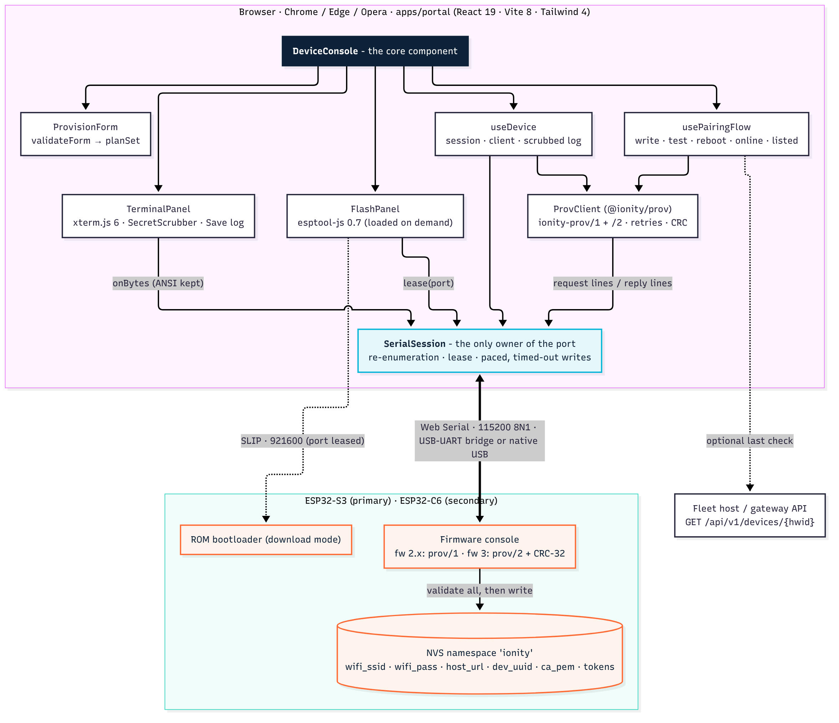
Source: docs/architecture/portal_components.mmd.
Piece | Responsibility | Key safety property
SerialSession | One reader loop, one write chain, the lease | A ReadableStream has exactly one reader – console, client and esptool-js never fight over it
ProvClient | Correlation, retries, CRC check, board identity | hello/get/set/scan are retried; test, reboot and factory_reset never are
planSet() | A valid form → the set fields this board accepts | What firmware 2.x cannot store is reported on the field, never sent and never lost
useTerminal / TerminalPanel | xterm.js lifecycle, batching, masking | Above 1 M unparsed characters new output is counted and dropped, not queued
usePairingFlow | The eight-step checklist and its messages | A failed step stops the flow and says what to fix; Stop aborts every wait
FlashPanel / installer | Download, checks, esptool-js | Nothing is written unless size, SHA-256 and the chip's bootloader magic match

3.1 The core component (condensed)
// apps/portal/src/features/device/DeviceConsole.tsx (condensed)
export function DeviceConsole({ serial, simulated = false }: Props) {
const device = useDevice(serial); // SerialSession + ProvClient + scrubbed log
const flow = usePairingFlow(device); // write → test → reboot → online → listed
const [form, setForm] = useState<Form>(EMPTY_FORM);
const busy = flow.state.running || flashing;

// what was typed as a secret is masked in the console and in the saved log
const secrets = useMemo(() => [form.pass, form.mqttPass, form.mcpToken, form.fleetToken], [/* … */]);
useEffect(() => device.setSecrets(secrets), [device.setSecrets, secrets]);

// after a native-USB re-enumeration, ask the board who it is again
useEffect(() => { if (open && reconnectsChanged && !flow.state.running) void identify(); }, [/* … */]);

const onSubmit = (valid: ValidForm, plan: SetPlan) => void flow.start({ form: valid, plan, hostApi });
return (
<div className="grid gap-4 lg:grid-cols-[minmax(0,1fr)_minmax(0,1.15fr)]">
<div>
<ConnectionBar device={device} busy={busy} />
{board && <BoardCard board={board} onFactoryReset={factoryReset} />}
<ProvisionForm form={form} setField={setField} board={board} client={device.client}
busy={busy} externalErrors={flow.state.fieldErrors} onSubmit={onSubmit} />
<PairingChecklist flow={flow.state} onStop={flow.stop} />
<FlashPanel device={device} busy={busy} onBusyChange={setFlashing} simulated={simulated} />
</div>
<TerminalPanel device={device} secrets={secrets} /> {/* xterm.js 6, sticky */}
</div>
);
}
// apps/portal/src/lib/serial/session.ts (condensed)
async #openPort(port: SerialPort, isReattach: boolean) {
if (!port.readable) await port.open({ baudRate: 115_200, bufferSize: 64 * 1024 }); // 255 B default overruns
await port.setSignals({ dataTerminalReady: false, requestToSend: false }); // never reset on open
this.#set({ status: 'open', reconnects: this.#snapshot.reconnects + (isReattach ? 1 : 0) });
this.#startReading(port); // one reader; BufferOverrun/Break/Framing/Parity take a new reader
}
#onPortDisconnect = () => this.#set({ status: 'detached' }); // native USB: chip reset
#onPortConnect = (ev) => this.#maybeReattach(ev.target); // same port, else same VID/PID

4. Pairing sequence
The hardest case: firmware 3 on an ESP32-S3 using its native USB port, which drops off the bus at every reset.
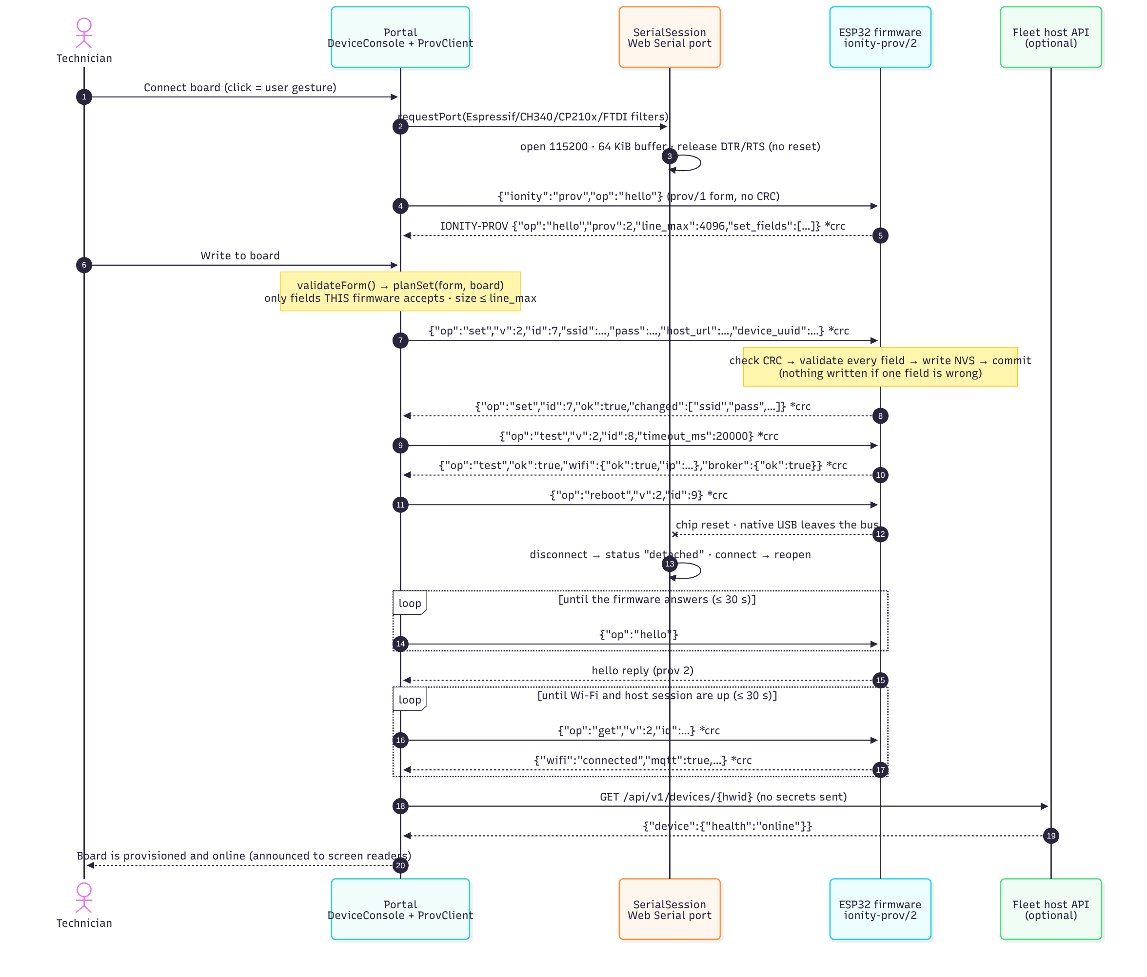
Source: docs/architecture/pairing_sequence.mmd.

5. ionity-prov/2 serial provisioning protocol

5.1 Framing
- One request per line, host → board: {"ionity":"prov","op":"<op>",…} and a newline (UTF-8 JSON).
- One reply per line, board → host: IONITY-PROV {…json…}. Every other line is ordinary log output, shown untouched.
- prov/2 (once hello says "prov":2): "v":2 and a numeric "id" in every request, echoed in the reply; a CRC suffix both ways, {…json…} *1a2b3c4d – CRC-32/ISO-HDLC (zlib/Ethernet, check value 0xCBF43926) of the JSON text's UTF-8 bytes.
- hello is always sent in the prov/1 form (no v, id or CRC): firmware 2.x ignores a CRC-suffixed line, and after a downgrade the host cannot know the version yet. Firmware 3 answers – like every reply – with the CRC suffix.
- Line limit: firmware 2.x keeps 767 characters (longer lines are dropped silently); firmware 3 advertises line_max (≥ 4096). The portal computes the exact request size and refuses a line that does not fit.
- Why the CRC: firmware 3 is multi-task, so a log line from another task can land inside a reply; the suffix turns silent corruption into a detected retry.

5.2 Operations
op | Request | Reply (besides ok, op, id) | Timeout · retries
hello | – | board identity (5.4) | 2.5 s · handshake loop 15–30 s
get | – | board identity | 3 s · 1 retry
set | fields of 5.3 (only those in set_fields) | changed (field names), reboot_required, identity | 6 s · 1 retry
scan | – | networks [{ssid, rssi, ch, open}] | 15 s · 1 retry
test | timeout_ms (default 15 000, max 30 000) | wifi {ok, ip, rssi, error}, broker {ok, detail}, board | timeout + 6 s · never
reboot | – | sent before the restart | 3 s · never
factory_reset | – | sent before the restart | 4 s · never

Errors: {"ok":false,"op":…,"id":…,"error":"…","field":"…"} – field (prov/2) names the rejected set field and is shown on that form field. A line whose CRC does not match is answered {"ok":false,"op":"error","error":"crc mismatch"} and not executed.

5.3 set fields → NVS namespace "ionity"
Wire field | NVS key | Rule (portal and firmware) | Secret
ssid | wifi_ssid | 1–32 bytes, no control characters
pass | wifi_pass | "" (open) · 8–63 printable ASCII · 64 hex raw PSK (prov/2 only) | yes
host_url (prov/2) | host_url | scheme://host:port[/path] – mqtt, mqtts, ws, wss, http; ≤ 128 bytes; port always written; path only for ws/wss; "" = mDNS
server, mqtt_port, http_port (prov/1) | same | derived from the host URL for firmware 2.x (mqtt:// and http:// only)
device_uuid (prov/2) | dev_uuid | RFC 9562, canonical lowercase; new boards get a UUIDv7
ca_pem (prov/2) | ca_pem | one PEM certificate, ≤ 3072 bytes
mqtt_user | mqtt_user | ≤ 64 bytes
mqtt_pass, fleet_token, mcp_token, ota_pass | same | ≤ 128 bytes; tokens [A-Za-z0-9._~-]{16,128} | yes
role | role | node | standalone
site, group | same | ^[a-z0-9][a-z0-9-]{0,31}$ (an MQTT topic level)
label | label | ≤ 48 bytes, no control characters

Empty optional fields leave the board's value unchanged. The canonical host URL always carries the port, so the firmware needs no default-port table – and http defaults to the fleet host's 8099, which a standard URL parser would otherwise read as port 80.

5.4 Identity reported by hello and get
prov, line_max, set_fields, hwid (esp32-<base MAC>), fw, product, chip, chip_rev, flash_mb, mac, provisioned, ssid, has_pass, host_url, device_uuid, has_ca, has_mqtt_pass, has_mcp_token, role, site, group, label, mode, wifi (connected | down), wifi_error, ip, rssi, mqtt, mcp_url. Secrets are reported only as has_* flags.
Naming trap kept from firmware 2.x: mcp_url is the board's own LAN MCP endpoint (http://<board-ip>/mcp); the host the board connects to is host_url (prov/2) or server + mqtt_port (prov/1).

6. Firmware obligations for Phase 3
The portal implements the host side and FakeBoard (@ionity/prov/testing) models the board side for the tests. Phase 3 implements the board side as follows.
- Announce at boot: print the hello reply unprompted once NVS is loaded.
- Accept both request forms – prov/1 (no v, id, CRC) and prov/2 – for every op, so older tools keep working.
- CRC both ways: verify the suffix when present (mismatch → error reply, no action); append it to every reply; echo id. If esp_rom_crc32_le is used, a Unity test must prove the check value 0xCBF43926; otherwise ship the 1 KiB table.
- Line buffer ≥ line_max (4096); UART / USB-CDC RX buffer ≥ 2 × line_max. An overlong line is discarded up to the next newline and answered "line too long".
- Atomic replies: one write under the same lock the log output uses (an esp_log_set_vprintf hook takes the console mutex).
- Validate, then write: check every set field first; on the first bad field reply with field and write nothing; otherwise write all keys through one NVS handle and commit once. Unknown fields are an error. set_fields lists exactly what is accepted.
- Never echo or log a secret – not in replies, not in ESP_LOG at any level.
- test without reboot: join with the stored settings, bounded by timeout_ms, in a worker task so the console and the task watchdog stay serviced; reply exactly once.
- reboot / factory_reset: reply, flush, wait ≥ 100 ms, restart. Factory reset erases namespace ionity and the Wi-Fi driver's stored config, not the PHY calibration.
- Migrate firmware 2.x settings on first boot: keep wifi_ssid / wifi_pass; turn server + mqtt_port into host_url; leave dev_uuid empty until provisioned.
- Latency: answer hello within 500 ms and set within 2 s while idle.
- Production boards keep NVS encryption on: the portal never writes a raw NVS image, the firmware does.

7. Web Serial engineering
- One owner. SerialSession holds the only reader and serialises writes; the console subscribes to bytes, the client to lines, esptool-js borrows the port through lease().
- Opening never resets the board: DTR and RTS are released right after open() (auto-reset circuits on CH340 / CP210x boards). Reset board is an explicit 120 ms EN pulse on RTS with IO0 released.
- Buffer: 64 KiB read buffer – Web Serial's 255-byte default overruns on an ESP-IDF boot log.
- Read errors: BufferOverrunError, BreakError, FramingError and ParityError are recoverable (a new reader, a notice that bytes were lost); anything else marks the session detached.
- Native USB (ESP32-S3 / C3 / C6 USB-Serial-JTAG): every chip reset drops the device. The session waits for connect (on the port and on navigator.serial), prefers the same SerialPort object and falls back to the same VID/PID, reopens and counts the re-attach – no new click needed.
- Writes: 256-byte chunks, 25 ms apart (firmware 2.x reads into a 256-byte Arduino buffer), each with a 3 s timeout so a stalled endpoint becomes an error, not a hang.
- Lease: stop the reader, close the port, hand it to esptool-js, close it afterwards and reattach – at once for USB-UART bridges, after re-enumeration for native USB. close() is refused during a lease.
- Isolation: a throwing listener is logged and skipped; it can never end the read loop.

8. Security
Concern | Measure
Secrets on screen | Typed passwords and tokens are masked as ••• in the console (a streaming scrubber holds back a possible secret prefix across USB chunks) and in the saved log; transmitted lines are logged redacted; the board reports has_* flags only
Secrets at rest | React state for the open tab only; localStorage holds a closed list of non-secret preferences
Secrets on the network | None. The only call is GET /api/v1/devices/{hwid} to the fleet host, when configured; an https page never calls an http host
Credentials in URLs | Refused in the MCP host URL and the host API address
Destructive actions | Factory reset and erase-all ask for confirmation (D10)
Firmware integrity | Manifest treated as untrusted (plain *.bin names, 64-hex SHA-256, 4 KiB-aligned offsets, size bound); download bounded by the manifest size; SHA-256 verified; bootloader magic checked at the chip's offset; unaligned NVS partitions refused; a failed install still hard-resets the chip
Look-alike risk | The simulator is a separate chunk loaded only by ?simulate= and shows a permanent SIMULATED BOARD banner

9. Accessibility
- axe-core 4.14 (WCAG 2.0 / 2.1 / 2.2 A and AA, best practice) on the finished pairing state: 0 violations.
- Visible labels above every control; hints and errors tied with aria-describedby, aria-errormessage and aria-invalid; the first invalid field receives focus; submit is disabled only while writing.
- Validation runs on blur – except when focus moves to a button, where a message appearing would shift the layout under the click – clears while typing, and runs in full on submit.
- One polite and one assertive live region; the console is deliberately not live; xterm's screen-reader mode can be switched on.
- Skip link, 3 px focus outlines, native dialog (focus on Cancel, Esc closes), 44 px targets, no horizontal scroll at 390 px, reduced motion respected, console colours lifted to 4.5:1.

10. Firmware install
The portal replaces flasher 2.0 and keeps its behaviour: manifest-driven images (firmware/manifest.json next to the page; the 2.0.0 manifest is read unchanged), the build chosen by chip family and console port (native-USB builds for VID 0x303A), and Keep board settings on by default. New: SHA-256 and size checks, the bootloader-magic check per chip (0x0 for S3/C3/C6, 0x1000 for ESP32/S2, 0x2000 for C5/P4), skipping the NVS-keys partition as well as NVS, a local .bin option, and esptool-js loaded only when needed. The per-chip check also fixes a flasher 2.0 bug: it required byte 0 to be 0xE9 and so refused the ESP32-classic image, whose bootloader starts at 0x1000. Installing is off in the simulator, which has no ROM bootloader.

11. User interface
The finished state of browser scenario S1: firmware 3 on native USB, provisioned and online. Desktop at 1440 × 900 with the console beside the form; phone width (390 px) stacks everything in one column.
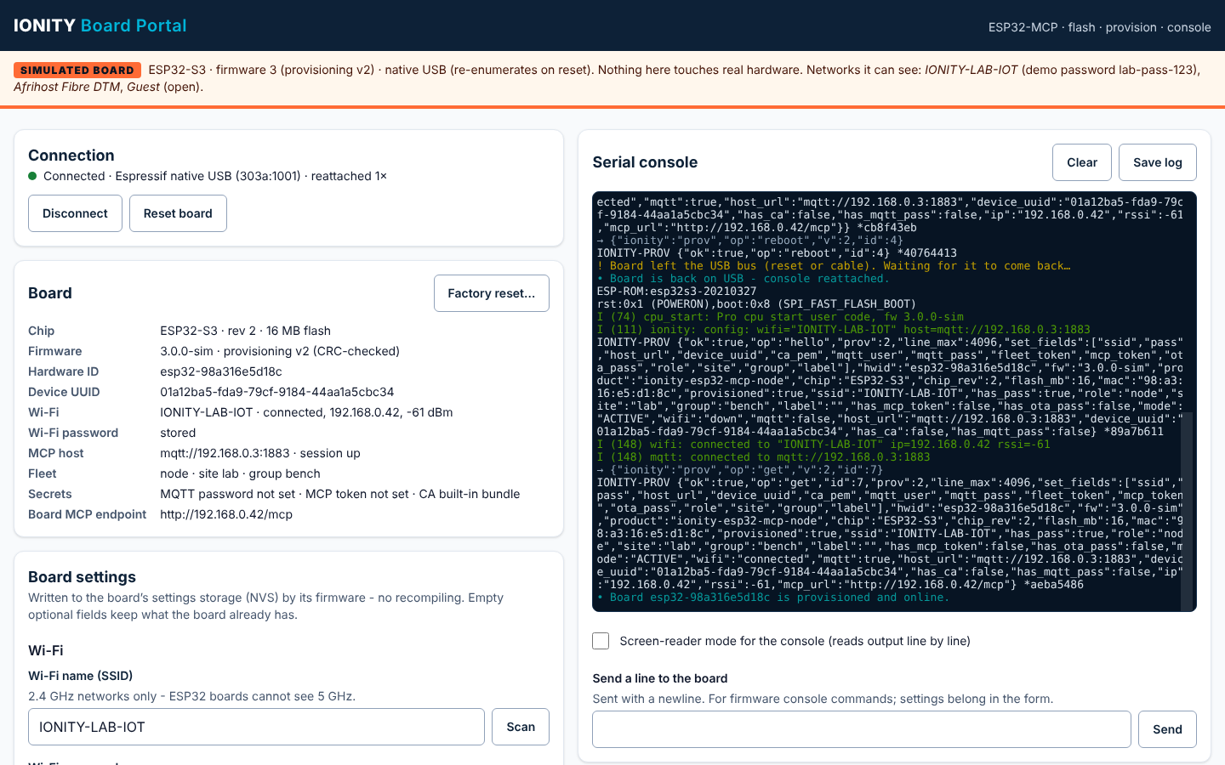
Desktop, 1440 × 900 – captured by the end-to-end run.
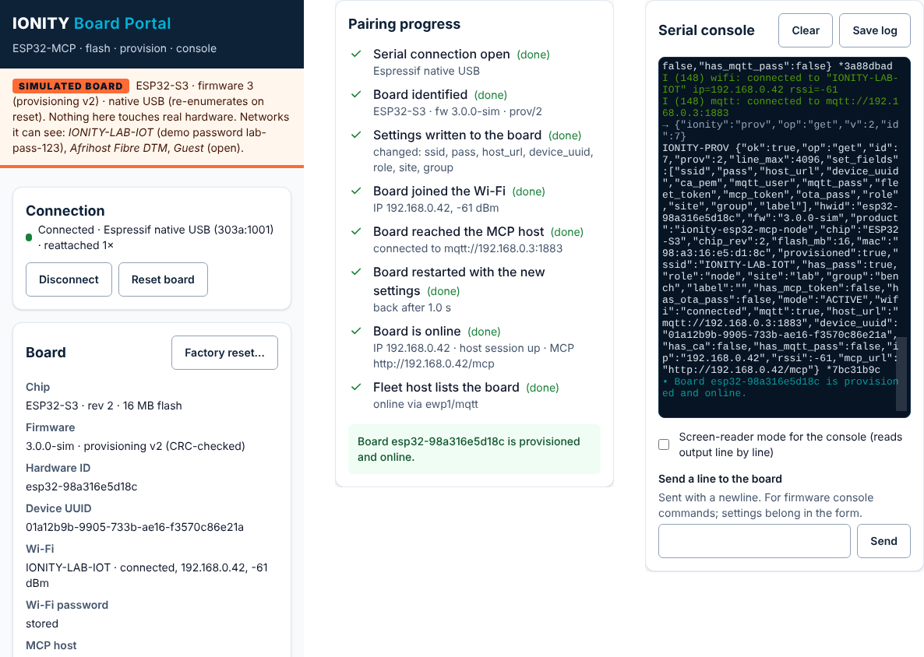
Phone width, 390 px – top of the page, pairing progress and console.

12. Verification log
Check | Result
Type-check, all workspaces (strict, exactOptionalPropertyTypes, noUncheckedIndexedAccess, erasableSyntaxOnly) | Pass – TypeScript 5.9.3
@ionity/ewp runtime tests | 9 / 9
@ionity/prov: framing, CRC, host URLs, UUIDv7, schema, planSet for prov/1 and prov/2, client against simulated firmware 2.x and 3 (CRC retry, timeouts, wrong password, firmware downgrade, unknown field) | 15 / 15
Portal unit tests (vitest 5): line splitting, secret scrubbing across chunks, partition table, manifest hardening, bounded download, host check, SerialSession + ProvClient over a simulated port (open without reset, provisioning, re-enumeration, EN reset, lease, overrun recovery, throwing listener) | 31 / 31
Production build (Vite 8) | No warnings; app 87 KB (30 KB gzip); React 219 KB; xterm 332 KB; esptool-js and simulator loaded on demand
Browser end-to-end (Playwright 1.56, Chromium) | 5 / 5 scenarios
Accessibility (axe-core 4.14, WCAG 2.2 AA + best practice) | 0 violations

Scenario | What it proves
S1 firmware 3, native USB | Full pairing incl. reboot through re-enumeration and the host listing (404 then 200); password, UUID and host_url land in NVS; no secret in the page, the console or the saved log; no horizontal scroll at 390 px
S2 firmware 2.x | mqtts:// refused on the field with focus moved there; mqtt:// accepted with the UUID warning; server and mqtt_port written, no UUID; factory reset asks first, Esc cancels, confirm erases
S3 validation | Errors on SSID, password, host URL and site; focus on the first; ARIA wiring; assertive announcement; error cleared while typing; nothing written
S4 wrong Wi-Fi password | Fails on the Wi-Fi step, password field marked and focused, then succeeds after the fix
S5 no Web Serial | Explanation shown, Connect disabled, no console errors

13. Running it, limits and next steps
npm install # once, at the repository root (npm workspaces)
npm run dev:portal # http://localhost:5173 - add ?simulate=v2-usb for a simulated board
npm run typecheck && npm test # all workspaces
npm run build -w @ionity/portal && npm run e2e:portal
- Firmware images for the install panel go in apps/portal/public/firmware/ (manifest.json + *.bin), copied from firmware/dist/ after firmware/build.py – fw 2.1.1 today; all four images pass the size, SHA-256 and bootloader checks.
- The root .gitignore ignores node_modules/ and the portal's firmware images (built and published by CI, not committed, like firmware/dist/).
- Flashing is covered by unit tests but cannot run end to end without a ROM bootloader. Hardware check before release: ESP32-S3 native USB, ESP32-S3 via CH340, ESP32-C6 dev kit, ESP32 classic – install with and without Keep board settings, then provision.
- The board side of ionity-prov/2 is a contract until Phase 3 implements section 6.
- The final check uses the fleet-host 2.x path GET /api/v1/devices/{hwid}; the gateway's REST API keeps that path.
- Web Serial is a Chromium desktop API; other browsers get an explanation instead of a broken page.

Appendix A – Document control
Field | Value
Document ID | DOC-2026-10-ESP32MCP-PORTAL-P2
Title | ESP32-MCP revamp – Phase 2: Provisioning Portal
Version / date | 1.0 – 11 October 2026 (SAST)
Status | Delivered – awaiting PROCEED to Phase 3
Classification | PUBLIC
Owner | Johan Wilhelm van Antwerp | Ionity (Pty) Ltd | Ionity Global (Pty) Ltd | AEDI
Prepared by | Claude (Anthropic), acting as lead architect for Ionity Global
Repository | github.com/dennisGIonity/Esp32-MCP – docs/architecture/PHASE-2-PORTAL.md, packages/provisioning/, apps/portal/
Related | DOC-2026-10-ESP32MCP-ARCH-P1 v1.1 (Phase 1: Architecture & Interfaces)
Governance / licence | Policy 986 AED | License AED 900 | CC BY-NC-SA 4.0 where stated
Rights | (c) 2018-2026 Antwerp Designs | Ionity (Pty) Ltd | Ionity Global (Pty) Ltd – All Rights Reserved – TM2
Web | www.ionity.today | www.ionity.world | Ref: www.ionity.co.za
 | Building Tomorrow, Today. | Anything is Possible with God.

