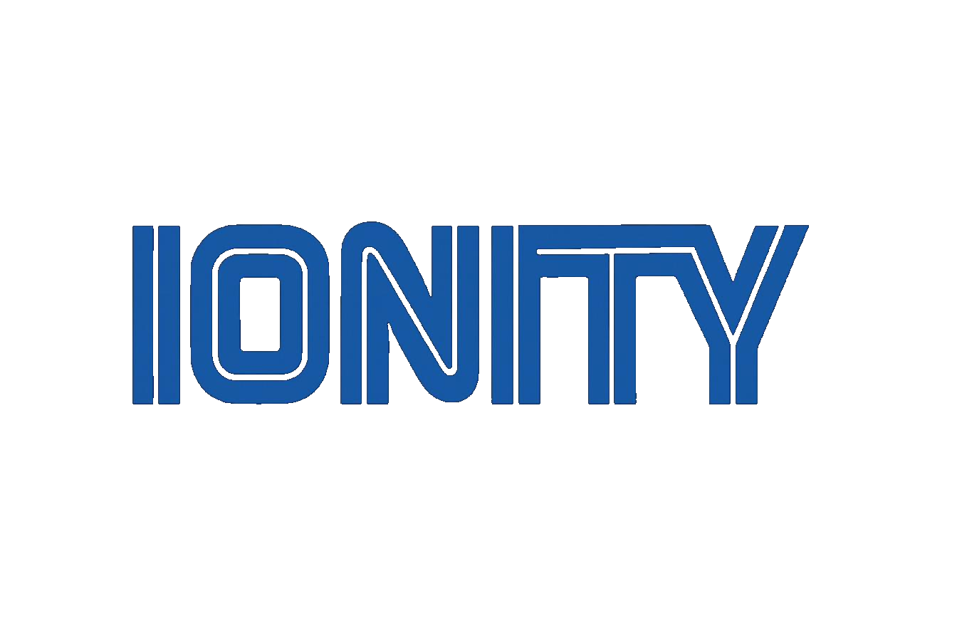
IONITY GLOBAL
(Pty) Ltd

Gate^Flame — Final Scope & Endgame
What the base model is, what the flagship becomes, and what is deliberately never built
Johan Wilhelm van Antwerp
Founder, Technical Lead & Architect — Ionity (Pty) Ltd | AEDI
Field | Value
Document ID | DOC-2026-08-024-SCOPE
Version | 1.0
Date | 24 August 2026 (SAST)
Governance | Policy 986 AED
Licence | AED 900 | CC BY-NC-SA 4.0 where stated
Classification | Internal
Supersedes | DOC-2026-08-020-TIER v1.0 (absorbed, not replaced)

INTERNAL
www.ionity.today | www.ionity.world | ai@ionity.today | +27 646 999 877
© 2018–2026 Antwerp Designs | Ionity (Pty) Ltd — All Rights Reserved — TM2
Building Tomorrow, Today. | Anything is Possible with God.

This is the scope document the other three answer to. The status report says what exists, the roadmap says what happens next, the dependency register says what could bite. This one says what we are actually building and — just as load-bearing — what we are refusing to build.

1. The sentence the whole product is built around
With one box on a household network, 100% filtering and the household surviving the box dying are mutually exclusive. There is no clever engineering that escapes this. Every function on the device sorts into one of three classes:
Class | Meaning | Consequence if the box dies
A | The box sits in the path of something the house needs | The internet breaks. Support call. Angry customer
B | A feature depends on the box | The feature stops. The internet is fine
C | Internal only | Nothing external happens

That single fact is why there are two products and not one. They are not good and better. They are two different answers to the same unavoidable trade, sold to two different people.
Same codebase. Same node agent. Same phone app. The split is which modules run and which install-time choices get made — never a fork. A fork would double the test surface and halve the honesty.

2. The two products

2.1 STANDARD — the base model (this one)
Sold on: “you will never think about this box again.” Optimises for Class A count = zero.
Architecturally it is a side-car, not a gate. ADR-001 (accepted 2026-08-24) is the decision that makes this true: the router forwards to us as its upstream DNS. Client devices are never pointed at the box, and the router’s DHCP settings are deliberately left alone. If the box is unplugged, the router falls back to its own resolver and nobody in the house notices anything except that the filtering stopped.
Design point | STANDARD setting | Why
Router handshake | Writes the router’s upstream DNS, never the LAN DHCP option | A dead box leaves nothing to reset. This is what makes "unplug it and nothing breaks" structurally true rather than watchdog-defended
Network claim | Never shipped. HEAL and OFFER only | CLAIM takes the default gateway, not just DNS. A dead box would mean total connectivity loss. Dropping it is the single highest-leverage decision in the entire design
Firewall bounce | Not shipped | Depends on CLAIM. Ships dead without it
DPI / SNI inspection | Not shipped | Same reason. Heavyweight-appliance capability
Threat level default | Low | A day-one Netflix breakage costs more than a day-one missed ad
IPv6 | Fixed or disabled once, at install — not masked at runtime | Runtime masking is exactly what turned a router misconfiguration into a box dependency
Board | Orange Pi Zero 2W class (2 GB) | Everything above fits. Nothing above needs more

Cost accepted, named openly: a small DNS leak rate — most router resolvers use the fastest upstream and fall back only on failure — and per-client attribution lost inside Pi-hole under router-forwarding mode. Both are the price of zero support calls, and both are stated to the customer rather than hidden.

2.2 PREMIUM — the flagship (the bigger one)
Sold on: “this is the strongest filter money can buy for your house.” Optimises for filtering strength, accepts Class A risk, and pays for that acceptance in hardware and a support relationship.
Design point | PREMIUM setting | Why
Router handshake | Writes the LAN DHCP DNS option — clients point at the box directly | Maximum filtering: nothing bypasses the box while it is alive
Network claim | Available, opt-in at provisioning | This is the tier allowed to take the default gateway, because it ships with the hardware and support that make the trade acceptable
Firewall bounce | Shipped, on by default | Meaningful now that real traffic crosses the box
DPI | Shipped, on by default — SNI/Host only. No MITM, no decryption, ever | The full nine-module security story without ever becoming a man in the middle of the customer’s own traffic
Threat level default | Medium | This customer explicitly bought maximum security
Hardware | Industrial SD/eMMC or NVMe, brownout-tolerant PSU, read-only rootfs, printed recovery card in the box | This tier does not eliminate the "box dies" branch — it makes it rare, and hands the customer a paper way out when it happens
Board | Pi 5 class | DPI and WAN audit need the headroom

2.3 What never differs between them
Everything Class C, plus the honesty architecture. A STANDARD customer’s dashboard is exactly as truthful about what is real and what is a gap as a PREMIUM customer’s. Specifically:
- The module registry reports not_implemented with a named gap — never a faked green light.
- Null is rendered as an em-dash. Zero is rendered as zero. They are never confused.
- The DataSourceBanner says out loud when a number is demo data.
- protectionStatus can say unconfigured and degraded, not just active — because for six days it said "active" over a box that had never filtered a single query.
- The health feed is outbound-only, health-fields-only, and off by default.
- IoniBot runs entirely offline over local probes, and says "unknown" rather than guessing.
This section is not a feature list. It is the product’s integrity guarantee, and it is the one thing that must never be tier-gated.

3. Definition of done — STANDARD v1.0
The base model is finished when all of the following are true at once. Not "mostly", not "on the bench" — on a stranger’s network, unattended.
# | Done means | Sprint
1 | A customer unboxes it, plugs it in, and pairs a phone without reading anything | F
2 | IoniBot walks them through pointing their router’s upstream DNS at the box, on their actual router, or honestly refuses and hands them a fallback | F
3 | The app shows real readings from their box — gravity, queries, blocks, clients, threats — and never a fabricated number | A, B
4 | History survives a reboot. Every chart is a range, not an instant | B
5 | Unplug the box for a minute, plug it back in, and yesterday is still there | B
6 | A green light in the app is provably a filtering box, verified by query in CI — not by four layers agreeing with each other | G
7 | The app is on Google Play under a signed release build, with a keystore that is backed up twice | C
8 | POPIA position is written down, the Information Officer is registered, and the privacy notice exists | D
9 | The box runs pinned image digests, not floating latest tags | H
10 | Unplugging it breaks nothing but filtering. Verified physically, on a real household | E

Item 10 is the acceptance test for the entire STANDARD product. If it fails, the tier does not exist — it is just a PREMIUM box with fewer features.

3.1 What is in STANDARD v1.0 and nothing more
Ships | Does not ship in v1.0
DNS filtering (Pi-hole v6 + Unbound) | CLAIM / gateway takeover
Threat dial and content categories | Firewall bounce
Pause with expiry, bypass mode | DPI / SNI inspection
Blocklist rebuild and reconcile-on-boot | Per-device profiles and per-child rules
Client list, threat log, telemetry | Cloud account, remote access from outside the LAN
History database and real charts | Multi-box / mesh
IoniBot offline guidance (job 2) | An on-device language model (job 1)
Phone app, seven screens, bubble bot | QR pairing — F.3, first new native dependency
Kiosk console on the box itself | Anything the customer must configure by hand

4. Definition of done — PREMIUM
PREMIUM does not start until STANDARD ships. It reuses every line of STANDARD and adds four things, each of which is a security surface rather than a feature:
# | Addition | The hard part
1 | CLAIM — the box takes the LAN DHCP DNS option, and optionally the default gateway | The failure story. Needs a printed recovery card, a hardware reset path, and a watchdog that is itself proven, not assumed
2 | nftables firewall bounce | This is where the first attempt produced its worst defect — an unvalidated IP reaching an nft argv. It gets the same adversarial review a second time, or it does not ship
3 | DPI, SNI/Host only | Raw-socket capability and real traffic. Must degrade honestly on a board that cannot do it, never silently
4 | WAN budget and zero-trust posture audit | Persistence and remedy text. Every finding must carry a fix a human can actually perform

Plus the hardware programme: industrial storage, brownout-tolerant supply, read-only rootfs, and the recovery card physically in the box. The flagship’s promise is not "more filtering" — it is "more filtering, and we made the box very hard to kill." Those are sold together or not at all.

5. Beyond both boxes — what the platform becomes
These are directional, not committed. Each one is written here so that a decision to skip it is a decision, not a drift.
Item | State | Note
feed-receiver | Written, 83 tests, deployed nowhere | The server side of the health feed. Needs a hosting location before POPIA s72 can be answered
Fleet view | Concept | Many boxes, one operator view. Only meaningful once feed-receiver exists and once more than one box is in the field
IoniBot job 1 — open-ended guidance | Deferred, deliberately | If it happens it goes in the phone, not the box. The base board has no RAM to give. Standing rule: IoniBot adds no required dependency
Per-device and per-child policy | Deferred | Needs per-client attribution, which router-forwarding mode costs us. Genuinely harder on STANDARD than on PREMIUM
Ionicrobes | Kept in the app, frozen | Ships as-is. Becomes its own project rather than growing inside this one
Own hardware revision | After PREMIUM | Only worth it once both tiers have shipped on off-the-shelf boards and the BOM is proven

6. Never built
Refusals, not backlog. Each of these would make the product easier to sell and worse to own.
Refused | Because
TLS interception / MITM | We would become the thing we are protecting against. DPI stays at SNI/Host and goes no further
Analytics or crash SDKs in the app | Nothing about a customer’s network leaves their LAN. If this ever changes it gets its own consent screen and its own POPIA review
Cloud-required operation | The box must work with the internet down and with our company gone
A green light that is not verified | Four layers truthfully reporting things that did not matter is how a box shipped that had never filtered anything. Never again
Auto-fixing dual-homing by downing an interface | On someone’s live household, unattended, that is an outage we caused
Acting on an undetermined check | gateway_forwards_to_us is None is not False. Undetermined means ask a human, never assume
Accepting a router password | It runs on the customer’s hardware and prompts locally. We never see it, never store it, never transmit it

7. Decisions that gate the scope
Nothing below is a task. Each is a fork in the road that changes what gets built.

Before hardware is ordered
# | Decision | What it changes
D1 | Pairing transport — self-signed TLS with pinning, or plain HTTP for v1? | Changes the QR payload. Retrofitting after units ship means re-pairing every device in the field
D2 | Pin the Pi-hole and Unbound image digests | A floating tag can change under a shipped unit in a customer’s house. That is the worst failure shape there is
D3 | Confirm the base board as the Orange Pi Zero 2W class | Locks the RAM budget, which is what forbids an on-box language model
D4 | Does the customer’s router fall back when its only static upstream dies? | If it does not, STANDARD’s zero-Class-A claim is false on that router model and the model needs a warning

Before the app is published
# | Decision | What it changes
D5 | The web demo screens — delete, or gate behind VITE_USE_MOCK_DATA? | One of them mints a fake gf_live_ token that looks exactly like a production credential
D6 | Does Ionicrobes ship in v1? | Play listing, store category, and the size of the review surface
D7 | Tier naming — two product names, or one name with a suffix? | Whether the app must detect and label which tier it is talking to

8. The order it has to happen in
Sequence, not schedule. Each row cannot start until the one above is real.
Stage | Gate
1 · Close out the household | The box filters on a real network, and the router forwards to it
2 · History database | Every chart is a range. A reboot is not amnesia
3 · Prove it on hardware | Real board, real thermal zone, real ARP table — not a container
4 · Make green mean something | CI proves filtering by query, not by four layers agreeing
5 · Plug and play | A stranger completes setup with no help. this is the product
6 · Play Store + POPIA | Both run in parallel from day one — they are queues, not tasks
7 · Manufacturing | Pinned digests, recovery card, BOM frozen
8 · Launch STANDARD | Item 10 of section 3 verified physically
9 · PREMIUM | Only after 8. CLAIM, bounce and DPI each get adversarial review

Sprints C (Play Store) and D (POPIA) start now and run in parallel with everything above. They are the only two items on the whole plan where the clock belongs to somebody else.

9. The one-line version
STANDARD is a box you forget about. PREMIUM is a box you trust with everything. Both tell you the truth about what they are actually doing, and neither of them ever breaks your internet without your permission.

