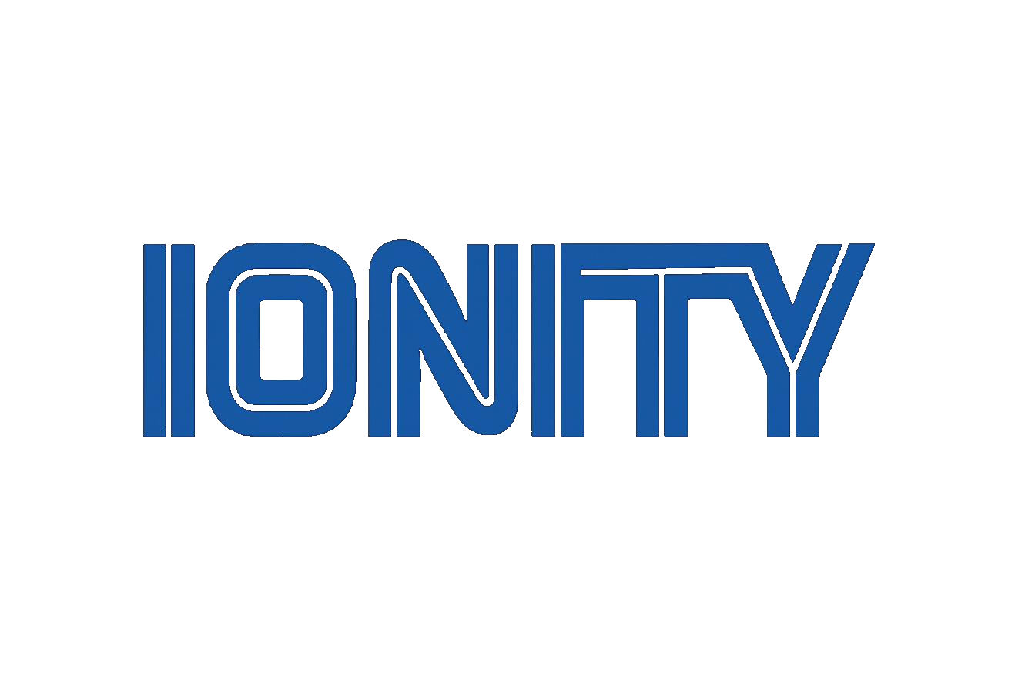

IONITY GLOBAL
(Pty) Ltd

Ionity NoteCad
POPIA Compliance Assessment
Voice-first AI workspace, as of 29 October 2026
Personal information · Live checks · The eight conditions · Findings and fixes

DOC-2026-10-NOTECAD-POPIA-01 | Version 1.0 | 29 October 2026
CONFIDENTIAL

www.ionity.today | ai@ionity.today

Index – Table of Contents
Ten sections and one appendix: the summary, what NoteCad holds about people, the live checks, each POPIA condition, data subjects' rights, the findings with fixes by priority, and what Ionity and each owner must still do outside the code.

Section | Topic | Page
1 | Summary | –
2 | Scope, method and limits | –
3 | Who is responsible | –
4 | Personal information NoteCad holds | –
5 | Live checks on WABAKIPI | –
6 | The eight conditions (sections 8-25) | –
7 | Data subjects' rights (sections 23-25) | –
8 | Special topics | –
9 | Findings and fixes, by priority | –
10 | Organisational to-do list | –
A | Appendix A - Document control | –

Note: Page numbers are indicative. Actual pagination depends on rendering and may shift slightly between Word versions. Use Word's Navigation Pane (View > Navigation Pane) for live navigation.

1. Summary
This is a technical compliance test of Ionity NoteCad against the Protection of Personal Information Act 4 of 2013 (POPIA). It covers the code as of commit 360e004 (29 October 2026) and the running stack on WABAKIPI. Every finding comes from the source code or from a check run against the live brain. Nothing here is legal advice. Matters the code cannot show, such as registering an Information Officer, are listed in section 10.
Overall: the architecture is favourable to POPIA. Data stays on the owner's PC by default, the cloud speech and model services are off, and role-based access (ADR 0014) limits each person to what they may see. Every change is logged with its author. Not yet compliant in four areas: there is no retention limit, deleted information survives in the sync journal and archives, the phone link is plain HTTP on the farm network, and nobody is told what is collected (no privacy notice, no notice to employees or to people heard in recordings).
Area | Result | Most important finding
Accountability (s8) | Partly | audit log and roles in place; no Information Officer, PAIA manual or breach process recorded
Processing limitation (s9-12) | Partly | purpose is clear and minimal; no notice or consent step for employees or for third parties heard on recordings
Purpose specification (s13-14) | Gap | no retention limit: audio, transcripts, sync journal and archives are kept with no end date
Further processing (s15) | Meets | the companion learns only for the owner's own replies, in a store per member
Information quality (s16) | Meets | every note can be corrected, undone, or traced back to its recording
Openness (s17-18) | Gap | no privacy notice in the desktop or phone app
Security safeguards (s19-22) | Partly | strong access control; but plain HTTP on the LAN, unencrypted database and audio, device tokens written to the access log, no breach procedure
Data subject participation (s23-25) | Partly | workspace export and full workspace deletion exist; no per-person access, correction or erasure
Cross-border transfer (s72) | Partly | Claude and Deepgram are off on WABAKIPI; when switched on, note text and audio go to the USA without a recorded basis

2. Scope, method and limits
Item | Detail
Code | github.com/dennisGIonity/Ionity_NoteCad_AI, main at 360e004: brain, companion, desktop app, phone app, Supabase migrations 0001-0008
Stack | WABAKIPI (Windows 11), started with start_notecad.ps1; brain 127.0.0.1:8788, Ollama 127.0.0.1:11434
Method | read every place personal information enters, is stored, leaves, or is deleted; ran live checks (section 5); scored each POPIA condition
Standard | POPIA sections 8-25 (the eight conditions), 26-35 (special and children's information), 55 (Information Officer), 57 (prior authorisation), 69 (direct marketing), 71 (automated decisions), 72 (transfers abroad)
Not covered | contracts and registrations (section 10), the Supabase project settings (none is configured), BitLocker or other disk encryption on WABAKIPI (needs administrator rights), iOS

3. Who is responsible
POPIA puts the duties on the responsible party: whoever decides why and how information is processed. For NoteCad that depends on how it runs:
How NoteCad runs | Responsible party | Ionity's role
On the farm's own PC (today) | the farm business (the owner) | software supplier; not an operator, because Ionity receives no personal information
With an Ionity-run edge node or Supabase project | the farm business | operator (s20-21): needs a written operator agreement with security measures and a duty to report breaches
With Claude or Deepgram switched on | the farm business | Anthropic and Deepgram become operators abroad (s72); Ionity should provide the terms

Ionity should therefore ship a privacy notice template and an operator agreement with NoteCad, so each owner can meet their own duties.

4. Personal information NoteCad holds
Data subjects: the owner; members (managers and employees who join with an invite); people named in notes (workers, contractors, suppliers); anyone audible in a recording.
Information | Where it is kept | How long
Voice recordings | data\brain\audio\<workspace> on the PC (14 files today); phone outbox until uploaded | until the workspace is deleted
Transcripts and note text | brain.db: captures, notes, tasks, alerts (43 captures today) | until deleted
Names and roles of people | person nodes and aliases (e.g. "Thabo, mechanic"); members, seats, invites | until deleted; a revoked member's name stays
Who did what, when | action_log (334 rows), Inbox, refused actions | until the workspace is deleted
Devices | devices: name, token hash, last seen, revoked | until the workspace is deleted
Every change, as a full row copy | sync_changes (11,749 rows), view_changes, sync_conflicts | never pruned, also after deletion
What the companion learned | data\companion: facts (name, role, location, people), style, per-owner LoRA | idle learned facts forgotten after 30 days; stated facts kept
Archives and backups | data\archive: 16 removed-workspace JSON files and 3 full copies of data\ (74 MB, audio included) | no end date
Access log | data\brain\logs\api.out.log (97 KB) | no rotation; holds device tokens (see 5)
Phone copy | IndexedDB / app files: the map the member may see, the outbox, the token | until revoked (then wiped)

Not collected: location (the captures.geo column exists but no app fills it), contacts, identity numbers, health data about people, banking details, children's information. No speaker identification or voiceprint is made, so recordings are not used as biometric information.

5. Live checks on WABAKIPI
Check | Result | Verdict
Which interfaces listen | brain 127.0.0.1:8788, Ollama 127.0.0.1:11434 only | Meets
Request from the LAN address 192.168.0.5 | connection refused (not on the network unless started with -Lan) | Meets
Request from this PC with no token | 200: this PC is trusted (NC_BRAIN_TRUST_LOOPBACK=1) | Partly
Wrong device token | 401 | Meets
Revoked device | 410 with wipe (Playwright roles.spec, CI) | Meets
Employee reads Financials (owner-only) | never on the map, digest, export, search words or live events (roles.spec) | Meets
Cross-site POST from another website | 403 | Meets
Cross-site GET | 200, but no Access-Control-Allow-Origin, so the browser blocks the read | Meets
Security headers | none (no Content-Security-Policy, X-Frame-Options, nosniff, Cache-Control: no-store) | Gap
Database at rest | plain SQLite (header "SQLite format 3"); audio files unencrypted | Gap
Access log | 4 device tokens in full in ?token= on the live-events URL | Gap
Cloud services | ANTHROPIC_API_KEY, NC_BRAIN_DEEPGRAM_KEY, NC_BRAIN_SYNC_TARGET not set in the vault: nothing leaves the PC | Meets
Phone (Android) | allowBackup=false (no cloud backup of app data); usesCleartextTraffic=true, androidScheme http | Partly

6. The eight conditions (sections 8-25)
Condition | Verdict | Evidence | Gap
1 Accountability (s8) | Partly | ADR 0014 roles; every write judged and logged with author and approver | no Information Officer, PAIA manual or compliance framework (s55, Regulation 4)
2 Processing limitation (s9-12) | Partly | collects only what the owner says; no location, contacts or IDs | no notice or consent screen; employees are not told their notes, actions and devices are recorded; third parties heard in recordings are not told
3 Purpose specification (s13-14) | Gap | purpose is stated (blueprint ION-ARC-NOTECAD-2026-001) | no retention period for audio, transcripts, logs, archives or the sync journal (s14 requires one)
4 Further processing (s15) | Meets | the companion learns only to answer the same owner; per-member stores | -
5 Information quality (s16) | Meets | notes can be edited, undone, and checked against the recording | -
6 Openness (s17-18) | Gap | - | no privacy notice in either app, no record of processing (s17)
7 Security safeguards (s19-22) | Partly | roles and views, hashed device tokens, one-time invites, throttled join, CSRF origin check, secrets in a vault outside the repo, revoke wipes phones | plain HTTP on -Lan; database and audio not encrypted; tokens in logs; no security headers; this PC needs no token; no breach procedure (s22); no operator agreements (s20-21)
8 Data subject participation (s23-25) | Partly | workspace export; workspace delete removes audio | no export or erasure for one person; deleted rows survive in sync_changes and archives

7. Data subjects' rights (sections 23-25)
Right | Today | Needed
Access (s23) | the owner can export a whole workspace (JSON) | an export for one person: notes that name them, their recordings, their actions, and what the companion learned about them
Correction (s24) | notes, names and aliases can be edited | -
Deletion (s24) | a whole workspace can be deleted, audio included; companion facts and owners can be deleted | erase one person: their recordings, name, aliases and authored rows (or anonymise them); also from sync_changes, view_changes, sync_conflicts and archives
Objection (s11(3)) | - | a way for an employee or third party to object, routed to the owner

8. Special topics
Topic | Finding
Special personal information (s26-33) | not collected by design. Free speech can contain health, religion or union matters about workers; the privacy notice should say not to dictate them, and the per-person erasure covers mistakes
Biometrics | voice is recorded but not used to identify anyone; if speaker identification is added later it becomes biometric (special) information and needs consent
Children (s34-35) | not collected; the notice should say the app is not for children
Prior authorisation (s57) | not needed: no account numbers, credit reporting, or transfer of special information abroad
Direct marketing (s69) | none
Automated decisions (s71) | the router files notes; employee changes are held or refused by fixed rules. Nothing decides about a person with legal effect, and refused changes go to a person. Compliant
Transfers abroad (s72) | off today. When the Claude key is set, note text and map labels go to Anthropic (USA); with the Deepgram key, audio goes to Deepgram (USA). Needs either the data subjects' consent or a binding agreement; switch on only with the notice updated. GitHub CI uses made-up data only
Employees | notes, devices and actions of employees are recorded. Under POPIA and labour law the employer must tell them (written notice, ideally in the employment contract or a policy)

9. Findings and fixes, by priority
# | Priority | Finding | Fix in NoteCad
1 | High | No retention limit (s14) | a retention setting per workspace (e.g. audio 90 days, transcripts and logs 1 year); a nightly job that deletes expired audio and prunes sync_changes and view_changes rows every peer has acknowledged
2 | High | Deleted information survives (s14, s24) | workspace delete also clears sync_changes, view_changes and sync_conflicts for that workspace; archives get an end date (e.g. 30 days) and are deleted after it
3 | High | Device tokens in the access log (s19) | send the live-events token in a header or a short-lived ticket, and redact token= in the log; rotate the 4 logged tokens (all from test runs; revoke them)
4 | High | Plain HTTP on the farm network (s19) | TLS for -Lan (a self-signed certificate pinned at pairing), then usesCleartextTraffic=false
5 | High | No privacy notice (s18) | a first-run notice on the desktop and on joining a phone: what is recorded, why, how long, who sees it, rights, contact; the owner's details filled in
6 | Medium | No per-person access and erasure (s23-24) | "Export person" and "Erase person" in People & seats, across all tables, audio and the companion
7 | Medium | Unencrypted database and audio (s19) | require BitLocker on the PC (check it at start-up and warn), or encrypt audio files with a key in the vault
8 | Medium | Phone token in plain app storage (s19) | Android Keystore (ADR 0014 decision 19, already planned)
9 | Medium | No security headers (s19) | Content-Security-Policy, X-Frame-Options DENY, nosniff, Referrer-Policy, Cache-Control: no-store on API responses
10 | Medium | Log files never rotate | rotate weekly, keep 4 weeks
11 | Low | This PC needs no token | keep for a single-user PC; the start script should say so and recommend NC_BRAIN_TRUST_LOOPBACK=0 on shared PCs
12 | Low | Cloud switches have no privacy gate (s72) | the brain refuses to use Claude or Deepgram until the owner has accepted a transfer notice in the app

10. Organisational to-do list
Who | Action
Ionity Global | register an Information Officer with the Information Regulator; publish a PAIA manual; write a privacy notice template and an operator agreement for NoteCad; a breach procedure (s22: tell the Regulator and the people affected as soon as reasonably possible)
Each farm owner | is the responsible party: give employees written notice; tell people they are being recorded where that applies; decide retention periods; sign the operator agreement if Ionity hosts anything
Before Claude or Deepgram are switched on | check Anthropic's and Deepgram's data terms (retention, training, region); record the s72 basis
Before Supabase is used | pick a region, enable encryption and backups, sign the Supabase data processing addendum

Re-test: after fixes 1-5, run this assessment again; the live checks in section 5 can be repeated against the stack in a few minutes.

Appendix A - Document control
Field | Value
Document | Ionity NoteCad - POPIA compliance assessment
Document ID | DOC-2026-10-NOTECAD-POPIA-01
Version | 1.0, 29 October 2026
Prepared by | Dennis Grobler (Wabakipi), with Claude Code | Ionity Global (Pty) Ltd | AEDI
Code assessed | Ionity_NoteCad_AI, main at 360e004
Governance / licence | Policy 986 AED | License AED 900
Rights | (c) 2026 Ionity Global (Pty) Ltd - All rights reserved
Company | IONITY GLOBAL (Pty) Ltd 2026/276325/07 | www.ionity.today | ai@ionity.today
Note | technical assessment, not legal advice; confirm sections 3, 8 and 10 with a POPIA practitioner

Building Tomorrow, Today. | Anything is Possible with God.

