RAMS {{RAMS_TITLE}}





{{RAMS_COMPANY_NAME}}
{{RAMS_SITE_ADDRESS_LINE1}}
{{RAMS_SITE_ADDRESS_LINE2}}
{{RAMS_SITE_CITY}}
{{RAMS_SITE_POSTCODE}}
{{RAMS_SITE_COUNTRY}}

Tel: {{RAMS_COMPANY_PHONE}}
Fax: {{RAMS_COMPANY_PHONE}}
Email: {{RAMS_COMPANY_EMAIL}}

CONTENTS

1 SCOPE OF WORKS 3
1.1 PURPOSE 3
1.2 duration of works 3
1.3 Location of Works 3
1.4 Deliveries 3
1.5 Technical Information and Reports 3
1.6 Pre- Commencement Communication 4
1.7 Sequence and Method of Works and Risk Assessment 4
1.8 permits 4
1.9 Plant, equipment and Materials 5
2 health and safety 6
2.1 Emergency contacts 6
2.2 Occupational Health 6
2.3 First Aid Procedures 6
2.4 fire and emergency Procedure 6
2.5 PPE 7
2.6 Third Party Safety / Access and Egress 7
3 environmental 8
3.1 Environmental Management 8
3.2 Spillage Procedure 8
3.3 Waste Disposal 8
4 briefing register 10

SCOPE OF WORKS

PURPOSE
The purpose of this document is to describe the works needed to carry out Excavation and Trench works
All personnel involved in the works will be briefed on this method statement prior to carrying out any works. They will also be asked to sign to confirm they understood the information given to them.

duration of works

Anticipated Commencement Date: | {{RAMS_START_DATE}}
Duration of Works: | {{RAMS_DURATION}}

Location of Works

The works are to be carried out at:

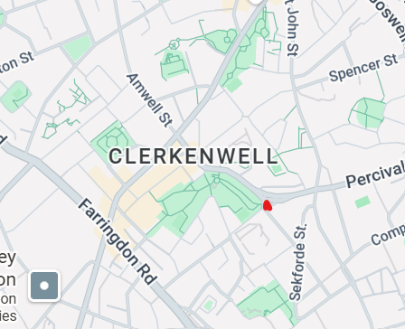

Deliveries
If this question is completed, add in the image
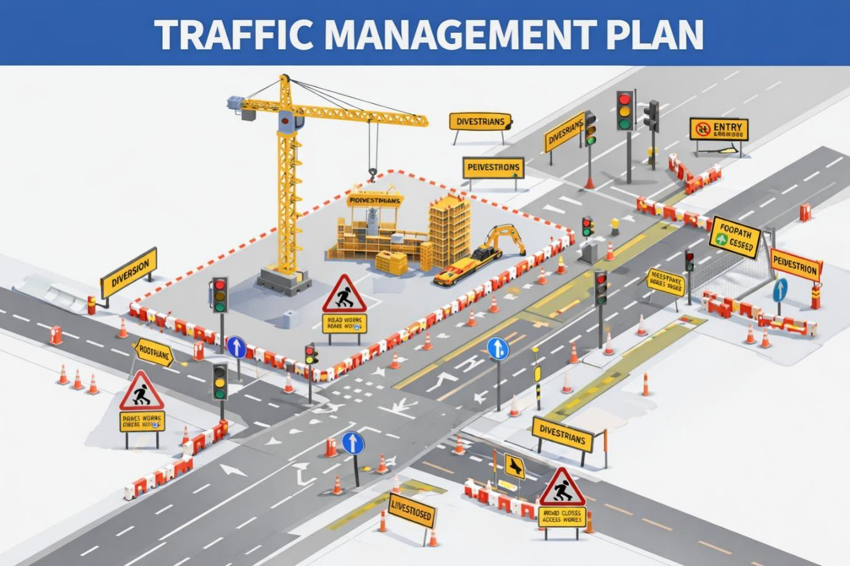
As per Clients CPP and Induction
    - Deliveries will be booked in with the clients system prior to arriving on site.
    - All vehicles will enter site asper site logistics plan .
    - Site traffic marshals/banksmen will direct deliveries onto site at which time our banksmen will take control of directing delivery to final unloading point.
    - Vehicle drivers are to stay in their vehicles
    - All delivery vehicles are to have suitable edge protection and access if an operative is required to get onto the tray of the vehicle.
    - For unloading of plant, edge protection is to be in place to edges of trailer, prior to operator accessing the trailer.
    - When unloading is complete, the vehicle will be directed out of works area and onto public road but client traffic marshals/banksmen will once again take over control of vehicle.

Technical Information and Reports
Acknowledgement has be made to any drawings / reports that are relevant to the development of the method statement. e.g. drawings, temporary works, underground services, reports, surveys, data etc.

Pre- Commencement Communication
Prior to works commencing this Method Statement and Risk Assessment will be briefed out to the operatives in a full induction which will be held on site. This will be in the format of a formal discussion specifically detailing the elements of this Method Statement and Risk Assessment the potential risks involved via the works followed by a post briefing questions and answers session. All operatives are specifically briefed in the tasks they are due to carry out under {{RAMS_COMPANY_NAME}} supervision and required to sign up to said methodologies.
No one is to start works until they have been fully briefed on the Method Statement and Risk Assessment, had a site-specific induction and attended the clients daily briefing if necessary. These communications are to be carried out:
Prior to carrying out works:

    - RAMS will be submitted and approved via Client’s Site Management
    - All operatives will receive a site induction from the client
    - All operatives will be briefed by the Manager/Supervisor as to the nature of the works,
    - Daily Briefings will be conducted within the area of the proposed works to all personnel every morning prior to commencing any works on site. The daily briefing will cover site- specific constraints and will bring to the attention any significant hazards and/or risks associated with the day’s operations and will also identify any areas/locations where no admittance is permitted due to the works and/or lifting
    - All operatives will wear task specific PPE and minimum PPE at all times as per client induction.
    - The client and other trade contractors and the logistics team will be made aware, of the planned works, programme and restrictions in good time and updated at the clients co-ordination meetings
    - The main site welfare facilities and safe access routes will be provided by the client
    - All permits completed / issued by the client
    - If required, {{RAMS_COMPANY_NAME}} to undertake a dilapidation survey of the work area prior to any works proceeding

Sequence and Method of Works and Risk Assessment

Chat GPT info dropped here:

Bulk or Minor Trench Excavation
- Utility runs to be marked with spray paint.
- Depths of trench must be communicated clearly to site team.
- A permit to break ground will be issued prior to any excavations commencing– HOLD POINT
- CAT scan of the entire area clearly marking out all detected signals at ground level. Consult Stats and as built drawings.
- Check the surrounding area for existing MH chambers & draw pits, lift all existing covers and check depths of the incoming utilities for clarity.
- Look for obvious signs in the existing surface finish for scars or differing reinstatement types that may indicate where a utility has been installed – compare with as-built drawings
- Flame proof overalls to be worn at all times while carrying out the works
- In the event that that a utility found during the CAT scanning operation & there is a possibility a service runs through the works area, op’s are reminded take extra care, a supervisor will be present for the start of a break out
- Slip trenches across excavation areas to be conducted before main dig commences to confirm locations and depths of services on stats drawings and to confirm if any Services or concrete structures that are not identified on stats drawings & surveys.
- Trenches to be hand dug by single operatives.

- The removal of the material will be excavated using a 360º excavator. A banksman will attend at all times to guide the excavator driver.
- The width at the top of the excavation must not exceed the specified width as shown on the construction issue drawings.
- The area will be cut and trimmed by the excavator to the lines and levels of the construction issue drawings,
- At this point the project management team & foreman will decide the on the most appropriate method of trench support or whether to step/ batter the trench excavation, if required.
- Trench to be barriered to prevent people or machinery falling in
- Excavated spoil will be removed from the works area to a stockpile within the site using forward tipping dumpers. Stop blocks will be installed near excavations when working with dumpers
- Groundwater is not anticipated, should water accumulate in an excavation it will be pumped to an area specified by the principal contractor. It should not be pumped to a drain (Storm or Sewer) or controlled waters without the principal contractor’s instruction and a copy of their licence to do so.
- Once trench is ready, utilities can be installed.
- Trench must be inspected visually every morning before work starts, a record of this is taken every 7 days or after adverse weather conditons. When working in a trench, team sizes are kept to a minimum to maintain a 2m social distance.

permits
The following permits are required to carry out the works
- {{RAMS_PERMIT_BREAK_GROUND}}
- {{RAMS_PERMIT_TO_WORK}}
- {{RAMS_PERMIT_TO_LIFT}}
- {{RAMS_PERMIT_WORK_AT_HEIGHT}}

Plant, equipment and Materials Maintenance

All Plant and Equipment listed in the method of works will come under PUWER and LOLER Regulations respectively
There will be a maintenance schedule in place and thorough examination certificates will be available upon request
All Operatives using plant and equipment will be trained to use them through formal training or familiarization / verbal on site training dependant on the risk

All materials will be procured as per design and installed as per manufacturer instructions.
If required, a dilapidation survey will be undertaken

health and safety

Emergency contacts

{{RAMS_COMPANY_NAME}} will supply at least 1 qualified first aider and 1 fire marshall (If necessary)

{{RAMS_FIRST_AIDERS}}
{{RAMS_FIRE_MARSHALLS}}

Occupational Health

Daily briefings will be held by the client every morning to all operatives before any works commence. Daily tasks and associated risks and controls will be highlighted and recorded.

Other Occupational Health Hazards associated with {{RAMS_COMPANY_NAME}} work processes:
- Dermatitis from contact with Wet concrete and other hazardous substances
- Silicosis through exposure to silica dust
- Tinnitus or noise induced hearing loss from breakout or cutting paving
- HAVS from overuse of tools. HAVS Register kept for all individuals who use medium to high vibrating tools, this is identified in the HAVS tool register.
- MSD’s from poor manual handling.

First Aid Procedures

Item | Location
First Aid Box | In site office and at work area
Accident Book | In site office
Hospital Details – As Per Clients Inductions

Nearest hospital – Added in only completed

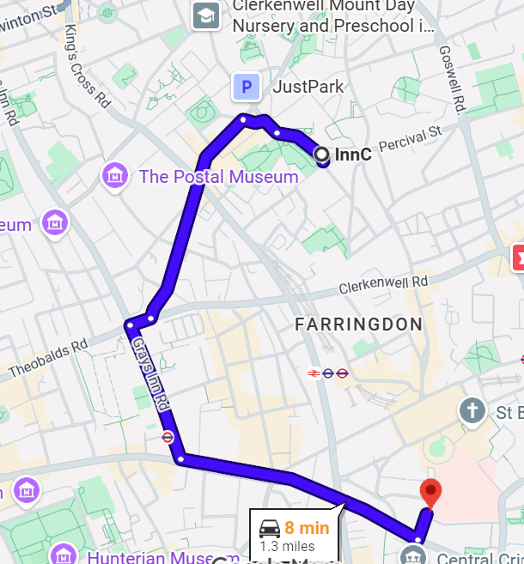
Performing First Aid

If someone is injured than the primary response is to preserve life. However, the first aider is required to take the necessary precautions to protect themselves in line with their first aid training.

fire and emergency Procedure
Please refer to the Client’s Fire Plan
All emergencies must be reported to the client management team immediately
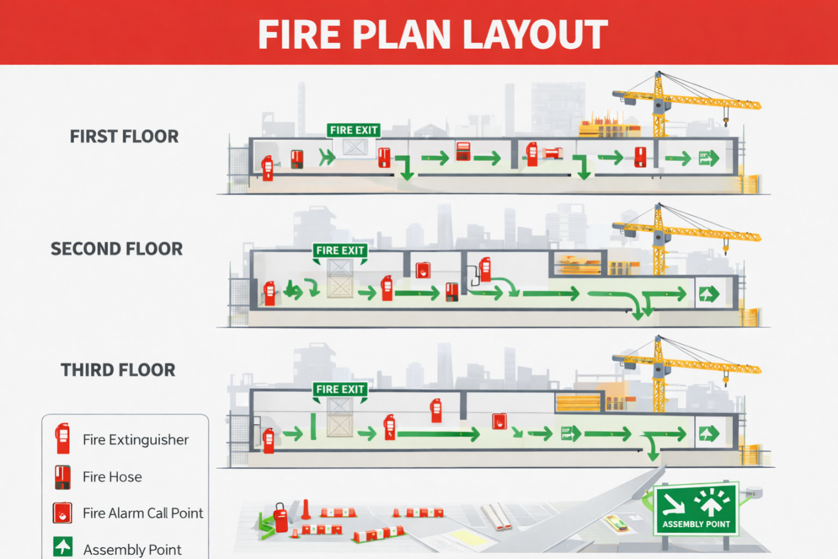

PPE
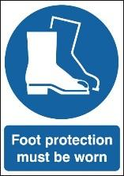



{{RAMS_COMPANY_NAME}} operate using a the following:
- Safety Helmet (BS EN397)
- Safety Footwear (BS EN345)
- Hi-Vi Jackets (BS EN471)
- Safety Glasses (BS EN166) if required
- Safety Gloves (BS EN388/374) if required
- Chin Straps if required
- Hearing protection if required

Third Party Safety / Access and Egress
All works will be within the exclusion zones as identified on the drawings provided, this will provide clear segregation of the works area and other trade contractors. The required measures will be taken to alert / protect other site workers, visitors, members of the public from our work activities. All walkways will be kept clear and any changes to the segregation will be communicated to those effected.
Main Delivery area has been identified above and will be managed by the Client.
Specialised routes have been arranged for deliveries in and out of site to minimise disruption to the local residents and businesses, the designated traffic routes are to be used. All vehicles entering site must be banked by a qualified and competent banksman. When unloading the vehicle and distributing the materials {{RAMS_COMPANY_NAME}} will ensure all employees understand the environmental and safety issues involved.
All materials will be correctly and safely stored in the designated areas ensuring that there is clear access to and around the materials. All packaging and binding wire will be removed immediately and disposed of in the correct manner to reduce the risk of trips and fire.

environmental

Environmental Management
For full environmental controls please refer to {{RAMS_COMPANY_NAME}} Environmental Policy.
Any hazardous substances used will be covered under a material safety data sheet or a COSHH Assessment
Excessive noise and vibration not only represents a major hazard to site workers but can disrupt and inconvenience neighbours and also disturb wildlife. {{RAMS_COMPANY_NAME}} will control and limit noise and vibration levels so that affected properties, and other sensitive receptors, are protected from excessive noise and vibration levels associated with construction activities.
As well as causing a nuisance to neighbours, dust can lead to both health issues to persons on and off site and can have adverse ecological impacts. Potential sources of emissions must be identified and appropriate controls applied to eliminate or minimise effects on neighbours and other sensitive receptors.

Spillage Procedure
In the event of a spillage the following procedure is to be followed:
- Stop Pollution from spreading - contain the spillage with materials from the site spill kit or sand and ensure any surface water drains are protected.
- Report the incident your Supervisor / Management immediately who will inform the Client. If it is a large spill (Over 1000L) or the substance has entered a drainage system or watercourse call the spill response contractor.
- Ensure Management are informed of the incident as soon as is reasonably practical.
- Contain at source - The most effective place to stop a spill is where the spill is happening, at the source. If the primary container or secondary containment have been breached or failed for any reason, try to contain the spill where it’s happening.
- Contain close to source - If you can’t stop the spill where it’s happening, aim to stop it as close to the source as possible. Where the spill has escaped from the primary and secondary containers you should try to stop it spreading.
- Transferring the leaking material into an undamaged container - If you can safely move the material that is spilling into another container, it will limit the size of the spill. Manual pumps may be suitable for small spills but would be inefficient for moving large volumes.
- Use absorbent products to soak up the spill - Absorbents are usually available as loose granules, sheets or rolls, pillows or booms. They can be used to soak up a spill and stop it spreading. There are different types of sorbent available, for example oil or chemically absorbents. You will need to select the appropriate absorbent for the materials on your site.
- Any contaminated absorbents, soil or sand must be disposed of in accordance with the Duty of Care.
- A Hazardous Waste Consignment Note will be required for the disposal of all contaminated spill response equipment

Waste Disposal
Any waste created by the works will be disposed of correctly and records kept in the site filling system.
Materials will be reused, segregated, recycled or disposed of as laid out in the data sheet.
All waste removed from site will be as per the Clients waste removal policy, if required a Waste Transfer Note or Hazardous Waste Consignment Note if containing all the legally required information, including the correct waste code.

briefing register
By signing the below register, I am agreeing that I have understood and will agree to adhere to the contents of this method statement and the associated risk assessments and COSHH assessments. I have attended a site induction and today’s daily briefing that explained the general site rules and necessary site-specific arrangements.
Job Description: |  | Excavation and trench works
No. | Name |  | Contractor | Date | Signature
1
2
3
4
5
6
7
8
9
10
11
12
13
14
15
16
17
18
19
20

