DUNST ’ODEUR’
SOUNDS FROM THE QUEER UNDERGROUND
COMPILATION CD ON USELESS SALVATION
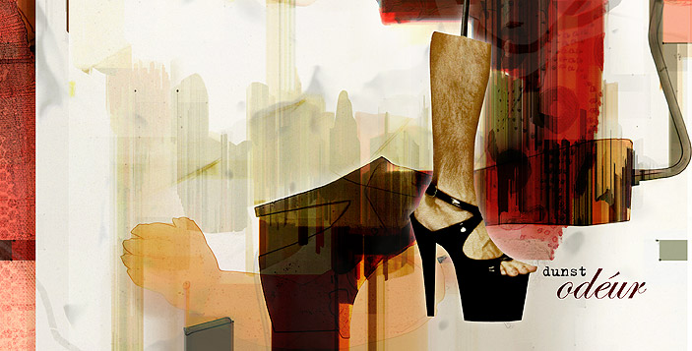
Useless salvation, the Danish cutting edge label that brought you Geeza, releases
first compilation album by Danish queer underground movement Dunst.

Dunst is, to say the least, notorious for their outrageous all night-dancefloor trash-drag
performances. Since the beginning in 2001, their highly visual , provocative and entertaining
shows have blown the tops of ecstatic crowds all over Europe.

The past four years Dunst has made numerous parties and events. E.g. poppers and darkroom party in a sightseeing bus with DJ. Bondage party at the HQ of Danish boy scouts, co-arranged COMA party feat. KLF and the ultimate queer contest Mr & Mrs Dunst.
Abroad Dunst has thrown a number of parties in Stockholm, Barcelona, Amsterdam and Berlin, latest at the new year homophobia event with Snax of Captain Comatose.

This compilation gathers the best tracks produced for these events.

The sounds are a vivid and innovative cocktail of contemporary underground and
popular styles ranging from indie, electronica, electro, punk to disco….

Even though every artist has an individual style, the music is connected by the same
nerve. It comes from an innermost wish to express a personal approach to queer lifestyle,
identity, sex, madness and the right to exist. These performances smell of what they are,
hence the title odeur.

The looks and trash drag performances by Dunst are highly unique, and have been compared
to legends like Leigh Bowery, Divine, Boy George, Dead Or Alive, Minty and Sylvester.

www.dunst.dk

A brief presentation of the artists :
Dennis Agerblad ; has released two cds with his Faroese band, Maður:glotti. Agerblad is highly acclaimed for his provocative and sensual performances. His contributions to this cd are both emotional , personal and yet danceable.
Hairwerk ; Appears with two tracks on the “munch of us “ compilation. A wellknown stylist, artist and performer. His musical style is a raw blend of electro with a twist of glam-rock. Famous ex Sort Sol guitarist Peter Peter appears on both Hairwerk tracks.
Puta ; The ultimate trash-drag of Copenhagen , performer, as well as writer and editor of gay fanzine PUHA. With musical mastermind Pelle, educated from Copenhagen academy of music, their music is an innovative take on the electro-clash genre, with twisted lyrics and highly advanced beats.
Minimal Martin ; DJ, grafitti painter and artist, with a musical style of his own. As his name suggests, he shows a great passion for minimal techno.
Johnny Warehouse ; Appears with two tracks on the “munch of us “ compilation. Professional dancer, wellknown performance artist. Musically Warehouse blends hip hop/rap, and hard minimal clubby beats.
Miss Fish ; Media and performance artist. Currently working with guitar player Luis Miguelez of Berlin electro punk band Glamour To Kill , on the EP “The beauty regime". On stage Miss Fish is notorious for his in your face performances, always leaving an astonished crowd. Miss Fish music is ranging from clubby disco to his roaring rock anthem ” I am for real”, inspired by indie band Six By Seven.
Alexis ; Alexis has released the single “Love Trip” on Edel Scandinavia ,and has been around clubland as a DJ for more than 20 years, mixing at almost any club in CPH, as well as clubs around Europe. “Give me more” is produced by Undergram, a blazing disco/prog-house track, bound to be an instant club hit.
For further information, interviews and promotion material please contact:
Useless Salvation, Sweden +46 44 310 980
Useless Salvation, Denmark +45 2513 0747
Email: salvation@useless-salvation.com

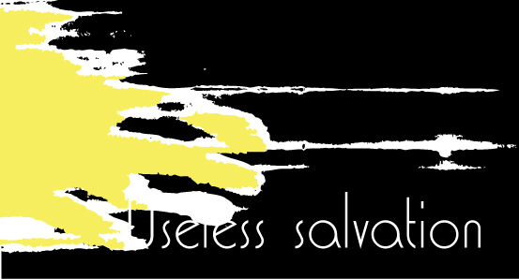

A divison of Mainline Group
Lundgrens Väg 7
290 10 Tollarp
Sweden
Ph. +46 44 310 980
salvation@useless-salvation.com
www.useless-salvation.com

