

**CSC 450 – Honors Research Project**

**Student: Dennis Krupitsky**

**Mentor: Dr. Natacha Gueorguieva**

College of Staten Island

[dennis.krupitsky@gmail.com](mailto:dennis.krupitsky@gmail.com)

**Deep Learning Image Recognition and Detection: Architectures, Learning and Applications**

**Table of Contents:**

1. Introduction to Deep Learning pg. 3
   1. – Purpose and use of Deep Learning pg. 3
   2. – Neural Networks pg. 4
   3. – Data Preprocessing pg. 5
2. Convolutional Neural Net and Model
   1. – Activation Functions
   2. – Optimizers
   3. – Confusion Matrix, K-Fold validation
   4. – Mini-batches of data
   5. – Imbalanced Data Sets
   6. – Experiments for overfitting
3. Experimentation
   1. – Dataset information
   2. – Experiment Details
   3. – Experiment Results

**1. Introduction to Deep Learning:**

With machine learning being an ever-growing, popular field within the artificial intelligence world, a subset of machine learning is **Deep Learning.** This specific subset is a learning technique for computers involving algorithms, and neural networks inspired by the human brain to learn from huge amounts of data. The process of creating a model could grow quite extensive as there are many facets to account for. A simple definition for a deep learning model can be described as an algorithm repeatedly performing a task, and each time have certain tweaks in order to improve the outcome. The “*deep*” within deep learning is a reference to the number of successive layers of representations, which could also he described as the *depth* of the model. A model could range from one to hundreds of successive layers, all learned during the exposure to training data. Deep learning has only come to surface as one of the most useful AI techniques in the last few decades, as we now have access to large amounts of labeled data for training (over 2 quintillion bytes of data is generated daily), and substantial computing power to train our models. Overall, deep learning allows modern machines to solve complex problems, by learning from experience.

**1.1: Purpose and use of Deep Learning:**

Deep learning is one of the areas that has attracted a lot of attention due to its potential for real world applications. It is widely used in real life applications, such as image classification, aerospace and defense, medical research, self-driving cars, robots, etc. There are several forms in which this type of machine learning can be trained. One allows for a training method with data that is pre-labeled, and through training the model is comparing the label it assigned the data to the actual label, to see if its prediction was correct or not, also known as supervised learning. As mentioned earlier, there is tons of data that is collected every day, but most of this data is not labeled, so we are not able to use it in supervised learning. This is where unsupervised learning comes in to play, we are still able to show the data to our deep learning networks, and it will learn to identify the data’s label.

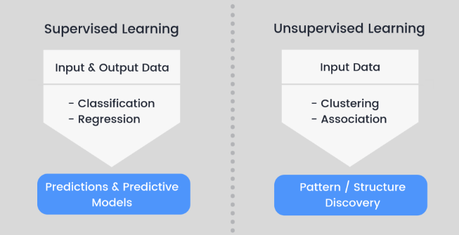

**Fig 1. Supervised vs Unsupervised learning**

These networks can be successfully applied to huge amounts of data for knowledge discovery, application of this knowledge, predictions based off the knowledge, etc. Deep learning is used to create actionable results. Deep learning allows us to advance and innovate within the real world, and is one of the most powerful aspects of machine learning.

**1.2: Neural Networks:**

Deep learning got its name for another reason, more specifically due to the neural networks it is comprised of have various deep layers that enable learning. A neural network is a set of algorithms, which as stated earlier are based off the human brain, which we design in order to recognize patterns, whether it be in images, text, etc. Neural networks assist us in clustering and classifying data. These neural networks are a set of layers that are stacked on top one-another that adjust to the properties of the training data.

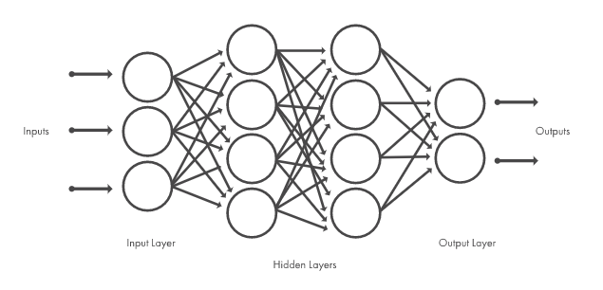

**Fig 2. Representation of a Neural Network**

The input layer is the initial data being brought in that will be used by the neural network. The hidden layers within neural networks make this one of the superior machine learning algorithms. These hidden layers are not visible to external systems, and are private to the neural network. The amount of these hidden layers can also range from zero to hundreds. Each hidden layer is comprised of neurons that receive an input from the previous layer, and does some sort of manipulation or transformation to the data before sending it to the next layer/neuron. The final layer in the flow chart is the output layer, which produces the result for the original inputs. Essentially each layer, start at the hierarchy, is combining information into something more and more complex, depending on the number of layers you utilize. Each node in a layer is connected with each node in the following layer, and each arrow in the connection golds a certain weight. This could also be perceived as the impact that the node has on the next layers node.

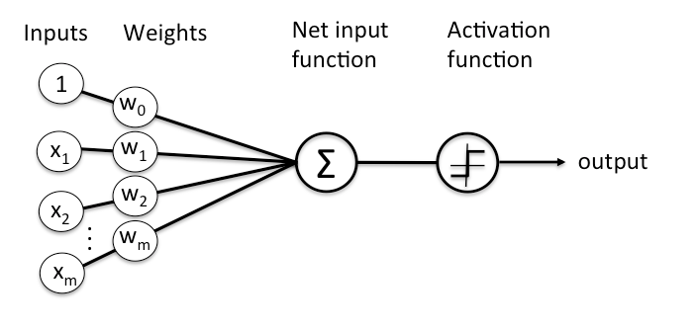

**Fig. 3 Representation of a single node/layer**

**1.3 Data Preprocessing:**

There is a crucial step that is taken before the training of a machine learning model, which helps improve both the quality of our data, and final result of the model. This step is called data preprocessing, a data mining technique used to transform raw data into usable formats. Within it there are several steps, such as data cleansing, data transformation, data distribution, etc. These steps allow our data to take a form in which they can create a model. We use this in order to combat data inefficiencies which could have negative effects on our experiments, such as inaccurate data, noisy data, inconsistent data, etc. If this step is skipped over, there is a possibility that a percentage of the results will be false.

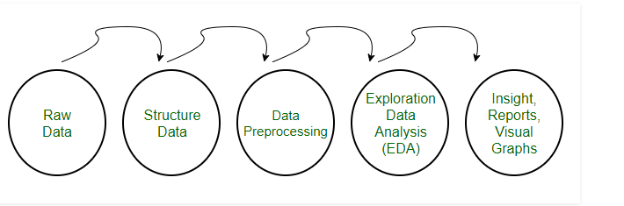

**Figure 4: Data Preparation**

Some of the widely used techniques include removing null data, rescaling data, standardizing data, binarizing data, and label encoding. Missing or null values should be handled properly during data preprocessing, in order to avoid altered results that will differ from the proper data. Rescaling data is the process of converting data that is comprised of attributes with varying scales, into common values which range between 0 and 1. This method is very useful in optimization algorithms. Standardizing data allows the transformation of values with a Gaussian distribution of differing means and of differing standard deviations into a standard Gaussian distribution that has a mean of 0 and standard deviation of 1. The formula looks as following:



**Figure 5: Standardization Formula**

Binarizing the data allows all values over the threshold to be marked 1, while all equal to or below the threshold are marked as 0. This method is useful when dealing with probabilities, as it allows the data to be transformed into crisp data. Label encoding transforms data labels, which are usually labeled with words in order to make it readable, into numbers or binary labels for the algorithms to be able to work with them. Another crucial step is to distribute the original collection of raw data into separate sets, more specifically training, validation, and testing sets. The training dataset contains data that will actually be used to train the model, as the model sees and learns from this data, therefore this set should have the biggest ratio of data. The validation dataset is used to evaluate a given model during its training, this data is used to fine-tune the hyperparameters, this set should have slightly more data than the testing from the remaining available data after the training set is allocated. The testing set is used to fully evaluate the model, after it has completed training (using test and validation sets). It should receive the remaining undistributed data. It is good practice to not have 2 sets containing the same data. Once the data has been preprocessed visual graphs, and reports are generated in order for the researcher to get a sense of the altered data’s values.