Through the Publications tab, all households and their info can be viewed. Options regarding subscriptions can be selected to the right.

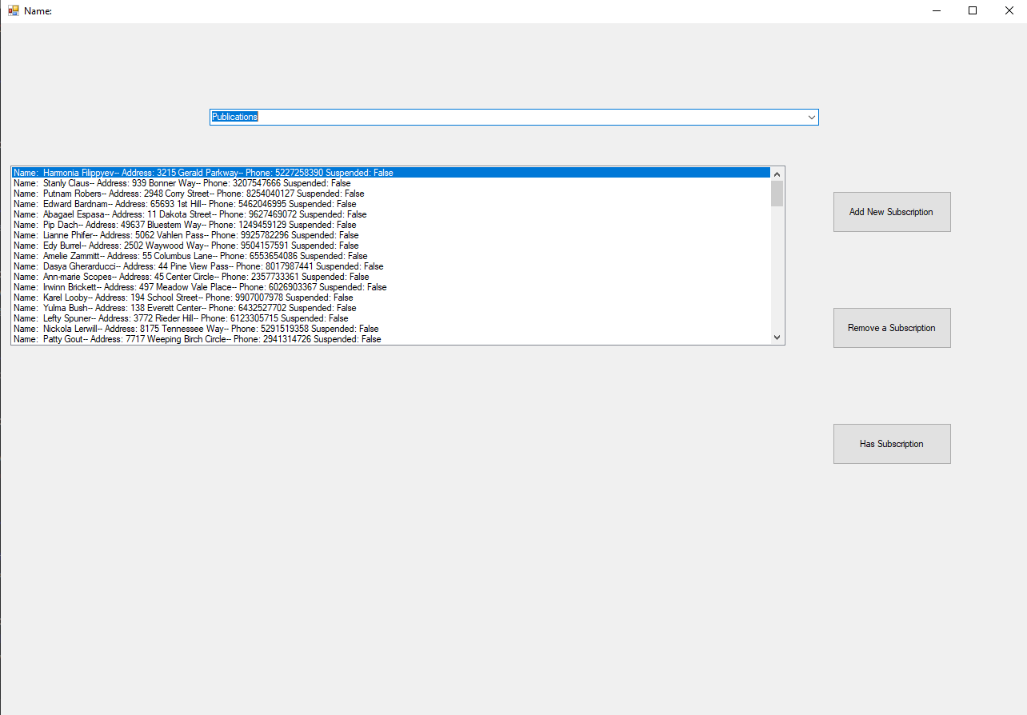

Here a subscription is being added to a household. Below, a confirmation message is displayed.

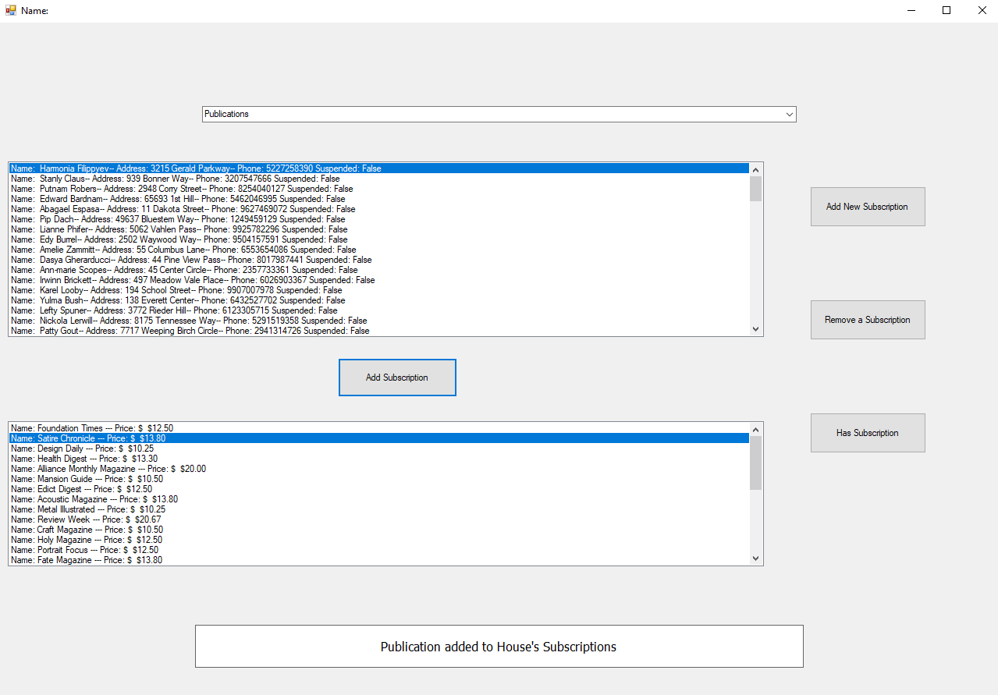

The household’s subscriptions can be viewed in the Billing tab. Each subscription’s name and price are displayed.

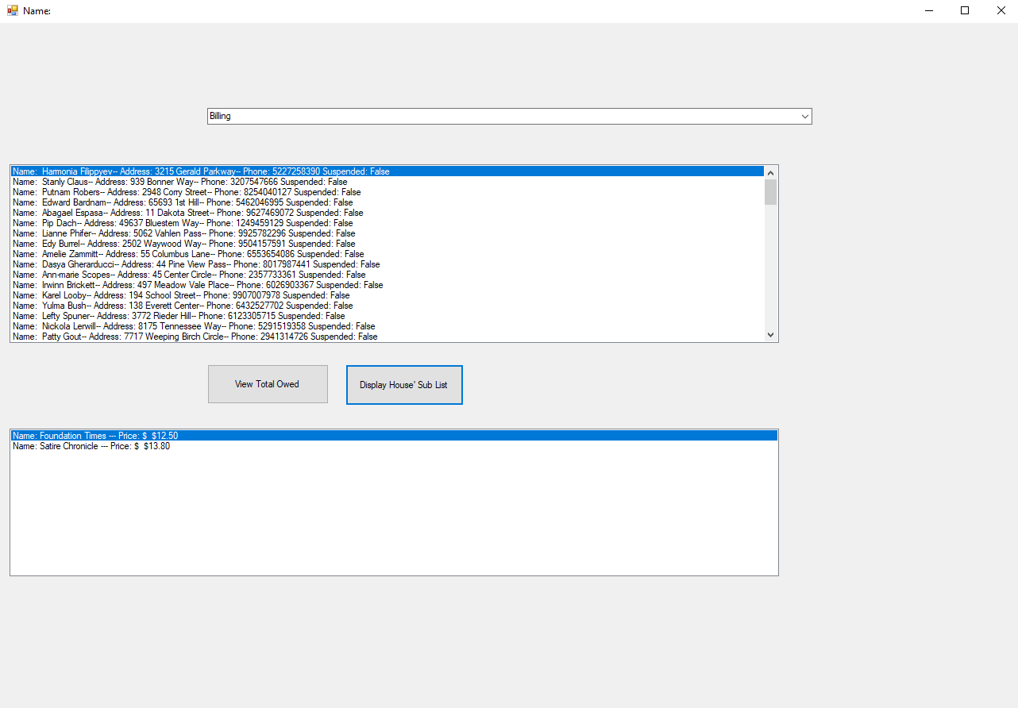

The total amount that the household owes can be displayed in the Billing tab as well. The program user can enter an amount paid and the household’s remaining balance will be updated.

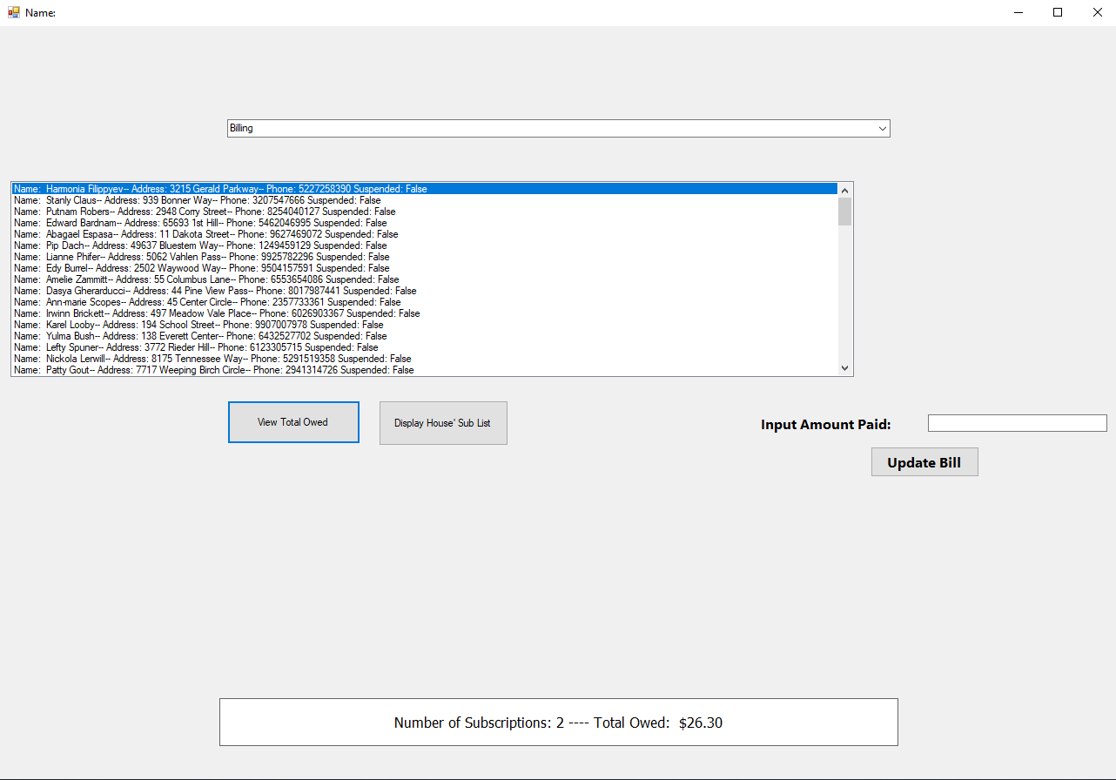

In the Summary Printout tab, the summary of subscribers for a given publication can be displayed, with the total owed to that publication. Below, our single test subscriber can be seen as quantity 1 subscribers.

