

Topic:

The Impact of Variance on   
Black-Scholes Model

Risk Management

Thomas Zellerer

Summer term 2020

presented by:

|  |  |  |
| --- | --- | --- |
| Dennis Blaufuss | Sergen Bayraktar | Sebastian Kokich |
| Walter-Hesselbach-Straße 54 | Schillerstr. 65 | Buchholzerstr. 20 |
| 60389 Frankfurt am Main | 63329 Egelsbach | 56154 Boppard |
| 1200621 | 1178960 | 1214646 |

Submitted:

12.08.2020

Contents

Figures II

Symbols III

1. Introduction 1

2. Theoretical Background 2

2.1 Black-Scholes Model 2

2.2 Greeks 5

2.2.1 Delta 5

2.2.2 Vega 5

2.2.3 Gamma 6

2.2.4 Theta 7

2.2.5 Rho 7

3. Study 8

3.1 Estimation Strategies 8

3.1.1 Historical Volatility 8

3.1.2 Implied Volatility 9

3.2 Setting 11

3.3 Analysis 12

4. Conclusion 17

Appendix IV

References VI

Statutory declaration VIII

# Figures

Figure 1: Vega of DAX Option (Lynxbroker, 2020) 6

Figure 2: Annualized volatility 12

Figure 3: Vega 14

Figure 4: Black-Scholes prices for put option 15

Figure 5: Black-Scholes prices for call option 15

# Symbols

V value of option

S stock price

r risk-less rate of return

t time until maturity date

T maturity date

CALL price/value for call option (call premium)

PUT price/value for put option (put premium)

E exercising or strike price

$d_{1}$ first Parameter of Black-Scholes model

$d_{2}$ second Parameter of Black-Scholes model

$∆$ Delta

$v$ Vega

$Γ$ Gamma

$Θ$ Theta

$θ$ driftless Theta

$ρ$ Rho

# 1. Introduction

Trading in options can be traced back to the 17th century and, especially in the 19th century, developed into a globally traded product on virtually all stock markets. Probably the largest and most influential model was developed by Robert Merton, Myron Scholes and Fischer Black in 1970. but since the markets back then were full of Imperfection (contradicting the assumptions mentioned in the following section) the model and its dynamic hedging pricing strategy was more a mathematical act of elegance, than being important in practical pricing (Mehrling, 2000, p. 25). Robert C. Merton and Myron S. Scholes (Fischer Black deceased in August 1995) were awarded with the Nobel-prize in 1997 after the options market became more important and their model turned out to be highly successful within the practical usage (Scholes & Merton, 1997). The topic of this scientific work relates to the impact of variance on the Black-Scholes model. For this purpose, the theory of the Black Scholes model and the related aspects, such as the "Greeks", are explained first. Afterwards, a case study is conducted using the programming language “R”, where the historical volatility of the market (S&P 500) is compared to the implied volatility.

# 2. Theoretical Background

## 2.1 Black-Scholes Model

Before talking about how the option price is calculated, a couple of assumptions are required, which can be split into two different groups. First there are some assumptions the assets need to fulfill and then there are some more for the market. The main requirement demands the security to be a European-type option due to only being exercisable at its expiration/ maturity date. In addition, there must be a riskless asset with a constant rate of return, and, regarding the Black-Scholes Model, the stock should not be paying dividends. Considering further extensions of the formula, payouts of dividends would be possible, in this paper however it will not play any role. Furthermore, the return rate of the stock must underly a random walk with drift, including the drift and volatility to be constant. To be exact the development is assumed to be a geometric Brownian motion. The second group of assumptions consider the market itself: It must be a frictionless market and thus no fees are incurring. Secondly, one should be able to borrow any amount of money at any time at the risk-free rate and have the possibility to buy and sell stocks at any time. The last assumption is the general assumption of absence of arbitrage opportunities (Black & Scholes, 1970, p. 640). Next, after looking at the different assumptions, the equation will be covered.

The Black-Scholes equation is as following:

$$\frac{∂V}{∂t}=rV-S\frac{∂V}{∂S}-\frac{σ^{2}S^{2}}{2}∙\frac{∂^{2}V}{∂S^{2}}$$

Two of the most famous solutions of this differential equation are the Black-Scholes formulas for the pricing of options:

$$CALL=S∙N\left(d_{1}\right)-E∙N(d_{2})∙e^{-rt}$$

$$PUT=E∙e^{-rt}∙N\left(-d_{2}\right)-S∙N(-d_{1})$$

With:

$$d_{1}=\frac{ln⁡(\frac{S}{E})+(r+\frac{σ^{2}}{2})∙t}{σ∙\sqrt{t}}$$

$$d_{2}=d_{1}-σ∙\sqrt{t}$$

The formula for the call price can be analyzed in two main parts. The first part $S∙N\left(d_{1}\right)$ is the stock price multiplied by the expected benefit of the option over purchasing the underlying outright. $N\left(d_{1}\right)$ can be interpreted as the probability of the Stock price on maturity date ($S_{T}$) being higher than the striking price of that option and thus the probability of exercise. The second part $E∙N(d_{2})∙e^{-rt}$ can be interpreted as the value of exercising at maturity date. $N(d_{2})$ therefore, stands for the probability that the stock price today ($S_{t}$) is higher than the striking price (Tompkins, 1994). Based on the assumption of having a European-type option the only date it can be exercised is the maturity date. Now the value of the call-option is the difference between those two parts as shown in the formula above (Merton, 1973). The formula for the put price can be concluded from the call price in combination with the put-call parity which is explained later in this paper.

The two main components that are the inputs for the normal distribution function are where the elegance of estimation of the time value appears. If those two factors did not have the minor difference the formula for the call price, simply would be as following:

$$S=E∙e^{-rt}∙x$$

While $x$ being a constant given by the normal distribution function. And thus, the option would either be worthless or worth its intrinsic value. The slight difference between the two factors $d_{1}$ and $d_{2}$ is the element $σ∙\sqrt{t}$ that determines the time value of the option. It even includes the impact of volatility on the value of the option (Tompkins, 1994, p. 41).

As mentioned above the formula for the put price can be concluded with the put-call parity, which is an important relationship between put and call options with the same strike price and maturity date. The same assumptions as in the Black-Scholes model apply here and for further explanation an example will be illustrated:

There are two portfolios: portfolio 1 which contains a call option and a zero-coupon bond and portfolio 2 which contains a put option and a share of the stock. The zero-coupon bond of portfolio 1 has a payoff that is the same as the strike price $E$ for the two options, while the date of payoff is the same as the maturity date T.

The value of portfolio 1 consists of the value of the bond, being $E$ at time $T$ and the value of the call option which is zero if $S_{T}>E$. So the combined value of portfolio 1 at time $T$ is as following:

$$V_{T}^{P1}=\left(S_{T}-E\right)+E=S_{T} , if S_{T}>E$$

$$V_{T}^{P1}=K , if S_{T}<E$$

At the same time, the value for portfolio 2 at time $T$ can be written as following:

$$V_{T}^{P2}=S_{T} , if S_{T}>E$$

$$V_{T}^{P2}=\left({E-S}_{T}\right)+E=E , if S_{T}<E$$

As shown if both portfolios have the same value for:

$$S_{T}>E , { V}_{T}^{P1}=V_{T}^{P2}=S_{T}$$

$$S_{T}<E , { V}_{T}^{P1}=V_{T}^{P2}=E$$

Since the portfolios have the same value at time $T$, they must have the same value at any time t, otherwise the assumption of absence of arbitrage opportunities is not given. The value today of the two portfolios are as following:

$$V_{t}^{P1}=CALL+E∙e^{-rT}$$

$$V_{t}^{P2}=PUT+S_{t}$$

Concluding from those two values at time t it must be given:

$$CALL+E∙e^{-rT}= PUT+S_{t}$$

Now this equation is known as the put-call parity. It shows that the value of a put option is a simple deduction of the value of the responding call option, already used above in this paper.

If the put-call parity is not given, an arbitrageur would be able to buy securities in one portfolio and short the other one. The arbitrageur would buy the call of the underpriced and short the put and the stock of the overpriced one (Hull, 2015, p. 241 f.).

## 2.2 Greeks

Individual and specific model parameters can easily be derived from the Black-Scholes model. This partial derivation of each parameter is called "Greeks" in the technical language, mainly because the derivation after each parameter is marked with a Greek letter. They are structured as follows:

1. Delta
2. Vega
3. Gamma
4. Theta
5. Rho

Only the Vega parameter is not identified by a Greek letter. The Greeks return a value that describes the sensitivity of the price to certain parameters, such as volatility. This paper only deals with the Vega in detail while the remaining Greeks are explained briefly.

### 2.2.1 Delta

The delta is the best-known variable among the Greeks. It is used to indicate the change in the option price relative to the change in the underlying asset price, and is used to calculate the incremental position, that is, the number of stocks represented by the option position. The delta can be calculated using the following formula:

$$∆_{CALL}=\frac{∂CALL}{∂S}=N(d_{1})$$

$$∆_{PUT}=\frac{∂PUT}{∂S}=N\left(-d_{1}\right)=N\left(d_{1}\right)-1$$

### 2.2.2 Vega

Volatility plays an important role in the pricing of options. It is not without reason that so much attention is paid to the expected fluctuation margin or implied volatility. In the Black-Scholes model, the sensitivity of volatility to the pricing of an option is also called Vega or often epsilon, eta, lambda or kappa. The higher the volatility in the underlying asset, the more value an option has. In principle, the following applies: If the underlying asset of the option corresponds to the price of the underlying, i.e. if it is at the money, the Vega is highest. For options that are far out of the money and far in the money, Vega is very low and tends towards zero. The formula for Vega is identical for both call and puts and is as follows:

$$v_{CALL,PUT}=\frac{∂CALL}{∂σ}=\frac{∂PUT}{∂σ}=\frac{S\sqrt{\frac{t}{2π}}}{ⅇ \frac{{d_{1}}^{2}}{2}}$$

The size or the influence of the volatility on the option price also depends on the expiration date, in example on the maturity of an option. The chart below shows the Vega of a DAX index call option with different terms. The blue line indicates the Vega for the option with a maturity of 60 days and the red line the Vega for the same option with a maturity of 30 days. It is clearly visible, that the Vega for the option with 60 days to maturity is more susceptible to fluctuations than the Vega for the option with 30 days to maturity.

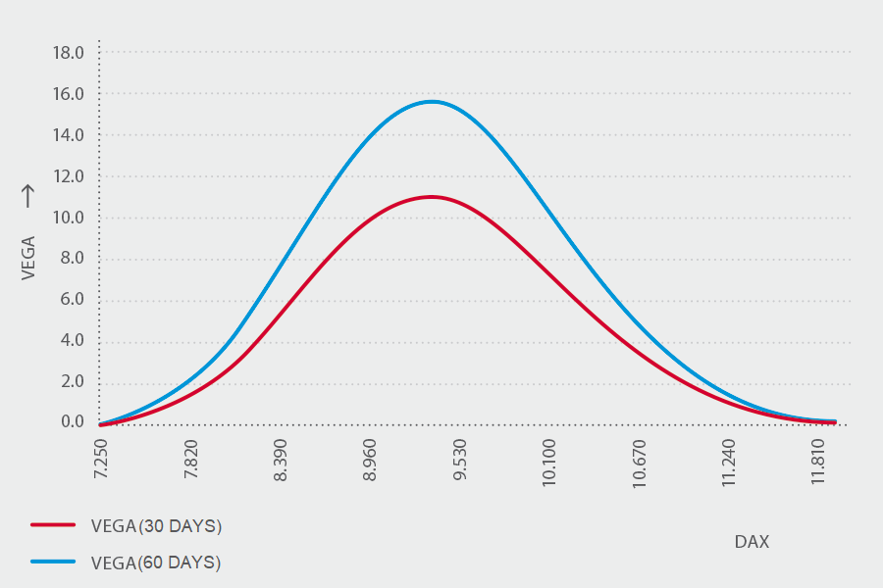

Figure 1: Vega of DAX Option (Lynxbroker, 2020)

### 2.2.3 Gamma

The Gamma of an option is the most important second derivative. If the price of the underlying asset changes, an option moves either deeper into the money or further out of the money. The Delta value changes accordingly. This rate of change is measured with the Greek Gamma. It thus indicates the change in the delta if the price of the underlying asset changes by one unit.

$$Γ_{CALL,PUT}=\frac{∂^{2}CALL}{∂S^{2}}=\frac{∂^{2}PUT}{∂S^{2}}=\frac{1}{Sσ\sqrt{2πt}∙e^{\frac{{d_{1}}^{2}}{2}}}$$

Gamma has the highest value for options at the money since price changes of the underlying asset at this point have the greatest influence on the delta.

### 2.2.4 Theta

In other words, the Theta indicates the extent to which the price of the option decreases if the remaining life of the option decreases by one day. As $t$ gets closer to maturity date, it is common to express the theta with a negative sign. Its formula is as following:

$$Θ_{CALL}=\frac{∂CALL}{∂t}=-\frac{S∙σ}{2\sqrt{2πt}}∙e^{\frac{{d_{1}}^{2}}{2}}-E∙re^{-rt}∙N(d_{2})$$

$$Θ_{PUT}=\frac{∂PUT}{∂t}=-\frac{S∙σ}{2\sqrt{2πt}}∙e^{\frac{{d_{1}}^{2}}{2}}-E∙re^{-rt}∙N(-d_{2})$$

Theta is positive for short option positions, while long option positions have a negative Theta (Steiner, 1999, p. 241). In practice, the driftless Theta is often of big interest. It takes the drift of the underlying out of account and thus isolates the effect of time decay. With that it is the same for put and call options (Haug, 2007, p. 66):

$$θ_{CALL}=θ_{PUT}=-\frac{S∙σ∙N(d_{1})}{2\sqrt{T}}$$

### 2.2.5 Rho

Another factor is the interest rate. Rho measures the sensitivity of the change in the interest rate level. If the interest rate level changes, this has an impact on the expected return on the underlying asset. Accordingly, a change in the interest rate is also due to a change in the option value. It tends to increase with maturity:

$$ρ_{CALL}=\frac{∂CALL}{∂r}=E∙e^{-rt}∙N(d_{2})$$

$$ρ_{PUT}=\frac{∂PUT}{∂r}=-E∙e^{-rt}∙N(-d_{2})$$

Rho for put options is negative while for call options it is positive (Haug, 2007, p. 68 f.). $Φ$, also referred as $ρ_{2}$, measures the sensitivity of the option’s value towards changes of dividend yield. It is not used in the main Black-Scholes model but is very important for derivations that face the problem with dividends (Haug, 2007, p. 70 f.).

# 3. Study

## 3.1 Estimation Strategies

### 3.1.1 Historical Volatility

Historical Volatility, also known as realized and statistical volatility, is a statistical measure of the realized returns´ spread over a period of time. It is one of the simplest possibilities to classify volatility and the most common way to calculate it, is standard deviation, which will be explained shortly. In general, it answers how much a securities´ price fluctuates from its mean value and therefore illustrates an indicator towards the risk of the security (Ladokin, 2009). The two important figures are the average returns, often shown as µ and the standard deviation of the returns, usually illustrated as $σ$. These ratios derive from the maximum likelihood formula, exemplified below:

$$f\left(x(1),x(2),…,x(n) ⃒o, µ \right)=\prod_{i=1}^{n}{\frac{1}{ o\sqrt{2π}}e^{-\frac{({x\left(i\right)-µ)}^{2}}{{2o}^{2}}}}$$

By restructuring and taking the logarithm we get the proof that µ and ℴ are the estimators to calculate the maximum likelihood of a normal distribution (Li, 2008). The formulas for these figures are as follows:

$$µ=\frac{\sum_{i=1}^{n}{r(i)}}{n}$$

$$o=\sqrt{\frac{\sum_{i=1}^{n}{{\left(r\left(i\right)-µ\right)}^{2}}}{n}}$$

The standard deviation can be given for any timespan but is usually given in an annualized form by multiplying the 1-day volatility with the square root of the number of trading days in a year (Matthäus, 2014).

Knowing how to calculate the realized volatility, it is time to evaluate this method. Using the actual rates of securities, the historical volatility enables a reliable measure of comparison. Furthermore, it seemed to be the most accurate method for option pricing until these started to have longer maturities. For short term maturities a constant volatility was a viable assumption because it did not seem likely to have significant fluctuations. During a longer period of time however, one could not simply assume to have a constant volatility. To describe this problem a little more, markets change gradually, and sometimes suddenly. Factors that cause them to change include new technologies, regulatory changes, altered perceptions in the wake of a scandal or crisis, or economic expansion or decline. The most recent example for a sudden change of the markets is the decline through The CoVid-19 pandemic. Regarding these factors, the forecasted volatility, calculated by historical data most probably is not reflective enough for the market today or in the future (Holton, 2003). This is the first reason why the volatility forecast calculated with the historical method is not precise enough for the real practical markets. A possible solution for this downturn would be to just consider the latest trading days for the calculation of the volatility. This would leave out the returns that seem away a long time and aren´t likely to have an impact on the future volatility. This approach, however, is a good transition to the next downturn of realized volatility. Using a small sample for the calculation usually produces a large standard error. This doesn´t only appear with a small sample, but because this calculation is a form of the Monte Carlo analysis, standard error will always arise and can only be reduced by extending the sample size. Reducing the considered returns of trading days would then only increase the standard error. For instance, a normal historical simulation includes a sample of 1000 and goes along with a standard error of 5%. Reducing this scope to 100 would boost the error up to 16% (Holton, 2003).The outcome of this illustrates that reducing the considered trading days is not a good solution to increase the precision of the forecasted volatility. It only boosts another problem that goes along with this calculation. The only way to get the problem of standard error under control is to keep the number of included trading days high.

This evaluation of the historical volatility method shows that it is not free from disadvantages. However, it is different from the Black Scholes´ methods implied volatility which will be explained in the next chapter.

### 3.1.2 Implied Volatility

One of the most popular research variables is the implied volatility, because for options trading, the historically oriented view of fluctuations plays only a marginal role. The implied volatility is also referred to as the expected fluctuation margin of an underlying asset. Historical volatility is often determined for investment products such as equity funds and bonds. Volatility is an instrument that does not reflect any information about future expectations or developments. Both historical and implied volatility have one thing in common - when markets rise, values fall, and when markets fall, values rise. Therefore, the implied volatility provides an investor with information about the fluctuation range of the underlying during the remaining term of the option, but it only indicates the width of the fluctuation and not its direction. This volatility is not, as is assumed, calculated using historical values, but by inserting the current option price in the Black-Scholes formula and then converting it according to the volatility (Vega). This method poses a problem - the Black-Scholes model is based on the assumptions of a perfect capital market and on the assumption that the underlying asset follows a geometric Brownian motion with constant volatility (Merk, 2011, p. 129). If these assumptions were all fulfilled in practical use, all options with the same underlying asset would have to exhibit the same implied volatility over the entire time to expiration. Due to the non-linear nature of the equation, the value for implied volatility can never be determined exactly since direct resolution is not possible - it must therefore be solved iteratively. Typical iterative methods are, for example, the Newton/Raphson method or the Gauss/Newton method (Merk, 2011, pp. 131-132).The Newton/Raphson method starts with a numerical estimate of the implied volatility. Then the Vega is used to achieve a progressive approximation of the actual implied volatility:

$$σ_{i+1}=\frac{σ_{i}-C\left(σ_{i}\right)-C_{m}}{\frac{∂C}{{∂σ}_{i}}}$$

$$σ_{i+1}=implicit volatility \\ C_{m}=Market price of the option \\ \frac{∂C}{{∂σ}_{i}}=S*ϕ\left(d_{1}\right)\sqrt{T}=Vega of the option at the location σ_{i} \\ ϕ=Probability density function$$

$$d_{1}=\frac{\log\left(\frac{S}{K}\right)+\left(r+\frac{σ^{2}}{2}\right)T}{σ^{2}\sqrt{T}}$$

If the difference between $σ_{i+1}$ and $σ_{i}$ is small enough and a given convergence barrier is reached, this process is terminated. Since the Vega of an option is approximately linear, this method converges to the actual implied volatility after only a few times (Merk, 2011, p. 131). In order to achieve a certain convergence that leads to a clear implicit volatility, the following formula was derived from Manaster and Koehler (Manaster & Koehler, 1982) for the starting value:

$$σ_{1}={\left[\left|log\frac{S}{K}+rT\right|\frac{2}{T}\right]}^{\frac{1}{2}}$$

In 1994, Rubinstein noted that implied volatility has little to do with the option price when the option price is low and the remaining term is short. The further the option is from the parity stock transaction, the less the influence of implied volatility on the option price. (Rubinstein, 1994)

## 3.2 Setting

The study done in this paper uses Stock data of Apple Inc. as the underlying. The historical volatility is calculated on the previous 250 trading days and annualized with 250 trading days as well. For the implied volatility Chicago Board Options Exchange’s volatility index of S&P 500 with the symbol VIX is used. Since this index is calculating implied volatility based on all S&P 500 stocks it is expected to be a little bit lower than historical volatility of Apple stock only. This decision was made, because in practice the market volatility is used far more often than implied volatility of one stock only. Furthermore, the data was retrieved via *quantmod* in R and herewith data for Apple stock and VIX is easily found. The following analysis is mostly done with R, while statistical tests are done with G*Power.

Furthermore, there are two assumptions done in this theoretical framework: Firstly, the strike price of an option is assumed to be the price of underlying at date of issue. Thus, if the option is issued on 12th of August 2020 the strike price is assumed to be the price of Apple stock on 12th of August 2020. Secondly, the risk-free rate is assumed to be 1% flat. This assumption is made to make the analysis easier and since the focus is on volatility and not risk-fee rate it seems convenient.

## 3.3 Analysis

The first comparison is between the two volatility estimators themselves as shown in following figure:

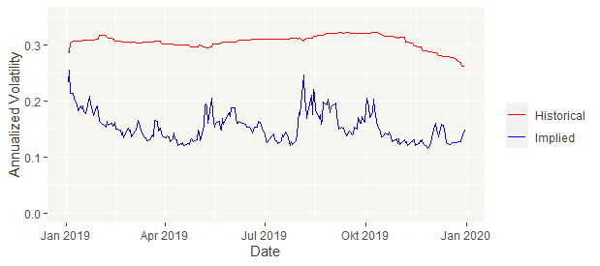

Figure 2: Annualized volatility

The historical one is as already mentioned notably higher than the implied one. Furthermore, the implied volatility itself is more volatile. To test if the observed effect is statistically significant following hypotheses are proposed:

$$H_{0}:{\overline{μ}}_{historical}={\overline{μ}}_{implied}$$

$$H_{1}:{\overline{μ}}_{historical}≠{\overline{μ}}_{implied}$$

Comparing the means of two variables is usually done with the Student’s t-test. One of the preconditions for using the normal t-test is that the two variables are homoscedastic, meaning that the variances of both populations (and not just the samples themselves) are statistically equal. Especially in a case like this with seemingly different variances of the two samples the therefore developed test from Howard Levene (1960) with following test variable has to be done beforehand:

$$L=\frac{\left(n-k\right)\sum_{i=1}^{k}{n_{i}{\left({\overline{y}}_{i.}-{\overline{y}}_{..}\right)}^{2}}}{\left(k-1\right)\sum_{i=1}^{k}{\sum_{j=1}^{n_{i}}{n_{i}{\left(y_{ij}-{\overline{y}}_{i.}\right)}^{2}}}} \sim F\left(\left(k-1\right),\left(n-k\right)\right) with$$

$$i=1, … ,k;$$

$$j=1, … ,n_{k};$$

$$n=\sum_{i=1}^{m}{n_{i}};$$

$$y_{ij}=\left|x_{ij}-x_{i.}\right|;$$

$${\overline{y}}_{i.}=\frac{1}{n_{i}}\sum_{i=1}^{n_{i}}{y_{ij}} and$$

$${\overline{y}}_{..}=\frac{1}{n}\sum_{i=1}^{m}{{n_{i}*\overline{y}}_{i.}}$$

The null hypothesis of Levene-Test is always:

$$H_{0}: σ_{1}^{2}=σ_{2}^{2}=…=σ_{k}^{2}$$

And thus:

$$H_{1}: σ_{i}^{2}≠σ_{j}^{2} for at least one combination of i,j$$

For the case of testing for equality of means of historical an implied volatility, in Levene-Test the null hypothesis must be rejected and thus normal t-test is not applicable. Therefore Bernard Welch (1947) has introduced a modification of Student’s t-test in which the degrees of freedom are calculated in a different way (or to be specific approximated). Welch’s t-test has the following test variable:

$$t= \frac{\overline{x}-\overline{y}}{\sqrt{\frac{s_{x}^{2}}{n_{x}}}+\frac{s_{y}^{2}}{n_{y}}} \sim t\left(v\right) with$$

$$v≈\frac{{\left(\frac{s_{x}^{2}}{n_{x}}+\frac{s_{y}^{2}}{n_{y}}\right)}^{2}}{\frac{s_{x}^{4}}{n_{x}^{2}v_{x}}+\frac{s_{y}^{4}}{n_{y}^{2}v_{y}}};$$

$$v_{x}= n_{x}-1 and$$

$$v_{y}= n_{y}-1$$

The proposed null hypothesis must be rejected and thus there is a significant difference between the historical and the implied volatility. Level of significance is chosen to be 5%. This level will be used throughout this analysis consistently.

The second comparison will be Vega:

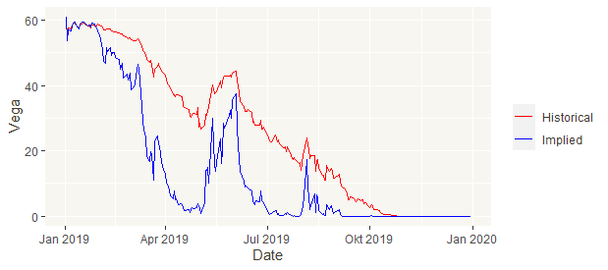

Figure 3: Vega

The observations are similar as previously: The implied one is a little bit lower, but in this case the volatility of both variables seem not to differ that much on the first sight. However, looking into the results of the Levene-Test, the variables must be assumed to be heteroskedastic. Thus, Welch’s t-test is used again with following hypotheses:

$$H_{0}:{\overline{μ}}_{Vega, historical}={\overline{μ}}_{Vega, implied}$$

$$H_{1}:{\overline{μ}}_{Vega, historical}≠{\overline{μ}}_{Vega, implied}$$

Again, the null hypothesis is to be rejected and thus the Vega of both estimations are statistically different as well.

The last comparison will be considering the prices calculated by Black-Scholes model using the two different volatility estimators. The first look will be at prices of a theoretical put option of Apple´s stock being issued on 1st January 2019 with a maturity of 1 year and thus maturity date on 31st December 2019. The two assumptions for risk-free rate and strike price mentioned earlier apply in calculation.

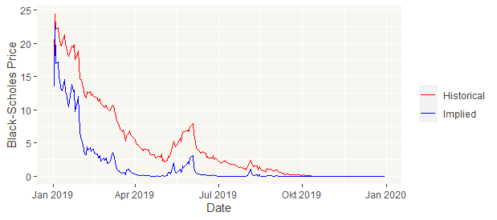

Figure 4: Black-Scholes prices for put option

The put option is priced lower for the implied volatility, which is as expected due to the earlier mentioned relation: the higher the volatility, the higher the price for an option (for a certain in the moneyness range). Furthermore, the difference in price is decreasing over time. For a statistical comparison, the following two hypotheses are proposed:

$$H_{0}:{\overline{μ}}_{Put, historical}={\overline{μ}}_{Put, implied}$$

$$H_{1}:{\overline{μ}}_{Put, historical}≠{\overline{μ}}_{Put, implied}$$

Again, Welch’s t-test is to be used, since the two variables are assumed to be heteroscedastic. The null hypothesis must be rejected and thus there is a significant difference of these two pricings. Following now, is the comparison of call option prices. Again, same assumptions and circumstances are used:

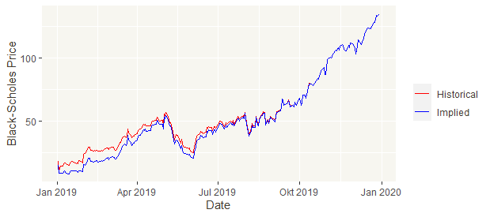

Figure 5: Black-Scholes prices for call option

Here the relative difference of both pricings is not as high as it was with the put option. Furthermore, the same observation of the difference decreasing over time can be made. This is due to the fact, that volatility’s impact on the pricing in Black-Scholes model is the biggest in the area of an options in the money state. With further distance of that mark the impact decreases. Again, for the statistical comparison, the following two hypotheses are proposed:

$$H_{0}:{\overline{μ}}_{Call, historical}={\overline{μ}}_{Call, implied}$$

$$H_{1}:{\overline{μ}}_{Call, historical}≠{\overline{μ}}_{Call, implied}$$

In this case of the null hypothesis of Levene-Test not being rejected, the normal t-test with following test variables can be used:

$$t= \frac{\overline{x}-\overline{y}}{\sqrt{\frac{s_{x}^{2}}{n_{x}}+\frac{s_{y}^{2}}{n_{y}}}} \sim t\left(n_{x}+n_{y}-2\right)$$

The null hypothesis is to be accepted and thus no significant differences of the to pricing can be assumed. On first sight, this seems to be a little bit conspicuous since for put prices there is a significant difference. There may be a problem with put-call parity matching this observation and thus both pricings are tested for put-call parity using the already mentioned formula:

$$\sum_{t=1}^{251}{CALL+E∙e^{-rT}+ PUT+S_{t}}$$

In theory, this sum should be zero but because of rounding there will always be a small sum. For this case both, the historical and implied, sum are equal with a total difference from put-call parity pricing of 0.961 for all 251 trading days in 2019 and thus there is no problem with put-call parity. The mentioned conspicuousness is explained by the fact, that the call option is strongly in the money while the put one is not and thus the parity changes in price are relatively small for the call options while relatively high for the put ones.

# 4. Conclusion

For the Nobel prize winning options pricing model developed from Robert Merton, Myron Scholes and Fischer Black in 1970 volatility or standard deviation is the only estimated input and thus there is a certain problem here. While the e. g. strike price is agreed value, one can only estimate how volatile a stock will behave in the future. The typical backwards looking historical variance with its estimation via maximum likelihood procedure shines with its simplicity and convenience but brings many problems with it. The first questionable aspect is how meaningful the past of volatility is on its future. Just looking at different phases of the market clarifies that the data is restricted by time. Furthermore, with historical estimation, the volatility is assumed to be flat. At this point the implied volatility is a good option, due to its so-called volatility smile, which simply means the increasing of volatility for options out of and in the money while relatively low volatility for options at the money.

With the Black-Scholes model and its analysis there are the Greeks being the derivatives towards one of the parameters of the Black-Scholes formula. Vega is the Greek measuring the impact of volatility. As observed Vega is smaller for the smaller volatility of the implied method. And thus Black-Scholes formulas using the implied volatility calculate lower put prices as well. This is due to the put option being out of the money in shown case. On the other hand, for the call prices since they were strongly in the money this observed impact was not significant. These observations were all statistically proven to be assumed.

The next steps regarding this study would be of two natures: The first one would be to consider more complex estimation approaches e. g. bootstrapping or simulation approaches. In those estimators there is a better possibility to not design the volatility flat as the volatility smile does in a small extent. The second and possibly more important step would be the practical comparison between both (and in another case even more) estimation strategies. Therefore, daily price data of in the case of this papers study an option on Apple stock that is issued on 1st January of 2019 with a maturity of one year is needed. With this data the difference between both Black-Scholes calculated prices and the real price could be analyzed. A formula like variance or mean absolute deviation seems good to be used in such a study.

# Appendix

G*Power protocols

Volatility

**t tests -** Means: Difference between two independent means (two groups) (welch’s t test)

**Analysis:** Post hoc: Compute achieved power

**Input:** Tail(s) = Two

Effect size d = 7.5209736

α err prob = 0.05

Sample size group 1 = 251

Sample size group 2 = 251

**Output:** Noncentrality parameter δ = 70.0498166

Critical t = 1.9668639

Df = 345

Power (1-β err prob) = 1.0000000

Vega

**t tests -** Means: Difference between two independent means (two groups) (welch’s t test)

**Analysis:** Post hoc: Compute achieved power

**Input:** Tail(s) = Two

Effect size d = 0.5755068

α err prob = 0.05

Sample size group 1 = 251

Sample size group 2 = 251

**Output:** Noncentrality parameter δ = 6.4343616

Critical t = 1.9647390

Df = 498

Power (1-β err prob) = 0.9999959

Put option

**t tests -** Means: Difference between two independent means (two groups) (welch’s t test)

**Analysis:** Post hoc: Compute achieved power

**Input:** Tail(s) = Two

Effect size d = 0.6013919

α err prob = 0.05

Sample size group 1 = 251

Sample size group 2 = 251

**Output:** Noncentrality parameter δ = 6.2353639

Critical t = 1.9655221

Df = 428

Power (1-β err prob) = 0.9999898

Call option

**t tests -** Means: Difference between two independent means (two groups)

**Analysis:** Post hoc: Compute achieved power

**Input:** Tail(s) = Two

Effect size d = 0.0939174

α err prob = 0.05

Sample size group 1 = 251

Sample size group 2 = 251

**Output:** Noncentrality parameter δ = 1.0521264

Critical t = 1.9647198

Df = 500

Power (1-β err prob) = 0.1827547

R code, PowerPoint and paper as Word document

<https://github.com/dennisblaufuss/risk_management_SoSe19/tree/master>

# References

Black, F. & Scholes, M., 1970. *The Pricing of Options and Corporate,* Chicago: University of Chicago.

Haug, E. G., 2007. *The Complete Guide to Option Pricing Formulas.* 2 ed. New York: McGraw-Hill Education.

Holton, G. A., 2003. *Value at Risk - Theory and Practice,* Oxford: Elsevier LTD.

Hull, J. C., 2015. *Options, Futures, and other Derivatives.* 9 ed. New Jersey: Pearson Education.

Ladokin, S., 2009. *Forecasting Volatility in the Stock Market,* Amsterdam: VU University Amsterdam.

Levene, H., 1960. Robust tests for equality of variances. In: I. Olkin et al., ed. *Contributions to Probability and Statistics: Essays in Honor of Harold Hotelling.* Palo Alto: Stanford University Press, p. 278–292.

Li, D., 2008. *Maximum Likelihood estimation of normal distribution.* [Online]   
Available at: https://daijiang.name/en/2014/10/08/mle-normal-distribution/  
[Accessed 6th August 2020].

Lynxbroker, 2020. *Vega.* [Online]   
Available at: https://www.lynxbroker.de/boerse/boerse-kurse/optionen/options-griechen/vega/  
[Accessed 8th September 2020].

Manaster, S. & Koehler, G., 1982. *The Calculation of Implied Variances from the Black-Scholes Model: A Note [The Pricing of Options and Corporate Liabilities].* vol. 37 ed. s.l.:Journal of Finance.

Matthäus, H., 2014. *Dichtefunktion, Standardnormalverteilung, Quantile.* 2015 ed. Wiesbaden: Springer.

Mehrling, P., 2000. *Understanding Fischer Black,* New York: Columbia University.

Merk, A., 2011. *Optionsbewertung in Theorie und Praxis.* 1. Auflage ed. Wiesbaden: Gabler Verlag / Springer Fachmedien Wiesbader.

Merton, R. C., 1973. Theory of rational option pricing. *The Bell Journal of Economics and Management Science,* 4(1), pp. 142-183.

Rubinstein, M., 1994. *Implied Binomial Trees.* vol. 49(3) ed. s.l.:Journal of Finance.

Scholes, M., 1997. *Derivatives in a Dynamic Environment.* [Online]   
Available at: https://www.nobelprize.org/nobel_prizes/economic-sciences/laureates/1997/scholes-lecture.pdf  
[Accessed 7th September 2020].

Scholes, M. & Merton, R. C., 1997. *Press Release.* [Online]   
Available at: https://www.nobelprize.org/nobel_prizes/economic-sciences/laureates/1997/press.html  
[Accessed 7th September 2020].

Steiner, R., 1999. *Mastering Financial Calculations.* 2 ed. Edinburgh Gate: Pearson Education.

Tompkins, R., 1994. *Options Explained 2.* Basingstoke: Macmillan Press Ltd.

Welch, B. L., 1947. The generalization of "Student's" problem when several different population variances are involved. *Biometrika,* 34(1-2), p. 28–35.

# Statutory declaration

We herewith declare that we have completed the present report independently, without making use of other than the specified literature and aids. All parts that were taken from published and non-published texts either verbally or in substance are clearly marked as such. This report has not been presented to any examination office in the same form.

Responsibility is as following:

Dennis Blaufuss: Chapter 3.2; 3.4; 4 & Code

Sergen Bayraktar: Chapter 1; 2.2 & 3.1.2

Sebastian Kokich: Chapter 2.1 & 3.1.1

Frankfurt am Main, dated: 12.08.2020



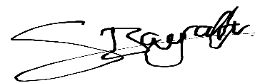

_____________________ _____________________ _____________________  
Dennis Blaufuss Sergen Bayraktar Sebastian Kokich