JDBC connection to a Progress 11.5 database (on Windows)

In order to connect JAVA to an OpenEdge Progress database we need a JDBC driver. For this we use:
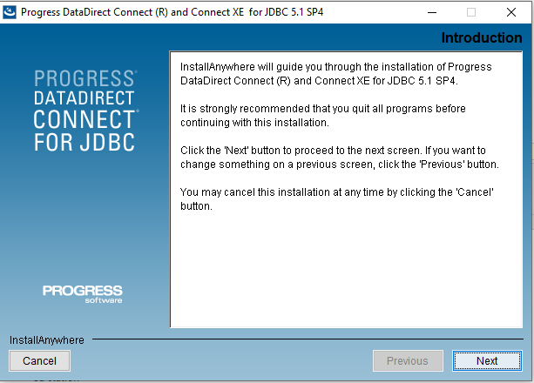
After installation you must include the JAR file into your project and add it as an external JAR file like this:

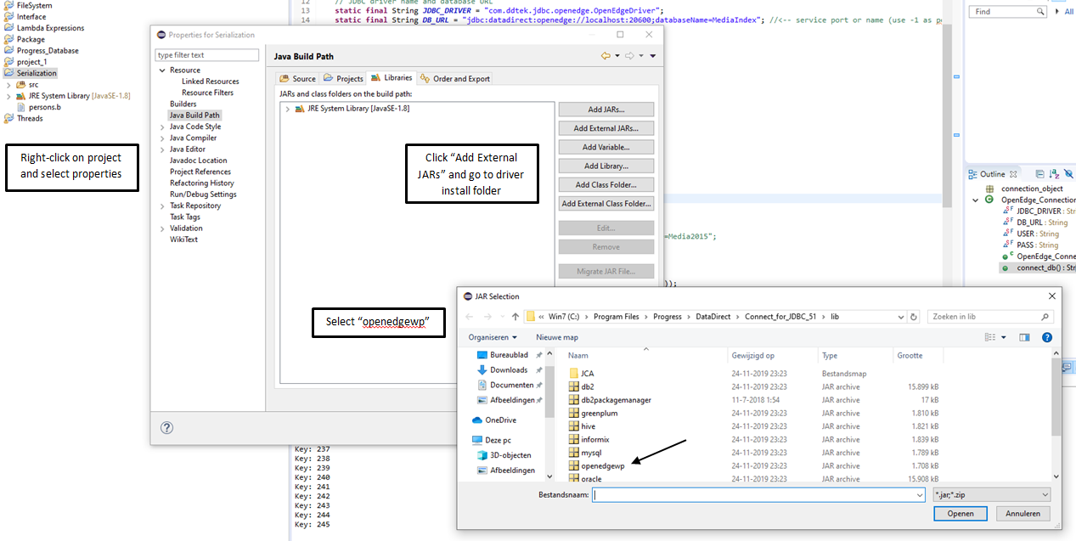
Now it's added to your project and you can use it.

It may come to pass that you can connect to the database but you cannot read the public tables. When this happenes you get error:

java.sql.SQLException: [DataDirect][OpenEdge JDBC Driver][OpenEdge] Access denied (Authorisation failed) (7512)

This means the user that you use to create the connection does not have sufficient rights.

The Progress database has a default user installed that has DBA right to the database, SYSPROGRESS. The creator of the database (the user ID with which the database was initially was created) is also added in the default user table with DBA access right.

The default users are created in a hidden database table _sysdbauth. This table is only accessible with SQL (not with 4GL ABL)

Usually the creator of the database is not known, so you can use SYSPROGRESS as a first user to get a connection going. SYSPROGRESS, however is an internal system account and should actually not be used permanently to acces a database.

In order to be able to use the SYSPROGRESS user as SQL user we need to setup this user in _User table. This can be done with the database administration tool. Create the _User entry as followes:

First connect to the database with a user that has a password. You are not allowed to maintain the user table if you don't login with a password.

Use the function “Edit User List...” and create the following user :

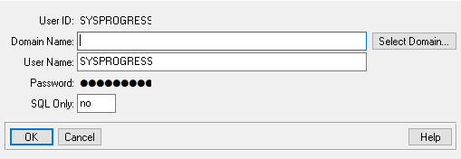

I used the following data:

ID: SYSPROGRESS
Domain name: <empty>
User name SYSPROGRESS
Password SYSPROGRESS
SQL only No.

What can be done now is you can log into the database with this user and you can run an SQL connection with this user. The latter is important because in order to grant rights to other user you need a user that has DBA Access.

What we also have done is create another user in _User tabel with the following data:

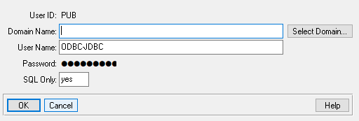
ID: PUB
Domain name: <empty>
User name ODBC-JDBC
Password PUB
SQL only Yes.

We set SQL only to “Yes” because it will not affect the number of licenced users for the database. It's a user purely meant for SQL connections.

We named it PUB because this will allow you to write “normal” queries like this:

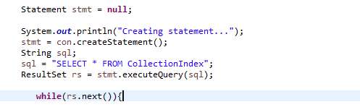
Instead of this form where you need to put the owner in front of each table:

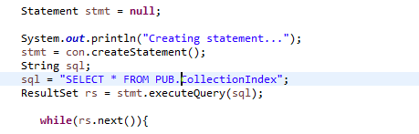
Now that we have got aour two users set up we need to log into SQL Explorer. This is a command line tool that can be used to perform SQL queries on the Progress database. We want to log in with SYSPROGRESS so we can give SQL rights to PUB.

First launch proenv and log in to the database using the following command:

sqlexp -db <dbname> -S <portnr> -H <host> -user SYSPROGRESS -password SYSPROGRESS

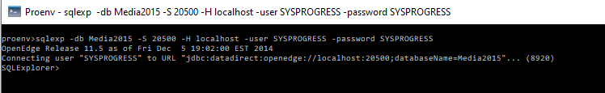
Judging from the prompt we are correctly logged in.

This statement gives all privileges to PUB on table COLLECTIONCLIPBOARD. You need to do this for all tables. Check using a query if all got updated correctly:

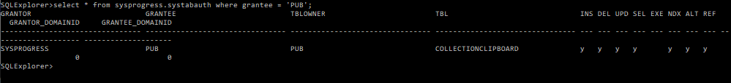
All went well, because all privileges are added (except EXE but that's the right to execute procedures)

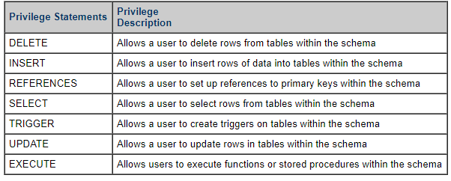

When autocommit is “off” for your connection you need to use the “COMMIT;” statement to “save” the changes

Use the exit-command to get back to PROENV and close it. The PUB user is now setup to be used in your code:

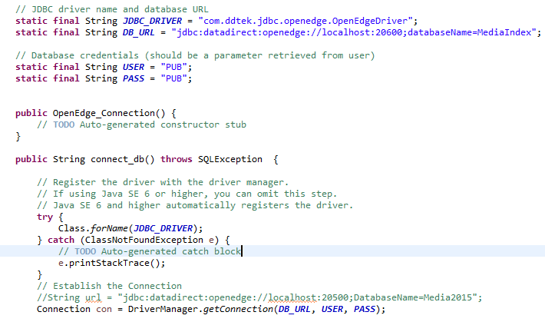
This will work.

