**Workshop 2 Answer sheet**

Name: _Chen XuChu________________________________________ ( 170146681 )

Part 3

Consider the problem statement of the online book store in the Laboratory Exercise 2.

The Pearl River Book Company is developing an online book store system through which its customers can buy books and sell their used books.  Public users are those who are not registered customers of the system.

Public users or registered customers can search books by entering keywords, which may appear in the title, author, or the book description.  The system displays a list of books that matches the keywords.  Each entry of the book list consists of the book title, author(s), the price for a new copy and the price range for used copies.  The user can select a book from list to display more detail information about it (availability, price for new copy, prices for used copies, table of contents, author, ISBN).  The user can add a copy of the book (either new or old) to the shopping cart.  The user can then continue to search for another book.  When the user finishes searching, the user can check out the books (Buy Book) in the shopping cart.  The system asks the user to login his/her account by entering the user’s email address and the account password.  If the user has not registered yet, the user can register for a new customer account at that point.  The user enters the email address, the home address and the password.  The system verifies that the email address has not been used by an existing customer before confirming the creation of the new customer account through an email message.  The system then asks the user to select the shipping option (express, priority, or ordinary).  Different shipping options have different prices.  The user can then select the payment method (credit card or the user account of the book store).  If the user selects the credit card payment method, the user enters the card number, type, and expiry date. The system then sends the credit card information and the amount charged to the external payment gateway.  The amount is calculated by adding the prices of the selected books and the selected shipping option. If the credit card transaction is approved, the external payment gateway will send back an approval code. Otherwise, the systems will ask the user to re-select the payment method and re-enter the payment information.  If the user selects payment by his/her account with a sufficient balance, the system charges the amount to the customer account.  Otherwise, the system asks the user to re-reselect the payment method.  Upon completion of payment, the system arranges delivery of the ordered books.  An external shipping agent is responsible for the delivery of the ordered books.  If an order involves new books, the system sends a shipping request to notify the shipping agent to collect the books from the book store. New books in the same order are shipped together.  If a used book has been ordered, the system sends a delivery request to notify the seller of the book and a shipping request to the shipping agent of the book store.  The shipping agent collects the book from the seller and delivers the book to the buyer.  Used books of the same order from the same seller are shipped together. After the book(s) has/have been delivered to the buyer, the shipping agent sends a shipping completion message to the system.  Upon receipt of this message, the system updates the seller’s customer account by adding the price of the used book minus the commission charge for the service.

A public user or a registered customer who wants to sell a used book can go through the above process in searching a book and displaying its information.  The user can then post a used copy for sale.  The system will ask the user to enter the price and the general condition of the used book.  Then the system further asks the user to enter the email address and password of his/her customer account for login.   If the user does not have a customer account, the user can create a new customer account as described in previous paragraph.

(Use the Food Ordering Example for Reference)

|  |  |  |
| --- | --- | --- |
| Base Use Case 1 | | Register Account |
|  | Actor a | Public User |
|  | Actor b | Customer |
|  | Actor c | Payment Gatewy |
|  | Actor d | Shipping Agent |
|  |  |  |
| Base Use Case 2 | | Search Book |
|  | Actor a | Public User |
|  | Actor b | Customer |
|  | Actor c | Payment Gatewy |
|  | Actor d | Shipping Agent |
|  |  |  |
| Base Use Case 3 | | Buy Book |
|  | Actor a | Public User |
|  | Actor b | Customer |
|  | Actor c | Payment Gatewy |
|  | Actor d | Shipping Agent |
|  |  |  |
| Base Use Case 4 | | Sell Used Book |
|  | Actor a | Public User |
|  | Actor b | Customer |
|  | Actor c | Payment Gatewy |
|  | Actor d | Shipping Agent |
|  |  |  |
| Base Use Case 5 | | Send Shipping Completion Message |
|  | Actor a | Public User |
|  | Actor b | Customer |
|  | Actor c | Payment Gatewy |
|  | Actor d | Shipping Agent |

**Identify FOUR major actors.** (foodOrdering-ppt13)

1. Public User (primary actor)

2. Customer

3. Payment GateWay

4. shipping Agent

**Identify FIVE use cases** (foodOrdering-ppt21)

1. Search Book

2.  Register Account

3. Buy Book

4. Sell Used Book

5. Send Shipping Completion Message

**Examine the roles of each actor and identify the use cases** (foodOrdering-ppt22)

Public user: Register, Search book

Customer: buy book, sell used book

Shipping agent: send hipping complete shipping

**Draw initial use case diagram** (visual paradigm) (foodOrdering-ppt22)

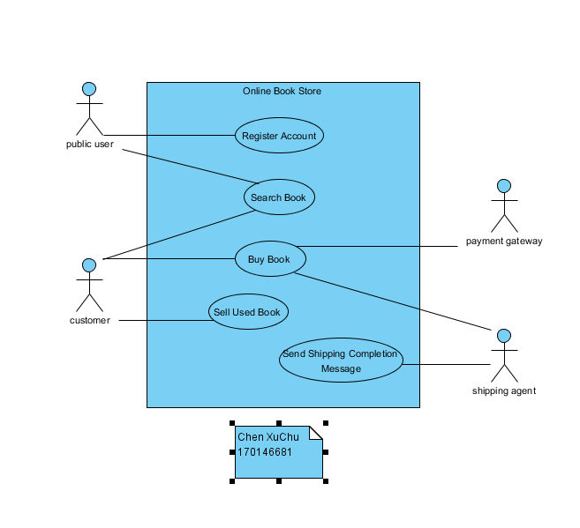

**Actor Descriptions** (foodOrdering-ppt15)

|  |
| --- |
| **Actor specification** |
| **Actor name:** Public User |
| **Description:** |

|  |
| --- |
| **Actor specification** |
| **Actor name:** |
| **Description:** |

|  |
| --- |
| **Actor specification** |
| **Actor name:** |
| **Description:** |

|  |
| --- |
| **Actor specification** |
| **Actor name:** |
| **Description:** |

**Use Case Brief Descriptions** (foodOrdering-ppt24)

|  |
| --- |
| **Use Case:** Register Account |
| **Use Case ID:** |
| **Actor:** |
| **Description:** |

|  |
| --- |
| **Use Case:** |
| **Use Case ID:** |
| **Actor:** |
| **Description:** |

|  |
| --- |
| **Use Case:** |
| **Use Case ID:** |
| **Actor:** |
| **Description:** |

|  |
| --- |
| **Use Case:** |
| **Use Case ID:** |
| **Actor:** |
| **Description:** |

|  |
| --- |
| **Use Case:** |
| **Use Case ID:** |
| **Actor:** |
| **Description:** |

**Develop the base case descriptions**

[Shift] + [Enter] in **Flow of Event**

|  |  |
| --- | --- |
| **Use case name** | Register Account |
| **Use case ID** |  |
| **Primary actor** |  |
| **Secondary actor(s)** |  |
| **Preconditions** |  |
| **Flow of events** |  |
| **Post-conditions** |  |
| **Alternative flows and exceptions** |  |
| **Non-behavior requirements** |  |
| **Assumptions** |  |
| **Issue** |  |
| **Source** |  |

|  |  |
| --- | --- |
| **Use case name** | Search Book |
| **Use case ID** |  |
| **Primary actor** |  |
| **Secondary actor(s)** |  |
| **Preconditions** |  |
| **Flow of events** |  |
| **Post-conditions** |  |
| **Alternative flows and exceptions** |  |
| **Non-behavior requirements** |  |
| **Assumptions** |  |
| **Issue** |  |
| **Source** |  |

|  |  |
| --- | --- |
| **Use case name** | Buy Book |
| **Use case ID** |  |
| **Primary actor** |  |
| **Secondary actor(s)** |  |
| **Preconditions** |  |
| **Flow of events** |  |
| **Post-conditions** |  |
| **Alternative flows and exceptions** |  |
| **Non-behavior requirements** |  |
| **Assumptions** |  |
| **Issue** |  |
| **Source** |  |

|  |  |
| --- | --- |
| **Use case name** | Sell Book |
| **Use case ID** |  |
| **Primary actor** |  |
| **Secondary actor(s)** |  |
| **Preconditions** |  |
| **Flow of events** |  |
| **Post-conditions** |  |
| **Alternative flows and exceptions** |  |
| **Non-behavior requirements** |  |
| **Assumptions** |  |
| **Issue** |  |
| **Source** |  |

|  |  |
| --- | --- |
| **Use case name** | Send Shipping Completion Message |
| **Use case ID** |  |
| **Primary actor** |  |
| **Secondary actor(s)** |  |
| **Brief description** |  |
| **Preconditions** |  |
| **Flow of events** |  |
| **Post-conditions** |  |
| **Alternative flows and exceptions** |  |
| **Non-behavior requirements** |  |
| **Assumptions** |  |
| **Issue** |  |
| **Source** |  |

**Iteratively elaborate the base use case description and determine the *extend*, *include* and *generalization relationships.* Refine the use case diagram and the use case descriptions to reflect the use case relationships.**

|  |  |  |
| --- | --- | --- |
| Base Use Case 1 | |  |
|  | Abstract Use Case |  |
|  | Abstract Use Case |  |
|  |  |  |
| Base Use Case 2 | |  |
|  | Abstract Use Case |  |
|  | Abstract Use Case |  |
|  |  |  |
| Base Use Case 3 | |  |
|  | Abstract Use Case |  |
|  | Abstract Use Case |  |
|  |  |  |
| Base Use Case 4 | |  |
|  | Abstract Use Case |  |
|  | Abstract Use Case |  |
|  |  |  |
| Base Use Case 5 | |  |
|  | Abstract Use Case |  |
|  | Abstract Use Case |  |

Refined Use Case Diagram (visual paradigm) (foodOrdering-ppt29)

**Refined Base Use Case Descriptions**

**(Only need to do the *Buy Book and its related use cases*)**

**Buy Book**

|  |  |  |
| --- | --- | --- |
| **Use case name:** | Buy Book | |
| **Use case ID:** |  | |
| **Primary actor:** |  | |
| **Secondary actor(s):** |  | |
| **Preconditions:** |  | |
| **Flow of events:** | 1. | Include (search book) |
|  |  |
|  |  |
|  |  |
| **Post conditions:** |  | |
| **Alternative flows and exceptions** |  |  |
|  |  |
|  |  |
| **Non-behavior requirements:** |  | |
| **Assumptions:** |  | |
| **Issue:** |  | |
| **Source:** |  | |

**Search**

|  |  |  |
| --- | --- | --- |
| **Use case name:** | Search | |
| **Use case ID:** |  | |
| **Primary actor:** |  | |
| **Secondary actor(s):** |  | |
| **Preconditions:** |  | |
| **Flow of events:** | 1. | xx |
|  |  |
|  |  |
|  |  |
| **Post conditions:** |  | |
| **Alternative flows and exceptions** |  |  |
|  |  |
|  |  |
| **Non-behavior requirements:** |  | |
| **Assumptions:** |  | |
| **Issue:** |  | |
| **Source:** |  | |

**Login**

|  |  |  |
| --- | --- | --- |
| **Use case name:** | Login | |
| **Use case ID:** |  | |
| **Primary actor:** |  | |
| **Secondary actor(s):** |  | |
| **Preconditions:** |  | |
| **Flow of events:** | 1. | xx |
|  |  |
|  |  |
|  |  |
| **Post conditions:** |  | |
| **Alternative flows and exceptions** |  |  |
|  |  |
|  |  |
| **Non-behavior requirements:** |  | |
| **Assumptions:** |  | |
| **Issue:** |  | |
| **Source:** |  | |

**Develop instance scenarios. For each use case, develop the instance scenarios to cover all possible paths of execution of the use case.** (foodOrdering-ppt30)

**(only need to do the *Buy Book*)**

|  |  |  |
| --- | --- | --- |
| **Parent Use case name:** | Buy Book | |
| **Parent Use case ID:** |  | |
| **Instance name:** | A customer buys a used book using a Credit Card | |
| **Instance ID:** |  | |
| **Environmental conditions and assumptions :** |  | |
| **Inputs:** |  | |
| **Instance flow description:** | 1. | xx |
|  |  |
|  |  |
|  |  |
|  |  |
|  |  |
| **Output:** |  | |