UI Workflow Draft: Notifications & Permissions

1. Notification Center Workflow
Goal: Provide real-time feedback for system actions (CRUD) and social interactions.

The User Journey
- Trigger: An event occurs (e.g., backend updates a user profile, or a new file is uploaded).
- Instant Feedback (Toast): A small, non-intrusive popup appears in the corner of the screen for 5 seconds.
  - Logic: If (action == "Delete") color = Red; Else color = Green;
- Persistence (The Bell): The "Bell" icon in the navbar shows a red badge with a count NNN.
- Interaction: User clicks the bell to open a scrollable panel.
  - Actions: "Mark all as read," "Delete notification," or "Click to view source."
- Management: A "Settings" link within the panel allows users to toggle which actions trigger notifications (e.g., "Don't notify me on updates").
Optional: send notifications when the browser is closed?
To send notifications when the browser is closed, we implement Web Push Notifications using Service Workers and the Push API. While standard real-time tools like SignalR require an active connection, Service Workers run in the background of the operating system, allowing the browser to "wake up" and display a notification even if the specific website tab or the main browser window is closed.
gravitec
pushpad

Study Materials (Notifications)
- Real-Time Communication: Study SignalR with [Framework]. Since we use ASP.NET Core, SignalR is the standard.
  - Official Microsoft SignalR Guide
- State Management: Learn how to manage a "global" notification state so the badge count updates across all pages.
  - Redux Toolkit: Real-world logic (or similar for Vue/Angular).
- UX Best Practices:
  - Designing Better Notifications (Smashing Magazine)

2. Advanced Permission Center Workflow
Goal: A centralized dashboard for Admins to manage what users can see and do.

The User Journey (Admin Perspective)
- Access: Admin navigates to /admin/permissions.
- Role Selection: A list of roles (Admin, Moderator, User) or specific Users is displayed.
- The Matrix: A table/grid showing features vs. actions.
  - Example: Feature: "File Upload" | Actions: [View, Upload, Delete, Overwrite].
- Granular Toggle: Admin toggles a permission.
  - Logic: The frontend sends a PATCH request to the backend.
- Live Enforcement:
  - UI Masking: The "Upload" button on the frontend instantly disappears for the affected user.
  - Route Guarding: If the user tries to type the URL /upload manually, they are redirected to a "403 Forbidden" page.

What to Study (Permissions)
- CASL (Isomorphic Permissions): This is the industry standard for managing permissions in JavaScript/TypeScript. It allows you to define permissions once and use them in the UI and the API.
  - CASL Documentation & Tutorials
- RBAC vs. ABAC: Understand the difference between Role-Based and Attribute-Based Access Control.
  - Auth0: RBAC vs. ABAC Explained
- Frontend Routing Guards: Learn how to protect routes in your specific framework (e.g., React Router Guards or Angular Guards).
  - React Router: Protected Routes Pattern

Study Links Summary
Topic | Primary Resource | Why it matters
SignalR | SignalR Client Docs | Essential for the "Live" notification feel.
Permissions | CASL.js Guide | Best way to handle "Major" permission logic cleanly.
File API | MDN Web Docs: Using Files | Necessary for the "Minor" File Management task.
API Integration | TanStack Query (React Query) | Handles loading/error states for your CRUD notifications.
- For the Advanced Permissions, will the backend send me a list of 'Claims' in the JWT, or should I fetch a 'Permissions' object on login?
- Browser/App or both?

The "Feature-First" Folder Structure proposal
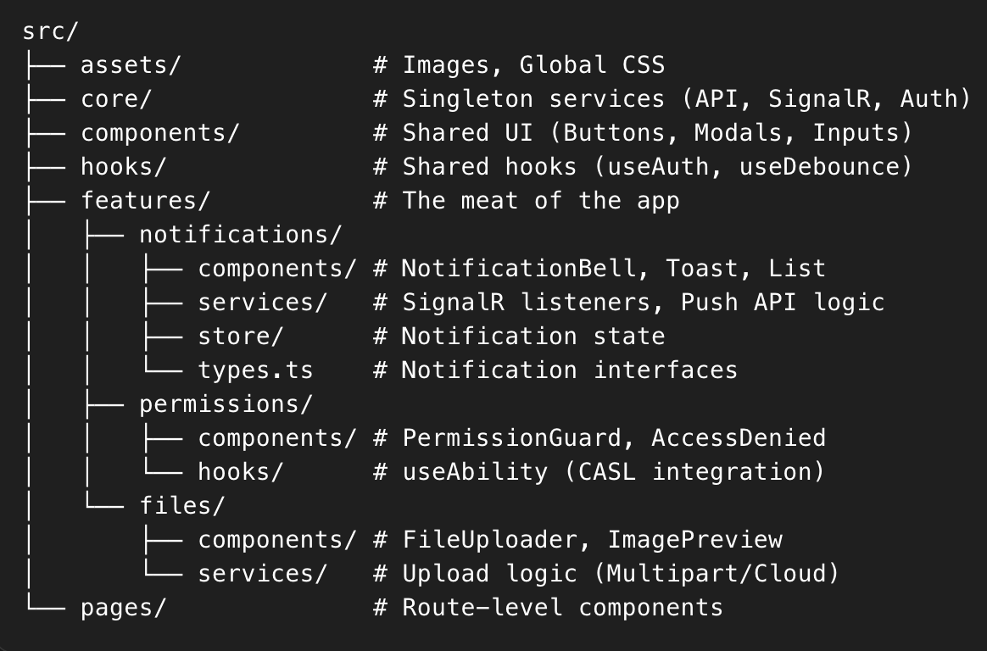

Summary of Principles
- Type Safety: Every API response must have a TypeScript interface. No any.
- Component Isolation: The FileUploader shouldn't care about the NotificationCenter. They communicate via the Global Store or API.
- API-First: Backend provides the Swagger/OpenAPI spec; frontend generate the types from it.

