# Software Developer Test

### Test requirements

Lights Out is a puzzle game consisting of an n x n grid of lights. At the beginning of the game, some of the lights are switched on. When a light is pressed, this light and the four adjacent lights are toggled, i.e., they are switched on if they were off, and switched off otherwise. The purpose of the game is to switch all the lights off.

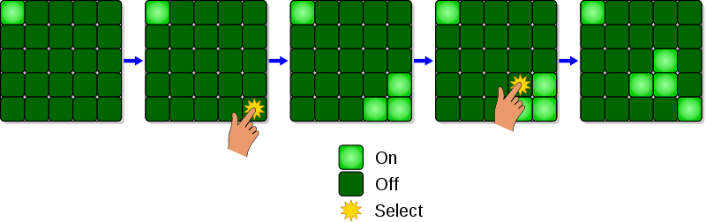

Image from Wikipedia.

Please Implement the game for a 5 by 5 grid in the .Net environment.

The game must start with some lights turned on, and the user keeps playing till they either give up or turn off all the lights.

Please choose the User Interface you would like to implement this in (Console, Desktop, Web).

### Project delivery

Once the project is completed please send us back the running project with all the code, you can send us a link of the repository where your project is saved or send us the complete folder.

Include in the solution any documentation required and any tests written for this solution.