Project 1: Static Foundations
Feedback for Steam Frame Info
Student: Dennis Dzhidzhora Course: CSC 436, Fall 2026 Reviewed at: aa8458d
Repo: github.com/dennisdzhidzhora22/CSC436-Project-1 Live: ddzh-csc436-project-1.netlify.app

Your grade is posted in Brightspace. This document is the reasoning behind it, category by category.

How this review was made
Your instructor reviewed this project with Claude (Anthropic's AI) as a second set of eyes. Claude cloned the repo, read all 198 lines of HTML, CSS and JavaScript and the AI transcript you included, ran the W3C validator, loaded the live site in real viewports at 320, 375, 768 and 1280 pixels, clicked through the image carousel in both directions to check the wraparound and the alt text, checked each of the five hotlinked image URLs, compared the live site to the repo, and read all sixteen commits. Every note in this document was read and approved by your instructor.

The short version
This is a small, correct page, and the repository around it is done properly. Sixteen commits over three days, each one a single change with a message that says exactly what it was. The README has all four items. You included the AI transcript the brief asks for, and it shows the right way to use the tool: you described a bug, asked for an explanation rather than a fix, then pushed back on the advice you did not need. That is the model.
The page itself has header, a list nav, main, four articles and a footer, with one h1 and an h2 on each article. The comparison table has proper th cells with scope. The body is a real CSS Grid with named areas, the carousel is a nested Grid, and the header is Flexbox. The image switcher wraps around correctly in both directions and updates the alt text with each picture, which most students forget. Nothing scrolls sideways at 375, 768 or 1280.
What holds it back is mostly that it is thin, and a few things were left in. The content is one paragraph, five bullets, a three-row table and five pictures. Two empty aside elements exist only to create side margins. The seven TODO comments from the starter template are still in the file. The arrow buttons contain a raw <, which is the page's one validator error, and have no accessible name. All five carousel images are hotlinked from other sites, and one of them is a Reddit preview URL with a signed token that will stop working. There are no custom properties, no focus styles, and the single media query is desktop-first. The work was also completed after the deadline, which your instructor is handling separately.

What Claude measured
Check | Result
W3C HTML validator | 1 error (unescaped < inside the left button), 1 info note
Horizontal scroll at 375 / 768 / 1280 px | None. At 320 px the page is 22 px wider than the screen
Heading order | One h1, three h2, no skipped levels; the carousel article has no heading
Semantic elements | header, nav (ul of 3), main, 4 article, footer, table with th scope; 2 empty aside
Layout | Grid on body with named areas, Grid on main, Grid on the carousel; Flexbox on header and nav
Media queries | 1, max-width: 680px (desktop-first)
Custom properties / focus styles | 0 / 0
Carousel | 5 images; right five times returns to the first; left from the first goes to the fifth; alt text changes with each
Carousel buttons | Text content < and >, no aria-label, no type
Nav at 375 px | Each link box is 46 px wide and 57 px tall: the words stack
Images | 5, all hotlinked: Steam CDN x2, The Verge, Reddit preview (signed URL), GamingBolt; 51 KB to 478 KB; none in the repo
Template comments | 7 TODO comments left in index.html
Console errors | 0
Commits | 16: one README-only commit Sep 15, then 15 commits Sep 19 to 21, each a single change
README | Title, description, how to run, live URL: all four
AI transcript | Included in ai_transcripts/; asks for explanation, not changes
Live vs repo | Identical

The site, phone and desktop
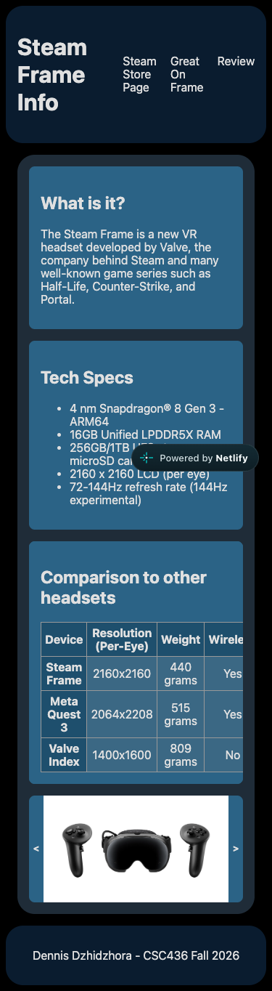  Phone, 375 by 667, full page. Nav links wrap word by word; the table scrolls inside its card. | 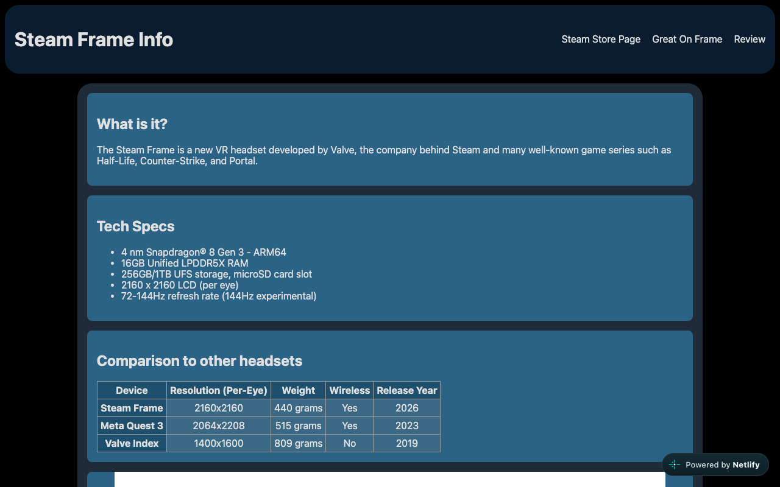  Desktop, 1280 by 800. Body grid with empty side tracks, cards stacked in main.

Semantic HTML

What is working
- The skeleton is right: header holding the h1 and a nav with a ul (index.html lines 12 to 21), main with an article per block, each with its own h2, and a footer with your name and the semester. The spec list is a real ul. The comparison table uses thead, th scope="col" for the columns and th scope="row" for each device (lines 49 to 82), which is the correct, and rarely seen, way to mark up a data table. The image has alt text, and the script keeps it accurate as the picture changes.

What to change
- Two empty aside elements (lines 25 to 26 and 91 to 92). They contain nothing and exist only to be the 1fr side tracks of the body grid. aside means content tangentially related to the main content, and it is a landmark, so a screen reader announces two empty complementary regions. Delete them and give main a max-width with margin-inline: auto, or keep the three-column grid and put nothing in the outer tracks. Same look, honest markup.
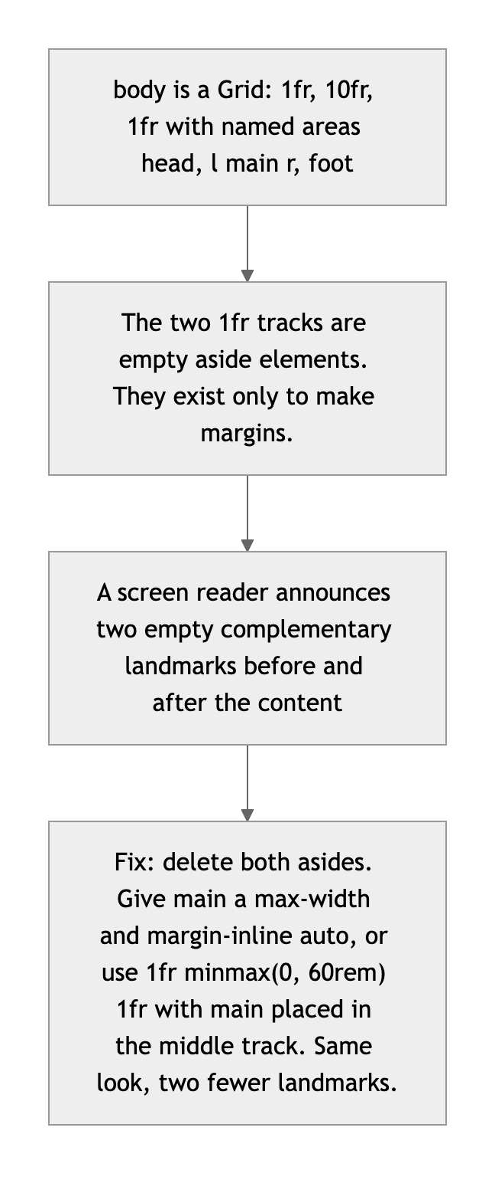
Diagram 1. Why the two empty asides exist, and what to use instead.
- The arrow buttons (lines 86 and 88). A raw < in HTML is the validator's one error; write &lt; and &gt;. The b inside is styling, not meaning; use CSS. And a button whose only content is a symbol has no name for a screen reader, so add aria-label="Previous image" and aria-label="Next image", plus type="button".
- Seven TODO comments from the starter file are still in the page (lines 6, 11, 23 to 24, 94 to 98). Anyone who views source sees the assignment checklist. Delete them once each one is done, which they are.
- Small: the carousel article has no heading, which the validator notes. A visually hidden h2 fixes it, or make that block a figure instead of an article.

CSS layout

What is working
- Grid with named areas on the body (styles.css lines 3 to 15). grid-template-areas with head, l main r, foot is the most readable way to describe a page layout, and it is yours. main is its own Grid with a gap so the cards stack evenly, and the carousel is a third Grid, 1fr 20fr 1fr, so the arrows hug the picture (lines 62 to 65). The header is Flexbox with space-between and the nav list is Flexbox with gap. box-sizing: border-box on everything, min-width: 0 on the grid items so the table cannot blow the page open, and overflow-x: auto on the cards so the table scrolls inside its box (lines 58 to 60). That last pair is the fix from your AI transcript, applied correctly.

What to change
- No custom properties, and the palette is typed by hand. Four blues and one grey appear across the file with no names. Put them in :root and the next theme change is one edit. Related: .site-header and .site-footer each declare background twice (lines 23 to 24 and 32 to 33); the first #bbbbbb is dead and should go.
- No focus styles. Tab to the nav links and the arrow buttons: the browser default ring on a navy background is hard to see. One :focus-visible rule with a 3px outline in your light blue covers every interactive element.
- The empty side tracks are doing a margin's job. 1fr 10fr 1fr is a clever way to center content, but it means the content width is always 10/12 of the screen, which is 1,066px on a 1280 display. A max-width: 70rem on main would read better on wide screens and would not need the two empty asides.
- Small: the table borders are declared on td, tr and th separately, with the same values each time; one rule covers all three.

Responsive design

What is working
- No horizontal scroll at 375, 768 or 1280. Below 680px the outer grid tracks collapse to zero and the content takes the full width, and the comparison table scrolls inside its card instead of stretching the page, which is the exact bug you diagnosed and fixed on September 20.

What to change
- The nav links wrap word by word on a phone. At 375px each link box is 46 pixels wide and 57 tall: "Steam Store Page" becomes three stacked words, and the three links sit as three narrow columns next to the title (styles.css line 26). Let the list wrap as whole items: flex-wrap: wrap on the ul and white-space: nowrap on the links, or stack the header into a column under 680px the way the body already changes there.
- Desktop-first, single query. The one media query is max-width: 680px (lines 17 to 21). The brief asks for mobile-first: make the single-column layout the base and add the side tracks inside a min-width query.
- At 320px the page is 22px wider than the screen. The brief's bar is 375, so this is a note, not a deduction; the header's title and three links are the likely cause.

JavaScript interaction

What is working
- The carousel is correct and compact (script.js lines 14 to 24). The modulo arithmetic wraps in both directions, including going left from the first image, and Claude clicked right five times and landed back on the first picture. Each entry pairs a URL with its own alt text, and the handler updates both, so the description is never stale. Twenty-three lines, no errors, no libraries.

What to change
- One feature, and the smallest version of it. The brief asks for at least one interaction, and this is exactly one. Two cheap upgrades: show "2 of 5" under the picture so the visitor knows there are five, and let the arrow keys move it (keydown on document, check event.key). A caption from the alt text would make the pictures mean something.
- The two handlers are the same function with a different sign. Write one showImage(delta) and call it with -1 and +1. Also currentImg should be let, not var.
- Nothing is preloaded. Each click fetches an image from another site for the first time, so the picture visibly pops in. new Image().src = nextUrl after each click, or all five at load, removes the wait.

Repository and deployment

What is working
- Sixteen commits, each one a single change, each message precise. "add responsive column widths for mobile devices," "adjust td cell background color for better contrast," "add hover styling to navbar links." This is the habit the brief asks for, and it is fully formed. The README has the title, a real description, two ways to run the project, and the live link. The live site matches the repo exactly, and it is on Netlify as the brief specifies.
- You included the AI transcript, which the brief asks for and almost nobody did. The conversation itself is a good example: a precise description of the symptom, an explicit "do not make changes, explain," and then a follow-up question that caught the tool recommending something you did not need. Keep doing exactly that.

What to change
- The timing. The first commit on September 15 is a two-line README; all of the site was built September 19 to 21, after the deadline. Your instructor is applying the late penalty separately, and your note about it was noted. The history itself is not the problem; the calendar is.
- Small: there is no .gitignore. Add one with .DS_Store, .vscode/ and node_modules/ before the first time one of them sneaks in.

Content and polish

What is working
- A real subject with real numbers: the specs are the published ones, the comparison table pits the Frame against the two headsets people actually cross-shop, and the nav goes to the store page, the compatibility list and a real review. The navy-and-blue palette is consistent, the cards read cleanly, and the footer is signed.

What to change
- All five images live on other people's servers (script.js lines 2 to 6). Two are on Steam's CDN, one on The Verge, one on GamingBolt, and one is a Reddit preview URL carrying a signed s= token, which Reddit rotates; that link will break. The brief asks for real images in your project. Download the five, resize them to about 1200px wide, put them in an images/ folder, and reference them locally. Then add width, height and loading="lazy" to the img.
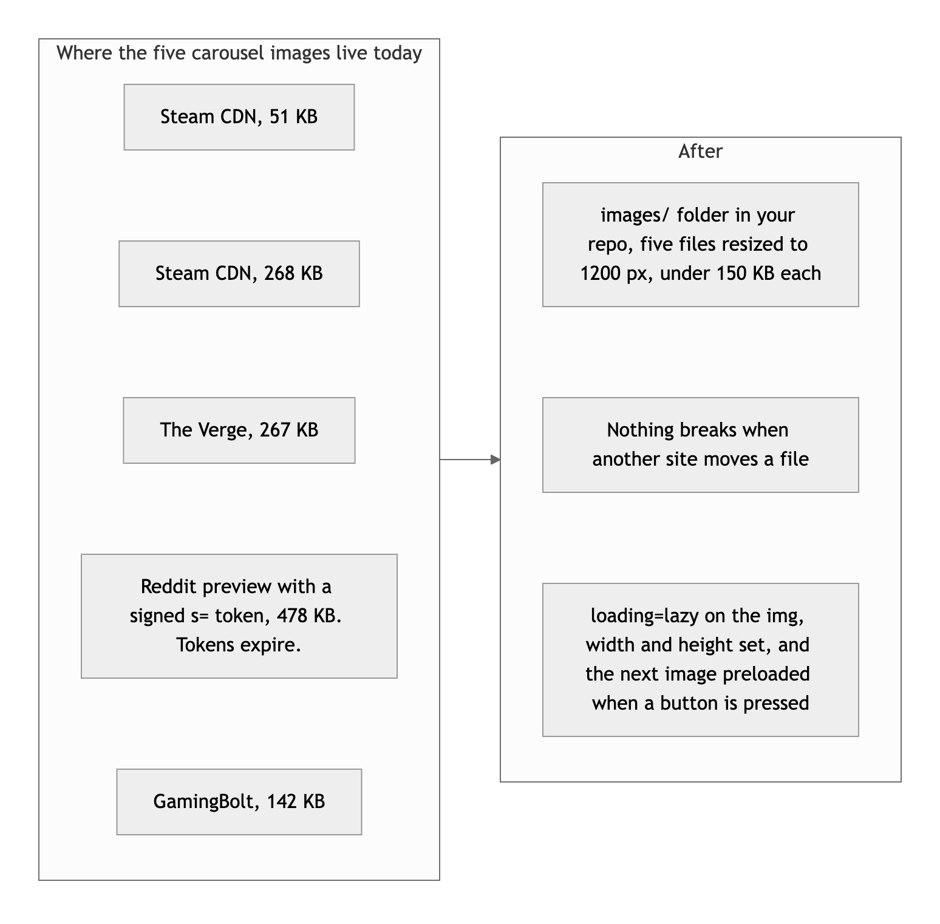
Diagram 2. Where the pictures live now, and where they should.
- There is not much to read. One sentence about what the Frame is, five bullets, three table rows. A paragraph on who it is for, a paragraph on how it compares in practice, a fourth and fifth row in the table, and a short verdict would make this an info page rather than a spec sheet.
- Small: the raw < and > as arrow glyphs look like placeholders. A pair of SVG chevrons, or even the single-angle quotation marks, reads as designed.

Your next moves
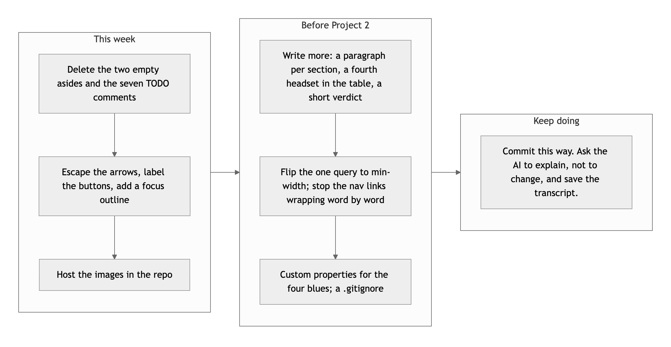
Diagram 3. This week, before Project 2, and what to keep doing.
- Clean the markup. Remove the empty asides and the TODO comments, escape the arrows, label the buttons, add a focus rule. Twenty minutes, and the validator goes to zero.
- Own the images. Five files in an images/ folder, sized and lazy-loaded. The Reddit one will break otherwise.
- Fill it in. More words, more rows, a caption under the carousel. The structure is ready for it.

The process here is already professional, Dennis; the page just needs more of you in it.
This review lives in a pull request on your repo. It only adds feedback files and does not touch your code. Your grade is in Brightspace. Questions go to office hours or the Brightspace board.

