Contents

Chapter 1: Introduction 3

1.1 Title of Research 4

1.2 Problem Statement 4

1.3 Research Objective 5

1.4 Research Design Table 5

1.5 Scope 6

1.6 Significant of Project 7

1.7 Conceptual Framework 8

Chapter 2: Literature Review 9

2.1 Web Application 9

2.2 Architecture of Web App 10

2.2.1 Single Page Applications (SPA) 10

2.2.2 Microservices 10

2.2.3 Serverless Architectures 11

2.3 Components of Web App 11

2.4 Attributes of a Quality Web App 11

2.4.1 Reliability 12

2.4.2 Usability 12

2.4.3 Security 12

2.4.4 Availability 12

2.4.5 Scalability 12

2.4.6. Maintainability 13

2.5 Project Management Systems 13

2.6 Technical Review 13

2.6.1 Django 13

2.6.3 React Web Franewrok 14

2.6.4 Python 15

2.6.4.2 Python Numeric extension 15

2.6.4.2 Uses of Python 15

2.6.4.3 Comparing Python with other languages 17

2.6.5.1 Constrants of REST 17

2.7 Related Works 18

2.7.1 Final Year Supervision Management System as a Tool for Monitoring Computer Science Projects (Marini et al, 2010) 18

2.7.1.2 Proposed Design 19

2.7.1.3 System Design 20

2.8 Research methodology 21

2.8.1 Waterfall Model 21

2.8.2 Prototype Model 22

2.8.3 RAD Model 23

2.8.4 Incremental Model 24

2.8.5 Spiral Model 25

2.8.6 Agile Model 26

3.0 Prelimary Studies 27

3.1 Research Design 27

3.2 Operational Framework 27

3.3 Research Instrument 28

3.4 Software Development Life Cycle (SDLC) 29

Chapter 4: Analaysis 31

4.1 Interview 31

4.1.1 Interview Candidate 31

4.1.2 Interview Questions 31

4.1.3 Interview Process 32

**4.1.4 Findings of Overall Results** 32

4.2 Use Case 33

4.2.1 Use case diagram for student 33

4.2.2 Use case table for students 34

4.2.3 Use case diagrm for Supervisor 39

4.2.4 Use case table for Supervisors 39

4.2.5 Usecase diagram for coordinator 44

4.2.6 Use case table for Coordinator 44

4.3 Requirements Specifications 53

4.3.1 Software involved 53

4.3.2 Hardware Involed 53

4.4 Functional Requirements 53

4.4.1 FYP Project Management Web application 53

4.5 Non-Functional Requirement 59

Chapter 5: Design Principle 63

5.1 Activity Diagram 63

5.1.1 Activity Diagram for Student 63

5.1.2 Activity Diagram for Supervisor 65

5.1.3 Activity Diagram for Coordiantor 66

5.2 Technical Deisgn 67

5.2.1Class Diagram 67

5.2.2 Sequence Diagram 68

5.2.3 State Transition Diagrams 71

5.3 Design Principle 73

5.3.1 Visibility 73

5.3.2 Feedback 75

5.3.3 Constraint 77

5.3.4 Affordance 79

5.3.5 Consistency 79

**References** 81

Appendix 84

# Chapter 1: Introduction

Many of today’s college graduates are lacking the skills of problem solving,critical thinking, communication and many other competencies as told by many employers (Moeller and Reitzes, 2011). To solve this issue, most universities including KDU University College have introduce the Final Year Project into the their syllabus and as a prerequsite for graduation to students which goals are to let students to improve their core competencies.

With the introduction of the Final Year Project into syllabus, students will have to undertake research in specific domains related to their field and in terms of Computer Science, develop a software or hardware. A supervisor of the student’s choosing is required to overlook the student’s project hence the relationship between supervisor and student plays an important role in successful completion of postgraduate studies (Ives and Rowley, 2005).

However, students have encountered many problems related to supervision when undergoing their FYP. (Grant and Graham,1999) found that inaccessbility of supervisors, provision of poor feedback and not keeping appointments are some of the most common issues leading to unsatisfactory supervision.(Wadesango and Machingambi ,2011) studied postgraduate students’ experiences with research supervisors in South Africa and found that the lack of supervisory support due to the supervisor’s other work load as well as poor feedback provided to their research work lead to unsatisfactory supervision as well.

There are other problems that are related to the student themsleves. (Hazamura and Hairulliza,2010) did a survey and found students lack time management skills and the capabiltiies of managing a project. They also found that students were affected by anxiety, stress and have lack strategy to complete their projects.

Hence a web-based final year project management system is proposed that aims to help the coordinators, supervisors and students in KDU University College with the final year project management.

## 1.1 Title of Research

Final Year Project management system for undergraduate’s final year project.

## 1.2 Problem Statement

**Lack of project management skill by students**

(Hazamura and Hairulliza,2010) survey shows that student today lack experience and insight when managing a project. They often underestimate the time required to complete their task or fail to understand the entire process in completing the task. Also, students have shown to not be able to determine accurately the current status of the their project hence many students do not realize they are behind schedule. Thus, an FYP project management system can help students keep their project on track by showing what they need to do.

**Inadequate support from supervisors.**

Secondly, most students feel like they don’t not get enough support from their supervisors. Research by (Kamaruzaman,2008) on students conducting FYP shows that only a few of their supervisors were supportive and sympathetic to their needs and do not serve the role of a resource person directing them to references and contacts for their research . However, (Eugene,2012) survey reported that most supports received by supervisors are related to altering, structuring and commeting on ducoments to meet scientific documents standards and very little support on data collection methods and other methods regarding research. The survery also reported that the some students find it their supervisors relatively inaccessible. Hence, a projet management web application would allow supervisors to more easily tend to their student’s requests.

**Diffuclty for coordinators to keep up to date on peformance of each supervisor and their students.**

In KDU, the monitoring of an FYP project is done manually by using physical log sheets and in class consultations everyweek. This obviously is not effective and shows that university lack the tools necessary to effectively monitor students progress.In (Villamane et al., 2014), 92.59% of lecturers responded that do not have a way to check FYP status without having to ask student themselves and 76% would like to have it. An FYP project management web application will elevate some of the issues regarding monitoring of students progress and make lives easier for supervisors.

## 1.3 Research Objective

* To investigate an appropriate methodology for developing a Final Year Project Management System.
* To design and develop a Final Year Project Management System for KDU
* To validate the functionality of the developed prototype

## 1.4 Research Design Table

|  |  |  |  |
| --- | --- | --- | --- |
| Research Question | Research Objective | Method | Outcome |
| What data is needed in the dashboard from the devices. | To investigate an appropriate methodology for developing a prototype FYP project management system | Literature Review | List of existing methodologies used in existing project management system |
| How to implement  a FYP project management system using Django. | To design and develop a FYP project management system | Prototype | A working prototype |
| What are the methods of evaluating the functionality of FYP project management system | To validate the functionality and data accuracy of the developed prototype | Experimental | A Functional Prototype |

## 1.5 Scope

**Basic Functionality**

The system shall have a appointment module for supervisors to set weekly timeslots for the whole semester or timeslots outside of the semester . Students can then request for the appointment timeslot and the supervisor can chooese to approve, reject or suggest different time slot.

**Intermediate Functionality**

The system shall have a project monitoring module for supervisors,coordinators and students. The Project Monitoring module shall allow the coordinator to set a standard schedule for submissions of project milestones. The project monitoring module will also send notifications to students to remind them of important deadlines. Students can upload related document related to the activities for further reference or for supervisor's review.The module will also include a Logbook section to replace the log sheets used in KDU. It allows student to digitally log discussions during meetings with supervisors and provide a separate area for entries regarding project development and project writing for the supervisors and student.

**Advance Functionality**

The system will have a coordinator module that allows coordinators to register new user the in FYP program, assign thes students to their respective supervisors,make announcements and view the overall progress of all the students. The coordinator module shall be be able to generate a report of overall student performance or a specific student performance based on rubric based criteria for grading purposes . The module will also AI use to predict whether a student will pass or fail their FYP by comparing information from the project monitoring module and information of previously failed FYP students.

## 1.6 Significant of Project

The FYP Project Management System implemented in KDU will students have a better of understanding of their project schedule and implementation by having milestones and deadlines set by the coordinator to remind them . It will also allow students to more easily request an appointment with their superviors thus increasing collobration. Furthermore, Supervisors will be able to keep track of multiple students under their supervision and their progress to informed supervisors which students need more attention. Lastly,The coordinators will have the most priviledges like setting deadlines, making announcement and be able to oversee everything from the number of students each superviors has and the overall performance of all students FYP project progress.

## 1.7 Conceptual Framework

Database

Smartphone

Display information

Store information

Process information

Receive information

Database

Data Analysis Tier

Communication Tier

HTML

XML

Browser

Application Tier

Laptop

PC

Device

# Chapter 2: Literature Review

This literature review will discuss on four major topics that relates in the development of this project that is Web Applications, Project Management Software,

## 2.1 Web Application

A web application is a client-server computer program that run in web browser. They are developed to be dynamic to accommodate constant changes in content, functions or databases. Furthermore, web applications provides friendly user interfaces and powerful functionalities that have gotten the embrace of many instructors and students (Lin&Jou,2012) . (Pretlow & Jayroe, 2010) states that Web Application could be applied in a way to assist instructors in administering educational activities to students as a new form of learning. New web applications technologies are constantly being introduced which will facilitate the growing userbase of web applications.

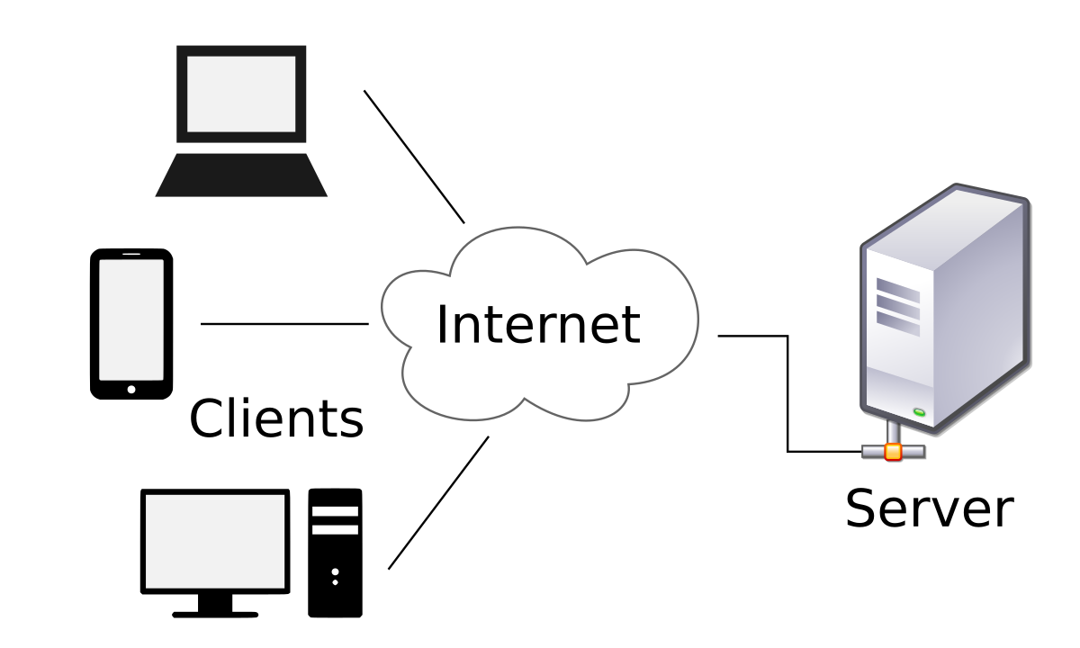

Figure 1: Client Server Model

## 2.2 Architecture of Web App

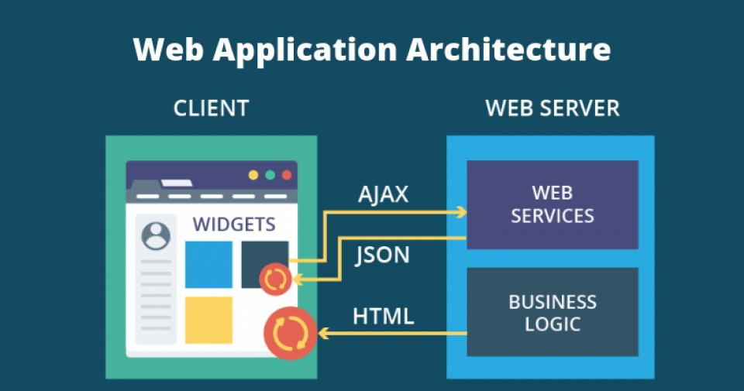

Figure 2: Web Application Diagram (Banga,2019)

The architecture of a web app is based on how the various componenets of the web app interact with each other. Hence, the type of architecture is determine by the pattern of interactions between the components (Banga ,2019).

### 2.2.1 Single Page Applications (SPA)

Single Page Application are build to provide a dynamic interactive user experience by updating the content on the current page instead of reloading an entirely new page from the server (Banga,2019). This allows the web application operate more like a destop application by only needing to request the most necessary elements of content from the server and prevents user experience interruptions. What make this possible is Asynchronous Javascrippt and XML which serves as the foundation of SPAs by enabling page communication.

### 2.2.2 Microservices

Microservices are small, lightweight services that execute a specific, single functionality (Banga ,2019). It is meant to help developers enchanec productivity and speed up the deployment by not having the components of the architecture be directly depedant on each other. Hence, they don’t have to be developed in the same coding language which allow develoeprs to use whatever fullstack technology they want.

### 2.2.3 Serverless Architectures

As the name implies, this architecture does not require the developer to bother with server insfracture as they can outsource server related task to third party cloud service providers. The benefit of this approach is that web developer can execute custom code logic without needing to fiddle with infrastrucutre related task (Banga,2019). This architecture works well with companies who don’t want to run their own back end servers with all the hardware that comes with it.

## 2.3 Components of Web App

* **UI/UX Web Application Components –** Handles what end-user see, settings and configuration and does not impede the back-end operation of a web application. For example, dashboards,notifications and settings (Banga, 2019).
* **Structural Components –** The parts that handle the functionality of the web application that includes user interaction,controls and database storage. The major components are client and Server (Banga, 2019).
* **Client Component -** The client component Is what the user’s interact with which are primarily developed in CSS, HTML, and JS. As it operates in the user’s web browser, there is no need for operating system or device-related adjustments(Banga, 2019).
* **Server Component –** Handles application logic which is the control center of a web application and data that stored in the database (Banga,2019). It can be build using one or more programming languages such as Python, Java or PHP.

## 2.4 Attributes of a Quality Web App

Software is evaluated by measuring the quality of attributes it has such as reliability,usability and maintainability. However, most companies have no reason to improve the quality of their software as it is more lucrative to deliver poor quality product sooner because of the time-to-market advantage (Offutt,2012). However, web applications are different as company running them requires customer to use their site and most importantly **returning** to their site. Hence, the a quality web application is required to convince user to return.

### 2.4.1 Reliability

Reliability is the ability of a system to continue operating in the expected way over time. Reliability is measured as the probability that a system will not fail and that it will perform its intended function for a specified time interval. A web app should not crash, but if it does crash it should be able to recover it self.

### 2.4.2 Usability

Usability means how easy is it for users to understand how to use the software. Users have grown to expect software to be easy to use (Offutt,2012). Hence, a website that su[pports usability requriements will improve trust among customers. A web app should provide fast reponse times. use of graphic interface and support the lattest standards in order to be usable.

### 2.4.3 Security

A web app should be secure to gain customer trust as they handle customer data and other important information (Offutt,2012) . Countermeasures must be in place to defend against Common attacks like Cross-Site Scripting, SQL injection, and DOS.

### 2.4.4 Availability

Web Application should be up 24/7 at all times with as little down time as possible for maintenance or upgrades. They should also be compatible with all browsers and not be limited one specific browser hence they must include code to be able to run on different browers to support as many users as possible (Offutt,2012) .

### 2.4.5 Scalability

Scalability is the ability of a system to either handle increases in load without impact on the performance of the system, or the ability to be readily enlarged. A web app should be designed in way to accommodate more users if necessary. Meaning a web app should constantly have the latest protocols and web technologies implemented to so.

### 2.4.6. Maintainability

Web Application must be easy to run and fix easily. Due to the nature of web apps, fixes can push to customers instantly via the web (Offutt,2012) . However, this is can be a double edge sword as it also makes developer complacent and accidentally release a fix without testing that causes compability issues for certain users. However, due to the nature of web app, the fix can be easily be pulled out and the a previous version be restored untill a suitable solution is found.

## 2.5 Project Management Systems

Project management software is a term covering vast types of software, including estimation and planning, scheduling, cost control and budget management, resource allocation, collaboration software, communication, quality management and documentation or administration systems, which are used to deal with the complexity and different aspects of large projects (Kundu,Bishoi 2015).

## 2.6 Technical Review

### 2.6.1 Django

Django is an open-source framework for backend web applications based on Python.Its primary goal is to make the creation of complex, database-driven websites easier.Django takes full advantage of Python dynamic capabilities which allows less code. It also emphazie loose coupling of layers and code which allows indepedency and rapid development, The implementation of the principle of don’t repeat yourself for database designs that organize tables to reduce redudancy and increase normalization (Django Software Foundation,2013).

2.6.2 Core Framework of Django

The Core framework of Django follows MTV (model-template-view) architecture which is based on the MVC (model-view-controller). The difference is that in Django, the controller controls which data is being presented instead of how is the data presented by using Python Callback functions. The “View” in MVC becomes the “Template” because in Django it handles how a data is being presented (Django Software Foundation,2013). The framework also contains:

* a lightweight and standalone web server for development and testing
* a form serialization and validation system that can translate between HTML forms and values suitable for storage in the database
* a template system that utilizes the concept of inheritance borrowed from object-oriented programming
* a caching framework that can use any of several cache methods
* support for middleware classes
* an internal dispatcher system that allows components to communicate events to each other
* an internationalization system that can translate created components into a variety of languages
* a serialization system that can produce and read XML and/or JSON files.
* a system for extending the capabilities of the template engine
* an interface for Python's built-in unit test framework
* Django REST framework for building Web APIs.

### 2.6.3 React Web Franewrok

React is a JavaScript library for building user interfaces. It is the view layer for web applications.(Reactjs.org,2019)At its core, React applications are made out of components that each contain their own module. These components can compose together to form a complex UI consisting of multiple components.

#### 2.6.3.1 Features of React

**JSX**

Javascript Extension is a React Extension that allows developers to have multiple DOMS using simple HTML code. (Morris,2019)Document Object Models (DOM) are what browsers used to arranged HTML files of a website and JSX is compatible with most browsers.

**Virtual DOM**

Normally a website will use HTML to update DOM which is suitable for static website but is not suitable for dynamic websites that uses many interactive elements.If JSX is used to update the DOM, React will create a “Virtual DOM” and compares it to the actual DOM to see what parts actually need to change (Morris,2019) . This kind of selective updating take less computing power hence improve website peformance.

### 2.6.4 Python

Python is an object-oriented programming language developed by Guido van Rossum in the 1990 that offers high level data structures with dynamic typing and dynamic binding. Which makes it popular in Rapid Application Development and as a scripting language to connect existing components. Besides, Python has an easy to learn syntax that priotises readability that reduces code maintenace (Python.org,2019).

Python has a very small kernel but can support other modules,libarires and packages. The list of libraries that are written in either Python itself, C or C++ language can provide different functionalities ranging from Perl-like regular expression to Graphical User Interface (GUI).

### 2.6.4.2 Python Numeric extension

Numeric Python also known as NumPy is python library that serve the basis of scientific computing in python. It is used for efficient storage because it provides a high-performance multidimensional array object. It also provides an assortment of routines for fast operations on the arrays including mathematical,logical,sorting,selecting and may more. . This efficiency allow users to code numerical operations in Python rather than re-coding in on other programming languages such as C or C++ (SciPy.org,2019).

### 2.6.4.2 Uses of Python

#### Database programming

Most modern application and software needs a integrated database to peform its operations. There are many database management system such as MySQL, Sybase and others that currently in used in many system today. Python is compatible with most database languages (Nosrati.M, 2011) which makes it a viable programming language for database operations.

#### Network and Web Development

Python language consist of different libraries that allows user to perform functions such as client-server connection, socket programming, and FTP (Nosrati.M, 2011). In addition, third party tools such as mod-Python allows web servers to run Python scripts. Python also has many different web frameworks, the two most popular ones are Django and Flask. Flask is a micro web framework, it provides the basic functionalities like routing requests without much overhead. Django has more features for building powerful backends with efficiency and security. This is because Django is equipped with a powerful ORM layer which facilitates dealing databases and performing different operations on the data (Nader,2019) .

#### System Programming

System Programming with python is made easier with the sys and the os module as they  serve as an abstraction layer between the application. What that means is python script can run independent of the OS. The abstraction layer also makes it possible to implement platform independent applications in Python, even if they access operating specific functionalities. What enables this functionality is that Python’s ability to work with the Shell which allows Shell Programming (Klein, 2019).

#### Graphical User Interface (GUI)

Python offers multiple options for developing GUI (Graphical User Interface). Out of all the GUI methods, tkinter is most commonly used method. It is a standard Python interface to the Tk GUI toolkit shipped with Python. Python with tkinter outputs the fastest and easiest way to create the GUI applications. GUI generated by python will look the same no matter on different platform because it is in pmw format (Nosrati.M, 2011).

### 2.6.4.3 Comparing Python with other languages

Python by default does not support certain security features like cryptography,aunthentication and access control unlike JAVA . Java provides a secure platform and enforces object-oriented programming models that makes most useful in the financial and security sector.  However, python is a more dynamic is easier to work with as attributes are created easier compared to Java (Bogdanchikov, Zhaparov and Suliyev, 2013). Python also offers a comprehensive ecosystem of open source financial libraries that make the life of a developer much easier when developing as well as maintaining.

2.6.5 REST API

REST or Representational State Transfer is architectural style for distribute hypermedia system and was first presented by Roy Fielding in 2000. The main purpose of REST is to provide interoperability between computer systems on the internet by defining a set of constraints for creating Web services (RestfulAPI,2019).

## 2.6.5.1 Constrants of REST

**Client–server**

**User interface concerns must be seperated from data storage cocerns. By doing so improves portability of user interface across many platforms and improves scability by simplifying the server components. Most importantly, it allows components to envovled indepentely of each other** (RestfulAPI,2019)**.**

**Stateless**

 Client Server Communication is constraint by having no client context stored on server between request. Each request from client to server must contain all of the information necessary to fullfill the request. Session state is therefore kept entirely on the client (RestfulAPI,2019).

**Cacheable**

Cache constraints require that the data within a response to a request be implicitly or explicitly labeled as cacheable or non-cacheable.(RestfulAPI,2019) Well managed caching improves scalability and performance by reducing the amount of client-server interactions (RestfulAPI,2019).

**Uniform interface**

This contraint requires RestFUL teams to simplify and decouple the architecture of a RestFul system which enables components to indepently envolved. It contains 4 other constraints which are identification of resources,manipualtion of resources through represnetation, self descriptive messages and hypermedia as the engine of application state (RestfulAPI,2019) .

**Layered system**

The layered system constraint allows an architecture to be composed of hierarchical layers by constraining component behavior. Client server dosen’t have to be directly connected to an server,it can be connected to an intermediary like a load balancer that will not affect the communication between client and server which allows scallability (RestfulAPI,2019).

**Code on demand**

This contraint is optimal as it allows client functionality to be extended by downloading and executing code in the form of applets or scripts (RestfulAPI,2019).

## 2.7 Related Works

### 2.7.1 Final Year Supervision Management System as a Tool for Monitoring Computer Science Projects (Marini et al, 2010)

This project was developed by the students in University Kebangsaan Malaysia (UKM) as their final year project. Preliminary observation conducted in their school have found that students were failing to complete their Final year project within the allocated time. Although, log book were used to document dicussion between supervisor and students and schedule were set by the school, there was no monitoring process to trigger students to meet all theit deadlines. Thus, to solve this issue , they designed and developed Supervision Management System.

### 2.7.1.2 Proposed Design

The proposed design contain 5 modules:

**Appointment module**

In the Appointment module, supervisor can set weekly timeslot for the whole semester and also unplanned time. Student can request appointment and the supervisor can approve or reject the request.

**Students and lecturers profile module**

Shows the students and lecturers basic and contact information. The students and lecturers are allowed to update the information and input other information such academic achievements, lsit of enrolled subjects and their final year project.

**Schedule monitoring module**

Admistrator can set standard schedule for report writing activies and the schedule can modify by supervisors to meet project requirements or their student needs. This module also lets supervisor monitor their student progress and will have colours codes to represent on time submission, late submission and no submission. It will also display the overall progress of all students under a lecturers sueprvision. Furthermore, the module will send notifications to students to remind them of importants dates. Finally, it can generate a report that list overall student’s status for supervisor administractive purposes.

**Log book module**

Replacement for paper logbooks. It allows student to log dicussion during meetings and is a separate area for students to log entries regarding system development and report writing activities. It will have the ability to let students upload documents and dowload documents for evaluation and reference.

**Administrator module**

The admistrator module will always be available to the department officer. Its purpose is to assign students to supervisors. From the above, set schedules and it will record the submissions of each student to the department office.

### 2.7.1.3 System Design

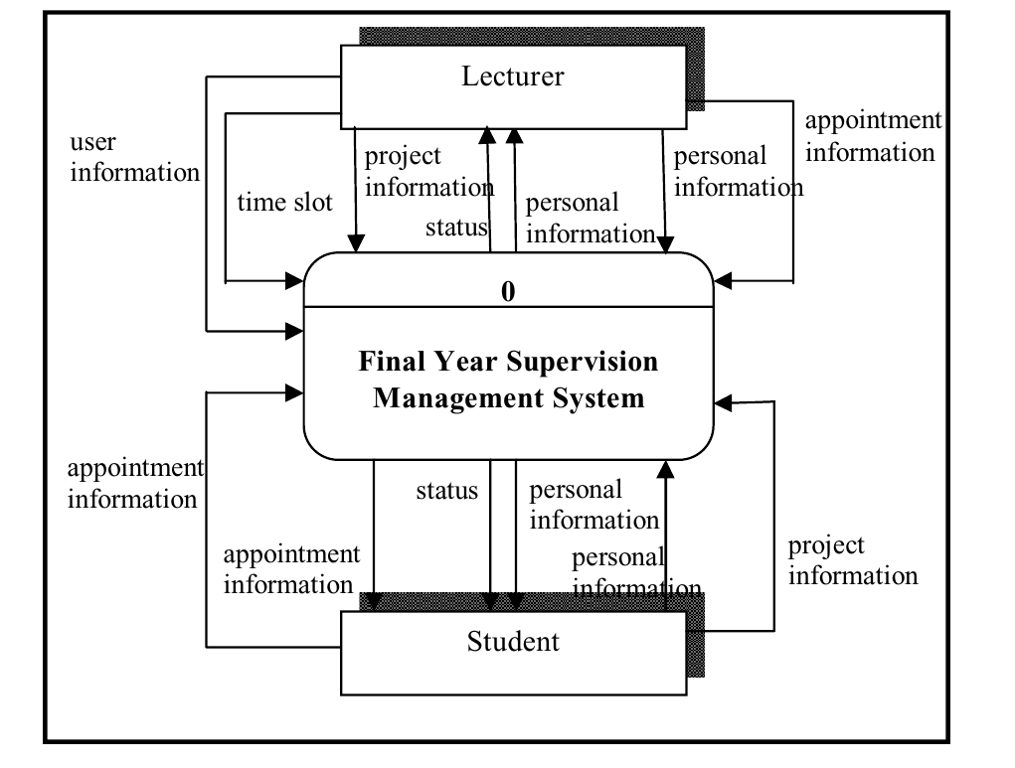

Figure 3: System Design of FYP supervision management system (Marini et al, 2010)

Figure 3 shows the System Design of the supervision management system. The system was written in PHP, the user interface was designed using Macromedia Dreamweaver CS3, and MySQL was used as the database system. phpMyAdmin was selected as the administration tool of choice by them .

## 2.8 Research methodology

A Soft Development Life Cycle (SDLC) is a process used in the industry to design and develop the software that is aim to produce a high quality software in a reasonable time frame and budget.

1. Waterfall Model
2. Prototype Model
3. Rapid application development Model (RAD)
4. Incremental Model
5. Spiral Model
6. V-Shaped Model
7. Agile Model

### 2.8.1 Waterfall Model

The Waterfall model is one of the worlds oldest model for development is also called the Linear-sequential life cycle model. Essentially, this model contain phases that are independent from each other and each phase has to be completed before moving to to next one which so why its called a linear sequential model.

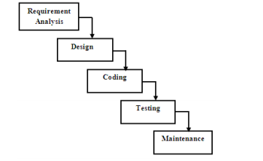

*Figure 4: Waterfall model life cycle*

**Pros of waterfall model**

* Requirements should be well defined before proceeding to development.
* Each phases will be completed in the state period of time before proceeding to following phase.
* Waterfall model is easy to implement since it’s a linear model.
* It requires minimal resources to implement this model.

**Cons of waterfall model**

* Most of the problems in a particular phase is not settled or solved completely during that phase itself.
* Inflexibility as the clients are not able to change their requirements in during the development process.

### 2.8.2 Prototype Model

A prototype is a working model with incomplete functionality to test the basic functions of the system. There is two types prototypes, a throwaway and evolutionary. An initial prototype is usually based on the client’s requirement. To create a prototype, one must follow the steps of requirement identification, initial prototype, prototype review, revision of prototype enhancement.

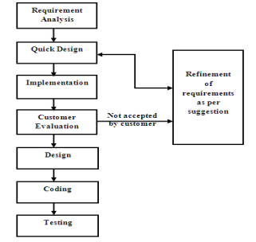

*Figure 5: Prototype model life cycle*

**Pros of Prototyping model**

* More interactions with client in the product before actual implementation.
* Clients would have a better understanding on how the system is being developed because they get to see a working model of the system.
* It takes much lesser time and cost effective as defects of the system can be detected in early stages.
* Quicker feedbacks from clients provides better solutions
* Functions that are missing in the system can be detected easily.

**Cons of Prototyping Model**

* Risk of insufficient requirement analysis owing to too much dependency on the prototype.
* Clients may get confused from the prototypes and actual systems.
* Prototyping can get complicated and time consuming if the scope of the system go beyond original plans.
* Developers may try to reuse the existing prototypes to build the actual system, even when it is not technically feasible. Developers may use existing systems which is not feasible to build the actual system.

### 2.8.3 RAD Model

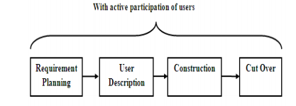 RAD or Rapid Application Development is a model that is a high-speed adaption of waterfall model. RAD model can be implement if the client’s requirement are not too many and the development cycle in RAD is small. In RAD model, the client is involved in the every phase of the cycle. There are four phases in the RAD cycle that is planning, user description, construction, and cutover.

*Figure 6: RAD Model life cycle*

**Pros of RAD Model**

* Developers can accommodate to clients requirement much easier.
* Progress is measured in this model.
* Iteration time can be short with use of powerful RAD tools.
* Productivity with fewer people in a short time.

**Cons of RAD Model**

* System that is build using RAD must be systems that can be modularized.
* Only highly skilled developers or designers can work in this model.
* Requires high modelling skills
* Inapplicable to cheaper projects as cost of modelling and automated code generation is very high.
* RAD is only suitable or projects that requires shorter development time.

### 2.8.4 Incremental Model

The incremental model is deem a model that reacts to client changes since the model is iterative in nature. After each release in this model, the client can use the product can accommodate changes in the product. When compared to the waterfall model, the waterfall model will deliver a fully working product and the interactive model only delivers an operational quality product at each release.

*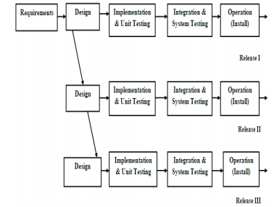Figure 7: Incremental model life cycle*

**Pros of Incremental Model**

* Able to develop a working software much faster and during early stages in SDLC.
* This is a flexible model, therefore it would be cheaper if the requirements and scope needed change.
* Easier to debug since it’s done by smaller iterations.
* Clients can communicate to every built of the system.

**Cons of Incremental Model**

* Requires proper planning and design.
* Developers need to understand and define the complete definition of the system before being able to break the system into smaller increments.
* Costly

### 2.8.5 Spiral Model

The spiral model consists of four different phases in each quadrant of a circle, the phases are planning, risk analysis, engineering and evaluation. In the first phase, clients requirement are gathered. In the planning phase, the developers determine the required resources for the system as well the functionalities that is required to be integrated in the system The risk analysis phase is to identify the risks involved and provide alternative solutions. The engineering phase and is where the system is developed and undergoes testing. The aim of the spiral model is to identify the risks that is related to the project and resolve these threats before it causes issues.

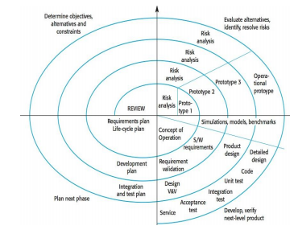

*Figure 8: Spiral model life cycle*

**Pros of Spiral Model**

* This model accommodates to change of requirements.
* Developers are allowed to extensively use prototypes
* Requirements is captured more accurately.
* Clients can view the systems during early stages itself.

**Cons of Spiral Model**

* Management in this model is very complex.
* End of the project may not be known early.
* Not suitable for project with low risks and expensive.
* Process involved in spiral model is complex.

### 2.8.6 Agile Model

Agile development is a combination of both incremental and iterative development, therefore the phases involved in the agile model is revisited repeatedly. In agile, the development is divided into small increments where these increments are in every phase development and the ability to move backwards in the increments. There are four agile factors that was pointed in the Agile Manifesto.

* Early customer involvement
* Iterative development
* Self-organizing teams
* Adaptation to change

**Pros of Agile Model**

* The main advantage of the agile model is that the model is able to respond to immediate change of requirements towards the project.
* There will be no guesswork between to development team and client as there is continuous communication between the client and developers.

**Cons of Agile Model**

* It is difficult to implement agile methodology in large projects as it is more difficult to judge the efforts and time required.
* Only seniors will be a position that allow them to make necessary decisions in agile development and this discourages the newcomer programmers.

## 3.0 Prelimary Studies

Research was done in the previous chapter to gain information about the Architecture Web Applications in general and the Frameworks for implementing it . The aim is to developed a FYP Project Managememt System for KDU for monitoring FYP students project more effectively . Prelimary observation in KDU have suggested that supervisors do not meet their students often and often have no idea how their students are performing on their projects even with the system of using physical Logsheets to monitor student progress.

Quantitative research method is selected for this research. Quantitative data focuses on measurements and results that can be quantified. Since this research will utilize experiment as a instrument for the test of the developed prototype, data on characteristic displayed by the people and time taken to perform task are all quantifiable data. Hence, quantitative research method is more suitable for this research.

## 3.1 Research Design

The purpose of this research is to design and develop a FYP Project Management system with Django. The system will provide tools necessary for better monitoring of students FYP and easier appointment scheduling with supervisor .

|  |  |  |
| --- | --- | --- |
| Research Objectives | Method | Outcome |
| To study the methods and techniques of utilizing Django. | Literature review | Understanding of the Django Framework. |
| Design and develop a FYP project Managememt system | Observation | Prototype of the FYP project Management System |
| To validate the FYP project Management System | Experiment | Validate and verify the system |

*Table 3.1 Research Design Table*

## 3.2 Operational Framework

|  |  |  |  |  |
| --- | --- | --- | --- | --- |
| Item | Phase | Activity Description | Output | Expected Contribution |
| Idea Generation | Phase 1:  Problem Identification & Motivation | Literature review  Preliminary Study | Identify literature review  and problem statement | Listing of current problem statement |
| Concept Studies | Phase 2: Suggestions & Solutions | Development of prototype | Identify the requirements of Project Management System | Listing of requirements of Project Management System |
| Data Collection & Confirmation of Study | Phase 3:  Identifying Elements for Proposed Model | Conduct Observation | Identify the design ideas and features for Project Management System | To propose a design for a Project Management system |
| Prototype Validation | Phase 4:  Validation | Report the feedback from the participant and do modification if necessary | Validation of prototype | Working prototype for KDU |

Table 3.2: Operation Framework table

## 3.3 Research Instrument

Interview is one of research instrument of this research. Interviews will be conducted on KDU Lecturers on their opinions and their necessity for a FYP Project Management System. Questions such as “What problems are you facing with students in FYP” and “Do you have a way to monitor student FYP effectively.” will be asked to justify the necessity of FYP Management System.

Experiment research instrument was also chosen to measure the performance and effectivives of the FYP management system . Factors to consider are all functions working as intended and and the usability of system.

|  |  |
| --- | --- |
| FYP management System |  |
| Participants | KDU lecturers, FYP Students |
| Technique | Think Aloud |
| Represensatitive task | Monitor FYP Project status, uploading files, Requesting Appointment |
| Measurements | Quantitative measurements of user engagement with system, measures of cognitive complexity, quantitative measurements of time taken to perform task and errors made. |
| Outline Plan | Present users with prototype system and tasks, record the observations of users carrying out task and refine results into categories identified. |

Table 3.3: Experiment research

## 3.4 Software Development Life Cycle (SDLC)

The research methodology that will be use is the agile methodology. Agile development is a based on incremental and iterative development where the development lfie cycle of a project is a split into multiple “increments” or “iteration” that has contributions in the all phases of development. This give the project the ability to do rapid changes throughout the life cycle easily.

Pros of Agile model:

* Good Adaptation to changes
* Get instant feedback from customer
* Rapid build delivery

Cons of Agile model:

* Hard to calculate the effort and time being used
* Hard to transfer the task if the employee had changed

The following table shows agile approach for this research project:

|  |  |  |
| --- | --- | --- |
|  | **Phases** | **Output** |
| **Inception** | Identify Problem   * Literature review | * List of problems identified |
| **Elaboration** | * Identify Problem Statement * Identify Research Objective * Identify Research Scope and Limitation | * Problem Statement Identified * Research Objective Identified * Scope and Limitation Identified |
| **Construction** | Identify the tools for the system development   * PC * Laptop * Atom Text Editor * Django Framework * React Library | * Tools for system development is identified * Prototype development completed * Updated Document |
| **Transition** | * Conduct Experiment * Obtain feedback | * Gain Feedback |

Table 3.4: Agile model

## Chapter 4: Analysis

### 4.1 Interview

It is important to evaluate the data collected in order to validate the objectives of this research and answer the research questions. As mentioned in previous chapters of this paper, the findings will be interpreted in a descriptive manner. This chapter covers the analysis, interpretation and presentation of the findings from this research.  The acceptance of the analysis and interpretation is to be supported by the outcome of the expert interview, which is the chosen method of data collection for this project.

### 4.1.1 Interview Candidate

The interview candidates are Miss Cindy and Miss Siti  who are currently Lecturers in KDU University College. Miss Siti is currently the FYP coordinator and advisor for computing students while Miss Cindy is a FYP advisors only. Miss Siti is required to coordinate FYP milestones and deadlines with all enrolled FYP computing students and ensure students submit their projects correctly while also finding time to meet her students under her consultation. Miss Cindy needs a way to plan and manage her consultation meetings with her students and reminds students to meet her for regularly instead of last minute.

### 4.1.2 Interview Questions

The interview with the candidate is a semi-structured interview. A semi-structured interview is one that is guided by a script, but certain interesting problems can be elaborated in more detail. This provides a good compromise between richness and replicability. The questions to be asked are a mixture of open-ended and close-ended questions. While closed questions are easier to analyse, open ended questions allow the candidate to elaborate his answer in a more detail fashion. The following is a list of questions to be asked during the interview:

1. What are the problems that FYP advisors/coordinators/students faced with students in the FYP program?
2. What is the role of  the FYP coordinator and what task does do they need to accomplish? (For Coordinator only)
3. Do you think an implementation of a project management system for FYP students/coordinators/advisors  would be helpful? Why?
4. What functions would you like  the FYP Project Management System to perform?
5. Will you be willing to use the application if the whole system is easy to use and functional ?

### 4.1.3 Interview Process

The interview was conducted on October 3rd and October 10th , 2019 at the SCCM Office . Before the interview begin, a set of question was prepared and was given to the candidate to read and understand what question that she will be asked. The main body of the interview began after a warm welcome and a series of question is asked shown in the previous section. To record answers discussed, a computer with a word processor is use to type in the response of the candidates. In order to keep up the speed of the interview candidate, the answer recorded is based on the main point and later the main point will be transcribed into a full sentence.

### **4.1.4 Findings of Overall Results**

In this section, the interviewee’s responses will be critically analysed and interpreted.When asked about the problems faced by FYP coordinators/students/ advisors, the advisor responded that student usually submit late or last minute, never see them for consultation or is afraid to see them, submit documents infrequently and submit documents are way too large to be graded in a short period of time.  For FYP students, the difficulty in finding time where both their advisor and them are free for consultation is the biggest problem they face. The coordinator responded that she has difficulty keeping track of each students progress on their FYP projects and which advisors that they’re under. Next, the role of the FYP coordinator is to go to class every week and set milestones for FYP students to deliver which can be a hassle to scheduled.  All candidates agree that a project management system for final year projects would be extremely helpful or is needed. In regards of the functions that the project management systems needs to have, the coordinator said that she would want the system to be able to show which student is under which advisor and how many students each advisor has. She would like to view the title and general progress of students on their FYP projects, analytics of what topics are popular among students or their progress, to able to set  presentation date and time and the Students are reminded with a notification and a place to deposit important documents or make announcements. The advisor responded that she would want a virtual log sheet system, being able to view students and advisors timetable so that they can set appointments based on both individuals schedules, set reminders for students to meet them and a repository to store discussion notes and documents during consultation. The students generally just want a way to schedule appointments with their advisors and a tracking system to track their progress and deadlines. Finally, coordinator and advisors both imply that a project management system is quite needed and will be willing to test run and use the system if up to specifications while the student think it’s a nice addition to the course.  All in all, the information and knowledge provided by the interviewee is invaluable when addressing the research questions of this project. This information would be heavily considered when designing the prototype model of FYP Project Management System.

## 4.2 Use Case

### 4.2.1 Use case diagram for student

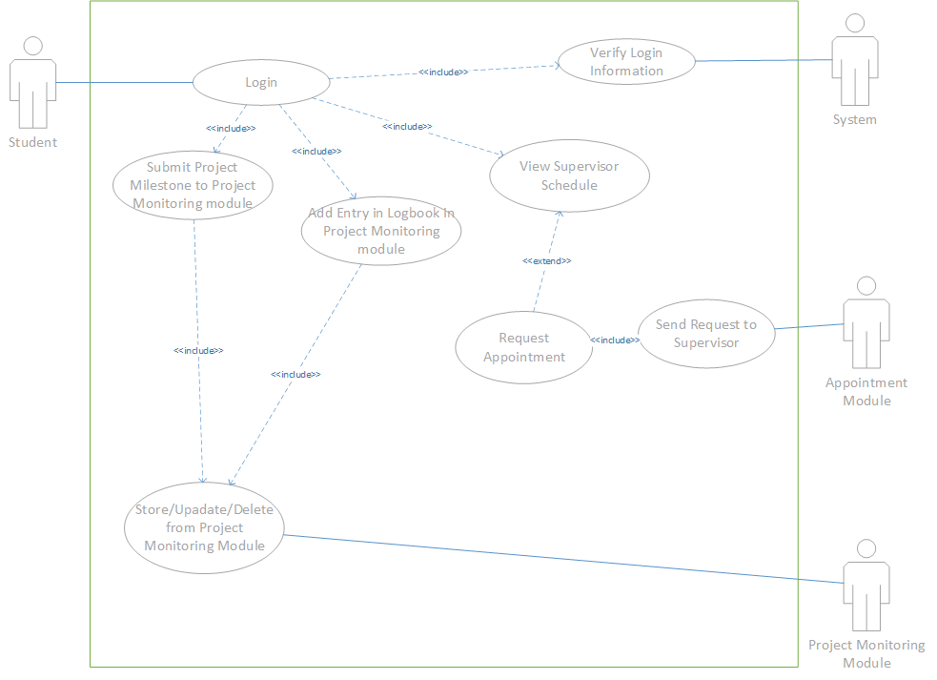

Figure 9: Use case diagram for student

### 4.2.2 Use case table for students

|  |  |  |  |
| --- | --- | --- | --- |
| Use case ID | | 1 | |
| Use case name | | Login | |
| Scenario | | Student login to the application | |
| Description | | Student need enter username and password in order to use the application | |
| Actors | | * Student * System | |
| Pre-conditions | | * Student must enter username and password | |
| Post-conditions | | * The application shall let the student proceed if the student username and password match with the database * The application shall not let the student proceed if username and password does not match with the database | |
| Flow of Events | Student | | Database |
|  | 1. Student visit the website 2. Student enter username and password | | 1. The database checks the login information |
| Expected Condition | | 1. Student can proceed to if the login information match with the database 2. Student remain in login page if the login information does not match with the database | |

|  |  |
| --- | --- |
| Use case ID | 2 |
| Use case name | View supervisor schedule |
| Scenario | Appointment module will display supervisor schedule |
| Triggering Event | Student must click on “View Supervisor Schedule” button |
| Description | Appointment module will fetch supervisor schedule and display on screen |
| Actors | * Appointment Module |
| Pre-conditions | * Student need to click on “View Supervisor Schedule” button |
| Post-conditions | * Supervisor Schedule are shown on screen |
| Flow of Events | 1. Student clicks on “View Supervisor Schedule” button on home page 2. Appoinment module fetch supervisor schedule. 3. Appointment module will display fetched information on screen |
| Expected Conditions | 1. Appointment module is not connected to system therefore nothing is shown 2. Supervisor has not configure their schedule hence no schedule is shown. 3. Supervisor Schedule is displayed on the screen. |

|  |  |
| --- | --- |
| Use case ID | 3 |
| Use case name | Request Appointment |
| Scenario | Student request Appointment by selecting available timeslot. |
| Triggering Event | Student click on empty time slot of supervisor schedule page. |
| Description | Appointment module verifys empty time slot is selected and notifies respective supervisor for confirmation. |
| Actors | * Appointment module |
| Pre-conditions | * Student need to click on empty time slot on supervisor schedule page. |
| Post-conditions | * Pop up showing that supervisor is notifield is shown on screen. |
| Flow of Events | * + - 1. Student click on empty time slot of supervisor schedule page.       2. Appointment module verifys empty time slot is selected and notifies respective supervisor for confirmation.       3. Pop up showing that supervisor is notifield is shown on screen. |
| Expected Conditions | Student did not select an empty time slot hence no request is sent and will remain on the view schedule page.  Request is successfully sent to supervisor by the appointment module. |

|  |  |  |  |
| --- | --- | --- | --- |
| Use case ID | | 4. | |
| Use case name | | Adding Log Entries in Logbook | |
| Scenario | | Student upload/update/delete relevant materials or documents | |
| Description | | Student can upload/update/delete relevant materials or documents in the Logbook section | |
| Actors | | * Student * Project Monitoring Module | |
| Pre-conditions | | * Student needs to select add new Log or previous added Log. | |
| Post-conditions | | * Student successful upload/update/delete files in the Logbook section. * The Project Monitoring module successful store/update/delete the files performed by the student | |
| Flow of Events | Student | | Project Monitoring module |
|  | 1. Student upload/update/delete files to the Logbook module. | | 1. The database store/update/delete files peformed by the student. |
| Expected Condition | | 1. Student successfully upload/update/delete files in the Logbook. 2. The Project Monitorign module successful perform store/update/delete on student logs. | |

|  |  |  |  |
| --- | --- | --- | --- |
| Use case ID | | 5. | |
| Use case name | | Submitting projectm milestone in project monitoring module. | |
| Scenario | | Student upload/update/delete relevant materials or documents for project milestone. | |
| Description | | Student can upload/update/delete relevant materials or documents in the project monitoring module | |
| Actors | | * Student * Project Monitoring Module | |
| Pre-conditions | | * Student needs to select the respective project milestone set by coordiantor. | |
| Post-conditions | | * Student successful upload/update/delete files in the project monitoring module . * The Project Monitoring module successful store/update/delete the files performed by the student | |
| Flow of Events | Student | | Project Monitoring module |
|  | 1. Student upload/update/delete files to the Logbook module. | | 1. The database store/update/delete files peformed by the student. |
| Expected Condition | | 1. Student successfully upload/update/delete files in the . 2. The Project Monitorign module successful perform store/update/delete on student logs. | |

### 4.2.3 Use case diagrm for Supervisor

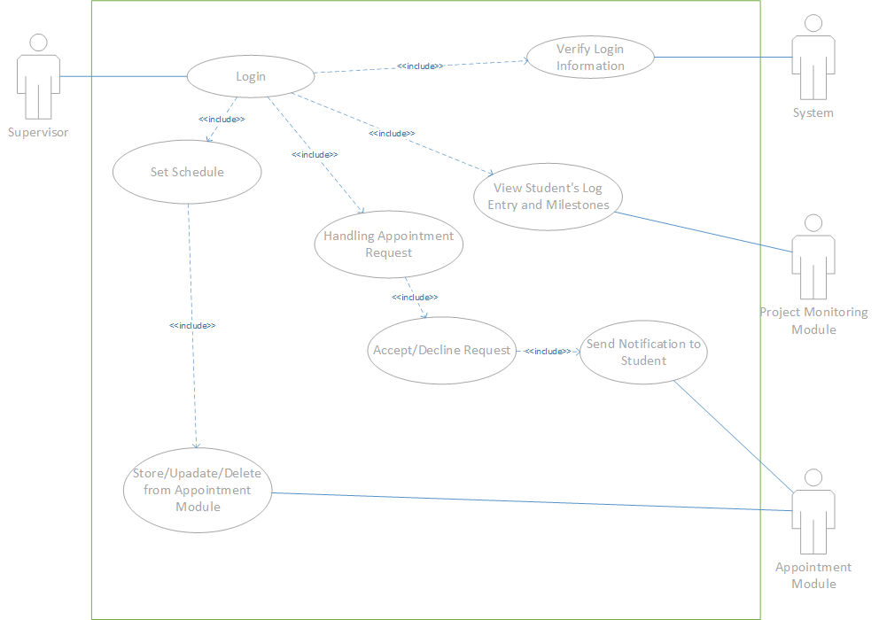

Figure 10: Use case diagram for supervisor

### 4.2.4 Use case table for Supervisors

|  |  |  |  |
| --- | --- | --- | --- |
| Use case ID | | 1 | |
| Use case name | | Login | |
| Scenario | | Supervisor login to the application | |
| Description | | Supervisor need enter username and password in order to use the application | |
| Actors | | * Student * System | |
| Pre-conditions | | * Student must enter username and password | |
| Post-conditions | | * The application shall let the student proceed if the student username and password match with the database * The application shall not let the student proceed if username and password does not match with the database | |
| Flow of Events | Supervisor | | System |
|  | 1.Supervisor visit the website  2.Supervisor enter username and password | | 1. The sytem checks the login information |
| Expected Condition | | 1.Supervisor can proceed to if the login information match with the database  2.Supervisor remain in login page if the login information does not match with the database | |

|  |  |  |  |
| --- | --- | --- | --- |
| Use case ID | | 2 | |
| Use case name | | Set Schedule | |
| Scenario | | The supervisor is adding his/her schedule to the system | |
| Description | | The supervisor is adding his/her schedule to the system by entering the time and date that they are free to be sent to the database. | |
| Actors | | * Supervisor * Appointment Module | |
| Pre-conditions | | * Supervisor must be logged into the system | |
| Post-conditions | | * Schedule is added to the Appointment Module | |
| Flow of Events | Supervisor | | Appointment module |
|  | 1. Supervisors enters the schedule page and selects add new schedule. 2. After adding their schedule, supervisors submits the schedule and waits for message. | | 1. Appointment module verifies the schedule details 2. The Appointment will create a directory under the supervisor’s name and saved his schedule 3. The Appointment module will display a success message after the schedule has been successfully saved |
| Expected Condition | | 1. Supervisor has no internet access and therefore unable to save schedule. | |

|  |  |  |  |
| --- | --- | --- | --- |
| Use case ID | | 3 | |
| Use case name | | Handling Appointment Request | |
| Scenario | | Supervisor views and accept or decline a student appointment request. | |
| Description | | Supervisor will received appointment request notification from students and can choose to accept or decline the appointment request | |
| Actors | | * Supervisor * Appointment module | |
| Pre-conditions | | * Supervisor must be logged into the system | |
| Post-conditions | | * The supervisor accepts/decline the appointment request. * Appointment updates the supervisor’s schedule accordingly. * The appointment module sends the respective accepted or decline notification to students. | |
| Flow of Events | Supervisor | | Appointment module |
|  | * + - 1. The super visor accepts/decline the appointment request | | 1. Appointment module updates the supervisor’s schedule accordingly.  2. The Appointment module sends the respective notification of accepted/declined notification to student. |
| Expected Condition | | 1. Supervisor ignores the request and no action is performed.  2. Supervisor loses connection while accepting/declining the appointment request and appointment module is not updated and no notification is sent. | |

|  |  |  |  |
| --- | --- | --- | --- |
| Use case ID | | 4. | |
| Use case name | | View Students submitted Progress | |
| Scenario | | Supervisor views their students progress in Project Monitoring module. | |
| Description | | Supervisor can view their respective students logs in Logbook or uploaded files in project monitoring module | |
| Actors | | * Supervisor * Project Monitoring module | |
| Pre-conditions | | * Supervisor needs to select which students Logs or files to view if they have more than one student under their supervision * Supervisor needs then to select which Logs or files to view in the project monitoring module | |
| Post-conditions | | * Project Monitoring module sucessfully display student’s uploaded documents/materials. | |
| Flow of Events | Supervisor | | Project Monitoring module |
|  | 1. Supervisor selects which students log to view if they have multiple students.  2. Supervisor selects which logs to view in the logbook module. | | 1. System display the selected log’s of respective student. |
| Expected Condition | | 1. Student have not submitted any materials to the logs hence empty. | |

### 4.2.5 Usecase diagram for coordinator

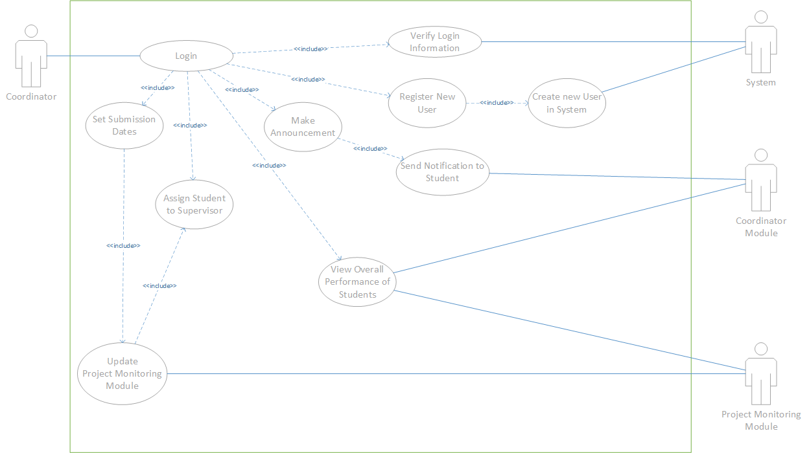

Figure 11: Use case diagram for coordinator

### 4.2.6 Use case table for Coordinator

|  |  |  |  |
| --- | --- | --- | --- |
| Use case ID | | 1 | |
| Use case name | | Login | |
| Scenario | | Coordinator login to the application | |
| Description | | Coordinator need enter username and password in order to use the application | |
| Actors | | * Coordinator * System | |
| Pre-conditions | | * Coordinator must enter username and password | |
| Post-conditions | | * The application shall let the coordinator proceed if the student username and password match with the database * The application shall not let the coordinator proceed if username and password does not match with the database | |
| Flow of Events | Coordinator | | System |
|  | 1.Coordinator visit the website  2.Coordinator enter username and password | | 1.The system checks the login information |
| Expected Condition | | 1.Coordinator can proceed to if the login information match with the database  2.Coordinator remain in login page if the login information does not match with the database | |

|  |  |  |  |
| --- | --- | --- | --- |
| Use case ID | | 2 | |
| Use case name | | Schedule submissions dates of project milestone | |
| Scenario | | The coordinator can schedule submissino dates for project milestone for monitoring and review purposes | |
| Description | | The coordinator can schedule submission dates in project monitoring module and it will send reminder to students if deadlines are near. | |
| Actors | | * Coordinator * Project Monitoring Module | |
| Pre-conditions | | * Coordinator must be logged into the system * Coordinator must select add new submission dates. | |
| Post-conditions | | * Project Minotoring module saves submission dates. * Project Monitoring module will send reminder to students when dates are nearing. | |
| Flow of Events | Coordinator | | Project Monitoring Module |
|  | 1. Coordinator Project monitoring module and selects add submission dates.  2.Coordinator enters time/date and title of the submission.  3. Coordinator clicks save button. | | 1. Project Monitoring module verifies the dates.  2. The Project Mobitoring will save the dates in a directory under the coordinator’s name.  3.The Project Monitoring Module will then show a success message and display the submission info on project monitoring page. |
| Expected Condition | | 1.Cordinator has no internet access and therefore unable to submit the inputed dates. | |

|  |  |  |  |
| --- | --- | --- | --- |
| Use case ID | | 3 | |
| Use case name | | Make Announcement Post | |
| Scenario | | The coordinator can make announcement to all students in FYP program | |
| Description | | The coordinator can make an announcement for certain reminders, change in deliverables, etc for all students enrolled in FYP. | |
| Actors | | * Coordinator * Coordinator Module | |
| Pre-conditions | | * Coordinator must be logged into the system * Coordinator write the details of the announcement. | |
| Post-conditions | | * Coordinator module display announcement and notifies all students. | |
| Flow of Events | Coordinator | | Coordinator Module |
|  | 1. Coordinator enters the details and announcement.  2. After filling up the details, coordinator clicks post and waits for the announcement to appear on their feed. | | 1. Coordinator module verifies the announcement details.  2. Coordinator module display the announcement on the main feed.  3. Coordinator module notifys all student that an announcement has been made. |

|  |  |  |  |
| --- | --- | --- | --- |
| Use case ID | | 4 | |
| Use case name | | Register New User | |
| Scenario | | The coordinator register new user enrolled in the Fyp program to the application | |
| Description | | The coordinator register new supervisor or students that have enrolled in FYP program. | |
| Actors | | * Coordinator * Coordinator Module | |
| Pre-conditions | | * Coordinator must be logged into the system * Coordinator must click register new user button. * Coordinator must input the details of the new user. | |
| Post-conditions | | * Coordinator module verifies details of new user. * Coordinator module create new user in the system. * Coordinator module will generate default username and password of new user to be given to the user. | |
| Flow of Events | Coordinator | | Coordinator module |
|  | 1. Coordinator select register new user button.  2. Coordinator input details of new user.  3. Coordinator click on the save button. | | 1. Coordinator module verify the details of new user.  2. Create new user in the system.  3. Generate default username and password of said user. |
| Expected Condition | | 1. Coordinator loses internet connection while registering new user. | |

|  |  |  |  |
| --- | --- | --- | --- |
| Use case ID | | 5 | |
| Use case name | | Assign students to Supervisor | |
| Scenario | | The coordinator is able assign students to their respective supervisor | |
| Description | | Coordinator can assign students to their supervisors for review purposes. | |
| Actors | | * Coordinator * Coordinator Module | |
| Pre-conditions | | * Coordinator must be logged into the system * Coordinator must click assign student to supervisor button. * Coordinator must select a supervisor from the list of registered supervisor. * Coordinator must add students from the list of registered students to be assigned to the selected supervisor. * Coordinator then click on cofirm button. | |
| Post-conditions | | * Coordinator module verifies the users selected. * Coordinator module establish a link between selected students and supervisor. * Coordinator module updates the Project Monitoring module to allow the selected supervisor to view files uploaded by the students assigned to them. | |
| Flow of Events | Coordinator | | Coordinator module |
|  | 1.Coordinator must click assign student to supervisor button.  2.Coordinator must select a supervisor from the list of registered supervisor.  3.Coordinator must add students from the list of registered students to be assigned to the selected supervisor.  4.Coordinator then click on cofirm button. | | 1.Coordinator module verifies the users selected.  2.Coordinator module establish a link between selected students and supervisor.  3.Coordinator module updates the Project Monitoring module to allow the selected supervisor to view files uploaded by the students assigned to them. |
| Expected Condition | | 1. Coordinator loses internet connection while assigning new user. | |

|  |  |
| --- | --- |
| Use case ID | 6 |
| Use case name | View FYP students performance |
| Scenario | Coordinator can view overall performance of all student in FYP. |
| Triggering Event | Coordinator clicks “View Report” button. |
| Description | System will retrieve a report from database of logbook module and display on screen. |
| Actors | * Coordinator module |
| Pre-conditions | * Coordinator clicks on “View Overall Peformance” button in the Projet section. |
| Post-conditions | * A dashboard must be display by the application. |
| Flow of Events | * Coordinator clicks on “View Overall Peformance” button in the project section * Coordinator module will generate dashboard information. * Coordinator module will display the dashboard on screen |
| Expected Conditions | 1. Coordinator module could not retrieve information from project monitoring module. |

## 4.3 Requirements Specifications

### 4.3.1 Software involved

|  |
| --- |
| Atom text editor |
| Django Web Framework |
| Django Rest API |
| Reactjs Library (Front End) |

### 4.3.2 Hardware Involed

|  |
| --- |
| PC (Windows 10) |
| Laptop (Macbook Pro) |

## 4.4 Functional Requirements

### 4.4.1 FYP Project Management Web application

|  |  |
| --- | --- |
| FR-001.1 Login Page | |
| FR-001.1 | The system shall request user to enter their email and password in the login form. |
| FR-001.2 | The system shall only allow email as an input for the email label before passing for verification. |
| FR-001.3 | The system shall prompt an error message if all the fields in the login form are not filled |
| FR-001.4 | The system shall prompt an error if the email or password is incorrect |
| FR-001.5 | The system shall direct user to announcement page if user credentials are correct |
| FR-001.6 | The system shall allow user to reset their password by clicking on the “Forgot Password” link below the form if they forget. |
| FR-001.7 | The system shall identify what access level the user’s account and provide the appropriate functions to the user. |

|  |  |
| --- | --- |
| FR-002 Announcement Page | |
| FR-002.1 | The system shall the display announcements made by the coordinator. |
| FR-002.2 | The system shall allow coordinators to make a new announcement by allowing to post stuff. |
| FR-002.3 | The system shall send a notification to all FYP students informing them a new announcement is made. |

|  |  |
| --- | --- |
| FR-003.1 Register new user | |
| FR-003.1 | The system shall request coordinator to fill the register user form by entering user name, student id, email, contact number and level of access they have. |
| FR-003.2 | The system shall will save the new user information and generate default username and password and send to the email of the user. |
| FR-003.3 | The system shall prompt new users to change their password once logged it. |

|  |  |
| --- | --- |
| FR-004.1 Assign students to their supervisor | |
| FR-004.1 | The system shall request coordinator to select the supervisor from a list of a registered supervisors and students from the list of registered students by their student id. |
| FR-004.2 | The system shall create a link between selected the student the supervisor in the project module and logbook module. |
| FR-004.3 | The system will give access to supervisor to view their student’s project submissions and Logbook entries. |

|  |  |
| --- | --- |
| FR-005 Project Page | |
| FR-005.1 | The system shall display the project data table that contains the title,date of submission, status, and description of projects set by the coordinator for students . |
| FR-005.2 | The system shall allow coordinator to proceed with adding new user after clicking the “add project” button that is only available for coordinators. |
| FR-005.3 | The system shall display a dashboard with overall progress of all students once coordinator click “view overall progress” button that is only available to coordinators. |
| FR-005.4 | The system shall display what project submission that their students have or have no submitted for supervisors. |

|  |  |
| --- | --- |
| FR-006.1 Schedule new project submissions. | |
| FR-006.1 | The system shall request coordinator to fill the project submission form by entering title, date, description and duration of submission. |
| FR-006.2 | The system shall will save the project submission and diplay the new project submission at project page. |
| FR-006.3 | The system then sends a notification to all students that a new project submission is added. |

|  |  |
| --- | --- |
| FR-007 Upload project files. | |
| FR-007.1 | Student clicks on the upload link on project submission list and select which file on their computer they would like to upload. |
| FR-007.2 | The system shall save the uploaded file and change the status of that specific project submission status to a tick that indicates that they have submitted. |

|  |  |
| --- | --- |
| FR-008 Logbook page | |
| FR-008.1 | The system shall provide an form and text area for students to write down their dicussion with their supervisors during appointments . |
| FR-008.2 | The system shall allow students to proceed when a “upload dicussion materials button” is clicked. |
| FR-008.3 | The system will save the log entry when the “submit” button is clicked. |
| FR-008.4 | The system shall display the submmited log entries to supervisors by their students. |

|  |  |
| --- | --- |
| FR-009 Upload Log Files. | |
| FR-009.1 | System will save the selected file to upload by the student to the logbook module. |
| FR-009.2 | The system shall display the uploaded log entries to the student. |

|  |  |
| --- | --- |
| FR-010 View schedule. | |
| FR-010.1 | The system display the schedule of the supervisor and the forms required to request an appointment when students click on the appointment tab. |
| FR-010.2 | The system will verify the date and time selected in the form is valid against schedule set by the supervisor. If not valid, will request student to input another date. |
| FR-010.3 | The system will send the appointment request to supervisor that is link to the student. |

|  |  |
| --- | --- |
| FR-011 Set Schedule. | |
| FR-011.1 | The system shall request supervisor to select the time and date for appointments. |
| FR-011.2 | The system will selected time and date in the appointment module. |

|  |  |
| --- | --- |
| FR-012 Handle Appointment Request. | |
| FR-012.1 | The system display all the appointment request that has been sent by the student to the supervisor. |
| FR-012.2 | The system will update the schedule of supervisor if a request is accepted to remove the open timeslot. |
| FR-012.3 | The system will send the appoporiate notification to the student if a request is accepted or declined. |

### 4.5 Non-Functional Requirement

|  |  |
| --- | --- |
| NF-001 | Performance |
| NF-001.1 | The time taken to perform login verification will not take more than 5 seconds |
| NF-001.2 | The time taken to send a notification will be more than 10 seconds. |
| NF-001.3 | The time taken to display project list in project page will not take more 30 seconds. |
| NF-001.4 | The time taken to save uploaded documents will not take more than 20 seconds. |
| NF-001.5 | The system will verify and add new project submission within 10 seconds |
| NF-001.6 | The time taken to update the modules if a function is performed will not take more than 30 seconds. |
| NF-001.7 | The time taken to create a new user will not take more than 30 seconds. |
| NF-001.8 | The time taken to generate a dashboard for student overall progress will not take more than 60 seconds. |
| NF-002 | Usability |
| NF-002.1 | The buttons and links in the website are well labelled to indicate to students, supervisors and coordinators. |
| NF-002.2 | There are placeholder on the input box for all forms in the system to indiciate what inform must be placed in those forms. |
| NF-002.3 | There is placeholder to indicate the user must input the username and password |
| NF-003.3 | All information in the data tables are correctly label to indicate what information they are displaying. |
| NF-003 | Reliability |
| NF-003.1 | The system will work continuously 24 hours provided cloudservers do not go down |
| NF-003.2 | The system shall stored every student’s uploaded file amd log entry safely and prevent corurption. |
| NF-003.3 | The system shall save the scheduled set by supervisor without fail. |
| NF-003.4 | The system shall display and save project submissions set by the coordinator without fail. |
| NF-003.5 | The system shall store every user data including what access levels they have without any error. |
| NF-003.6 | The system shall be able to differentiate what access level the logged in user is and provide the approriate session without fail. |
| NF-004 | Security |
| NF-004.1 | All the special characters in the input field will be filtered out to prevent SQL injection |
| NF-004.2 | User can't leave any empty field on the login page in order to log into the system |
| NF-004.3 | Student has no access viewing other students project files and supervisor has no access to other students log entries and project files that are not assigned to them. |
| NF-004.4 | Coordinator,students or supervisor has no access to the web application backend to perform any modification of code. |
| NF-004.5 | Student and Supervisor has no access to all project files uploaded to the website. |
| NF-004.6 | The data in the project modules shall only be added, modified or removed by the coordinator. |
| NF-005 | Maintainability |
| NF-005.1 | The database admistrator should always update the data in the database. |
| NF-005.2 | The database is structured in a way that it is always ready to accept data in the database table. |
| NF-005.3 | The codes are programmed with enough comments to allow easy navigation of codes and debugging of codes |
| NF-005.4 | System administrator constantly updates to codes to prevent any system crash. |
| NF-005.5 | All the source codes, dataset, training data and library files shall be backedup to an external server in the event the system is destroyed. |
| NF-006 | Compatibility |
| NF-006.1 | The website shall be developed using Django with libraries that are compatible with all systems. |
| NF-006.2 | The web application shall be able to be access via any modern browser ( Firefox, Chrome, Edge, Safari) |
| NF-006.3 | The web application shall support most file types (PDF,doc, docx,PNG) |

# Chapter 5: Design Principle

## 5.1 Activity Diagram

Activity diagram is basically a flowchart to represent the flow from one activity to another activity. The activity can be described as an operation of the system This flow can be sequential, branched, or concurrent.

### 5.1.1 Activity Diagram for Student

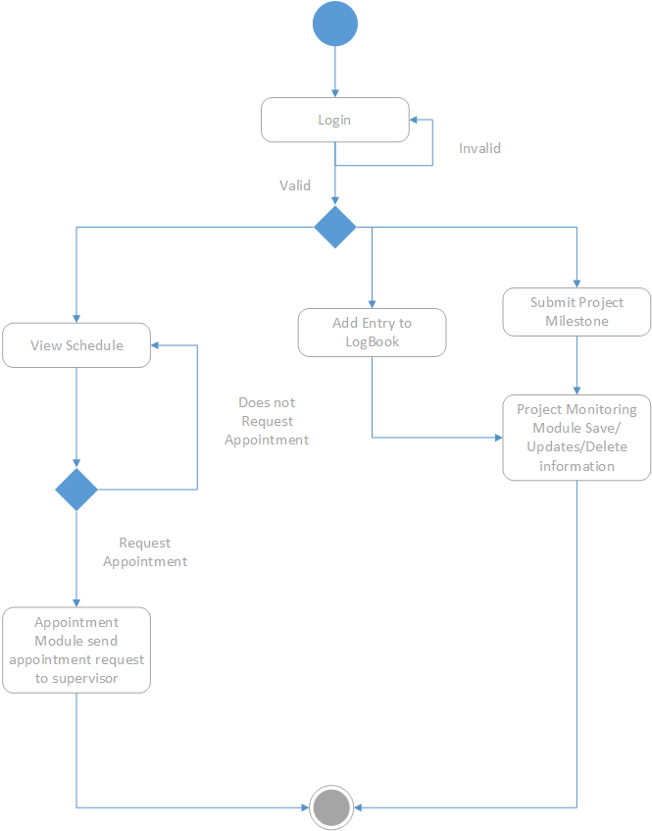

Figure 12: Activity Diagram for Student

Figure 12 is an activity diagram for the students. First, students need to enter username and password in order to login into the system. The system will perform authentication process. If the students enters invalid username and password, the student will remain in login page until the student enter a valid username and password. Once logged it, depending on what the students chooses, the system will peform these main 3 functions which is view schedule, Add Entry to logbook and, submitting project file . The system will display the schedule and send an appointment request if student choose. The system will save the uploaded files or documents from students to the project monitoring module if entry to logbook and project submissions were used.

### 5.1.2 Activity Diagram for Supervisor

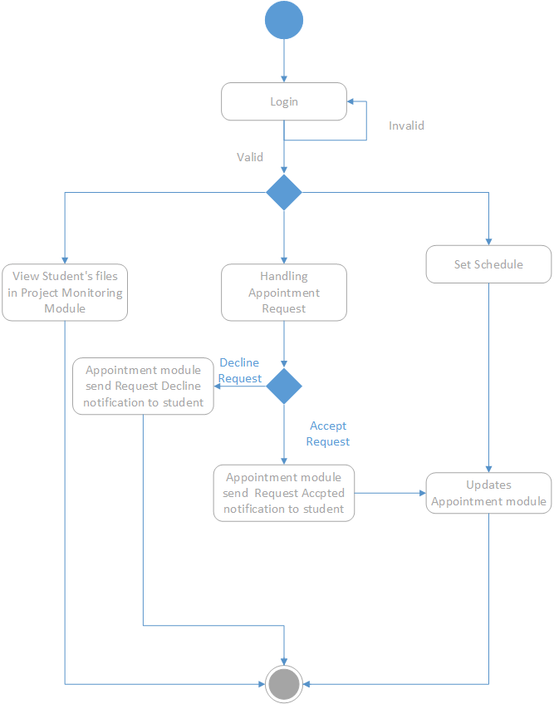

Figure 13: Activity Diagram for Supervisor

Figure 13 is an activity diagram for supervisors. Same process for the supervisor as students for the login phase. System will display the project files of the students that are assigned to supervisor . System will display the appointment requests when handling appointment request is selected and supervisor will be able to choose to accept or decline. Once a choice is a selected, the appropriate notification will be sent by the system to the student that sent the request. The system will also save the schedule that was set by the supervisor to the appointment module if supervisor did select the add schedule.

### 5.1.3 Activity Diagram for Coordiantor

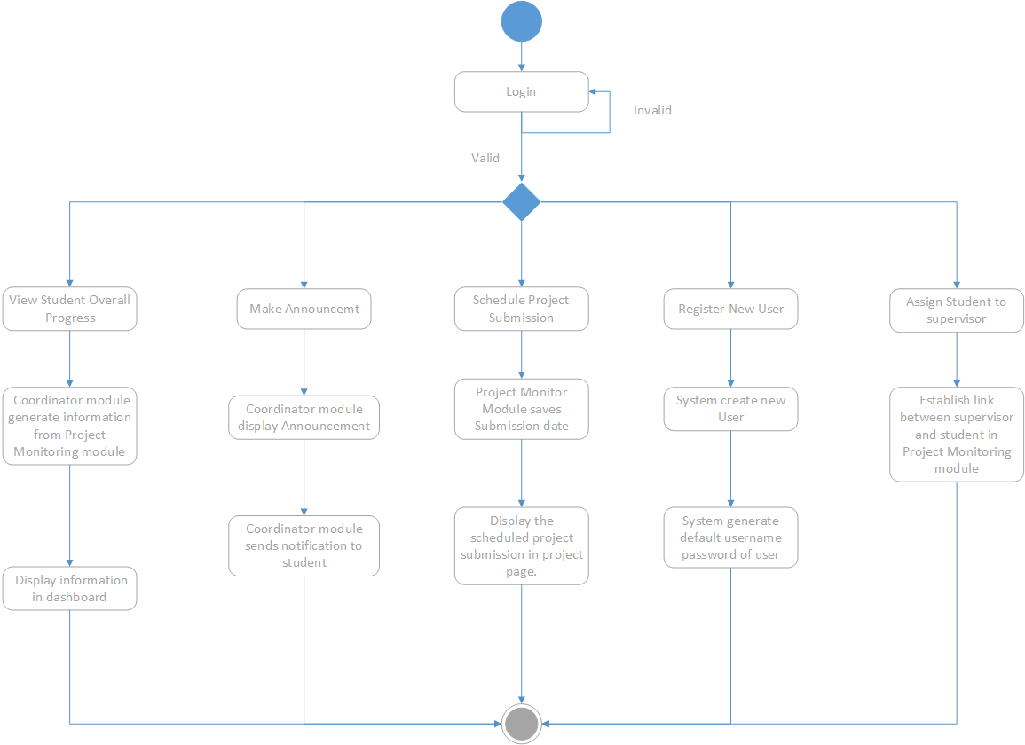

Figure 14: Activity Diagram for coordinator

The above is activity diagram for the coordinator. Once logged it, coordinator can peform 5 task. If view student overall progress is chosen, coordinator module will compile the information from projet monitoring module and display it in a dashboard to the coordinator. If make announcement is choosen, coordinator module will display the announcement that coordinator posted and send a notification to all students. Project Monitor module will save scheduled submission date and display it on the project page if Schedule project submission is chosen.

## 5.2 Technical Deisgn

### 5.2.1 Class Diagram

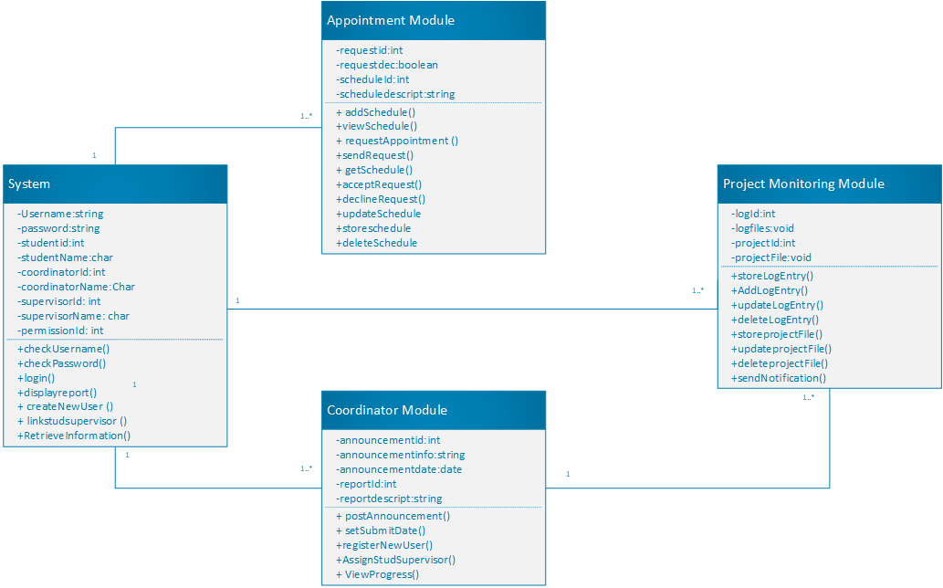

Figure 15: Class Diagram

Figure 15 is a class diagram which depicts the relationship between subsystem within the overall system. It includes its corresponding attributes and its operations. The system class primarily contains the necessary attributes for differentiating the users and contains all the operations relating user handling like login and creating new user. The appointment class contains all the operations related to requesting appointments to setting up the schedule and attributes to identify which schedule belongs to which supervisor. Coordinator class contains operations only available to the coordinator which scheduling submissions and assigning students to supervisor. Project monitoring class will have attributes for the project files and log entries that students upload and the operation for handling those files.

### 5.2.2 Sequence Diagram

#### 5.2.2.1 Sequence Diagram for Student

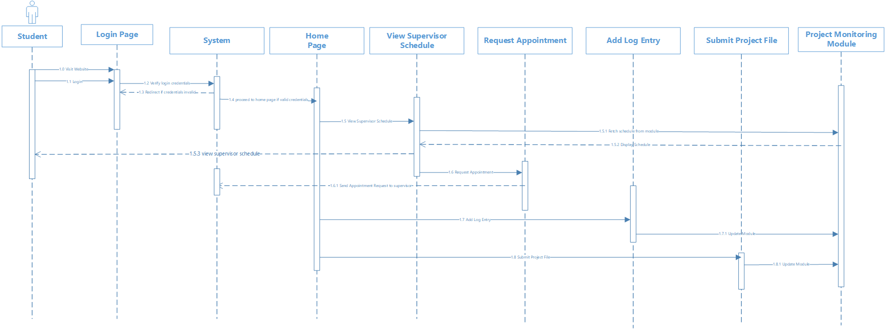

Figure 16: Sequence diagram for student.

#### 5.2.2.2 Sequence Diagram for supervisor

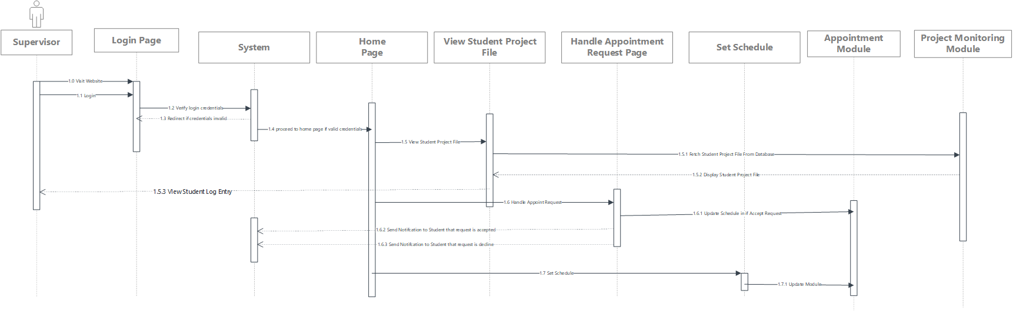

Figure 17: Sequence diagram for supervisor.

#### 5.2.2.3 Sequence Diagram for coordinator

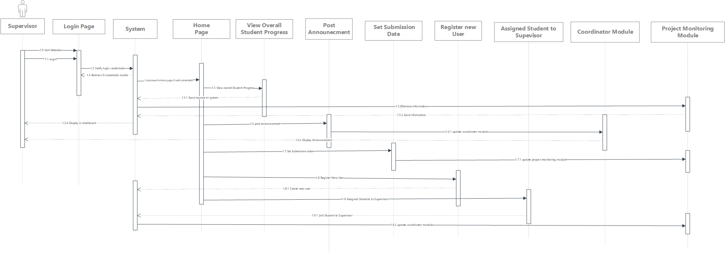

Figure 17: Sequence diagram for coordinator.

### 5.2.3 State Transition Diagrams

#### 5.2.3.1 State Transition Diagrams for student

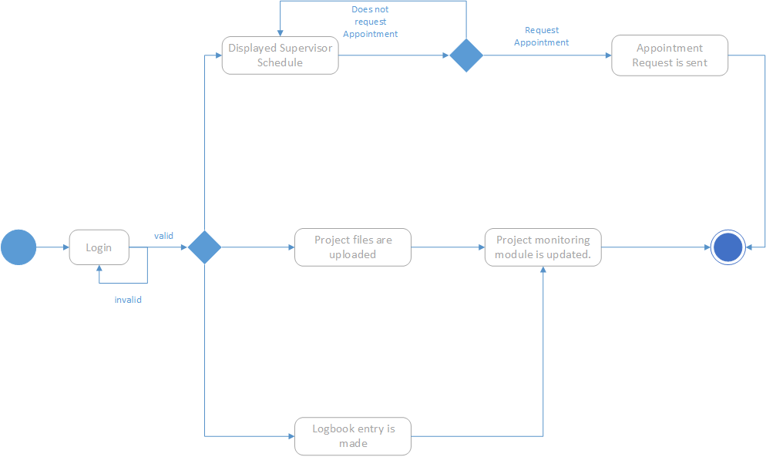

Figure 18: State Transition Diagram for student

Student is logged it, if student request to view, schedule is displayed, if appointment is requested, notification is sent. If project files are uploaded by students, project monitoring module is updated. If logbook entry is made by students, project monitoring module is also updated.

#### 5.2.3.2 State Transition Diagrams for supervisor

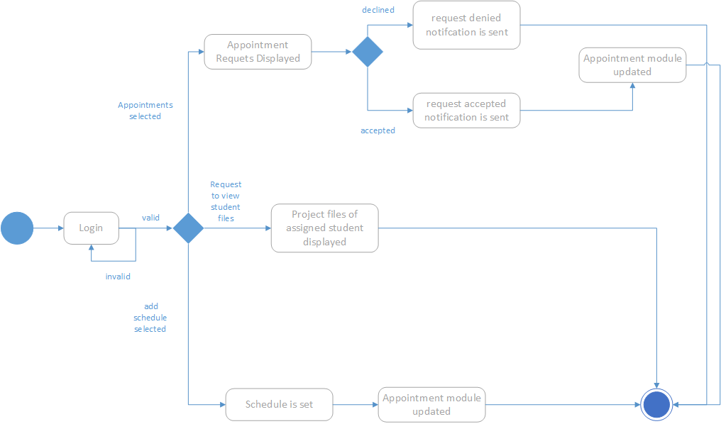

Figure 19: State transition diagram for supervisor

Supervisor needs to logined. If appointments was clicked, appointment request will be displayed. If request were accepted, accept nofication will be sent and appointment module is updated. If declined, decline notification will be sent. Project files of assigned student will be displayed if viewing of student files is chosen.Finally, if add schedule is selected and schedule is set by supervisor, appointment module will be updated.

#### 5.2.3.3 State Transition Diagrams for coordinator

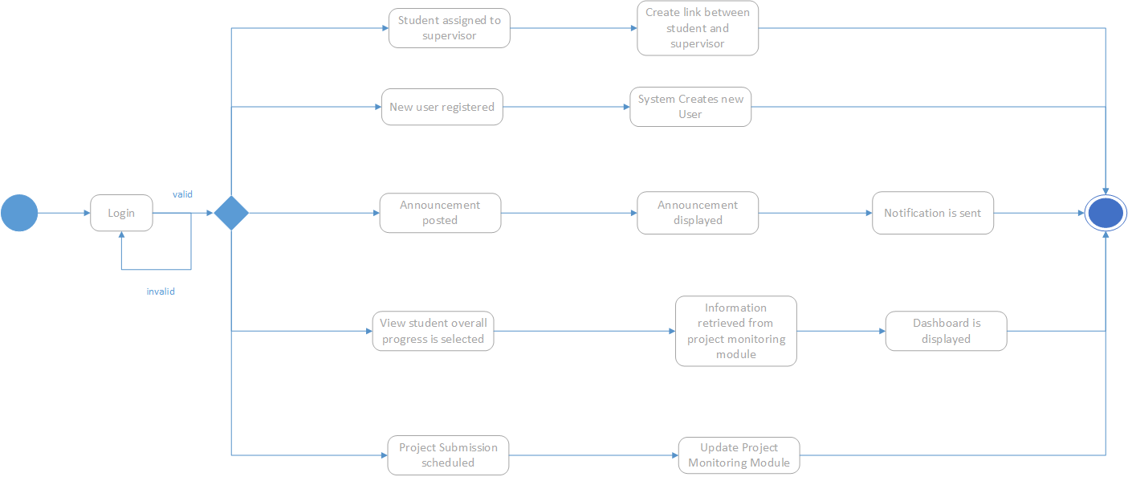

Figure 20: State Transition Diagram for coordinator

Coordinator is logined. If assigning student to supervisor form is completed. Student is assigned to their supervisor and a link is created between student and supervisor. If new user form is completed, new user will be registered and system created a new user. If announcement was posted by coordinator, announcement will be displayed and notification is sent to all students. If view student overall progress button is clicked, information is retrieve from project monitor module and is displayed in a dashboard. If the for scheduling a submission is completed, project monitoring module is updated.

## 5.3 Design Principle

### 5.3.1 Visibility

Visibility is one of the key principles that we must adhere while designing a website. The important functions of the website must be clear and well defined for user to know what that particular button will execute. In our website, one of main functions are project monitoring and appointment request. Figure below shows that project submissions page of the website and appointments list. The buttons are visible enough and the labelling is clear for users to know what that particular button will execute. In addition, there is a navigation bar created on every page, which also allows user to perform the main functions of the website.

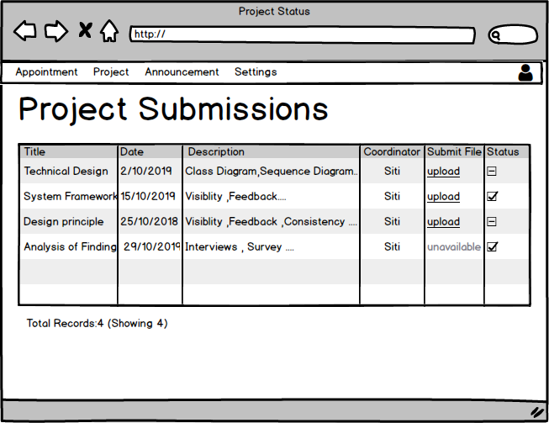

Figure 5.1: Project Submission Page.

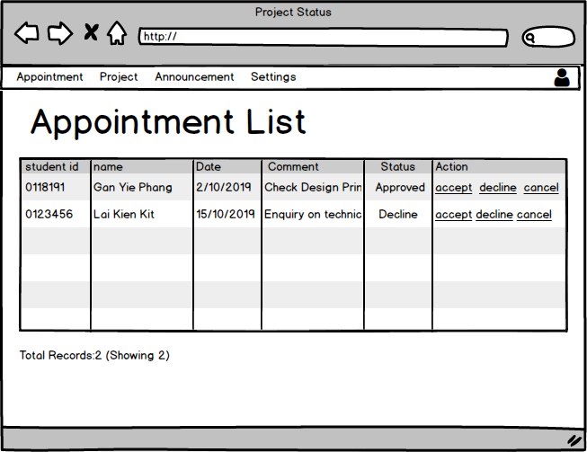

*Figure 5.2:Appointment List page*

### 5.3.2 Feedback

Feedback refers to whether the website is prompting a message to the user to know if that function is been executed. Feedback is another vital principle that we must apply, as users are not aware on what the website is running on the backend. In the website, there are several prompt messages if the user has selected the correct timeslot based on the schedule or incorrect timeslot. Figure below are screenshots of the message displayed to user.

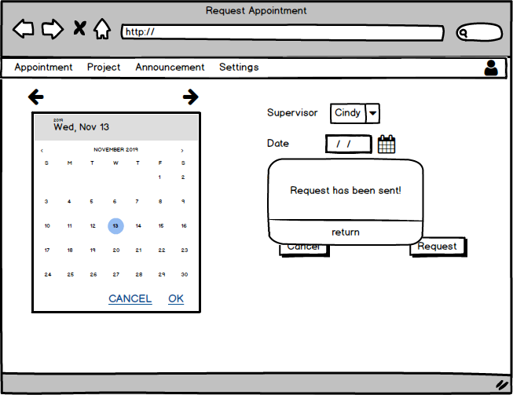

*Figure 5.3: Success message displayed on screen*

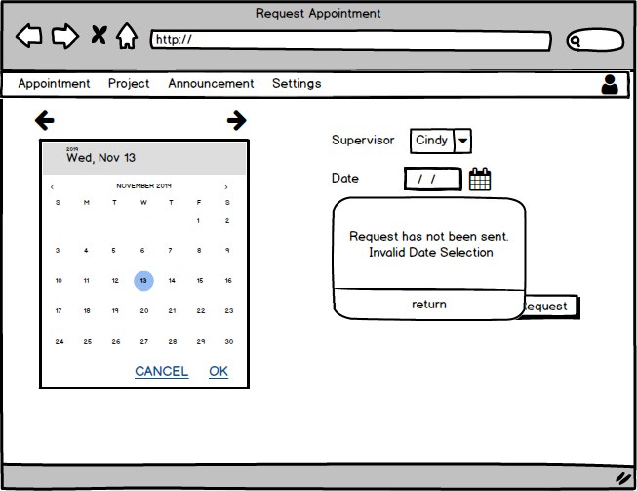

*Figure 5.4: Error message displayed on screen*

### 5.3.3 Constraint

Constraint is defined as practice of limiting user actions on a system. Sometimes. Limits has to be placed to prevent users from performing an action that may harm the system or harm their user experience. In figure below, we greyed out one of link buttons and made it unclickable as it is currently set to unavailable by the coordinator. For the new students registration page, yo can see the add button is greyed out as well since coordinator has not filled anything yet.



*Figure 5.5:Submit file link is greyed and unvailable.*

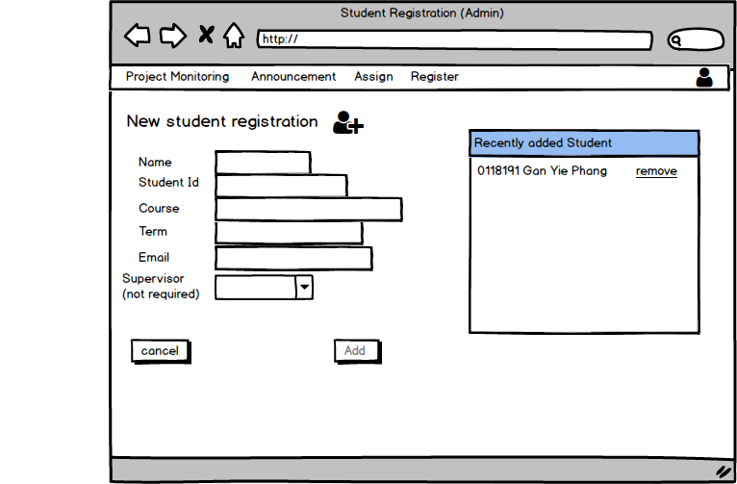

*Figure 5.6: New student registration page*

### 5.3.4 Affordance

Affordance refers to how fast a user can learn the functionalities of the website. In other words, affordance is also means giving a clue. In our website, all the buttons labelled in such manner that the user would know what the button functionality is.



*Figure 5.7: View Appointment list page with accept decline and cancel buttons*



*Figure 5.8: Navigation bar links*

### 5.3.5 Consistency

Consistency refers to having similar operations and similar elements for achieving similar tasks. If you see the diagram above, navigation panels is in the same place on every page , size, and color proving that the website also adheres the consistency principle. Based on figure 5.1 and 5.2, appointment list page and project submission page uses the similar data tables to convey information to the user and have similar functionalities.

# **References**

Moeller, B. & Reitzes, T. Integrating Technology with Student-Centered Learning. Report Nellie Mae Education Foundation,.www.nmefdn.org; 2011.

Ives, G., & Rowley, G. (2005). Supervision selection or allocation and continuity of supervision: PhD students’ progress and outcomes. Studies in Higher Education, 30(5), 535-555. http://dx.doi.org/10.1080/03075070500249161

Grant, B. & Graham, A. (1999). Naming the game: Reconstructing graduate supervision. Teaching in Higher Education, 4(1), 77-89. <http://dx.doi.org/10.1080/1356251990040105>

Wadesango, N. and S. Machingambi. 2011. Post graduate students’  experiences with research supervision. Journal of Social Anthropology 2(1): 31‒37.

Hazura Mohamed & Hairulliza Mohamad Judi.Weights Determinant for a Set of Contributing Factors in Completing Undergraduate Final Year Project. Proceedings of the 2nd International Conference on Mathematical Sciences (ICMS2). 30 Nov -3 Dec 2010, Kuala Lumpur;2010.

Kamaruzaman, J. 2008. A Forest Science Effective Research Supervision in the Faculty of Forestry, Universiti Putra Malaysia. International Education Studies, 1(2): 58-64.

Ezebilo, E.E. (2012). Challenges in Postgraduate Studies: Assessments by Doctoral Students in a Swedish University.

Villamane, M., Ferrero, B., Alvarez, A., Larranaga, M., Arruarte, A., & Elorriaga, J. A. (2014). *Dealing with common problems in engineering degrees’ Final Year Projects. 2014 IEEE Frontiers in Education Conference (FIE) Proceedings.* doi:10.1109/fie.2014.7044431

Lin, Y. and Jou, M. (2012). A Web Application Supported Learning Environment for Enhancing Classroom Teaching and Learning Experiences. *Procedia - Social and Behavioral Sciences*, 64, pp.1-11.

Pretlow, C., & Jayroe, T. (2010). Training in the clouds. Computers in Libraries, 30(4), 18-23. Schneckenberg, D., Ehlers, U., & Adelsberger, H.;1; (2011). Web 2.0 and competence-oriented design of learning—Potentials and implications for higher education. British Journal of Educational Technology, 42(5), 747-762.

Banga, S. (2019). *Web Application Architecture: Definition, Models, Types, and More*. [online] Hackr.io. Available at: https://hackr.io/blog/web-application-architecture-definition-models-types-and-more [Accessed 14 Nov. 2019].

Offutt, J. (2002). Quality attributes of Web software applications. *IEEE Software*, 19(2), pp.25-32.

Kundu, Joydeep & Bishoi, Tanmoy & Bhattacharya, Manasija & Chowdhury, Anupam. (2015). PROJECT MANAGEMENT SOFTWARE-AN OVERVIEW. International Journal of Current Innovation Research. 1. 129-135.

Djangoproject.com. (2019). *The Web framework for perfectionists with deadlines | Django*. [online] Available at: https://djangoproject.com [Accessed 14 Nov. 2019].

Restfulapi.net. (2019). *What is REST – Learn to create timeless REST APIs*. [online] Available at: https://restfulapi.net/ [Accessed 14 Nov. 2019].

Morris, S. (2019). *React JS—What is It? What is Used For? Why Should You Learn It? - Skillcrush*. [online] Skillcrush. Available at: https://skillcrush.com/2019/05/14/what-is-react-js/ [Accessed 14 Nov. 2019].

Klein, B. (2019). *Python Advanced: Python and the Shell*. [online] Python-course.eu. Available at: https://www.python-course.eu/os_module_shell.php [Accessed 14 Nov. 2019].

Python.org. (2019). *Welcome to Python.org*. [online] Available at: https://www.python.org/ [Accessed 14 Nov. 2019].

Reactjs.org. (2019). *React – A JavaScript library for building user interfaces*. [online] Available at: https://reactjs.org/ [Accessed 14 Nov. 2019].

Docs.scipy.org. (2019). *What is NumPy? — NumPy v1.17 Manual*. [online] Available at: https://docs.scipy.org/doc/numpy/user/whatisnumpy.html [Accessed 14 Nov. 2019].

Nosrati, M., 2011. Python: An appropriate language for real world programming. World Applied Programming, 1, pp.110-117.

Nader, Y. (2019). *Python vs Java in 2019 - Comparison, Features & Applications - Hackr.io*. [online] Hackr.io. Available at: https://hackr.io/blog/python-vs-java-2019 [Accessed 14 Nov. 2019].

Bogdanchikov, A., Zhaparov, M. and Suliyev, R., 2013. Python to learn programming. In Journal of Physics: Conference Series (Vol. 423, No. 1, p. 012027). IOP Publishing.

Bakar, M., Jailani, N., Shukur, Z. and Yatim, N. (2011). Final Year Supervision Management System as a Tool for Monitoring Computer Science Projects. *Procedia - Social and Behavioral Sciences*, 18, pp.273-281.

## Appendix

Gantt Chart

