Application Note xxx2
  - Icom IC7610 SoapySDR SPI
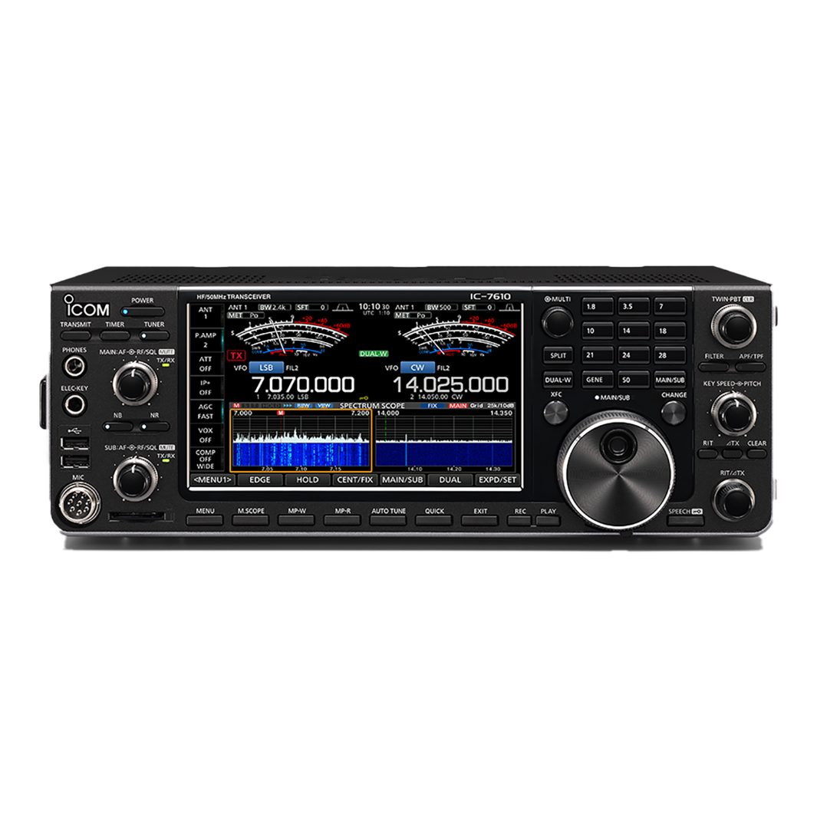
Dennis HardiNG | MicroHAMS | January 20, 2026

Abstract
This document covers the SoapySDR API developed for the Icom IC7610 radio I/Q output.

Getting the Software
The software is available as part of the IcomIC7610IQ project located at <github link>.

Other Useful Documents
SoapySDR is an open-source, vendor-neutral API and runtime library that acts as a universal wrapper for SDR Hardware Drivers. For additional information on SoapySDR see the SoapySDR Wiki.

Prerequisites
I/Q signals and IC-7610 control commands are exchanged through the [USB 2] port on the IC-7610. Though the driver provided by ICOM, is compatible with FTDI D3xx driver, you must install the Icom Driver. If you install the driver from FTDI, the driver will fail to find the device. You need to install the driver (USB I/Q Package for HDSDR) that can be downloaded from Icom web site <add link>.

Introduction

Development Environment
The recommended development environment is MSYS2 UCRT64 or MSYS2 MINGW.
For instructions on installing the development environment see the Getting_Started.md document

Supported SoapySDR API Methods
API Wiki page

Public Member Functions
virtual | ~Device (void)
 | virtual destructor for inheritance More...
virtual std::string | getDriverKey (void) const
virtual std::string | getHardwareKey (void) const
virtual Kwargs | getHardwareInfo (void) const
virtual void | setFrontendMapping (const int direction, const std::string &mapping)
virtual std::string | getFrontendMapping (const int direction) const
virtual size_t | getNumChannels (const int direction) const
virtual Kwargs | getChannelInfo (const int direction, const size_t channel) const
virtual bool | getFullDuplex (const int direction, const size_t channel) const
virtual std::vector< std::string > | getStreamFormats (const int direction, const size_t channel) const
virtual std::string | getNativeStreamFormat (const int direction, const size_t channel, double &fullScale) const
virtual ArgInfoList | getStreamArgsInfo (const int direction, const size_t channel) const
virtual Stream * | setupStream (const int direction, const std::string &format, const std::vector< size_t > &channels=std::vector< size_t >(), const Kwargs &args=Kwargs())
virtual void | closeStream (Stream *stream)
virtual size_t | getStreamMTU (Stream *stream) const
virtual int | activateStream (Stream *stream, const int flags=0, const long long timeNs=0, const size_t numElems=0)
virtual int | deactivateStream (Stream *stream, const int flags=0, const long long timeNs=0)
virtual int | readStream (Stream *stream, void *const *buffs, const size_t numElems, int &flags, long long &timeNs, const long timeoutUs=100000)
virtual int | writeStream (Stream *stream, const void *const *buffs, const size_t numElems, int &flags, const long long timeNs=0, const long timeoutUs=100000)
virtual int | readStreamStatus (Stream *stream, size_t &chanMask, int &flags, long long &timeNs, const long timeoutUs=100000)
virtual size_t | getNumDirectAccessBuffers (Stream *stream)
virtual int | getDirectAccessBufferAddrs (Stream *stream, const size_t handle, void **buffs)
virtual int | acquireReadBuffer (Stream *stream, size_t &handle, const void **buffs, int &flags, long long &timeNs, const long timeoutUs=100000)
virtual void | releaseReadBuffer (Stream *stream, const size_t handle)
virtual int | acquireWriteBuffer (Stream *stream, size_t &handle, void **buffs, const long timeoutUs=100000)
virtual void | releaseWriteBuffer (Stream *stream, const size_t handle, const size_t numElems, int &flags, const long long timeNs=0)
virtual std::vector< std::string > | listAntennas (const int direction, const size_t channel) const
virtual void | setAntenna (const int direction, const size_t channel, const std::string &name)
virtual std::string | getAntenna (const int direction, const size_t channel) const
virtual bool | hasDCOffsetMode (const int direction, const size_t channel) const
virtual void | setDCOffsetMode (const int direction, const size_t channel, const bool automatic)
virtual bool | getDCOffsetMode (const int direction, const size_t channel) const
virtual bool | hasDCOffset (const int direction, const size_t channel) const
virtual void | setDCOffset (const int direction, const size_t channel, const std::complex< double > &offset)
virtual std::complex< double > | getDCOffset (const int direction, const size_t channel) const
virtual bool | hasIQBalance (const int direction, const size_t channel) const
virtual void | setIQBalance (const int direction, const size_t channel, const std::complex< double > &balance)
virtual std::complex< double > | getIQBalance (const int direction, const size_t channel) const
virtual bool | hasIQBalanceMode (const int direction, const size_t channel) const
virtual void | setIQBalanceMode (const int direction, const size_t channel, const bool automatic)
virtual bool | getIQBalanceMode (const int direction, const size_t channel) const
virtual bool | hasFrequencyCorrection (const int direction, const size_t channel) const
virtual void | setFrequencyCorrection (const int direction, const size_t channel, const double value)
virtual double | getFrequencyCorrection (const int direction, const size_t channel) const
virtual std::vector< std::string > | listGains (const int direction, const size_t channel) const
virtual bool | hasGainMode (const int direction, const size_t channel) const
virtual void | setGainMode (const int direction, const size_t channel, const bool automatic)
virtual bool | getGainMode (const int direction, const size_t channel) const
virtual void | setGain (const int direction, const size_t channel, const double value)
virtual void | setGain (const int direction, const size_t channel, const std::string &name, const double value)
virtual double | getGain (const int direction, const size_t channel) const
virtual double | getGain (const int direction, const size_t channel, const std::string &name) const
virtual Range | getGainRange (const int direction, const size_t channel) const
virtual Range | getGainRange (const int direction, const size_t channel, const std::string &name) const
virtual void | setFrequency (const int direction, const size_t channel, const double frequency, const Kwargs &args=Kwargs())
virtual void | setFrequency (const int direction, const size_t channel, const std::string &name, const double frequency, const Kwargs &args=Kwargs())
virtual double | getFrequency (const int direction, const size_t channel) const
virtual double | getFrequency (const int direction, const size_t channel, const std::string &name) const
virtual std::vector< std::string > | listFrequencies (const int direction, const size_t channel) const
virtual RangeList | getFrequencyRange (const int direction, const size_t channel) const
virtual RangeList | getFrequencyRange (const int direction, const size_t channel, const std::string &name) const
virtual ArgInfoList | getFrequencyArgsInfo (const int direction, const size_t channel) const
virtual void | setSampleRate (const int direction, const size_t channel, const double rate)
virtual double | getSampleRate (const int direction, const size_t channel) const
virtual std::vector< double > | listSampleRates (const int direction, const size_t channel) const
virtual RangeList | getSampleRateRange (const int direction, const size_t channel) const
virtual void | setBandwidth (const int direction, const size_t channel, const double bw)
virtual double | getBandwidth (const int direction, const size_t channel) const
virtual std::vector< double > | listBandwidths (const int direction, const size_t channel) const
virtual RangeList | getBandwidthRange (const int direction, const size_t channel) const
virtual void | setMasterClockRate (const double rate)
virtual double | getMasterClockRate (void) const
virtual RangeList | getMasterClockRates (void) const
virtual void | setReferenceClockRate (const double rate)
virtual double | getReferenceClockRate (void) const
virtual RangeList | getReferenceClockRates (void) const
virtual std::vector< std::string > | listClockSources (void) const
virtual void | setClockSource (const std::string &source)
virtual std::string | getClockSource (void) const
virtual std::vector< std::string > | listTimeSources (void) const
virtual void | setTimeSource (const std::string &source)
virtual std::string | getTimeSource (void) const
virtual bool | hasHardwareTime (const std::string &what="") const
virtual long long | getHardwareTime (const std::string &what="") const
virtual void | setHardwareTime (const long long timeNs, const std::string &what="")
virtual void | setCommandTime (const long long timeNs, const std::string &what="")
virtual std::vector< std::string > | listSensors (void) const
virtual ArgInfo | getSensorInfo (const std::string &key) const
virtual std::string | readSensor (const std::string &key) const
template<typename Type >
Type | readSensor (const std::string &key) const
virtual std::vector< std::string > | listSensors (const int direction, const size_t channel) const
virtual ArgInfo | getSensorInfo (const int direction, const size_t channel, const std::string &key) const
virtual std::string | readSensor (const int direction, const size_t channel, const std::string &key) const
template<typename Type >
Type | readSensor (const int direction, const size_t channel, const std::string &key) const
virtual std::vector< std::string > | listRegisterInterfaces (void) const
virtual void | writeRegister (const std::string &name, const unsigned addr, const unsigned value)
virtual unsigned | readRegister (const std::string &name, const unsigned addr) const
virtual void | writeRegister (const unsigned addr, const unsigned value)
virtual unsigned | readRegister (const unsigned addr) const
virtual void | writeRegisters (const std::string &name, const unsigned addr, const std::vector< unsigned > &value)
virtual std::vector< unsigned > | readRegisters (const std::string &name, const unsigned addr, const size_t length) const
virtual ArgInfoList | getSettingInfo (void) const
virtual void | writeSetting (const std::string &key, const std::string &value)
template<typename Type >
void | writeSetting (const std::string &key, const Type &value)
virtual std::string | readSetting (const std::string &key) const
template<typename Type >
Type | readSetting (const std::string &key)
virtual ArgInfoList | getSettingInfo (const int direction, const size_t channel) const
virtual void | writeSetting (const int direction, const size_t channel, const std::string &key, const std::string &value)
template<typename Type >
void | writeSetting (const int direction, const size_t channel, const std::string &key, const Type &value)
virtual std::string | readSetting (const int direction, const size_t channel, const std::string &key) const
template<typename Type >
Type | readSetting (const int direction, const size_t channel, const std::string &key)
virtual std::vector< std::string > | listGPIOBanks (void) const
virtual void | writeGPIO (const std::string &bank, const unsigned value)
virtual void | writeGPIO (const std::string &bank, const unsigned value, const unsigned mask)
virtual unsigned | readGPIO (const std::string &bank) const
virtual void | writeGPIODir (const std::string &bank, const unsigned dir)
virtual void | writeGPIODir (const std::string &bank, const unsigned dir, const unsigned mask)
virtual unsigned | readGPIODir (const std::string &bank) const
virtual void | writeI2C (const int addr, const std::string &data)
virtual std::string | readI2C (const int addr, const size_t numBytes)
virtual unsigned | transactSPI (const int addr, const unsigned data, const size_t numBits)
virtual std::vector< std::string > | listUARTs (void) const
virtual void | writeUART (const std::string &which, const std::string &data)
virtual std::string | readUART (const std::string &which, const long timeoutUs=100000) const
virtual void * | getNativeDeviceHandle (void) const

Static Public Member Functions
static KwargsList | enumerate (const Kwargs &args=Kwargs())
static KwargsList | enumerate (const std::string &args)
static Device * | make (const Kwargs &args=Kwargs())
static Device * | make (const std::string &args)
static void | unmake (Device *device)
static std::vector< Device * > | make (const KwargsList &argsList)
static std::vector< Device * > | make (const std::vector< std::string > &argsList)
static void | unmake (const std::vector< Device * > &devices)

