 |  | PREDICTED
 |  | 0 | 1 | 2 | 3 | 4
TRUE | 0 | 734 | 1 | 0 | 0 | 0 | 0.9986
 | 1 | 125 | 1073 | 0 | 62 | 0 | 0.8516
 | 2 | 0 | 0 | 900 | 0 | 0 | 1
 | 3 | 0 | 14 | 0 | 1336 | 0 | 0.9896
 | 4 | 21 | 7 | 2 | 0 | 1125 | 0.9740
 |  | 0.8341 | 0.9799 | 0.9978 | 0.9557 | 1 | 0

 |  | PREDICTED (%)
 |  | 0 | 1 | 2 | 3 | 4 | Precision (%)
TRUE (%) | 0 | 99.86 | 0.14 | 0.0 | 0.0 | 0.0 | 99.86
 | 1 | 9.92 | 85.16 | 0.0 | 4.92 | 0.0 | 85.16
 | 2 | 0.0 | 0.0 | 100.0 | 0.0 | 0.0 | 100.0
 | 3 | 0.0 | 1.04 | 0.0 | 98.96 | 0.0 | 98.96
 | 4 | 1.82 | 0.61 | 0.17 | 0.0 | 97.40 | 97.40
 | Recall (%) | 83.41 | 97.99 | 99.78 | 95.57 | 100.0

 | CLASS 0 | CLASS 1 | CLASS 2 | CLASS 3 | CLASS 4
RGB IMAGES |  |  |  |  | 
BINARY IMAGES |  |  |  |  | 

Test N° | Accuracy (%)
Test 1 | 92.5
Test 2 | 89.2
Test 3 | 84.3
Test 4 | 92.1
Test 5 | 78.8
Test 6 | 80.9
Test 7 | 90.8
Test 8 | 79.0
Test 9 | 95.7
Test 10 | 81.2
Max. | 95.7
Std. Dev. | 6.3
Mean | 86.5

Layer | Type | Input | Kernel | Stride | Output
Input | input | 1x48x48 | N/A | N/A | 1x48x48
C1 | conv. | 6x48x48 | 5x5 | 1 | 6x48x48
S2 | mp. | 6x44x44 | 2x2 | 2 | 6x22x22
C3 | conv. | 16x22x22 | 3x3 | 1 | 16x16x16
S4 | mp. | 16x16x16 | 2x2 | 2 | 16x8x8
F5 | fc. | 16x8x8 | 8x8 | 1 | 120x1
F6 | fc. | 16x8x8 | 8x8 | 1 | 120x1
Output | fc. | 10x1 | 120x1 | 1 | 10x1

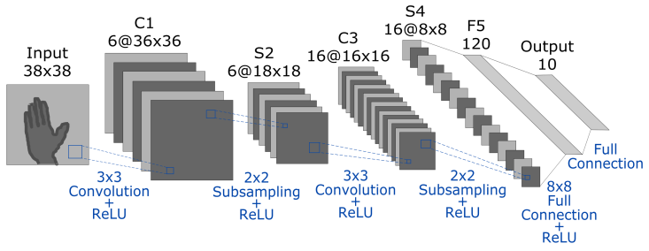

 | Images
Person 1 (Training) | 6 150
Person 2 (Training) | 5 730
Person 3 (Testing) | 5 400
Person 4 (Training) | 5 670
Person 5 (Training) | 6 615
Person 6 (Training) | 5 850
Person 7 (Training) | 5 985
TOTAL IMAGES | 41 400
IMAGES FOR TRAINING  (Person 1, 2, 4, 5, 6, 7) | 36 000
IMAGES FOR TESTING  (Person 3) | 5 400

Training:

- Images from Kinect were taken for training:
Number of persons: 6 (person 1, person 2, person 4, person 5, person 6, person 7)
Total of images for training: 4916 images

Number of images per person:
Person1: 878 images
Person2: 862 images
Person3: 727 images
Person4: 738 images
Person5: 827 images
Person6: 797 images
Person7: 814 images

- Training details:
batch size: 64
momentum: 0.9
base learning rate: 0.001
learning rate policy: drop the learning rate in "steps" by a factor of ‘gamma’ every ‘stepsize’ iterations
gamma: 0.1
stepsize: 1000
max iterations: 5000

Testing:

- Images from Kinect and different camera were taken for testing:
Information of Kinect for testing:
Number of persons: 1 (person 3)
Total of images for testing: 727 images

- Information of different camera for testing:
Number of persons: 2
Total of images for testing: 400 images

 | 1st fold | 2nd fold | 3rd fold | 4th fold | 5th fold
Person 01 | Test | Train | Train | Train | Train
Person 02 | Train | Test | Train | Train | Train
Person 03 | Train | Train | Test | Train | Train
Person 04 | Train | Train | Train | Test | Train
Person 05 | Train | Train | Train | Train | Test
Max. Accuracy | 70.00% | 93.20% | 96.70% | 96.10% | 91.40%
Average  Accuracy | 67.68% | 90.42% | 95.80% | 95.80% | 90.24%
Variance | 1.9670 | 3.6220 | 0.775 | 0.707 | 0.893

