|  |  |  |  |  |  |  |  |
| --- | --- | --- | --- | --- | --- | --- | --- |
|  | | PREDICTED | | | | |  |
| 0 | 1 | 2 | 3 | 4 |  |
| TRUE | 0 | 734 | 1 | 0 | 0 | 0 | 0.9986 |
| 1 | 125 | 1073 | 0 | 62 | 0 | 0.8516 |
| 2 | 0 | 0 | 900 | 0 | 0 | 1 |
| 3 | 0 | 14 | 0 | 1336 | 0 | 0.9896 |
| 4 | 21 | 7 | 2 | 0 | 1125 | 0.9740 |
|  |  | 0.8341 | 0.9799 | 0.9978 | 0.9557 | 1 | 0 |

|  |  |  |  |  |  |  |  |
| --- | --- | --- | --- | --- | --- | --- | --- |
|  | | PREDICTED (%) | | | | |  |
| 0 | 1 | 2 | 3 | 4 | Precision (%) |
| TRUE (%) | 0 | 99.86 | 0.14 | 0.0 | 0.0 | 0.0 | 99.86 |
| 1 | 9.92 | 85.16 | 0.0 | 4.92 | 0.0 | 85.16 |
| 2 | 0.0 | 0.0 | 100.0 | 0.0 | 0.0 | 100.0 |
| 3 | 0.0 | 1.04 | 0.0 | 98.96 | 0.0 | 98.96 |
| 4 | 1.82 | 0.61 | 0.17 | 0.0 | 97.40 | 97.40 |
|  | Recall (%) | 83.41 | 97.99 | 99.78 | 95.57 | 100.0 |  |

|  |  |  |  |  |  |
| --- | --- | --- | --- | --- | --- |
|  | CLASS 0 | CLASS 1 | CLASS 2 | CLASS 3 | CLASS 4 |
| RGB IMAGES | colour_class1 | colour_class3 | colour_class4 | colour_class5 | colour_class6 |
| BINARY IMAGES |  |  |  |  |  |

|  |  |
| --- | --- |
| Test N° | Accuracy (%) |
| Test 1 | 92.5 |
| Test 2 | 89.2 |
| Test 3 | 84.3 |
| Test 4 | 92.1 |
| Test 5 | 78.8 |
| Test 6 | 80.9 |
| Test 7 | 90.8 |
| Test 8 | 79.0 |
| Test 9 | 95.7 |
| Test 10 | 81.2 |
| Max. | 95.7 |
| Std. Dev. | 6.3 |
| Mean | 86.5 |

|  |  |  |  |  |  |
| --- | --- | --- | --- | --- | --- |
| Layer | Type | Input | Kernel | Stride | Output |
| Input | input | 1x48x48 | N/A | N/A | 1x48x48 |
| C1 | conv. | 6x48x48 | 5x5 | 1 | 6x48x48 |
| S2 | mp. | 6x44x44 | 2x2 | 2 | 6x22x22 |
| C3 | conv. | 16x22x22 | 3x3 | 1 | 16x16x16 |
| S4 | mp. | 16x16x16 | 2x2 | 2 | 16x8x8 |
| F5 | fc. | 16x8x8 | 8x8 | 1 | 120x1 |
| F6 | fc. | 16x8x8 | 8x8 | 1 | 120x1 |
| Output | fc. | 10x1 | 120x1 | 1 | 10x1 |

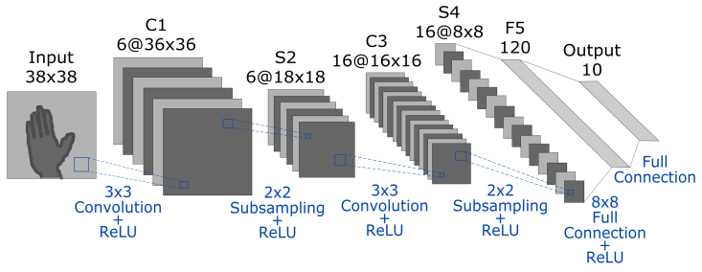

|  |  |
| --- | --- |
|  | Images |
| Person 1 (Training) | 6 150 |
| Person 2 (Training) | 5 730 |
| Person 3 (Testing) | 5 400 |
| Person 4 (Training) | 5 670 |
| Person 5 (Training) | 6 615 |
| Person 6 (Training) | 5 850 |
| Person 7 (Training) | 5 985 |
| TOTAL IMAGES | 41 400 |
| IMAGES FOR TRAINING  (Person 1, 2, 4, 5, 6, 7) | 36 000 |
| IMAGES FOR TESTING  (Person 3) | 5 400 |

Training:

- Images from Kinect were taken for training:

Number of persons: 6 (person 1, person 2, person 4, person 5, person 6, person 7)

Total of images for training: 4916 images

Number of images per person:

Person1: 878 images

Person2: 862 images

Person3: 727 images

Person4: 738 images

Person5: 827 images

Person6: 797 images

Person7: 814 images

- Training details:

batch size: 64

momentum: 0.9

base learning rate: 0.001

learning rate policy: drop the learning rate in "steps" by a factor of ‘gamma’ every ‘stepsize’ iterations

gamma: 0.1

stepsize: 1000

max iterations: 5000

Testing:

- Images from Kinect and different camera were taken for testing:

Information of Kinect for testing:

Number of persons: 1 (person 3)

Total of images for testing: 727 images

- Information of different camera for testing:

Number of persons: 2

Total of images for testing: 400 images

|  |  |  |  |  |  |  |  |
| --- | --- | --- | --- | --- | --- | --- | --- |
|  | 1st fold | 2nd fold | 3rd fold | 4th fold | 5th fold |  |  |
| Person 01 | Test | Train | Train | Train | Train |  |  |
| Person 02 | Train | Test | Train | Train | Train |  |  |
| Person 03 | Train | Train | Test | Train | Train |  |  |
| Person 04 | Train | Train | Train | Test | Train |  |  |
| Person 05 | Train | Train | Train | Train | Test |  |  |
| Max. Accuracy | 70.00% | 93.20% | 96.70% | 96.10% | 91.40% |  |  |
| Average  Accuracy | 67.68% | 90.42% | 95.80% | 95.80% | 90.24% |  |  |
| Variance | 1.9670 | 3.6220 | 0.775 | 0.707 | 0.893 |  |  |