Task 5.2P
Home Page
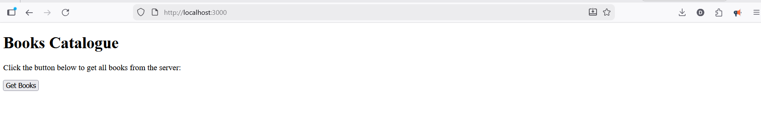
Showing all books after clicking “Get Books”

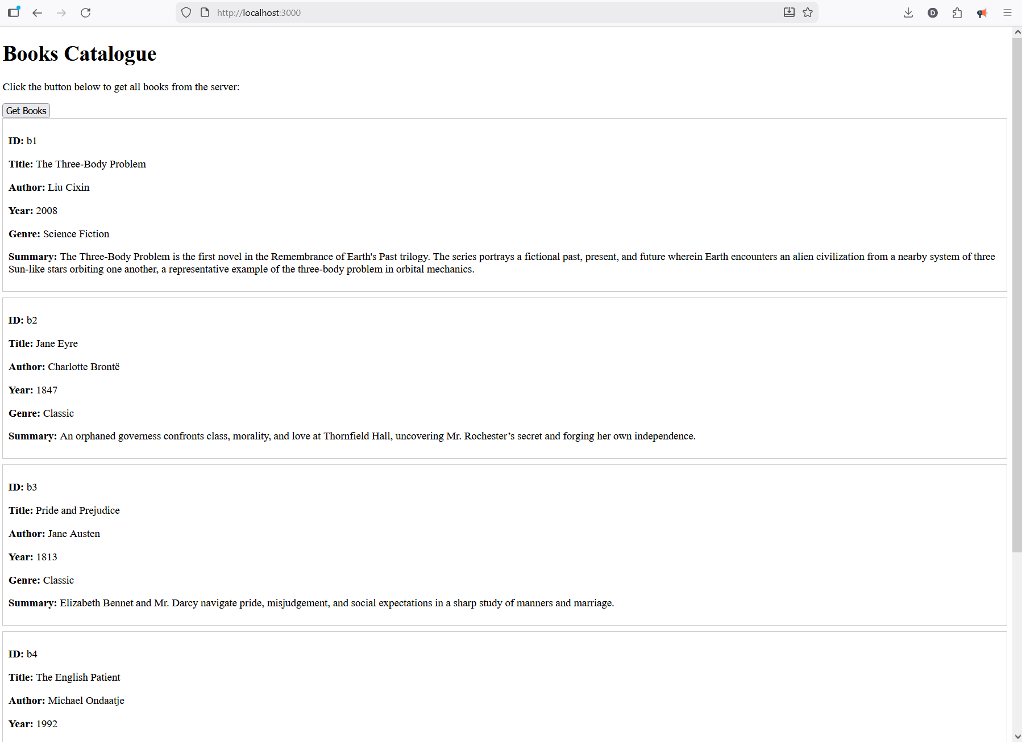
Route for specific book
