ER Diagram — Online Shopping Platform
Entity-Relationship model derived from the platform's data requirements document.

Diagram
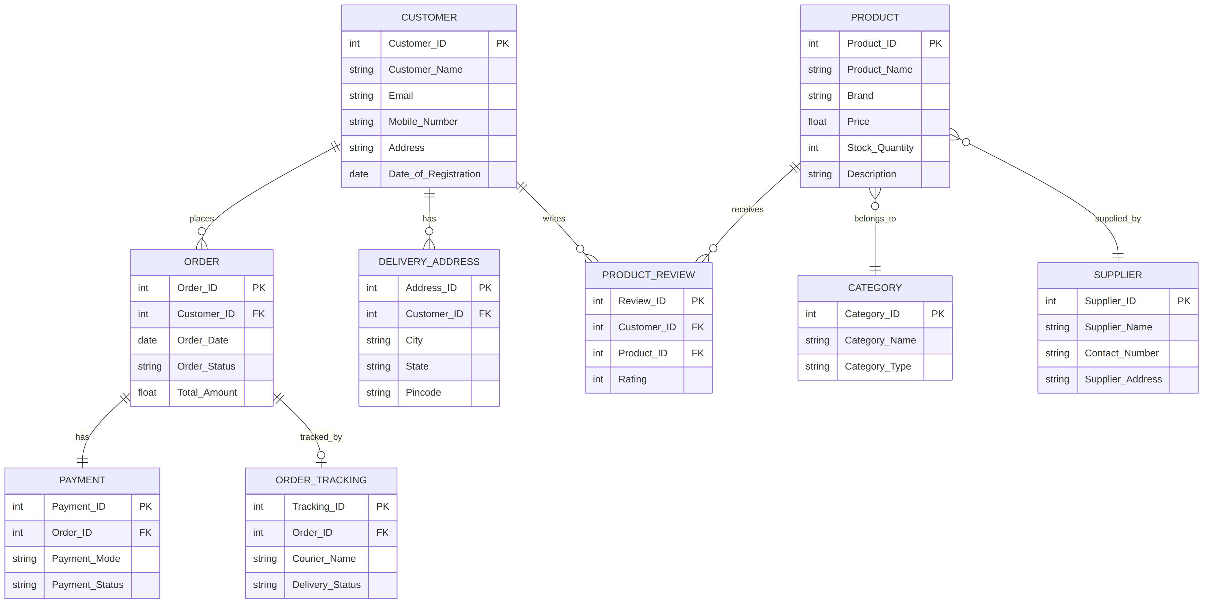

Core Entities and Primary Keys
Each box in the diagram represents an entity (a table). Every entity has a Primary Key (PK) — a unique identifier that no two records may share — and some carry Foreign Keys (FK), which reference another entity's PK and enforce the relationship between the two tables.
Entity | Primary Key | Description
CUSTOMER | Customer_ID | Stores registration details: name, email, mobile number, address, registration date.
PRODUCT | Product_ID | Stores catalog details: name, brand, price, stock quantity, description.
CATEGORY | Category_ID | Classifies products into sections and types.
SUPPLIER | Supplier_ID | Stores supplier contact and address details.
DELIVERY_ADDRESS | Address_ID | Stores multiple saved addresses per customer.
ORDER | Order_ID | Stores order date, status, and total amount.
PAYMENT | Payment_ID | Stores payment mode, status, and date for an order.
PRODUCT_REVIEW | Review_ID | Stores customer ratings and review messages for products.
ORDER_TRACKING | Tracking_ID | Stores courier, current location, and delivery status for an order.

Reading the Relationship Notation
The crow's-foot symbols at each end of a connecting line describe cardinality:
- A single bar ( | ) means “exactly one.”
- A circle ( o ) means “zero or optional.”
- A crow's foot ( < ) means “many.”

Relationships in the Diagram
- Customer places Order — one customer can place many orders (one-to-many). Every order belongs to exactly one customer.
- Customer has Delivery_Address — one customer can save many delivery addresses.
- Customer writes Product_Review — one customer can write many reviews.
- Product receives Product_Review — one product can receive many reviews. Product_Review sits between Customer and Product, which is why it carries two foreign keys.
- Order has Payment — modeled as one-to-one, since each order has exactly one payment record.
- Order tracked_by Order_Tracking — one order optionally has one tracking record (zero-or-one), since tracking may not exist until the order ships.
- Product belongs_to Category — many products fall under one category.
- Product supplied_by Supplier — many products can come from one supplier.

Gap to Note
The Order and Product entities are never directly connected in this model. A real e-commerce schema needs a junction entity — typically Order_Item (Order_ID, Product_ID, Quantity, Unit_Price) — to represent the many-to-many relationship between orders and products, since one order usually contains multiple products and one product appears across many orders. The source requirements document does not define this entity, so it has been left out of the diagram above, but it is the most important addition for a complete or production-ready schema.

