**Course Four**

# From Data to Insight: The Power of Statistics



# Instructions

Use this PACE strategy document to record decisions and reflections as a data professional as you work through this portfolio project. As a reminder, this document is a resource that you can reference in the future and a guide to help consider responses and reflections posed at various points throughout projects.

# Course Project Recap

Regardless of which track you have chosen to complete, your goals for this project are:

* Understand and assess the proposed scenario
* Demonstrate knowledge of how to prepare, create, and analyze an A/B test using statistics
* Apply descriptive and inferential statistics, probability distributions, confidence intervals, and hypothesis testing in Python
* Articulate findings in an executive summary for external stakeholders

# Relevant Interview Questions

Completing this portfolio project will empower you to be respond to the following interview topics:

* How would you explain an A/B test to stakeholders who may not be familiar with analytics?
* If you had access to company performance data, what statistical tests might be useful to help understand performance?
* What considerations would you think about when presenting results to make sure they have impact or achieve the desired results?
* What are some effective ways to communicate statistical concepts/methods to a non-technical audience?
* In your own words, explain the factors that go into an experimental design for designs such as A/B tests.

**Reference Guide**

This project has four tasks; the visual below identifies how the stages of pace are incorporated across those tasks.

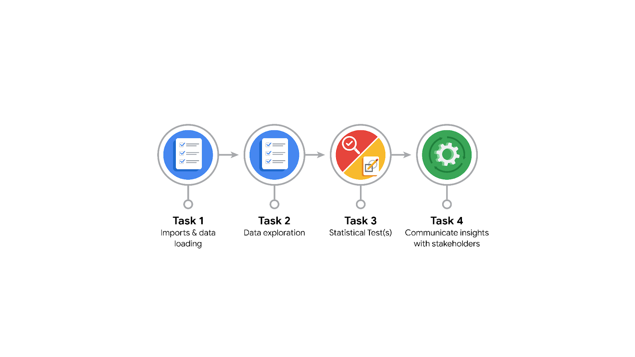

**Data Project Questions & Considerations**

**PACE: Planning Stage**

* What is the main purpose of this project?
* What is your research question for this project?
* What is the importance of random sampling?
* Give an example of sampling bias that might occur if you didn’t use random sampling.



**PACE: Analyzing & Constructing Stages**

* In general, why are descriptive statistics useful?
* How did computing descriptive statistics help you analyze your data?
* In hypothesis testing, what is the difference between the null hypothesis and the alternative hypothesis?
* How did you formulate your null hypothesis and alternative hypothesis?
* What conclusion can be drawn from the hypothesis test?

**PACE: Execute Stage**

* What key business/organizational insight(s) emerged from your A/B test?
* What recommendations do you propose based on your results?