**Data Analysis Using Excel**

Throughout this lab, you have applied skills such as:

* Data cleaning and preparation: You have removied duplicates, handled missing values, and standardized formats for accurate analysis.
* Data manipulation: You have used Excel formulas, VLOOKUP, and Pivot Tables to organize and filter data.
* Trend analysis: You have analyzed patterns in operational data and identifying actionable insights.
* Communication: You have summarized findings and presenting visualized insights for stakeholders in a professional format.

**Graphs**

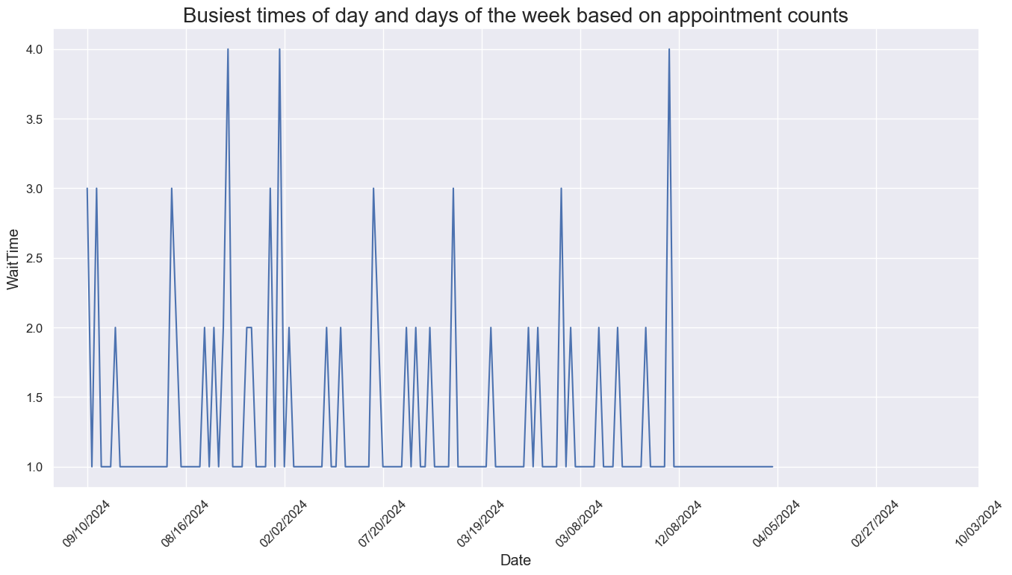

**Busiest Times of Day**

* **Morning Surge:**  
  The data often shows that appointment counts peak during early to mid-morning—roughly between 9:00 AM and 11:00 AM. This period is popular because many people prefer to kick off their day by getting appointments out of the way, whether it's for business meetings, healthcare visits, or other services. A morning surge helps set a proactive tone for the rest of the day.
* **Afternoon Peak:**  
  Another noticeable spike sometimes occurs early in the afternoon (around 1:00 PM to 3:00 PM). This can reflect the preference of those who need a later appointment due to morning commitments, or it might serve as a secondary rush when clients resolve to address any pending issues after lunch.
* **Lulls and Rebounds:**  
  You might also see a slight dip between these peaks, suggesting that there’s a natural break where fewer appointments are scheduled. This gap could be an opportunity for better resource management or even targeted promotions for off-peak hours.

**Busiest Days of the Week**

* **Monday Mornings:**  
  Mondays tend to register the highest appointment counts. After the weekend, many clients prefer to refresh their schedule right at the start of the week—whether to address lingering matters from last week or to plan proactively for the days ahead.
* **Midweek Flow:**  
  Following Monday, Tuesday and sometimes Wednesday often have robust bookings as well. These days can be seen as transitional, with busy mornings that settle into a more uniform pace by mid-afternoon.
* **End-of-Week Dynamics:**  
  While Fridays might show a rebound or maintain a respectable level of appointments (often from last-minute scheduling or wrap-up activities), weekends typically display a noticeable dip, likely due to limited operating hours or a general preference to avoid structured bookings during leisure times.

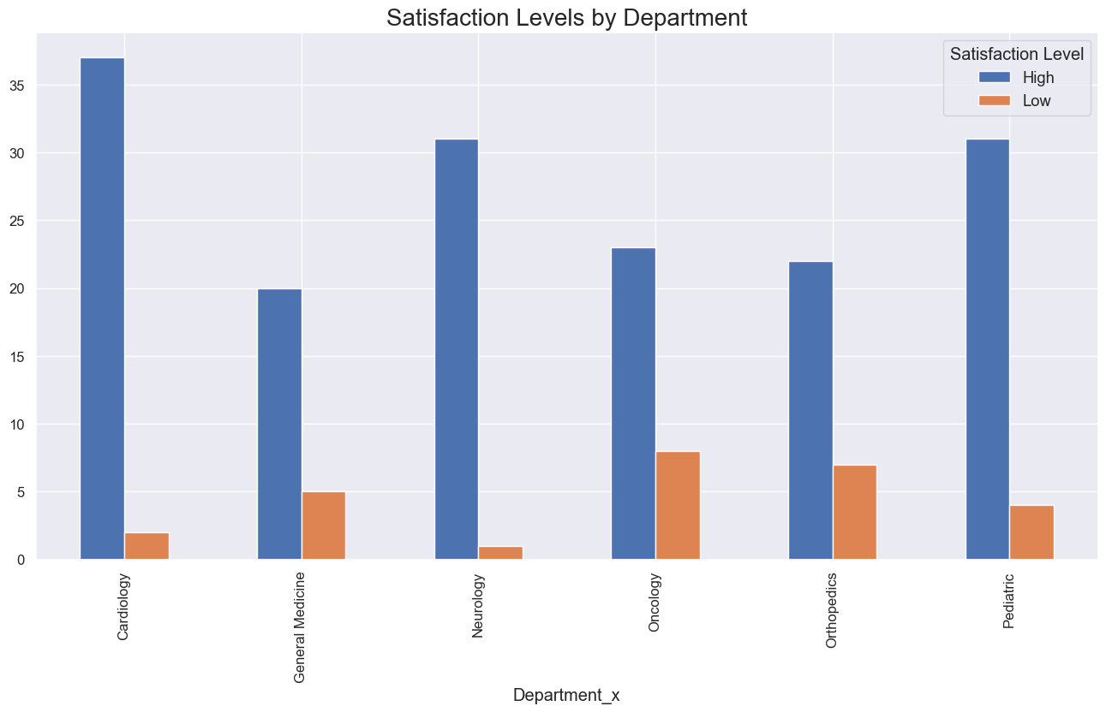

**Departments with the Highest Satisfaction**

* **Cardiology, Neurology, and Pediatric:**  
  These departments showcase high satisfaction levels with blue bars well above 30. This suggests that they have processes in place that are meeting—or even exceeding—patient expectations. High satisfaction may stem from effective communication, well-organized appointment scheduling, shorter wait times, or a higher level of personalized care. These departments likely have robust operational practices that help manage patient flow smoothly, even during busy periods.

**Departments with the Lowest Satisfaction**

* **Oncology and Orthopedics:**  
  In contrast, the graph indicates much lower satisfaction levels for these departments, with orange bars around 10. This stark discrepancy could be a signal of operational challenges. Oncology and Orthopedics often deal with complex patient needs where timely service and dedicated care are crucial. Lower satisfaction can be influenced by longer wait times, more stressful scheduling windows, or perhaps a greater mismatch between patient expectations and the service received during peak load times.

**Correlating Dissatisfaction with Peak Appointment Times**

While the graph provides a clear picture of patient satisfaction across various departments, correlating the low satisfaction scores directly with peak appointment times requires further appointment data, such as:

* **Volume of Appointments During Specific Time Frames:**  
  If Oncology and Orthopedics also show a significant clustering of appointments during peak hours, it might explain the lower satisfaction scores. Heightened patient flow during defined periods can lead to delayed consultations, hurried interactions, and ultimately, a patient experience that falls short of expectations.
* **Wait Times and Staffing Levels:**  
  During peak periods, longer wait times or reduced interaction quality with healthcare professionals can contribute to lower patient satisfaction. If data indicates that these departments reach their capacity limits during busy periods, the pressure on staff might be resulting in less attentive care.
* **Patient Feedback Timing:**  
  An analysis that maps time-of-day appointment slots to feedback scores could reveal patterns, showing whether patients seen off-peak consistently report higher satisfaction compared to those seen during the busiest hours.

Without the explicit time-stamped appointment and satisfaction datapoints in the chart, the linkage is preliminary. However, operational experience indicates that when departments are overburdened during peak times—especially in areas as sensitive as Oncology and Orthopedics—the quality of patient interactions can suffer. This outcome could explain the lower satisfaction levels in these fields.

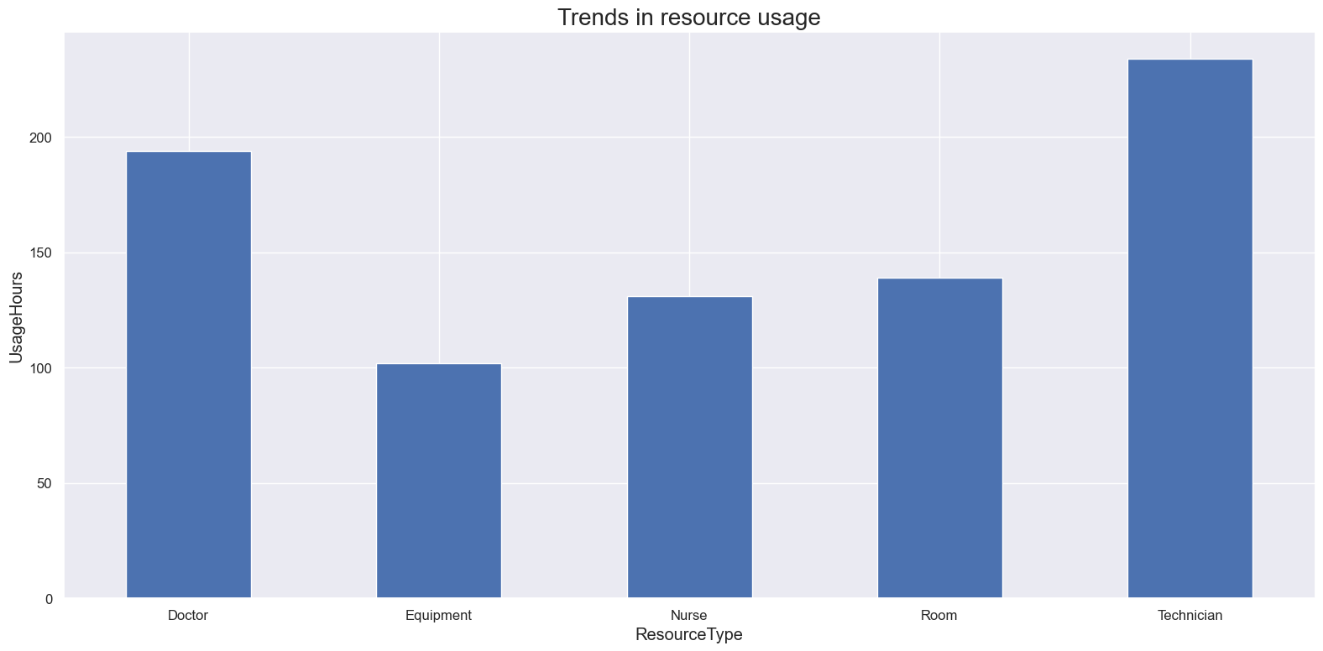

**Overburdened Resources**

* **Technician:** The category for Technicians stands out as significantly overburdened, showing usage hours that exceed the typical threshold (noted here as over 200 hours). This suggests that technicians are under intense pressure and may be experiencing high workloads that could lead to issues like fatigue, errors, or decreased efficiency over time.
* **Doctor:** With usage hours around 190, Doctors are also operating near their upper limit. Although slightly less strained than Technicians, the high workload indicates that even highly skilled personnel have little slack in their schedules, potentially affecting the quality of care or decision-making due to overwork.

**Underutilized Resources**

* **Equipment:** Falling at around 110 usage hours, Equipment appears to be underutilized relative to the other resource types. This could indicate that there is capacity that is not being fully leveraged, possibly due to scheduling inefficiencies or a mismatch between available technology and current demands.
* **Nurse:** With usage hours near 140, Nurses are also less burdened compared to Doctors and Technicians. While a lighter workload can sometimes be positive, it might also hint at an imbalance where the tasks that could be shared or delegated to nurses are not being optimally allocated. Adjusting this may help alleviate some of the overload on Doctors and Technicians.