**Risk Register**

|  |  |  |  |  |  |  |  |
| --- | --- | --- | --- | --- | --- | --- | --- |
| **Risk ID** | **Risk Description** | **Risk Category** | **Likelihood** | **Impact** | **Severity** | **Mitigation Strategy** | **Calculated Severity** |
| HF-R001 | Sensitive patient data could be compromised during process changes. | Technical | Medium | High | High | To be determined | High |
| HF-R002 | Staff may resist adopting new workflows due to insufficient training. | Operational | High | Medium | High | To be determined | High |
| HF-R003 | Inefficient appointment scheduling leading to a high rate of no-shows (17.78%) and cancellations (15.56%). | Operational | High | Medium | High | To be determined | High |
| HF-R004 | Long patient wait times (average 40.25 minutes) and negative feedback rate (25%) indicating potential dissatisfaction. | Operational | High | High | High | To be determined | High |
| HF-R005 | Staff may not receive adequate training on new workflows or technologies. | Operational | Medium | Medium | Medium | To be determined | Medium |
| HF-R006 | New or existing systems may experience unexpected downtime. | Technical | Low | High | Medium | To be determined | Medium |
| HF-R007 | Staff may not fully adopt the new workflows or technologies. | Stakeholder | Medium | Medium | Medium | To be determined | Medium |
| HF-R008 | Stakeholders may have differing or unclear expectations for the project. | Stakeholder | Low | Medium | Low | To be determined | Low |
| HF-R009 | Unavailability of resources (11.63%) may hinder timely patient care and service delivery. | Operational | Medium | Medium | Medium | To be determined | Medium |
| HF-R010 | Challenges in integrating new systems with existing infrastructure. | Technical | Low | Medium | Low | To be determined | Low |

**Risk Assessment Matrix**

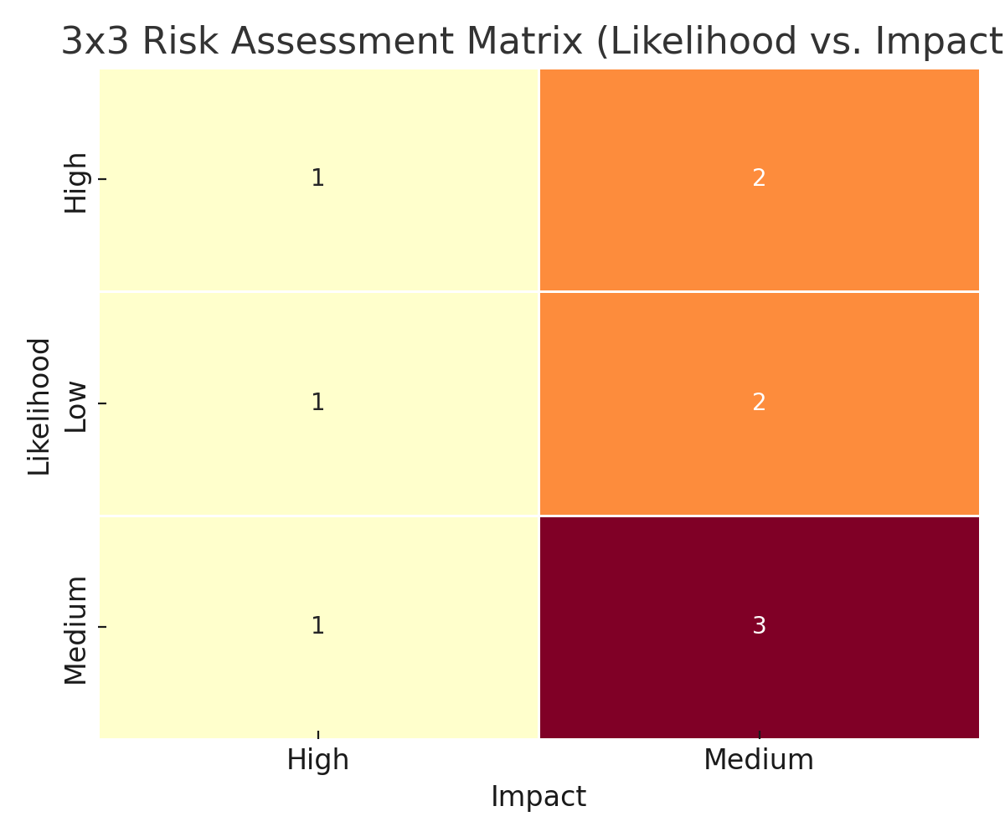

**SWOT Analysis for HealthFirst Care – Healthcare Project Risk Management**

**Strengths:**

* **Strong leadership and internal audit involvement in risk oversight.**
* **Existing infrastructure supports risk tracking and response planning.**
* **Reliable collection of performance metrics, such as patient wait times.**

**Weaknesses:**

* **Resistance from staff toward new workflows and technologies.**
* **Manual or fragmented workflows leading to inefficiencies.**
* **Limited training on new systems, impacting staff readiness.**
* **Unclear expectations among stakeholders delaying project alignment.**

**Opportunities:**

* **Staff training programs can improve adoption and reduce resistance.**
* **Process automation (e.g., HRIS, scheduling tools) to streamline operations.**
* **Improved stakeholder engagement through clearer communication strategies.**
* **Stronger data integration to reduce technical risks and silos.**

**Threats:**

* **Data privacy concerns due to the handling of sensitive patient information.**
* **Integration challenges between new and legacy systems.**
* **Potential delays in implementation due to limited resource availability.**
* **Continued resistance from stakeholders or staff if change management is inadequate.**