Add Supplier Details use case

Table 1 add supplier details use case scenario of a successful save
 | Steps performed | Information for steps
1 | Admin clicks on the add order button
2 | Admin enters the supplier details and clicks on the submit button
2.1 | The system checks if any column entry is missing and throws an error back to the admin if any is missing
2.2 | The error message is displayed on the interface and Admin rectifies
2.3 | Admin resends if, checks pass the system checks to see if the organization with such username exists
 | If exists error 302 is returned and admin rectifies
3 | If all checks pass 201 is returned
preconditions | Admin is logged in
Postconditions | Supplier details are successfully added

Supplier details data flow

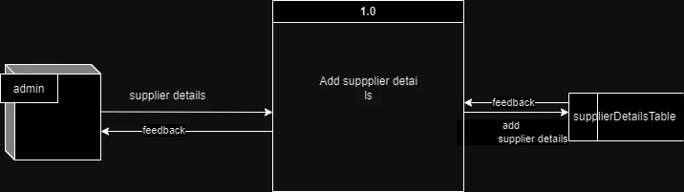

Supplier Details Data structure
- Data flow description : Takes supplier details from the user interface and sends them for processing
- source : Admin
- Destination : process 1.0
- Type of data flow : Form details
- Data structure traveling with the flow : supplier details
- Volume/Time : 10/hour

Supplier Details data Elements
- SupplierID: Will be generated from the database
- SupplierName: Name of the supplier .
  - Length: varchar30
  - Unique

Wireframe
