Use Case: Manage Product Details
Product in this scenario represents all the items that the shop sells.

Use case description

- Actors: Admin
- Description: The Admin adds, updates, or deletes product details
- Precondition: Admin must be logged in and have capabilities to manage product data.
- postcondition: product details are updated in the system accordingly.
- Success Guarantee: Admin is able to CRUD product details successfully
- Main flow:
- Admin navigates to the product details section
- Admin views a list of products
- Admin can add products, update/delete existing products

Use case scenario on Adding a new product

Steps performed:

- Admin navigates to the product details section
- Admin clicks on the button to add product details
- A modal presents a form to add product details
- Admin fills in the form with the correct details
- Admin clicks on submit
- If errors? the error is returned together with an error message
- If no errors, success icon should be showed and the modal with the form closed.

Use case scenario on Editing a product detail

- Admin navigates to the product details section
- Each product has got a Edit button
- Admin clicks on the edit button
- Admin is directed to a page / a modal shows up with a form and all details of that product.
- Admin updates what is necessary
- Admin submits the forms.
- If the name is not unique or any other error exists, error is shown
- Admin rectifies the error and resubmits the form
- If no error, success icon should be shown.
- That product name should be updated everywhere.

Use case scenario on Deleting a product

- Admin navigates to the product details section
- Each product has got a Delete button
- Admin clicks on the delete button
- The product is deleted and removed from view

Data flows

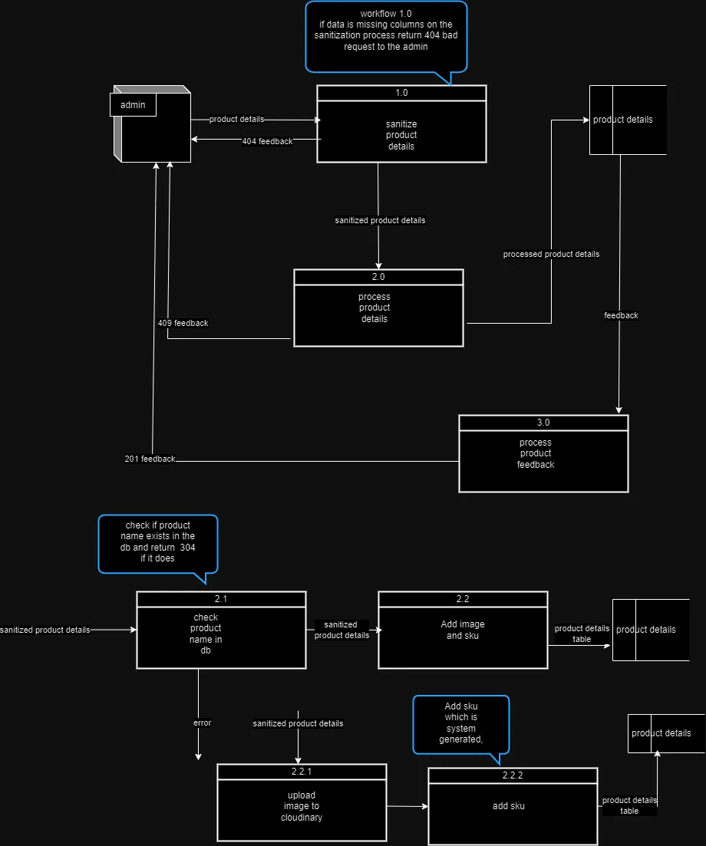

Product details data flow
- Name: Product details
- Description: Contains the details of the product from the Admin and is used to create a new record of the product in the system.
- Source: Admin
- Destination: Sanitize produce details process
- Comments:

Data structure
Element name | Description | Length | Base  /Derived | Default value | Validation criteria
 |  |  |  |  | Upper limit | Lower limit | comments
Product name | This is the name of the product | 6 | Base | Not null | Char =40 | Char >2
productCategory | Each product will belong to a certain category | derived | Derived | Not null | Derived | derived
Product description | Detailed description of the product (e.g., grade, type). | Varchar (255) | Base | Null | Char = 255 | Char >= 10
productImageURL | url to an image of the product | Varchar(50) | Derived | null | Char<= 50 | Char >=10

processed data flow
- ProductName
- Sku
- ProductCategory
- Product Description
- ProductImaeURL

feedback data flow

 | Description | Length | Base  /Derived | Default value | Validation criteria
 |  |  |  |  | Upper limit | Lower limit | comments
ProductID | The unique id for each record | Char > 10 | Derived | Cannot be null | Unknown | unknown | Will be derived from db
Product name | This is the name of the product | 6 | Base | Cannot be null | Char =40 | Char >2
Sku | A unique identifier or code for the product (used for tracking and inventory). | unknown | Derived | Cannot be null | Char <=15 | Char > 5 | Will be derived from the db or system
DateAdded | Date the product was added to the system | Date-length | derived | Cannot be null | unknown | Unknown | MM/DD/YY
DateUpdated | Last update date for product information | Date-length | derived | Cannot be null | unknown | unknown | MM/DD/YY
productCategory | Each product will belong to a certain category | derived | Derived | Cannot Not null | Derived | derived
Product description | Detailed description of the product (e.g., grade, type). | Varchar (255) | Base | Null | Char = 255 | Char >= 10
productImageURL | url to an image of the product | Varchar(50) | Derived | null | Char<= 50 | Char >=10

