Add Supplier Details use case

Table 1 add supplier details use case scenario of a successful save

|  |  |  |
| --- | --- | --- |
|  | Steps performed | Information for steps |
| 1 | Admin clicks on the add order button |  |
| 2 | Admin enters the supplier details and clicks on the submit button |  |
| 2.1 | The system checks if any column entry is missing and throws an error back to the admin if any is missing |  |
| 2.2 | The error message is displayed on the interface and Admin rectifies |  |
| 2.3 | Admin resends if, checks pass the system checks to see if the organization with such username exists |  |
|  | If exists error 302 is returned and admin rectifies |  |
| 3 | If all checks pass 201 is returned |  |
| preconditions | Admin is logged in | |
| Postconditions | Supplier details are successfully added | |
|  |  |  |
|  |  |  |
|  |  |  |

# Supplier details data flow

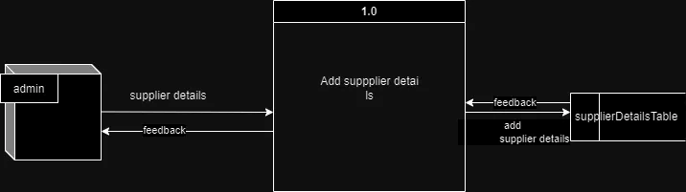

## Supplier Details Data structure

1. **Data flow description** : Takes supplier details from the user interface and sends them for processing
2. **source** : Admin
3. **Destination** : process 1.0
4. **Type of data flow** : Form details
5. **Data structure traveling with the flow** : supplier details
6. **Volume/Time** : 10/hour

## Supplier Details data Elements

1. SupplierID: Will be generated from the database
2. SupplierName: Name of the supplier .
   1. Length: varchar30
   2. Unique

## Wireframe

