# Use Case: Manage Product Details

Product in this scenario represents all the items that the shop sells.

## Use case description

* Actors: Admin
* Description: The Admin adds, updates, or deletes product details
* Precondition: Admin must be logged in and have capabilities to manage product data.
* postcondition: product details are updated in the system accordingly.
* Success Guarantee: Admin is able to CRUD product details successfully
* Main flow:

1. Admin navigates to the product details section
2. Admin views a list of products
3. Admin can add products, update/delete existing products

### Use case scenario on Adding a new product

Steps performed:

1. Admin navigates to the product details section
2. Admin clicks on the button to add product details
3. A modal presents a form to add product details
4. Admin fills in the form with the correct details
5. Admin clicks on submit
6. If errors? the error is returned together with an error message
7. If no errors, success icon should be showed and the modal with the form closed.

### Use case scenario on Editing a product detail

1. Admin navigates to the product details section
2. Each product has got a Edit button
3. Admin clicks on the edit button
4. Admin is directed to a page / a modal shows up with a form and all details of that product.
5. Admin updates what is necessary
6. Admin submits the forms.
7. If the name is not unique or any other error exists, error is shown
8. Admin rectifies the error and resubmits the form
9. If no error, success icon should be shown.
10. That product name should be updated everywhere.

### Use case scenario on Deleting a product

1. Admin navigates to the product details section
2. Each product has got a Delete button
3. Admin clicks on the delete button
4. The product is deleted and removed from view

# Data flows

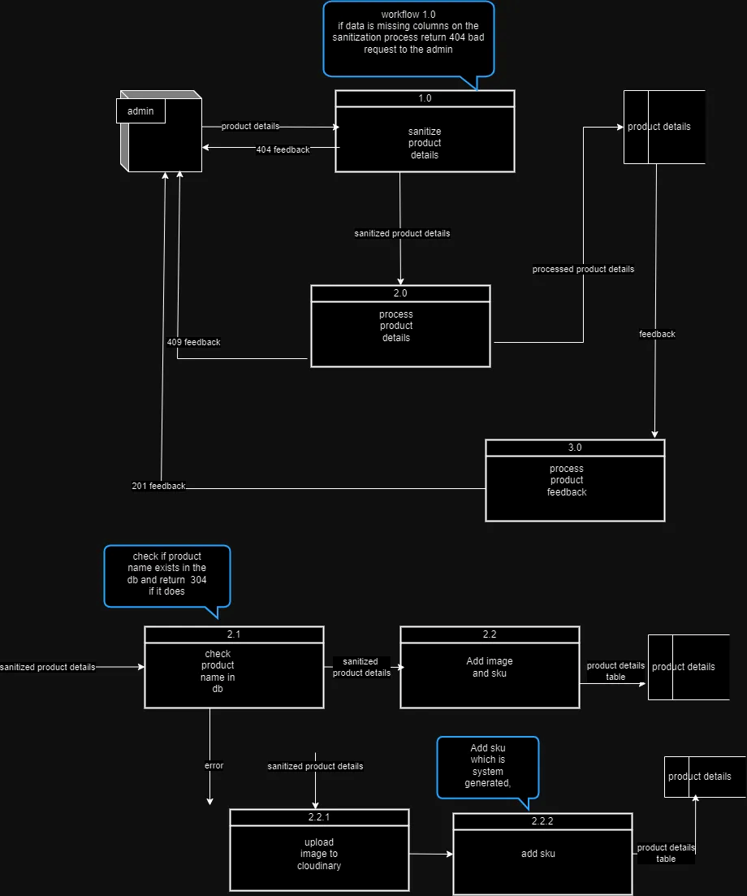

## Product details data flow

1. Name: Product details
2. Description: Contains the details of the product from the Admin and is used to create a new record of the product in the system.
3. Source: Admin
4. Destination: Sanitize produce details process
5. Comments:

### Data structure

|  |  |  |  |  |  |  |  |
| --- | --- | --- | --- | --- | --- | --- | --- |
| Element name | Description | Length | Base  /Derived | Default value | Validation criteria | | |
|  |  |  |  |  | Upper limit | Lower limit | comments | |
| Product name | This is the name of the product | 6 | Base | Not null | Char =40 | Char >2 |  | |
| productCategory | Each product will belong to a certain category | derived | Derived | Not null | Derived | derived |  | |
| Product description | Detailed description of the product (e.g., grade, type). | Varchar (255) | Base | Null | Char = 255 | Char >= 10 |  | |
| productImageURL | url to an image of the product | Varchar(50) | Derived | null | Char<= 50 | Char >=10 |  | |

## processed data flow

* ProductName
* Sku
* ProductCategory
* Product Description
* ProductImaeURL

## feedback data flow

|  |  |  |  |  |  |  |  |
| --- | --- | --- | --- | --- | --- | --- | --- |
|  | Description | Length | Base  /Derived | Default value | Validation criteria | | |
|  |  |  |  |  | Upper limit | Lower limit | comments | |
| ProductID | The unique id for each record | Char > 10 | Derived | Cannot be null | Unknown | unknown | Will be derived from db | |
| Product name | This is the name of the product | 6 | Base | Cannot be null | Char =40 | Char >2 |  | |
| Sku | A unique identifier or code for the product (used for tracking and inventory). | unknown | Derived | Cannot be null | Char <=15 | Char > 5 | Will be derived from the db or system | |
| DateAdded | Date the product was added to the system | Date-length | derived | Cannot be null | unknown | Unknown | MM/DD/YY | |
| DateUpdated | Last update date for product information | Date-length | derived | Cannot be null | unknown | unknown | MM/DD/YY | |
|  |  |  |  |  |  |  |  | |
|  |  |  |  |  |  |  |  | |
| productCategory | Each product will belong to a certain category | derived | Derived | Cannot Not null | Derived | derived |  | |
| Product description | Detailed description of the product (e.g., grade, type). | Varchar (255) | Base | Null | Char = 255 | Char >= 10 |  | |
| productImageURL | url to an image of the product | Varchar(50) | Derived | null | Char<= 50 | Char >=10 |  | |