MOBILE APPLICATION DEVELOPMENT LOGBOOK
Student Name
Dennis Muruka
Registration Number
BIT/2025/67727
Course Unit
Mobile Application Development
Institution
Mount Kenya University
Department
Computing and Informatics
Lecturer
Nyoro Michael
Technology Used
- Flutter
- Dart Programming Language
- IntelliJ IDEA
- Android SDK
- Gradle
Device Used
Mi 8 Android Phone

WEEK 1
- Introduction and Environment Setup
Objective
To install and configure Flutter development tools for Android mobile application development.
Activities Carried Out
- Installed Flutter SDK on Windows operating system.
- Installed IntelliJ IDEA for Flutter development.
- Installed Flutter and Dart plugins in IntelliJ IDEA.
- Configured Flutter SDK path.
- Installed Android SDK tools.
- Configured Android command-line tools.
- Configured Java environment variables.
- Connected Android device using USB debugging.

Commands Used
flutter doctor - Used to verify whether Flutter SDK, Android SDK, Java, and connected devices are properly configured for Flutter application development.
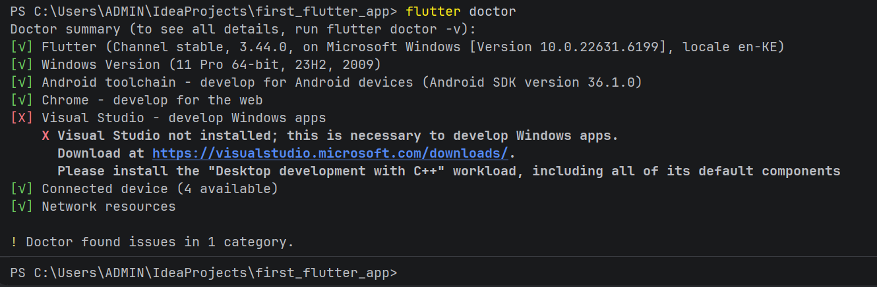

flutter doctor --android-licenses - Used to accept Android SDK license agreements required for building and running Android applications using Flutter.

Challenges Encountered
- Flutter command was not recognized in PowerShell.
- Android SDK command-line tools were missing.
- JAVA_HOME variable was incorrectly configured.
- Gradle and NDK installation failed after unexpected computer shutdown.
Solutions Applied
- Added Flutter path to system environment variables.
- Installed Android SDK command-line tools.
- Corrected JAVA_HOME configuration.
- Deleted corrupted NDK files and reinstalled them automatically using Gradle.
Outcome
Flutter development environment was successfully configured and verified using Flutter Doctor.
Observations
- Flutter Doctor helps identify missing dependencies and SDK issues.
- First Gradle build takes longer because dependencies are downloaded from the internet.
- Stable internet connection is important during initial setup.

- Running Flutter Application on a Physical Android Device
Objective
To create and successfully run a Flutter mobile application on a physical Android device.

Activities Carried Out
- Enabled Developer Options on the Android phone.
- Enabled USB Debugging on the phone.
- Connected Mi 8 phone to the computer using a USB cable.
- Authorized USB debugging access.
- Created a Flutter project in IntelliJ IDEA.
- Configured Flutter SDK path.
- Selected Android phone as the target device.
- Ran Flutter application using Flutter commands and IntelliJ IDEA.

Procedure Followed
- Opened IntelliJ IDEA.
- Created a new Flutter project.
- Selected Flutter SDK location.
- Connected Mi 8 phone using USB cable.
- Enabled File Transfer mode on the phone.
- Allowed USB debugging authorization popup.
- Opened terminal in IntelliJ IDEA.
- Executed Flutter run command.

Commands Used
Write these exactly:
flutter run
flutter devices

Explanation of Commands
flutter run
Used to build, install, and launch a Flutter application on a connected device.
flutter devices
Used to display all connected devices available for Flutter development.
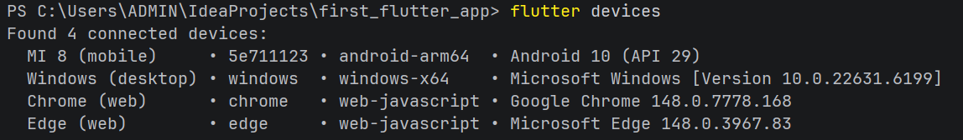

Challenges Encountered
- Flutter initially attempted to run the application on Windows instead of the Android phone.
- Gradle build process took a long time during the first build.
- Internet connection was required for Gradle dependency downloads.
- USB disconnection occasionally caused loss of device connection.

Solutions Applied
- Selected Mi 8 phone as the target device in IntelliJ IDEA.
- Maintained stable internet connection during the first Gradle build.
- Reconnected USB cable and reauthorized USB debugging when connection was lost.
- Re-ran Flutter application after reconnecting the device.

Outcome
The Flutter application was successfully built and installed on the Mi 8 Android device.
Observations
- First Flutter build takes longer because Gradle downloads dependencies.
- Physical Android devices provide faster testing than Android emulators on low-resource computers.
- Flutter hot reload allows instant UI updates without rebuilding the entire application.
Screenshot Evidence Section
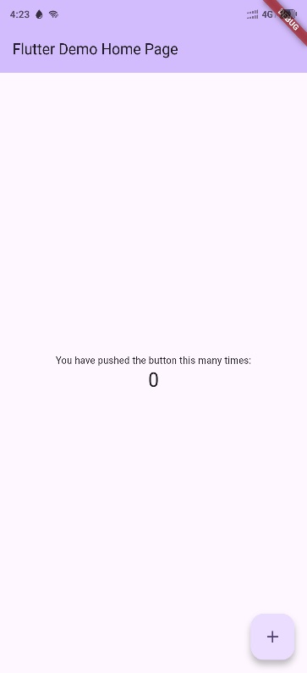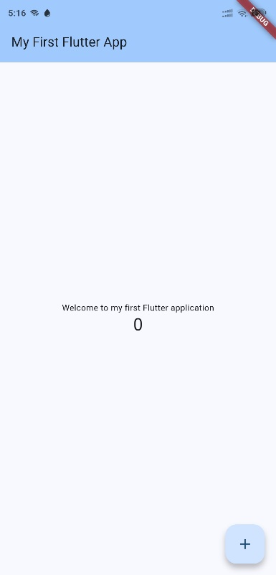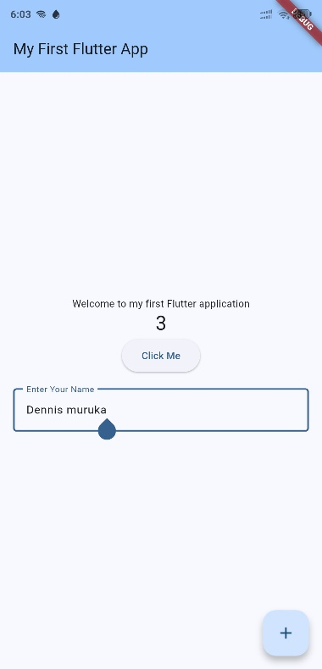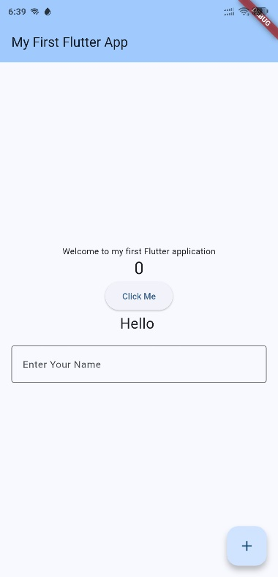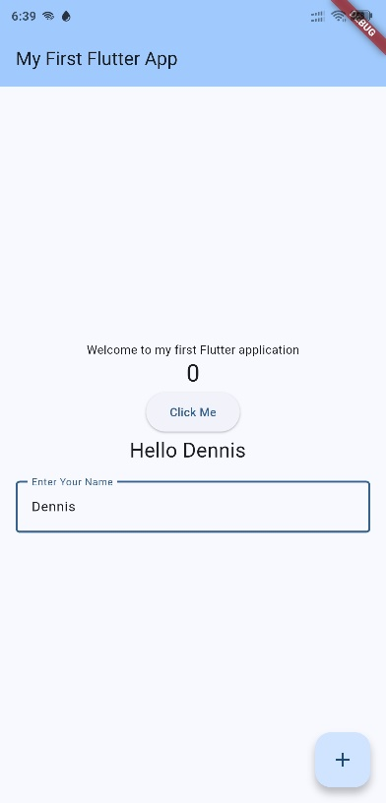

- Flutter User Interface Customization and Widgets

Objective
To customize the Flutter user interface using widgets, themes, colors, and text components.

Activities Carried Out
- Opened the main.dart file in IntelliJ IDEA.
- Modified the application title.
- Changed the displayed welcome text.
- Customized the application theme color.
- Used Flutter hot reload to apply changes instantly.
- Studied Flutter widget structure.

Procedure Followed
- Opened the Flutter project in IntelliJ IDEA.
- Navigated to:
lib/main.dart
- Modified the MaterialApp title.
- Modified the AppBar title text.
- Changed the application theme color.
- Saved the file using:
Ctrl + S
- Observed automatic hot reload on the Android device.

Code Modifications Performed
Changed Application Title
From:
title: 'Flutter Demo',
To:
title: 'My First Flutter App',

Changed Home Page Title
From:
home: const MyHomePage(title: 'Flutter Demo Home Page'),
To:
home: const MyHomePage(title: 'My First Flutter App'),
Changed Welcome Text
From:
'You have pushed the button this many times:'
To:
'Welcome to my first Flutter application'

Changed Theme Color
From:
seedColor: Colors.deepPurple
To:
seedColor: Colors.blue

Flutter Widgets Learned
MaterialApp
Provides the overall structure and theme of the Flutter application.
Scaffold
Provides the basic page structure such as AppBar and Body.
AppBar
Creates the top navigation bar of the application.
Text Widget
Displays text on the application screen.
Column Widget
Arranges widgets vertically.

Challenges Encountered
- Syntax errors occurred after incorrect code modification.
- Some Flutter keywords were accidentally removed during editing.
- Flutter application temporarily lost connection to the Android device.

Solutions Applied
- Corrected Flutter syntax errors.
- Restored missing Flutter keywords.
- Reconnected Android device and reran the application.

Outcome
The Flutter application interface was successfully customized and displayed correctly on the Android device.
Observations
- Flutter hot reload updates the UI instantly after saving changes.
- Widgets are the basic building blocks of Flutter applications.
- Theme customization changes the visual appearance of the application. Screenshot Evidence Section

- Implementing Interactive Widgets and Button Handling

Objective
To implement interactive widgets and handle user interactions using buttons in a Flutter application.

Activities Carried Out
- Added an ElevatedButton widget to the Flutter application.
- Implemented button click functionality using onPressed().
- Displayed button interaction messages in the terminal.
- Practiced Flutter event handling concepts.
- Tested button interaction on the Android device.

Procedure Followed
- Opened:
lib/main.dart
- Located the children section inside the Column widget.
- Added an ElevatedButton.
- Implemented onPressed() function.
- Saved the file using:
Ctrl + S
- Used Flutter hot reload to update the application.
- Pressed the button on the Android phone to test functionality.

Code Implemented
ElevatedButton(
onPressed: () {
print('Button Pressed');
},
child: const Text('Click Me'),
),

Explanation of Code
ElevatedButton
Creates a clickable button in Flutter applications.
onPressed()
Defines the action to execute when the button is clicked.
print()
Displays output messages in the terminal for debugging purposes.

Flutter Concepts Learned
Event Handling
Allows Flutter applications to respond to user actions such as button clicks.
Interactive Widgets
Widgets that allow users to interact with the application.
Debugging Output
Flutter can print debugging messages to the terminal using the print() function.

Challenges Encountered
- Incorrect widget placement caused syntax errors.
- Missing commas and brackets generated Flutter errors.
- Flutter occasionally lost connection to the Android device.

Solutions Applied
- Corrected widget placement inside the children list.
- Added missing commas and brackets.
- Reconnected the Android device and reran the application.

Outcome
A clickable button labelled:
Click Me
was successfully implemented and responded correctly to user interaction.

Observations
- Flutter widgets must be placed correctly within widget trees.
- Buttons can execute functions using onPressed().
- Terminal debugging helps track application behavior during development.

Terminal Output Observed
Button Pressed

- Implementing User Input Using TextField
Objective
To implement user input functionality using the TextField widget in Flutter applications.

Activities Carried Out
- Added a TextField widget to the Flutter application.
- Added input decoration and labels.
- Customized the appearance of the text field.
- Tested user text input on the Android device.
- Learned Flutter form and input concepts.

Procedure Followed
- Opened:
lib/main.dart
- Located the children section inside the Column widget.
- Added a TextField widget below the button.
- Added:
  - InputDecoration
  - OutlineInputBorder
  - label text
- Saved the file using:
Ctrl + S
- Used hot reload to update the application.
- Tested text entry on the Android device.

Code Implemented
Padding(
padding: const EdgeInsets.all(16.0),
child: TextField(
decoration: InputDecoration(
border: OutlineInputBorder(),
labelText: 'Enter Your Name',
),
),
),

Explanation of Code
TextField
Allows users to enter text into the Flutter application.
InputDecoration
Used to customize the appearance of the text field.
OutlineInputBorder
Creates a visible border around the text field.
Padding
Adds spacing around widgets to improve UI appearance.

Flutter Concepts Learned
User Input Handling
Flutter applications can receive user data using input widgets such as TextField.
Widget Decoration
Widgets can be visually customized using decoration properties.
Layout Spacing
Padding improves application readability and user interface organization.

Challenges Encountered
- Incorrect placement of widgets caused Flutter syntax errors.
- Missing commas and brackets generated build errors.
- TextField initially appeared too close to other widgets.

Solutions Applied
- Corrected widget placement inside the children list.
- Added missing commas and brackets.
- Added Padding widget to improve spacing and layout appearance.

Outcome
A functional text input field labelled:
Enter Your Name
was successfully implemented and tested on the Android device.

Observations
- Flutter TextFields allow user interaction through text entry.
- InputDecoration improves the visual appearance of forms.
- Padding helps create cleaner and more organized user interaction

- Dynamic User Input and State Management in Flutter

Objective
To implement dynamic user input handling and state management using TextEditingController and setState() in Flutter applications.

Activities Carried Out
- Created a TextEditingController.
- Connected the controller to the TextField.
- Captured user-entered text dynamically.
- Used setState() to update the user interface.
- Displayed user-entered names on the application screen.
- Tested dynamic updates on the Android device.

Procedure Followed
- Opened:
lib/main.dart
- Declared a TextEditingController.
- Created a variable to store displayed text.
- Connected the controller to the TextField.
- Modified the button’s onPressed() function.
- Used setState() to refresh the user interface dynamically.
- Added a Text widget to display user-entered names.
- Saved the file using:
Ctrl + S
- Tested the application on the Mi 8 Android phone.

Code Implemented
TextEditingController Declaration
final TextEditingController _nameController = TextEditingController();
String _displayName = '';

Connecting Controller to TextField
TextField(
controller: _nameController,
decoration: InputDecoration(
border: OutlineInputBorder(),
labelText: 'Enter Your Name',
),
),

Button Event Handling Using setState()
onPressed: () {
setState(() {
_displayName = _nameController.text;
});
},

Displaying Dynamic User Text
Text(
'Hello $_displayName',
style: const TextStyle(fontSize: 24),
),

Explanation of Code
TextEditingController
Used to control and retrieve text entered into a TextField.
setState()
Updates the application user interface whenever application data changes.
Dynamic UI
Allows the application to update displayed information instantly based on user interaction.

Flutter Concepts Learned
State Management
State management allows Flutter applications to update and manage changing data dynamically.
Dynamic Widgets
Widgets can change automatically based on user input and application state.
User Data Handling
Flutter applications can capture, process, and display user-entered data.

Challenges Encountered
- Incorrect placement of setState() caused errors.
- Missing controller connections prevented text updates.
- Minor Flutter syntax errors occurred during editing.

Solutions Applied
- Correctly placed setState() inside the button’s onPressed() method.
- Properly connected TextEditingController to the TextField.
- Corrected missing brackets and commas.

Outcome
The application successfully captured user-entered names and dynamically displayed greeting messages such as:
Hello Dennis

Observations
- Flutter dynamically updates the interface using setState().
- TextEditingController is useful for retrieving text input.
- Dynamic user interfaces improve interactivity in mobile applications.

Week 2
Activities Carried Out:
Created a Flutter login interface containing username and password input fields, a login button, and application icon using Flutter widgets.
Flutter Widgets Used:
- TextField
- ElevatedButton
- Icon
- Column
- Padding
- SizedBox
Outcome:
A functional login page was successfully displayed on the Android device.
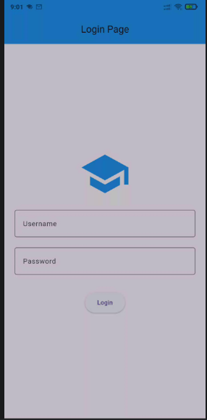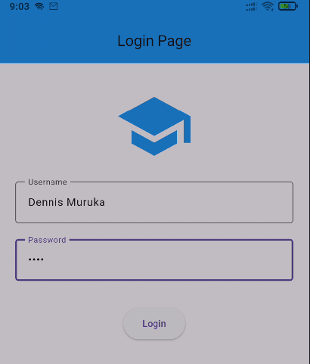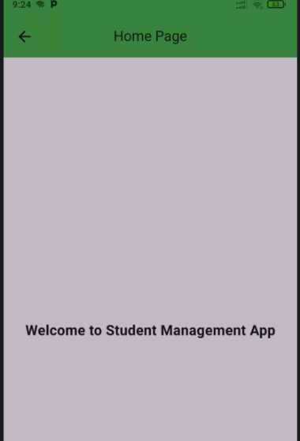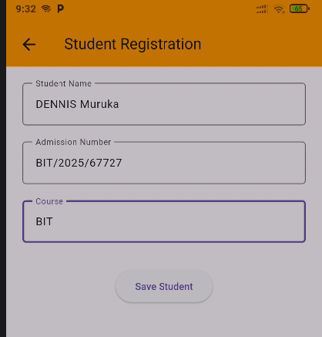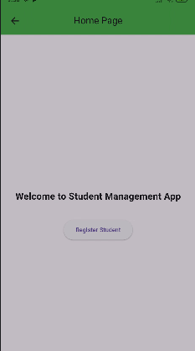

WEEK 3
1. Requirements Analysis
I reviewed the system requirements and identified the key functionalities that the application would provide. The major modules identified included:
- User Authentication
- Dashboard Management
- Student Registration
- Student Records Management
- Reports Generation
- User Profile Management
- System Settings
2. User Interface Planning
I planned the overall layout and navigation structure of the application. Wireframes were sketched to determine the placement of menus, buttons, forms, and navigation components.
3. Prototype Design Using Figma
I used Figma to create a high-fidelity prototype of the Student Management System. The prototype consisted of the following screens:
- Splash Screen
- Login Screen
- Dashboard Screen
- Student List Screen
- Student Details Screen
- Add Student Screen
- Edit Student Screen
- Reports Screen
- Profile Screen
- Settings Screen
4. Design System Development
A consistent design system was established including:
- Colour palette selection
- Typography standards
- Reusable buttons
- Form components
- Navigation elements
- Card layouts
This ensured consistency throughout the application design.
5. Prototype Navigation
Interactive links were created between screens to simulate real application navigation. This enabled testing of user flows and overall usability.
6. User Experience Improvements
Several improvements were made to enhance usability including:
- Simplified navigation structure
- Clear labeling of buttons and menus
- Improved screen layouts
- Consistent spacing and alignment
- Mobile-friendly design principles
TOOLS AND TECHNOLOGIES USED
- Figma (UI/UX Design and Prototyping)
- Mobile Application Design Principles
- Material Design Guidelines
SKILLS ACQUIRED
During the week, I gained practical skills in:
- UI/UX Design
- Mobile Application Prototyping
- User Requirement Analysis
- Design Thinking
- Screen Layout Planning
- Interactive Prototype Development
- Application Workflow Design
CHALLENGES ENCOUNTERED
The following challenges were encountered:
- Selecting an appropriate navigation structure for the application.
- Ensuring consistency across all screens.
- Designing responsive layouts suitable for mobile devices.
SOLUTIONS IMPLEMENTED
To address these challenges:
- I researched modern mobile application design practices.
- I adopted reusable design components.
- I tested navigation flows repeatedly to improve usability and user experience.
ACHIEVEMENTS
By the end of the week, I successfully developed a complete interactive prototype for the Student Management System. The prototype clearly demonstrated the intended functionality, user workflow, and visual design of the application and provided a strong foundation for the implementation phase.
CONCLUSION
Week 3 was productive as it focused on designing and validating the Student Management System before development. The completed prototype will guide the coding and implementation stages of the project, reduce development errors and improve overall system quality.

