MOUNT KENYA UNIVERSITY
MOBILE APPLICATION DEVELOPMENT (BIT 4107)
WEEK 7 PROJECT LOGBOOK
NAME: DENNIS MURUKA
REGISTRATION NUMBER: BIT/2025/67727
INSTITUTION: MOUNT KENYA UNIVERSITY - THIKA MAIN CAMPUS
DEPARTMENT: COMPUTING AND INFORMATICS
LECTURER: MR. NYORO MICHAEL

INDEX
TASK 15 — Firebase Project Dashboard
TASK 16 — Firebase Authentication Enabled
TASK 17 — Firestore Database Created
TASK 18 — Students Collection
TASK 19 — Attendance Collection
TASK 20 — Student Database Structure
TASK 21 — ERD Diagram
TASK 22— Student Registration Form
TASK 23 — Students List Screen
TASK 24 — Attendance Marking Screen
TASK 25 — Attendance Records in Firestore

TASK 15
Firebase Project Dashboard
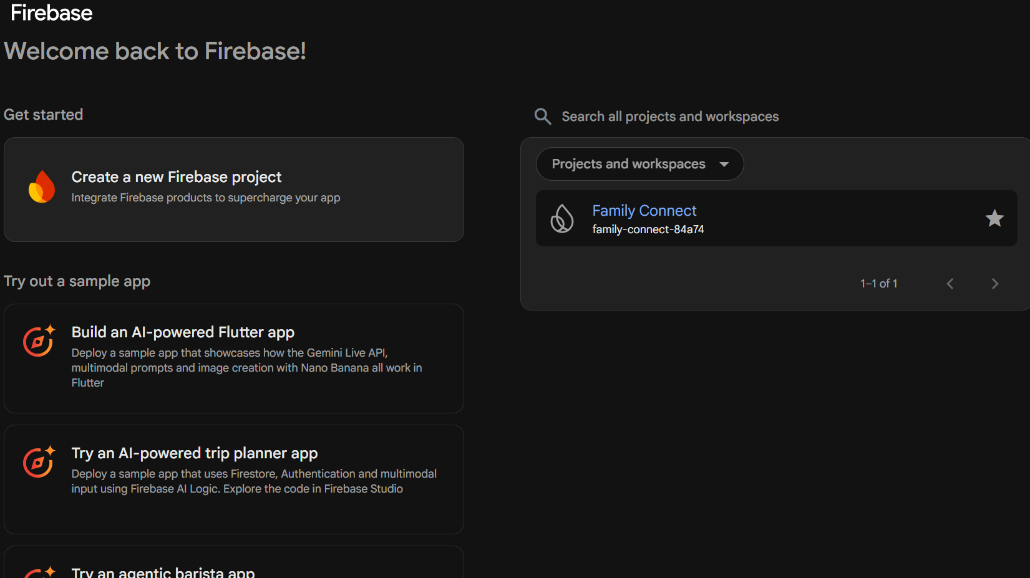

TASK 16
Firebase Authentication Enabled
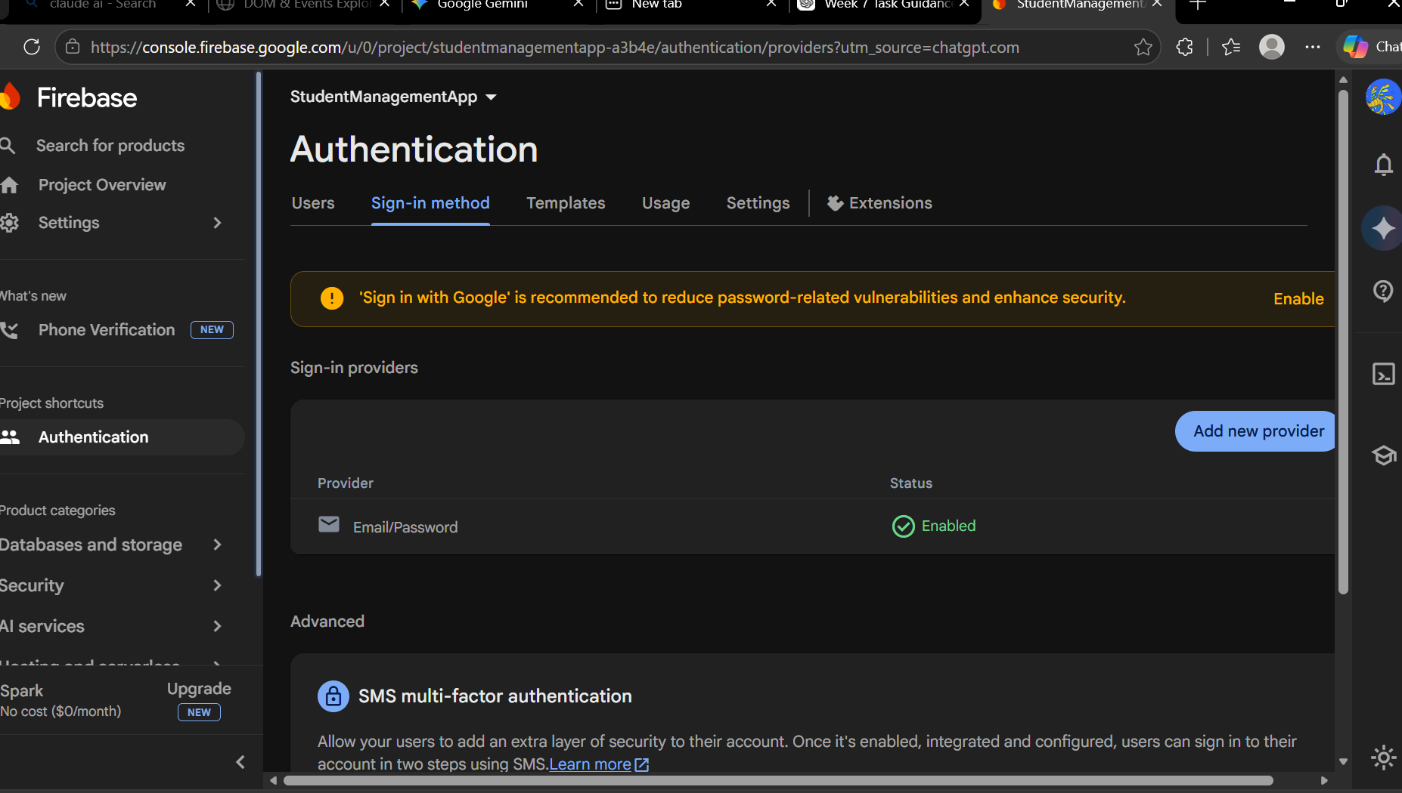

TASK 17
Firestore Database Created
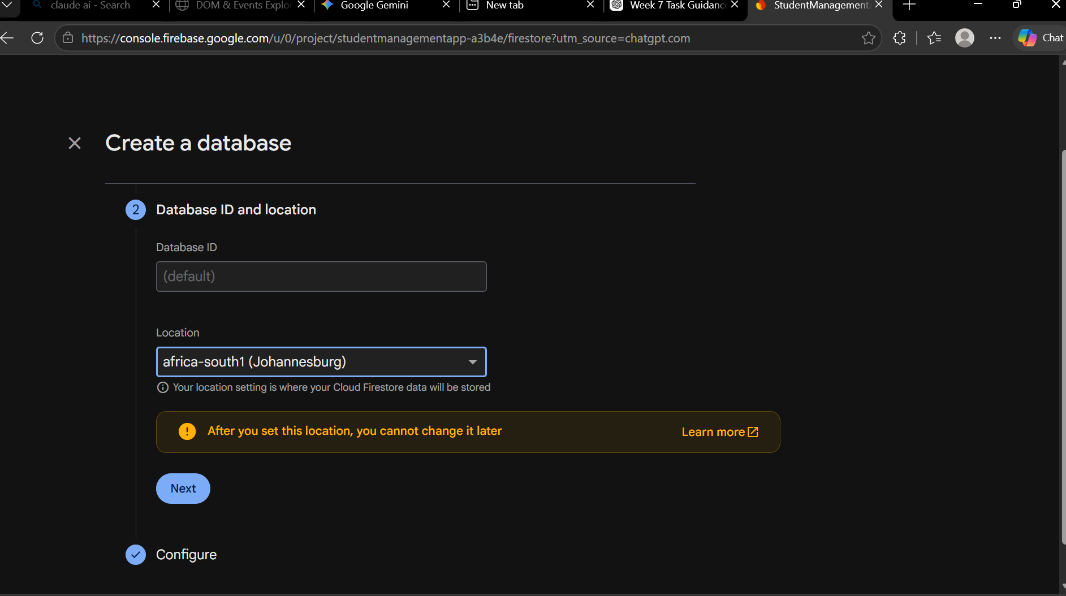

TASK 18
Students Collection
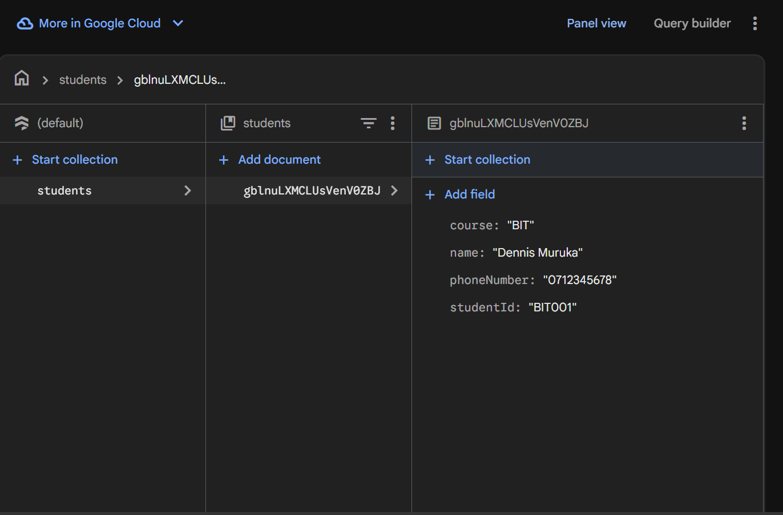

TASK 19
Attendance Collection
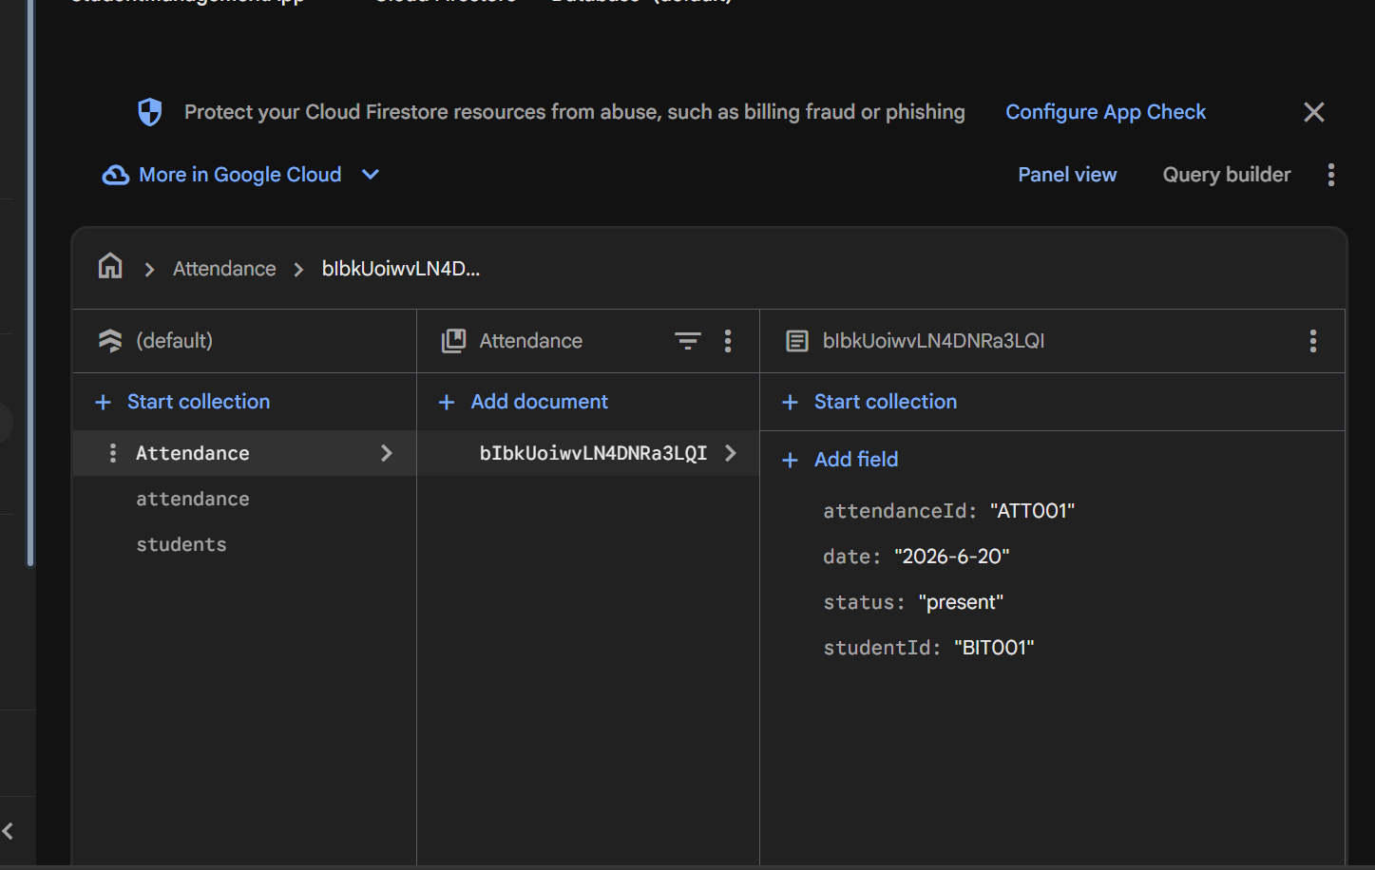

TASK 20
Student Database Structure
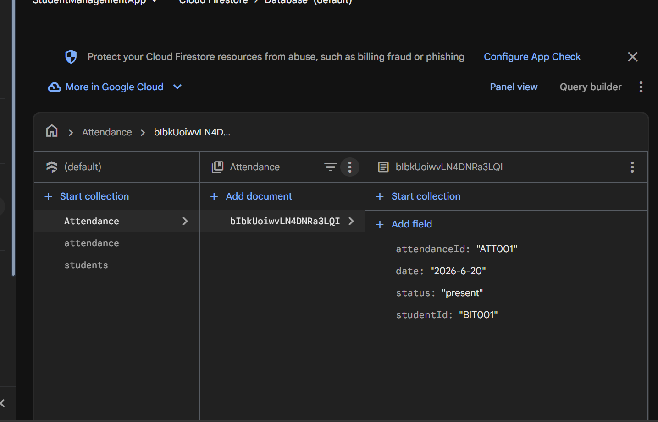

TASK 21
ERD Diagram
TASK 21
ENTITY RELATIONSHIP DIAGRAM (ERD)
PK studentId
name
year
course

phoneNumber

STUDENT

1

PK attendance
FK studentId

M
ATTENDANCE
status

date

Relationship:
One Student can have Many Attendance Records (1:M)
TASK 23
Students List Screen
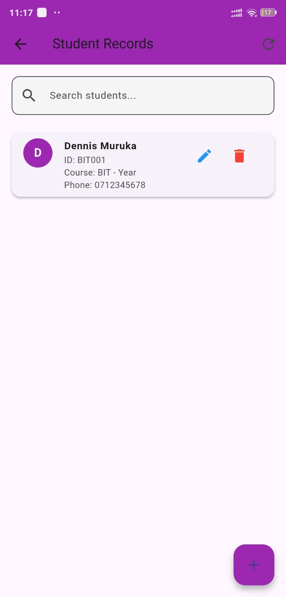

TASK 24
Attendance Records in Firestore


