MSc Data Analytics
Module: Computer Vision and Artificial Intelligence

Automated Plant Disease Detection Using Advanced Deep Learning-Based Image Classification: Comparative Evaluation and a Novel Approach Architecture

Assignment type: Practical skills assessment (including production of an artefact)
Issued by: Dr. Fahmid Al Farid
Submission date: 24/09/2026
Student name: [insert] Student ID: [insert]
Word count: 2,997 (Introduction to Conclusion, including headings and figure captions; excluding title page, abstract, tables, references and appendix)
Artefact: plant_disease_classification.ipynb (Python, PyTorch 2.11, Google Colab Tesla T4)

Abstract
Plant diseases destroy up to 40% of global crop production each year, yet timely diagnosis still depends on scarce expert knowledge. This study developed an automated leaf-disease classifier in PyTorch using the PlantVillage dataset from Kaggle, which contains 54,305 images in 38 crop–disease classes. Nine architectures were implemented and compared: a custom CNN, ResNet18, ResNet50, MobileNetV3-Large, EfficientNet-B0, three single-component EfficientNet-B0 variants and PlantAttnNet, a proposed model that combines multi-scale feature fusion, CBAM attention and generalised-mean pooling. Models were trained on a stratified 19,007-image subsample and evaluated on accuracy, macro precision, recall, F1-score, parameters, FLOPs, latency, calibration, robustness and Grad-CAM explanations. Test accuracy ranged from 97.76% to 99.65%, with multi-scale fusion alone performing best. PlantAttnNet reached 99.44% but did not significantly beat its EfficientNet-B0 baseline (McNemar p = 1.00). On 2,332 independent PlantDoc field images, accuracy fell to 11–19%, showing that laboratory accuracy does not guarantee field performance.
Keywords: plant disease detection; deep learning; image classification; transfer learning; EfficientNet; attention mechanism; PlantVillage; model scalability

1. Introduction
Plant diseases reduce crop yields, damage farm incomes and threaten food security worldwide. The Food and Agriculture Organization estimates that pests and diseases destroy up to 40% of global crop production every year (FAO, 2025). Losses grow when infection goes unnoticed, because lesions on a few leaves can spread through a whole field within one season. Reliable diagnosis still depends on trained plant pathologists, who are scarce and cannot inspect large farms leaf by leaf.
Image classification with deep convolutional neural networks (CNNs) offers a scalable alternative to manual inspection. A CNN learns discriminative colour, texture and shape cues directly from labelled leaf photographs, so no hand-crafted features are required (Shoaib et al., 2023). Trained models can run on smartphones or low-cost edge devices, which makes diagnosis available to farmers without laboratory access (Zhang et al., 2025). Published accuracies above 99%, however, rarely come with model cost, statistical uncertainty or behaviour on field photographs, although these factors decide whether a model is useful in practice (Xiang, Shi and Zhu, 2026).
The objective of this study is to develop a model for automated plant disease diagnosis and to test critically whether a novel design improves on established architectures. The first aim is to compare nine architectures by learnable parameters, computation and scalability. The second aim is to propose PlantAttnNet and to isolate each of its components through ablation. The third aim is to evaluate every model with accuracy, precision, recall, F1-score, confusion matrices, calibration and robustness tests. The final aim is to test generalisation on independent field images.

2. Literature Review
Early plant disease systems combined hand-crafted colour and texture descriptors with classical classifiers such as support vector machines. These pipelines needed new feature design for each crop and lighting condition, so they scaled poorly (Shoaib et al., 2023). Deep CNNs removed that step by learning features end to end, and fine-tuned ImageNet networks now routinely exceed 99% accuracy on PlantVillage (Shoaib et al., 2023). Explainable-AI studies have since paired such classifiers with visual explanations that show which leaf regions drive each prediction (Nigar et al., 2024; Alhammad et al., 2025).
Recent work has focused on reducing model cost without losing accuracy. Lightweight backbones such as MobileNetV3 and EfficientNet-B0 use depthwise-separable convolutions and compound scaling to match larger networks with far fewer parameters (Zhang et al., 2025). Wang, Zhang and Tian (2024) added the Convolutional Block Attention Module (CBAM) and fused shallow feature maps to capture small tomato lesions. Jansi and BR (2026) combined EfficientNet-B0 with CBAM and noted that randomly initialised attention layers can destabilise fine-tuning. Arshad, Javed and Saudagar (2026) replaced average pooling with learnable generalised-mean (GeM) pooling, which emphasises strongly activated regions, and reported gains on laboratory and field images.
Three gaps motivate the present study. First, PlantVillage leaves are photographed on uniform backgrounds, and a fine-tuned ResNet-50 lost 67.7 percentage points of accuracy when it was tested on PlantDoc field images (Xiang, Shi and Zhu, 2026). Second, few studies report parameters, FLOPs and latency together, or ablate each proposed module against a strong baseline with a significance test. Third, calibration and robustness to blur, noise and poor lighting are seldom measured, although they determine whether predictions can be trusted in the field (Wang, 2023). This study addresses all three gaps within a single, reproducible pipeline.

3. Problem Formulation
Plant disease spreads quickly, and manual scouting across large fields is slow, subjective and often too late. A useful automated system must recognise many diseases on many crops and must be small and fast enough to run on field devices. It should also signal when it is unsure, so that doubtful cases can be referred to an expert. The practical goal of this project is therefore to build a model that classifies a single leaf image by crop and disease type.
Formally, let x be an RGB leaf image and y one of K = 38 crop–condition labels, comprising 26 disease and 12 healthy classes. The task is to learn a classifier f(x; θ) that minimises error on unseen images while keeping parameters, FLOPs and latency low. Training minimises cross-entropy with label smoothing of 0.1, which discourages over-confident outputs. The success criteria were a macro-F1 of at least 0.98 (O1), a like-for-like comparison of parameters, GFLOPs and latency (O2), a McNemar test of each PlantAttnNet component at α = 0.05 (O3), and measured robustness and external validity (O4).

4. Dataset Preparation

4.1 Source and labelling
The PlantVillage dataset was obtained from Kaggle at https://www.kaggle.com/datasets/mohitsingh1804/plantvillage (accessed 21 September 2026). It contains 54,305 RGB leaf images in 38 folders whose names give the crop and condition and serve as class labels. The data cover 14 crops, 26 disease classes and 12 healthy classes (Table 1, Figure 1). Class sizes range from 152 images (potato healthy) to 5,507 (orange Huanglongbing), an imbalance ratio of 36.2. Classes were not reweighted, and stratified splitting, macro-averaged metrics and per-class reporting were used instead to expose any effect of imbalance.
Table 1: PlantVillage dataset statistics (notebook Sections 3 and 3b)
Item | Value | Item | Value
Total images | 54,305 | Min / max images per class | 152 / 5,507
Classes (crops) | 38 (14) | Mean / median per class | 1,429.1 / 1,092.5
Healthy / disease classes | 12 / 26 | Imbalance ratio (max / min) | 36.2
Normalised entropy | 0.919 | Classes below 50% of median | 8
Images used (35% stratified) | 19,007 | Train / validation / test | 13,304 / 2,851 / 2,852

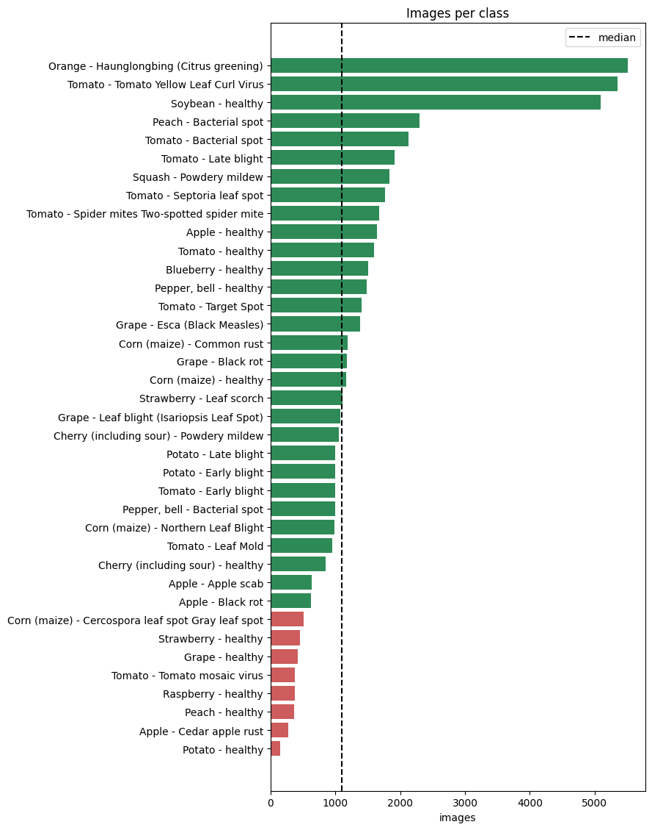
Figure 1: Images per class in PlantVillage

4.2 Sampling, splits and preprocessing
Because of Colab GPU limits, a stratified 35% subsample of 19,007 images was drawn, and an integrity check found no corrupt files. The subsample was split 70/15/15 by class with random seed 42, and no class share differed from the full data by more than 0.03 percentage points. Models were selected on validation accuracy, and the test set was used only once. PlantVillage contains several photographs of the same leaf, so a random split may place near-duplicates in both training and test data and inflate scores (Xiang, Shi and Zhu, 2026). Leaf identity is not recorded in the Kaggle copy, so this risk could not be controlled.
Images were resized to 160 × 160 pixels and normalised with ImageNet statistics. Training augmentation applied random resized crops (scale 0.7–1.0), horizontal and vertical flips, rotations of up to 20° and colour jitter of 0.2, which mimic natural variation in orientation, framing and lighting (Figures 2 and 3). Validation and test images were only resized and normalised, so evaluation remained deterministic. For external validation, PlantDoc was downloaded from https://www.kaggle.com/datasets/nirmalsankalana/plantdoc-dataset, and its folders were mapped to 28 matching PlantVillage classes, giving 2,332 field images after capping each class at 100.
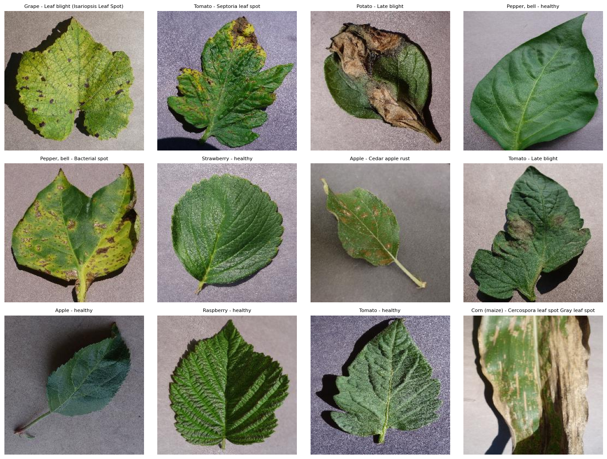
Figure 2: Sample images from twelve randomly chosen classes
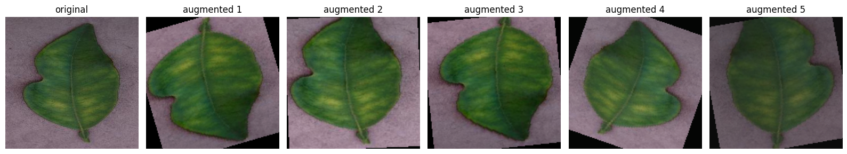
Figure 3: Original leaf and five augmented variants

5. Model Architecture
Nine models were chosen to span a wide range of size and design (Table 2). A custom four-block CNN is the from-scratch baseline, ResNet18 and ResNet50 represent residual depth, and MobileNetV3-Large and EfficientNet-B0 represent efficient mobile design. Every model except the custom CNN starts from ImageNet weights with a new 38-way classifier. The selection follows the brief's criteria of accuracy, size and training cost, and Table 3 itemises each architecture's measured advantages and disadvantages.
Table 2: Complexity and scalability of the nine models (160 × 160 input, Tesla T4)
Model | Params (M) | Size (MB) | GFLOPs | Latency bs1 (ms) | Throughput (img/s) | Train time (min)
SimpleCNN | 1.18 | 4.74 | 2.64 | 1.8 | 1,976 | 13.1
ResNet18 | 11.20 | 44.82 | 1.85 | 3.1 | 4,358 | 13.5
ResNet50 | 23.59 | 94.56 | 4.17 | 8.7 | 1,454 | 15.7
MobileNetV3-Large | 4.25 | 17.10 | 0.22 | 8.7 | 2,839 | 14.9
EfficientNet-B0 | 4.06 | 16.39 | 0.39 | 12.4 | 1,578 | 15.6
EffNet-B0 + CBAM | 4.26 | 17.21 | 0.39 | 17.4 | 1,872 | 15.8
EffNet-B0 + GeM | 4.06 | 16.39 | 0.39 | 16.8 | 1,823 | 16.2
EffNet-B0 + Multi-scale | 4.06 | 16.41 | 0.39 | 17.4 | 1,777 | 15.7
PlantAttnNet (proposed) | 4.27 | 17.24 | 0.39 | 12.9 | 2,348 | 16.0

Table 3: Advantages and disadvantages of each architecture (from the measured results)
Model | Advantages | Disadvantages
SimpleCNN | Smallest model (1.18 M); fastest at batch 1 (1.8 ms); needs no pretraining | Lowest accuracy (97.76%); 2.64 GFLOPs; weakest robustness (65.1% mean)
ResNet18 | Simple and stable; highest throughput (4,358 img/s); 99.12% accuracy | 11.2 M parameters; lowest blur accuracy among pretrained models (0.770)
ResNet50 | Strong accuracy (99.30%); good PlantDoc transfer (18.9%) | Largest model (23.6 M, 94.6 MB); highest compute (4.17 GFLOPs)
MobileNetV3-Large | Lowest compute (0.22 GFLOPs); 99.47% accuracy; best PlantDoc accuracy (19.2%) | Batch-1 latency no better than ResNet50 despite 19× fewer FLOPs
EfficientNet-B0 | 99.47% with 4.06 M parameters; best accuracy per parameter | Slowest baseline at batch 1 (12.4 ms); weak under noise (0.759)
EffNet-B0 + CBAM | Better blur and noise robustness than the baseline (88.2% mean) | +0.21 M parameters; no accuracy gain
EffNet-B0 + GeM | Only one extra parameter; strong blur robustness (0.893) | Accuracy 0.11 points below baseline (not significant)
EffNet-B0 + Multi-scale | +0.004 M parameters; best accuracy, F1 and robustness (93.0%) | Wider classifier input (1,392-d); evidence from a single seed
PlantAttnNet (proposed) | Competitive accuracy (99.44%) at 4.27 M parameters and 0.39 GFLOPs | No accuracy gain over baseline; component gains not additive

Plant lesions range from pinpoint spots to leaf-wide mildew, yet at a 160-pixel input the final EfficientNet-B0 feature map is only 5 × 5 pixels, which may discard small lesions. PlantAttnNet therefore modifies EfficientNet-B0 in three ways (Figure 4). First, stage-5 features (112 channels, stride 16), which retain fine lesion texture, are tapped alongside the final 1,280-channel features. Second, each feature map passes through CBAM, which applies channel attention followed by spatial attention. Third, each map is pooled by GeM with a learnable exponent initialised at 3, and the two descriptors are concatenated (1,392 dimensions) before dropout of 0.3 and a linear layer.
The design adds 0.21 million parameters (+5.2%) and about 0.001 GFLOPs to the baseline. Three further variants, each adding only one component to EfficientNet-B0, complete the ablation. This structure allows the contributions of multi-scale fusion, attention and pooling to be measured separately. It also tests whether the three components compound, as the literature implies (Wang, Zhang and Tian, 2024; Arshad, Javed and Saudagar, 2026).
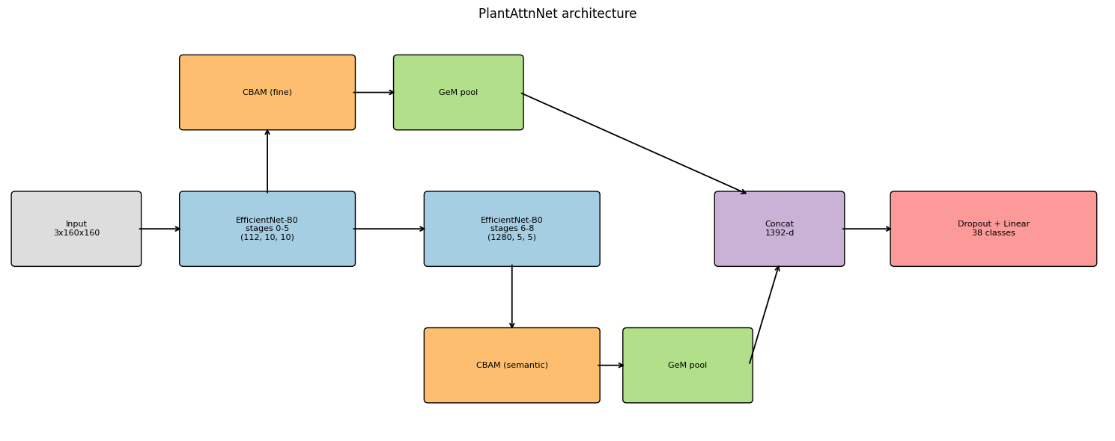
Figure 4: PlantAttnNet architecture

6. Implementation
The notebook uses Python, PyTorch 2.11 (Ansel et al., 2024) and torchvision on a Colab Tesla T4 GPU. Checkpoints and splits are saved to Google Drive, so a disconnected session resumes from the last completed epoch. The data pipeline reads the persisted split, applies the transforms above and loads batches of 64 images. A model factory builds all nine networks from one dictionary and asserts that each produces 38 logits (Screenshot 1). Parameters and FLOPs are counted deterministically, while latency and throughput are timed at several input resolutions (Screenshot 2).
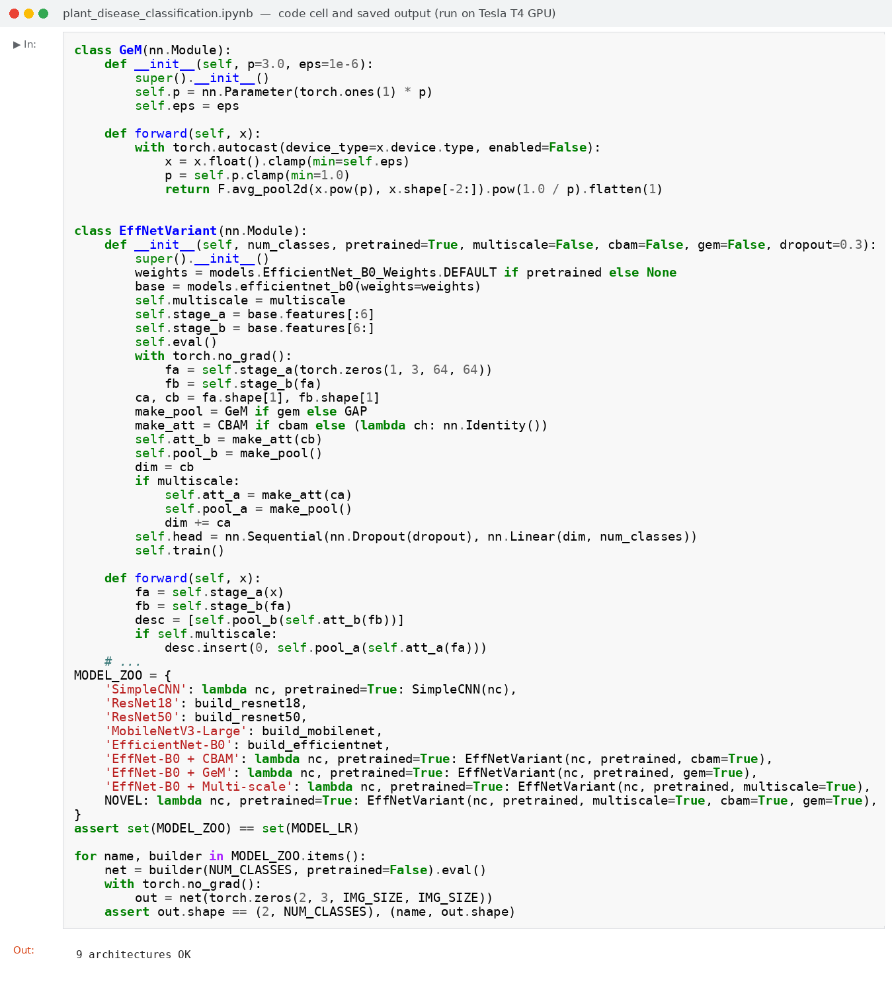
Screenshot 1: Model definitions and architecture check
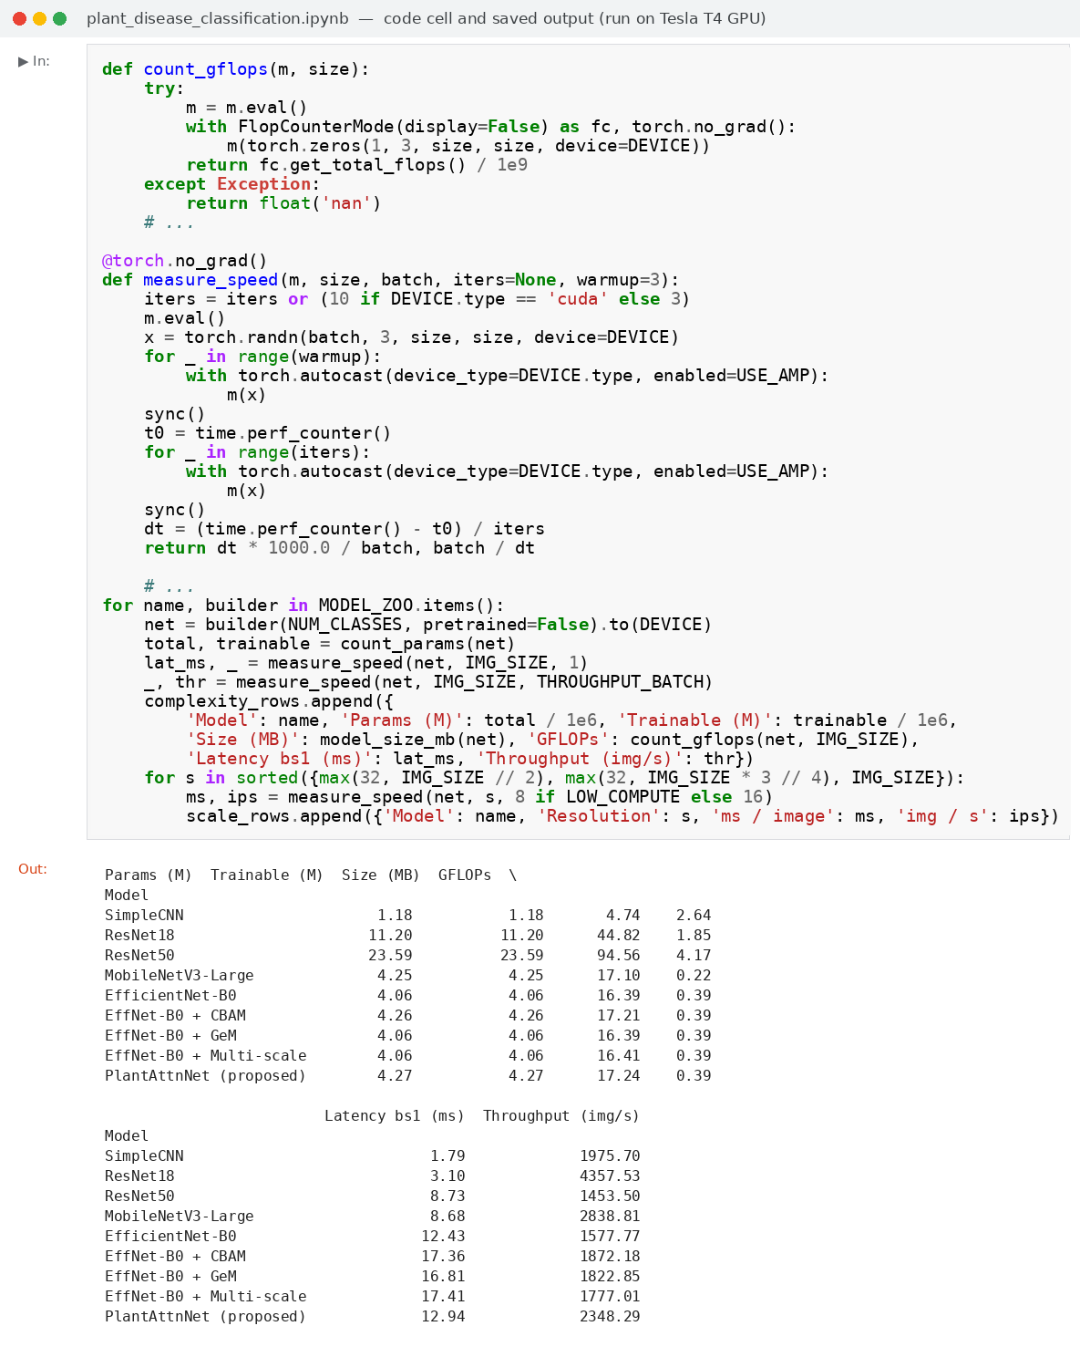
Screenshot 2: Complexity measurement code and output
The training loop uses AdamW with weight decay 0.01, a 20% linear warm-up followed by cosine decay, and a peak learning rate of 1 × 10⁻³ (2 × 10⁻³ for the custom CNN and 5 × 10⁻⁴ for ResNet50). Label smoothing of 0.1, gradient clipping at 1.0 and mixed precision were applied throughout (Screenshot 3). Each model trained for up to 12 epochs with early stopping after four epochs without validation gain, and the best-validation weights were kept. Evaluation computes accuracy and macro precision, recall and F1 with scikit-learn, confusion matrices, exact McNemar tests, robustness tests and Grad-CAM heat-maps (Screenshot 4). All random seeds were fixed at 42, and each model was trained once.
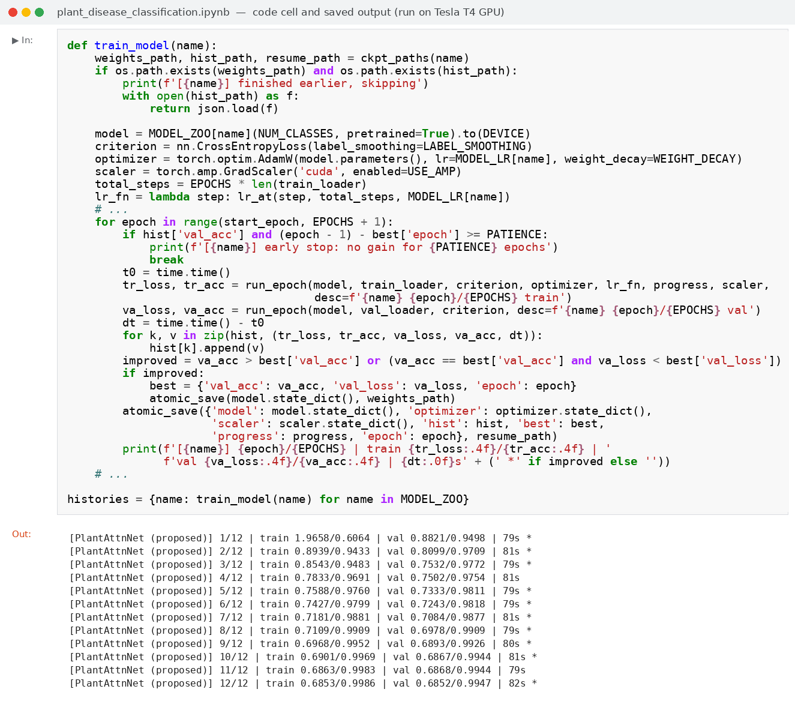
Screenshot 3: Training loop and PlantAttnNet epoch log
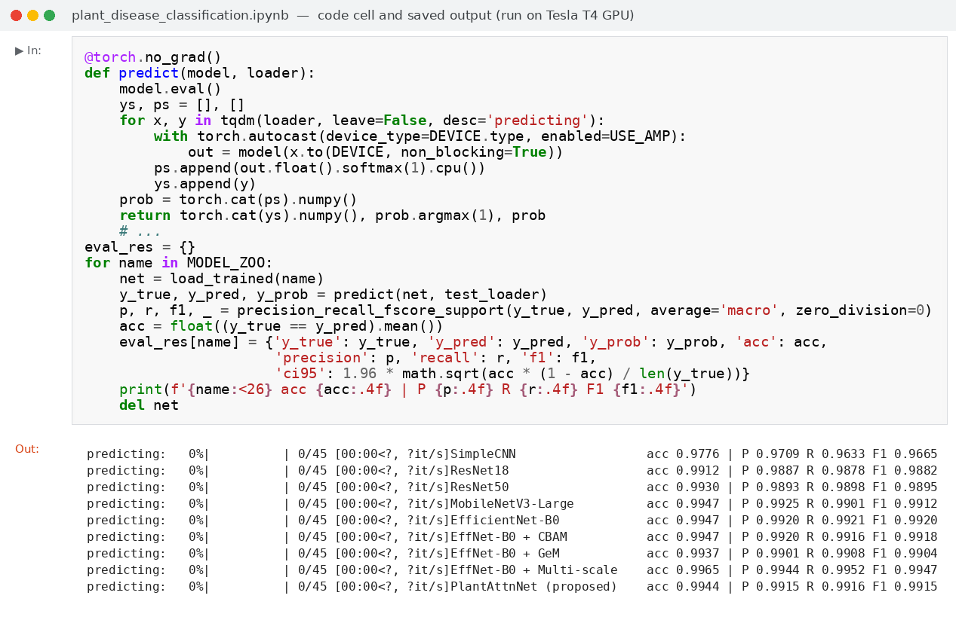
Screenshot 4: Test-set evaluation code and output

7. Model Evaluation

7.1 Overall performance
Table 4 shows that all eight pretrained models exceeded 99.1% test accuracy and 0.988 macro-F1, so criterion O1 was met, whereas the custom CNN reached 97.76%. Macro averages weight every class equally, so they penalise weak minority classes more heavily than accuracy does. The 95% confidence intervals of the six best models (±0.22 to ±0.31 points) overlap heavily, so their ranking is unreliable, because 0.3 points is only about eight images. Pretraining is the clearest driver of performance, since the custom CNN trailed PlantAttnNet by 1.7 points (McNemar p < 0.001). This comparison mixes scratch training with fine-tuning, however, and the custom CNN was still improving at epoch 12.
Table 4: Test-set results (2,852 images; macro-averaged precision, recall and F1)
Model | Accuracy (±95% CI) | Precision | Recall | F1 | Errors
SimpleCNN | 97.76% (±0.54) | 0.9709 | 0.9633 | 0.9665 | 64
ResNet18 | 99.12% (±0.34) | 0.9887 | 0.9878 | 0.9882 | 25
ResNet50 | 99.30% (±0.31) | 0.9893 | 0.9898 | 0.9895 | 20
MobileNetV3-Large | 99.47% (±0.27) | 0.9925 | 0.9901 | 0.9912 | 15
EfficientNet-B0 | 99.47% (±0.27) | 0.9920 | 0.9921 | 0.9920 | 15
EffNet-B0 + CBAM | 99.47% (±0.27) | 0.9920 | 0.9916 | 0.9918 | 15
EffNet-B0 + GeM | 99.37% (±0.29) | 0.9901 | 0.9908 | 0.9904 | 18
EffNet-B0 + Multi-scale | 99.65% (±0.22) | 0.9944 | 0.9952 | 0.9947 | 10
PlantAttnNet (proposed) | 99.44% (±0.27) | 0.9915 | 0.9916 | 0.9915 | 16

7.2 Parameters and scalability
Figure 5 shows that accuracy does not rise with model size. The EfficientNet-B0 variants and MobileNetV3-Large cluster at the top of the chart, left of both ResNets, matching ResNet50 (99.30%) with 5.6–5.8 times fewer parameters and 11–19 times fewer FLOPs (Table 2). ResNet50 therefore gains no accuracy from its extra 19.5 million parameters. The custom CNN has only 1.18 million parameters but needs 2.64 GFLOPs, so parameters and computation are different measures. Latency follows neither, since MobileNetV3 needs 19 times fewer FLOPs than ResNet50 yet has the same 8.7 ms latency, and the throughput curves show an under-used GPU (Appendix, Figure A1). Parameter and FLOP counts are therefore the reliable scalability measures.
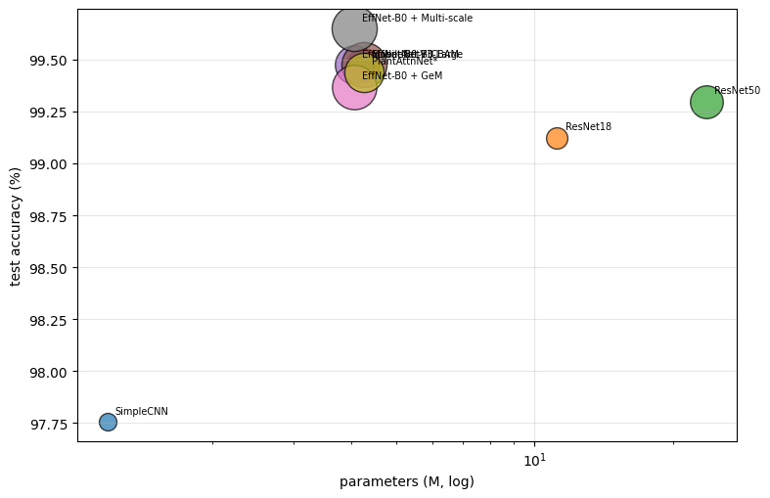
Figure 5: Test accuracy against parameter count

7.3 Training behaviour and overfitting
Figure 6 separates the models into two clear groups. Pretrained models exceeded 90% validation accuracy after one epoch and plateaued by about epoch 8, whereas the custom CNN climbed steadily until epoch 12. Train–validation gaps were at most 0.40 points, and test accuracy stayed within 0.39 points of validation accuracy (Appendix, Figure A2). There is therefore no evidence of overfitting or selection bias. The custom CNN shows a negative gap of 1.5 points because augmentation and dropout apply only during training. Final losses plateau near 0.68, close to the floor set by label smoothing, so they do not indicate underfitting (Figure A3).
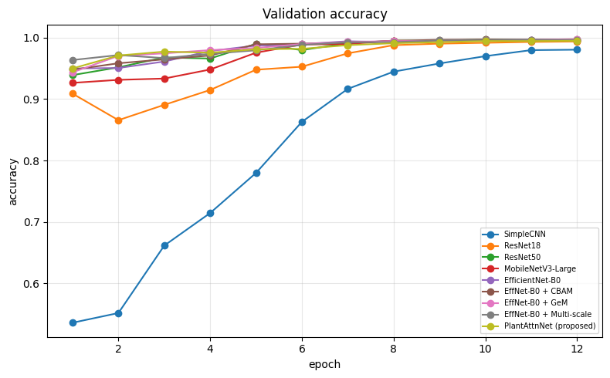
Figure 6: Validation accuracy per epoch

7.4 Ablation and statistical comparison
Figure 7 shows that the proposed model did not outperform its baseline (Table 5). PlantAttnNet scored 99.44% against 99.47% for EfficientNet-B0, a difference of one image (p = 1.00). Only the multi-scale bar rises above the baseline, gaining five images (p = 0.23), while CBAM gained none and GeM lost three. Adding CBAM and GeM to multi-scale fusion lowered accuracy by 0.21 points (p = 0.11). The hypothesis that CBAM and GeM would compound the benefit of multi-scale fusion is therefore not supported.
Table 5: Ablation on the test set (exact McNemar test against EfficientNet-B0)
Configuration | Accuracy | F1 | Params (M) | Δ accuracy (pp) | p-value
EfficientNet-B0 (baseline) | 99.47% | 0.9920 | 4.056 | – | –
+ CBAM | 99.47% | 0.9918 | 4.261 | 0.00 | 1.000
+ GeM | 99.37% | 0.9904 | 4.056 | −0.11 | 0.508
+ Multi-scale | 99.65% | 0.9947 | 4.061 | +0.18 | 0.227
PlantAttnNet (all three) | 99.44% | 0.9915 | 4.267 | −0.04 | 1.000

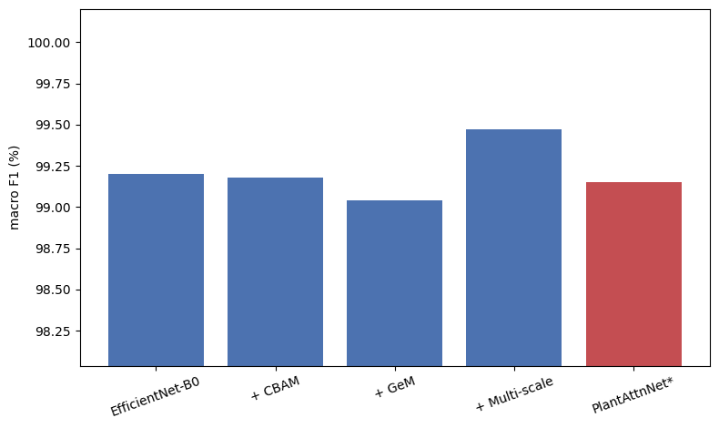
Figure 7: Ablation macro-F1 by configuration
Several explanations are plausible, although none was tested directly. Accuracy sits near a ceiling of about 99.5%, leaving little room for any module to show a gain. The randomly initialised attention layers received only 12 epochs on 13,304 images, which matches the instability reported by Jansi and BR (2026). Each model was also trained with a single seed, so differences below about 0.3 points cannot be attributed to design. With eight pairwise tests, only the comparison with the custom CNN survives a correction for multiple comparisons.

7.5 Per-class results and errors
Figure 8 shows the confusion matrix of the best model, EfficientNet-B0 with multi-scale fusion, whose near-perfect diagonal reflects only 10 errors in 2,852 test images. It scored F1 = 1.000 on 29 of 38 classes, and potato healthy was classified perfectly from eight test images. The few off-diagonal cells cluster in two places, with five corn and four tomato disease confusions. The weakest class was Cercospora leaf spot (F1 = 0.912), which fell to 0.873 for PlantAttnNet (Appendix, Figures A4 and A5). Class size was uncorrelated with F1 (Spearman ρ = −0.10, p = 0.56; Figure A6), so errors come from look-alike diseases rather than small classes.
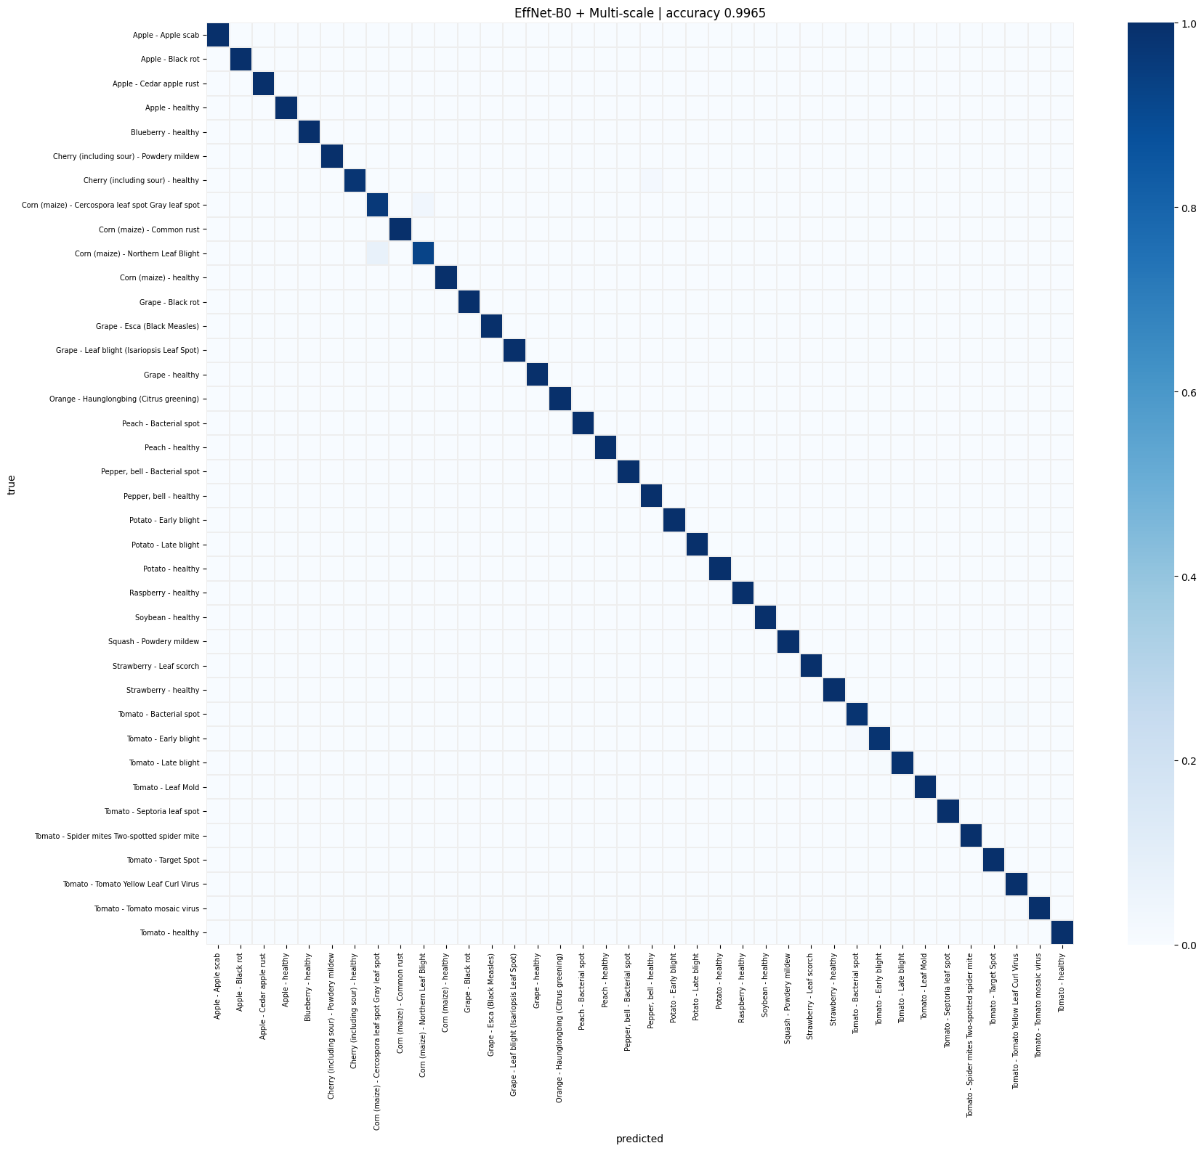
Figure 8: Confusion matrix of the best model
Figure 9 shows why these pairs are difficult. Corn leaves with northern leaf blight carry elongated tan streaks and small brown spots that resemble Cercospora gray leaf spot. Several tomato errors involve leaves with only a few faint spots, such as a bacterial spot leaf predicted as yellow leaf curl virus at 0.31 confidence. The cherry leaf predicted as healthy pepper shows no symptoms, so the model could rely only on leaf shape. Confidence on errors ranged from 0.31 to 0.87, whereas correct predictions were usually confident (Appendix, Figure A7).
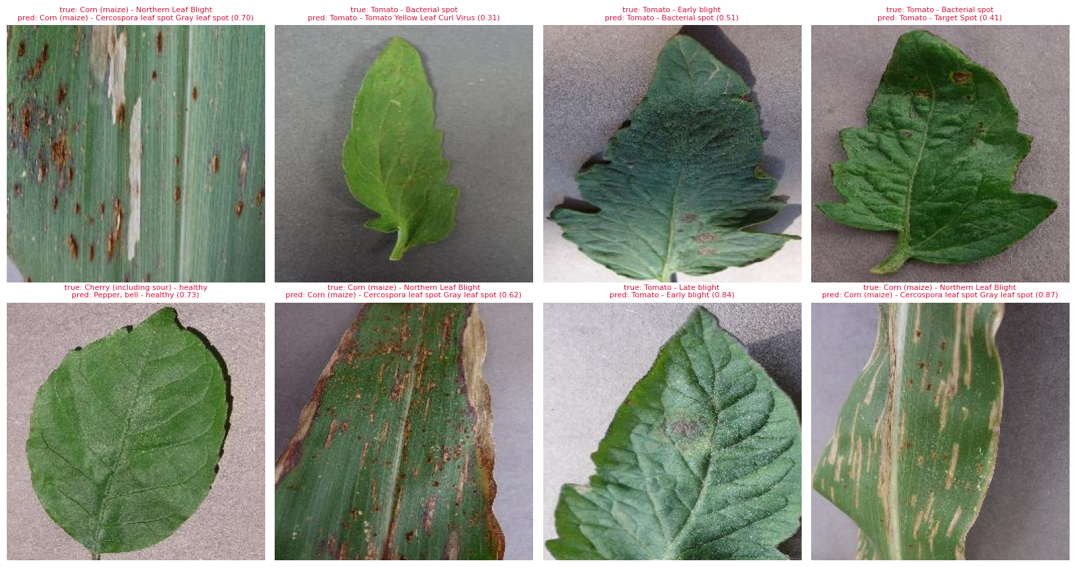
Figure 9: Misclassified test images

7.6 Confidence and calibration
Expected calibration error was 0.092–0.126, but the reliability curve lies above the diagonal, indicating under-confidence (Appendix, Figure A8). Mean confidence on correct predictions was about 0.90 while accuracy exceeded 99%, consistent with label smoothing (Wang, 2023). Probabilities should therefore be recalibrated with temperature scaling. Confidence still ranks errors usefully, since wrong predictions averaged 0.64 against 0.90 for correct ones (Figure A9). The best model made no error above 0.9 confidence, which supports referring low-confidence images to an expert.

7.7 Robustness to image degradation
Figure 10 compares accuracy under blur (radius 2), noise (σ = 25) and halved brightness on 1,000 test images (Table 6). The darkened bars stay close to the clean ones, with every pretrained model above 97.8%, but blur and noise cause large drops. EfficientNet-B0 fell to 82.8% under blur and 75.9% under noise, whereas multi-scale fusion held 90.9% and 88.8%, the highest corrupted scores. This supports the design rationale, because the stage-5 tap keeps finer lesion texture. CBAM and GeM alone also helped, with mean corrupted accuracies of 88.2% and 89.4% against 85.9% for the baseline. PlantAttnNet averaged only 86.2%, however, so the gains were not additive and remain suggestive with one seed.
Table 6: Robustness on 1,000 test images and external validation on PlantDoc (2,332 images)
Model | Clean | Blur | Noise | Dark | Mean corrupted | PlantDoc acc. | PlantDoc F1
SimpleCNN | 0.973 | 0.589 | 0.553 | 0.810 | 65.1% | 11.0% | 0.100
ResNet18 | 0.988 | 0.770 | 0.794 | 0.978 | 84.7% | 16.1% | 0.137
ResNet50 | 0.991 | 0.823 | 0.755 | 0.988 | 85.5% | 18.9% | 0.192
MobileNetV3-Large | 0.994 | 0.817 | 0.790 | 0.987 | 86.5% | 19.2% | 0.172
EfficientNet-B0 | 0.993 | 0.828 | 0.759 | 0.989 | 85.9% | 15.6% | 0.145
EffNet-B0 + CBAM | 0.992 | 0.837 | 0.818 | 0.990 | 88.2% | 18.1% | 0.164
EffNet-B0 + GeM | 0.992 | 0.893 | 0.800 | 0.989 | 89.4% | 17.2% | 0.164
EffNet-B0 + Multi-scale | 0.994 | 0.909 | 0.888 | 0.993 | 93.0% | 15.0% | 0.139
PlantAttnNet (proposed) | 0.994 | 0.827 | 0.769 | 0.991 | 86.2% | 18.7% | 0.172

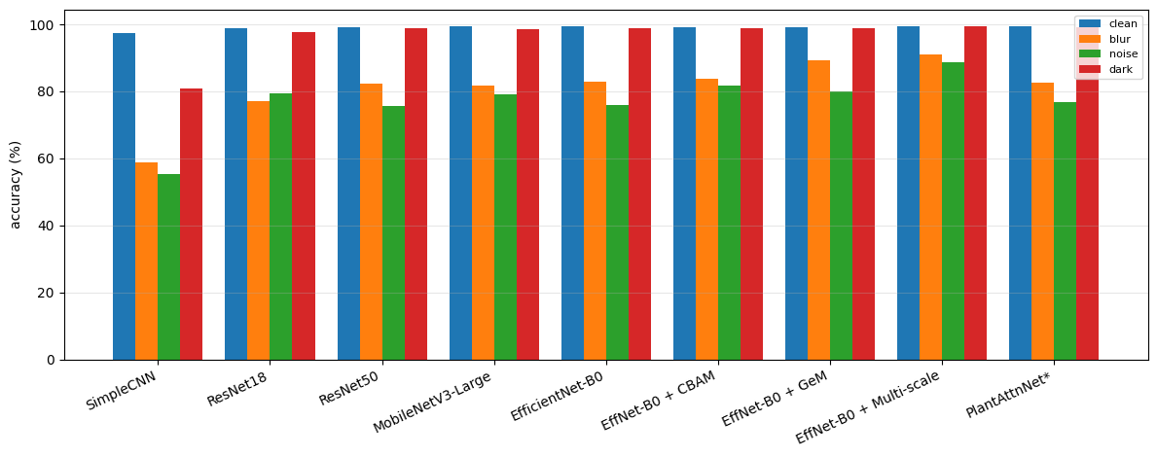
Figure 10: Accuracy under blur, noise and darkening

7.8 External validation on field images
Figure 11 sets PlantVillage accuracy beside PlantDoc field accuracy, and the gap dominates the chart. On PlantDoc, accuracy fell to 11.0–19.2%, drops of 80–87 percentage points (Table 6). In-domain rank did not predict transfer, since the best PlantVillage model scored only 15.0%, below MobileNetV3-Large (19.2%) and ResNet50 (18.9%). The collapse is consistent with the 67.7-point drop reported by Xiang, Shi and Zhu (2026), whose models shifted attention from lesions to background on field images. The manual class mapping and noisy web images add uncertainty, but a laboratory-trained model cannot be deployed in fields as it stands.
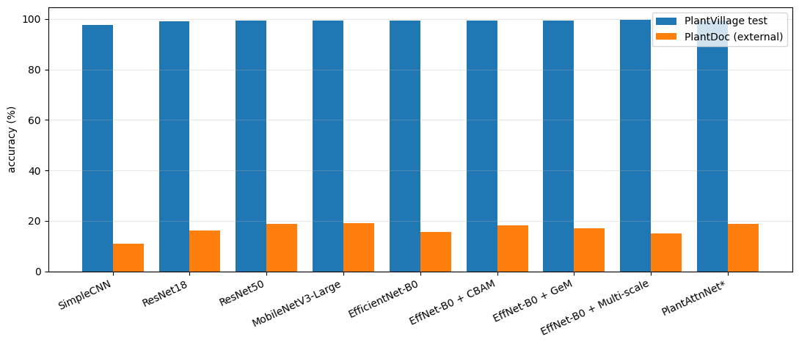
Figure 11: PlantVillage versus PlantDoc accuracy

7.9 Explainability, sustainability and ethics
Figure 12 overlays Grad-CAM heat-maps from PlantAttnNet's final block, where red marks the regions that most influenced each prediction. Such maps let agronomists judge whether a prediction rests on genuine disease symptoms. All six examples were classified correctly, yet the strongest activation lay on the leaf margin and background rather than the lesions. In the grape and corn rust examples, the central spots remain largely blue. This pattern is not proof of shortcut learning, but it agrees with reported background bias and helps explain the PlantDoc collapse (Xiang, Shi and Zhu, 2026).
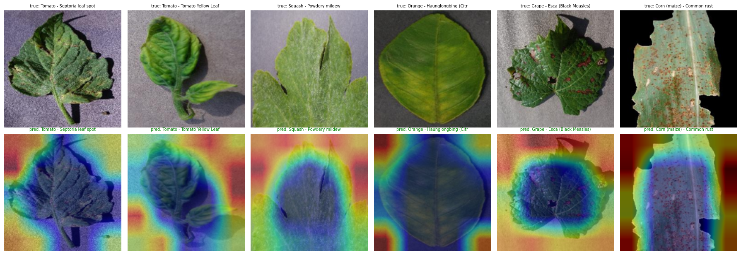
Figure 12: Grad-CAM heat-maps for PlantAttnNet
Training all nine models took 136.6 GPU-minutes, which, assuming 70 W and 0.4 kg CO₂e per kWh, amounts to 0.16 kWh or about 0.06 kg CO₂e. This footprint is small, but it grows with the number of seeds and models, and repeated inference in deployment adds further energy cost (Luccioni, Jernite and Strubell, 2024). Ethically, a false 'healthy' label can delay treatment, and a false disease label can trigger needless pesticide use. At 11–19% field accuracy, the model can serve only as decision support with human verification.
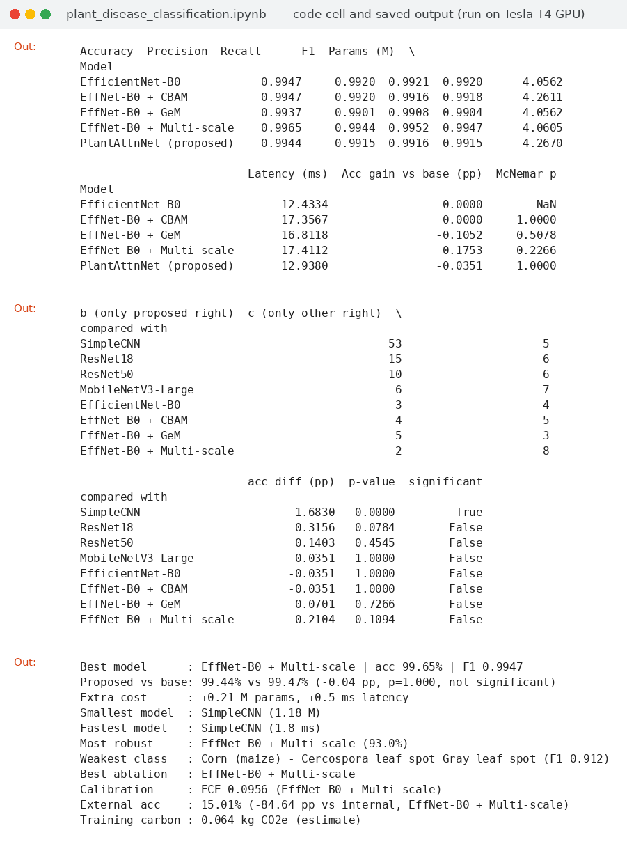
Screenshot 5: Ablation, McNemar and key-findings outputs

8. Conclusion
This study built and compared nine image classifiers for automated plant disease diagnosis. Pretrained lightweight networks reached about 99.5% accuracy on PlantVillage with around 4 million parameters, matching a 23.6-million-parameter ResNet50. The proposed PlantAttnNet is a compact, working model (4.27 million parameters, 99.44% accuracy), but it did not improve on its baseline, and no such claim is made. The ablation is more informative, because multi-scale fusion alone gave the best accuracy, F1 and robustness at negligible cost, while attention and GeM added cost without benefit. On this evidence, EfficientNet-B0 or MobileNetV3-Large, optionally with the multi-scale tap, is preferable to ResNet50 or the full PlantAttnNet for deployment.
The study has several limitations. Each model was trained with a single seed on a 35% subsample, so differences under about 0.3 points remain unresolved, and leaf-level leakage could not be excluded. Most importantly, field accuracy collapsed to 11–19%, which shows that PlantVillage accuracy is not evidence of field readiness. Future work should use repeated seeds with leaf-level splits and should train on mixed laboratory and field images with background augmentation (Arshad, Javed and Saudagar, 2026). Confidence should also be recalibrated with temperature scaling, and quantised models should be tested on devices linked to field-monitoring tools.

References
Alhammad, S.M. et al. (2025) 'Deep learning and explainable AI for classification of potato leaf diseases', Frontiers in Artificial Intelligence, 7, article 1449329. Available at: https://doi.org/10.3389/frai.2024.1449329 (Accessed: 22 September 2026).
Ansel, J. et al. (2024) 'PyTorch 2: faster machine learning through dynamic Python bytecode transformation and graph compilation', in Proceedings of the 29th ACM International Conference on Architectural Support for Programming Languages and Operating Systems, Volume 2 (ASPLOS '24). New York: ACM, pp. 929–947. Available at: https://doi.org/10.1145/3620665.3640366 (Accessed: 22 September 2026).
Arshad, Z., Javed, A. and Saudagar, A.K.J. (2026) 'ConvGeM-NeXt: a deep learning framework for plant disease detection', Frontiers in Plant Science, 17, article 1763739. Available at: https://doi.org/10.3389/fpls.2026.1763739 (Accessed: 22 September 2026).
FAO (2025) FAO Director-General calls for investments on plant health to ensure global food security [Press release]. 17 March. Available at: https://ippc.int/en/news/fao-director-general-calls-for-investments-on-plant-health-to-ensure-global-food-security/ (Accessed: 22 September 2026).
Jansi, E. and BR, K. (2026) 'EfficientNet-CBAM-prototype: an attention-guided EfficientNet framework with dynamic prototype representation for tomato disease classification', Frontiers in Plant Science, 17, article 1918175. Available at: https://doi.org/10.3389/fpls.2026.1918175 (Accessed: 22 September 2026).
Luccioni, S., Jernite, Y. and Strubell, E. (2024) 'Power hungry processing: watts driving the cost of AI deployment?', in Proceedings of the 2024 ACM Conference on Fairness, Accountability, and Transparency (FAccT '24). New York: ACM, pp. 85–99. Available at: https://doi.org/10.1145/3630106.3658542 (Accessed: 22 September 2026).
Nigar, N. et al. (2024) 'Improving plant disease classification with deep-learning-based prediction model using explainable artificial intelligence', IEEE Access, 12, pp. 100005–100014. Available at: https://doi.org/10.1109/ACCESS.2024.3428553 (Accessed: 22 September 2026).
Shoaib, M. et al. (2023) 'An advanced deep learning models-based plant disease detection: a review of recent research', Frontiers in Plant Science, 14, article 1158933. Available at: https://doi.org/10.3389/fpls.2023.1158933 (Accessed: 22 September 2026).
Wang, C. (2023) 'Calibration in deep learning: a survey of the state-of-the-art', arXiv preprint arXiv:2308.01222. Available at: https://doi.org/10.48550/arXiv.2308.01222 (Accessed: 22 September 2026).
Wang, Y., Zhang, P. and Tian, S. (2024) 'Tomato leaf disease detection based on attention mechanism and multi-scale feature fusion', Frontiers in Plant Science, 15, article 1382802. Available at: https://doi.org/10.3389/fpls.2024.1382802 (Accessed: 22 September 2026).
Xiang, K., Shi, D. and Zhu, X. (2026) 'Quantifying the reliability gap in cross-domain plant disease classification: benchmarking the limited efficacy of standard mitigation techniques under controlled-to-field shift', Frontiers in Plant Science, 17, article 1826962. Available at: https://doi.org/10.3389/fpls.2026.1826962 (Accessed: 22 September 2026).
Zhang, J. et al. (2025) 'LDL-MobileNetV3S: an enhanced lightweight MobileNetV3-small model for potato leaf disease diagnosis through multi-module fusion', Frontiers in Plant Science, 16, article 1656731. Available at: https://doi.org/10.3389/fpls.2025.1656731 (Accessed: 22 September 2026).

Appendix: Supplementary Figures
The figures below are generated by the notebook and support the discussion in Section 7. They are referenced in the text as Figures A1 to A9.
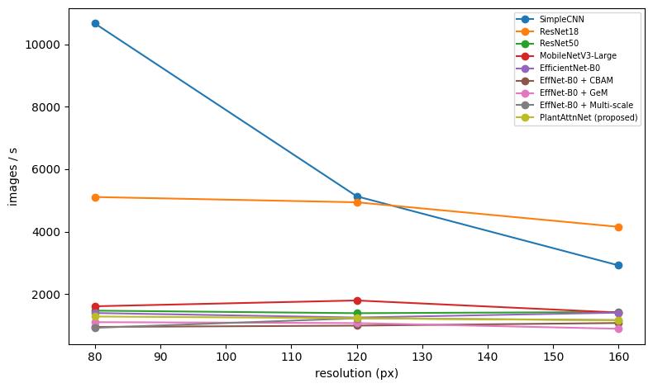
Figure A1: Throughput against input resolution
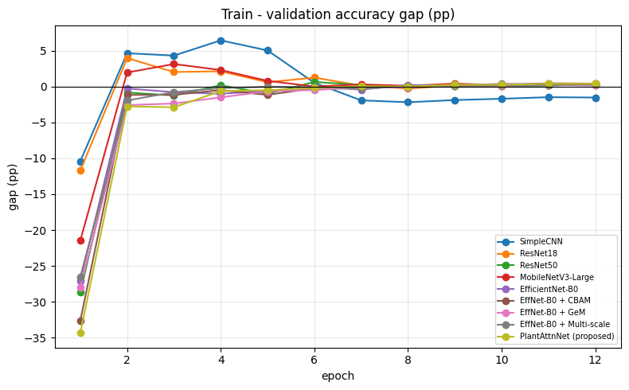
Figure A2: Train–validation accuracy gap per model
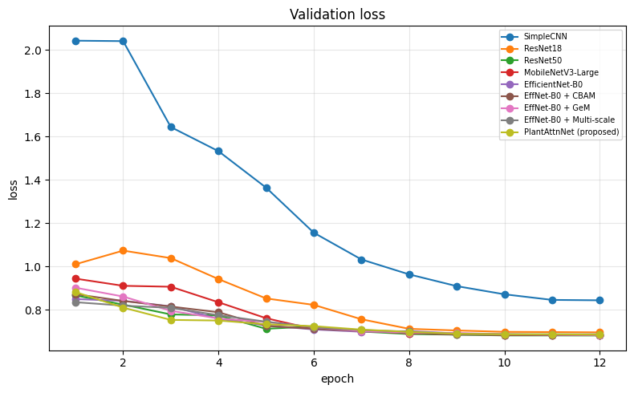
Figure A3: Validation loss per epoch
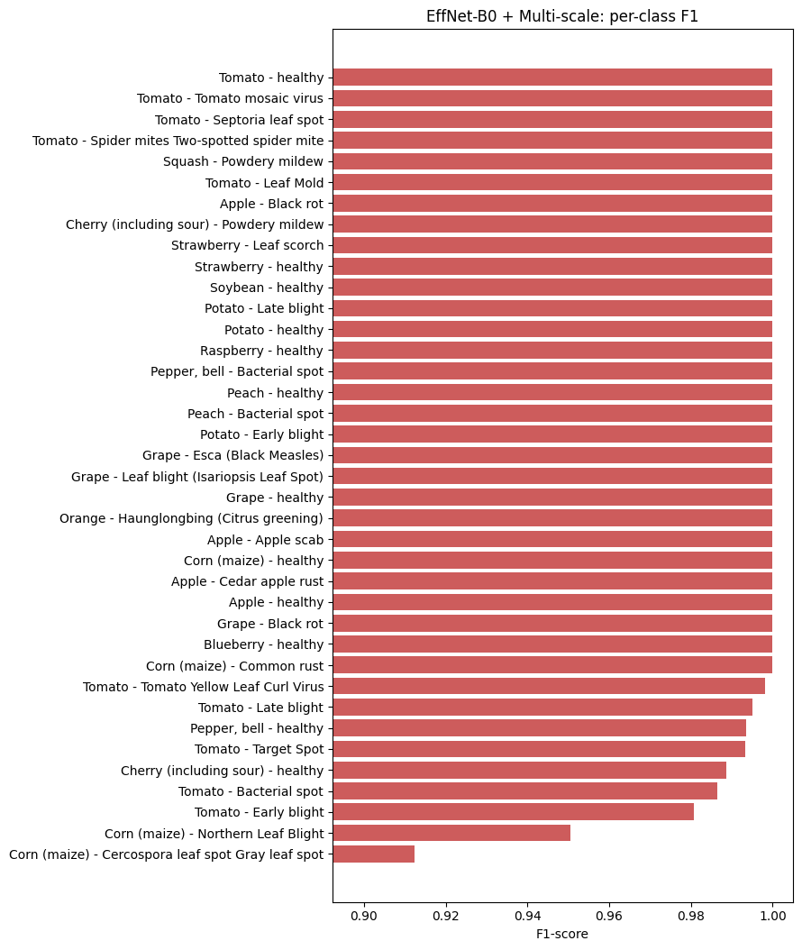
Figure A4: Per-class F1-score of the best model
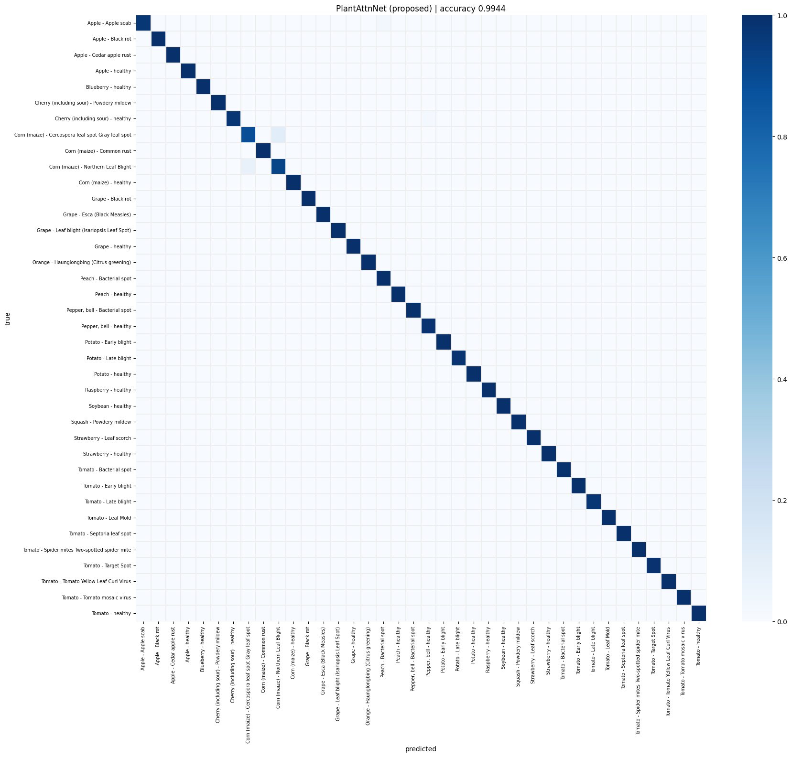
Figure A5: Confusion matrix of PlantAttnNet
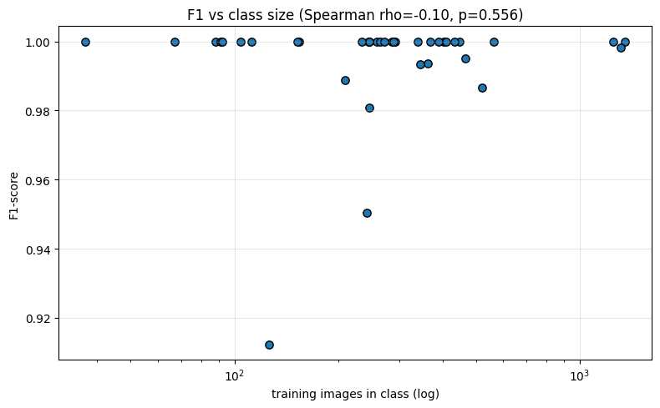
Figure A6: Per-class F1-score against the number of training images
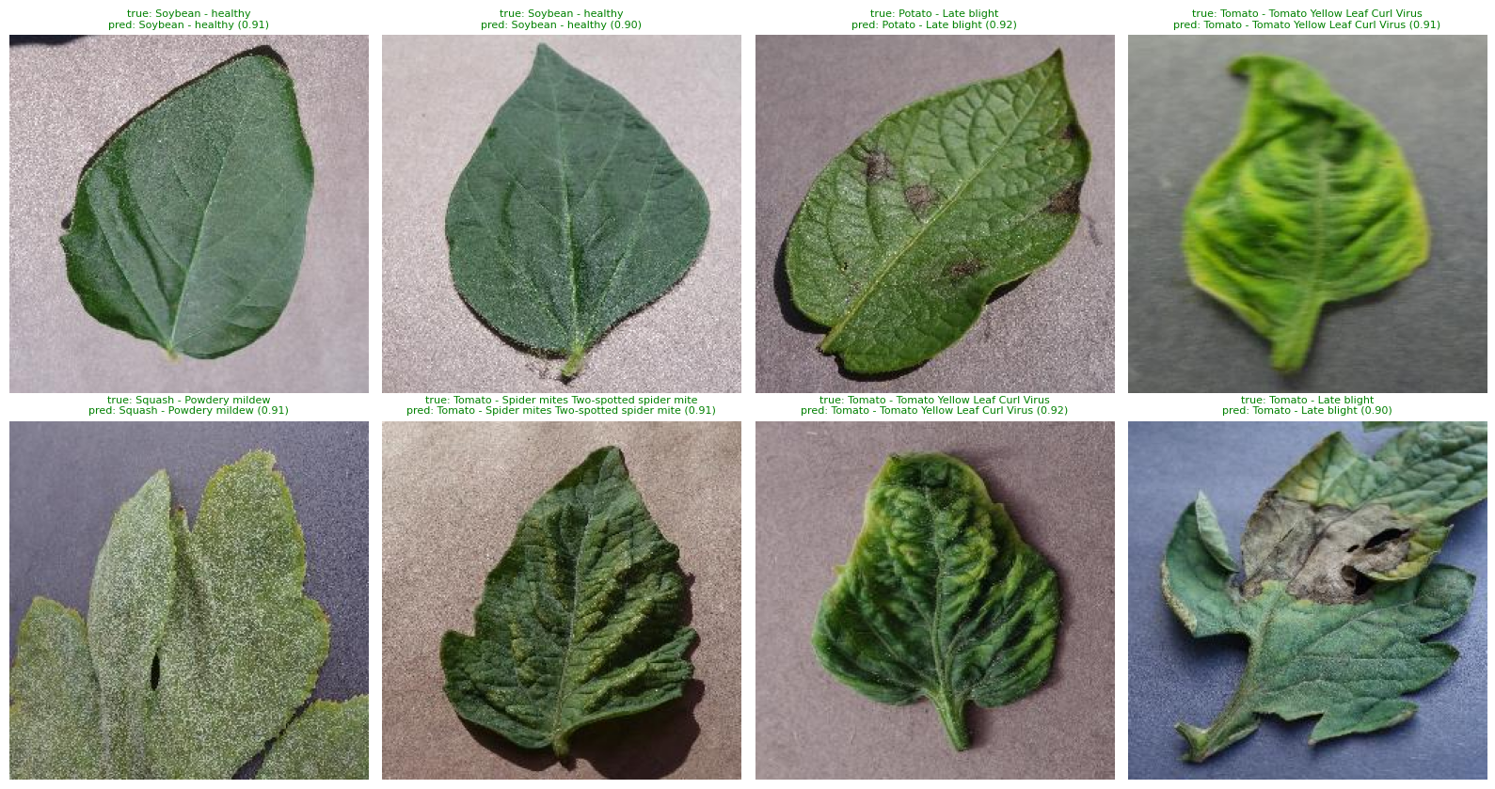
Figure A7: Example test predictions from PlantAttnNet
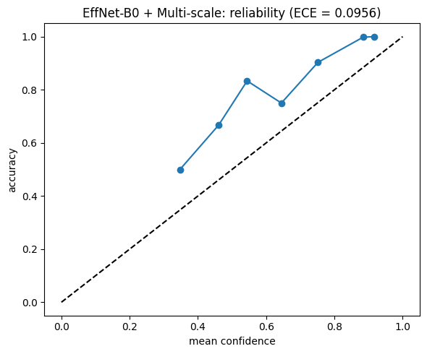
Figure A8: Reliability diagram of the best model
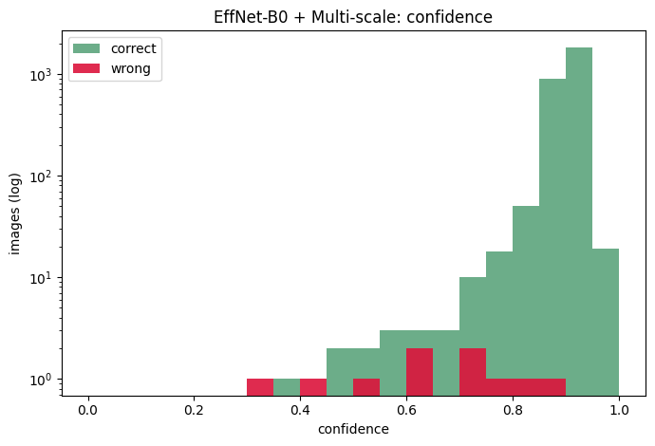
Figure A9: Confidence of correct and wrong predictions for the best model

