05-High-Level-Design
ATS‑V3 Enterprise Recruitment Operating System

Document Control
Version | 1.0
Status | Draft Enterprise Edition
Owner | ATS-V3 Architecture Team
Classification | Internal
Purpose | High Level Architecture
Audience | CTO, Architects, Developers

Revision History
Version | Date | Author | Description
1.0 | 2026-06-18 | OpenAI | Initial enterprise draft

Executive Summary
ATS‑V3 provides Applicant Tracking, CRM, AI Matching, Reporting and Workflow Automation within a secure multi-tenant SaaS architecture.

Architecture Diagram
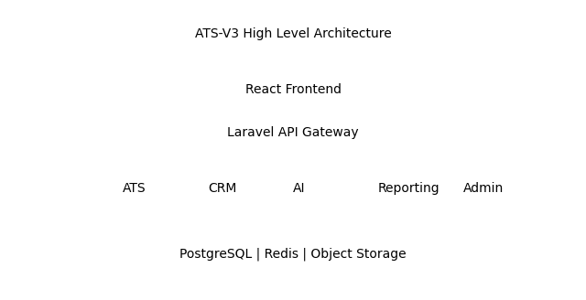

Architecture Principles
API First
Cloud Native
Secure by Design
Tenant Isolation
Auditability
Scalability

Capability Matrix
Capability | Description | Priority
ATS | Jobs, candidates, applications | High
CRM | Companies and contacts | High
AI | Matching and recommendations | High
Reporting | Operational and executive analytics | High

Sample Business Workflow
Create Job → Create Job Profile → Upload CV → Candidate Profile → Match → Application → Interview → Offer → Hire

Security Model
RBAC, MFA-ready authentication, encryption at rest, encryption in transit, audit logging and tenant isolation.

Traceability Example
Business Objective | Functional Requirement | Business Rule | Test Case
BO-001 Reduce Time-to-Hire | FR-007 Execute Match | BR-001 93% Rule | TC-001 Score=93

