06-Low-Level-Design (Enterprise Edition)

Document Control
Version | 1.0
Status | Enterprise Draft
Owner | ATS-V3 Architecture Team
Audience | Developers, Architects
Purpose | Implementation Blueprint

Executive Summary
Defines the internal implementation architecture, service boundaries, validation framework, event model, security controls and audit requirements for ATS‑V3.

Module Interaction Diagram
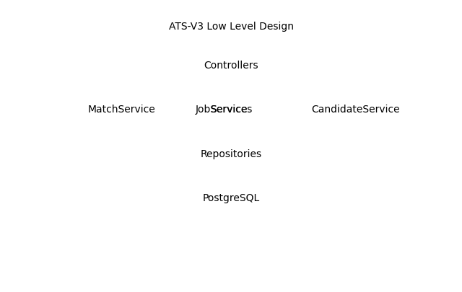

Service Catalogue
Service | Responsibility | Criticality
JobService | Job lifecycle management | High
CandidateService | Candidate lifecycle | High
MatchService | Scoring and recommendations | Critical
ApplicationService | Application workflow | High
ReportingService | Analytics and exports | Medium

Validation Matrix
Rule ID | Field | Validation | Failure
VR-JOB-001 | Title | Required | ValidationError
VR-CV-002 | CV File | PDF/DOCX | ValidationError
VR-MATCH-001 | Candidate Profile | Must Exist | BusinessRuleViolation

Event Catalogue
JobCreated, JobPublished, CVUploaded, MatchCompleted, CoverLetterGenerated, ApplicationSubmitted, InterviewScheduled, OfferCreated.

Permission Matrix
Admin=Full Access | Recruiter=ATS Operations | Hiring Manager=Review & Interview | Viewer=Reporting Only

Sample Domain Object
Job
id: 1001
title: Senior Software Engineer
status: Open
requiredSkills: Laravel, React, AWS

Audit Requirements
All create/update/delete actions, workflow transitions, matching decisions and permission changes must be persisted.

Traceability Matrix
BO-001 -> FR-007 -> BR-001 -> TC-001

