08-Database-Schema (Enterprise Edition)

Document Control
Version | 1.0
Status | Enterprise Draft
Owner | Data Architecture Team
Purpose | Authoritative Data Model
Audience | Architects, Developers, DBAs

Executive Summary
Defines the enterprise data architecture, ownership model, retention strategy, indexing standards and entity relationships for ATS‑V3.

Entity Relationship Diagram
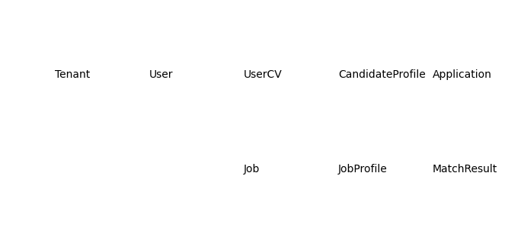

Core Entity Catalogue
Entity | Purpose | Owner | Retention
Tenant | Ownership boundary | Platform | Life of tenant
User | System access | Tenant | Configurable
Job | Hiring requirement | Recruiter | Configurable
CandidateProfile | Candidate record | Recruiter | Configurable
Application | Hiring workflow | Recruiter | Configurable
AuditLog | Compliance record | System | 7 years

Data Dictionary Example
Field | Type | Required | Index | Description
title | varchar | Yes | No | Job title
status | enum | Yes | Yes | Workflow state
tenant_id | uuid | Yes | Yes | Ownership key

Index Strategy
Composite indexes: tenant_id,status and tenant_id,created_at. Full text indexes for candidate_profiles and job_profiles.

Retention Matrix
Audit Logs=7 Years, Applications=Tenant Policy, AI Records=Tenant Policy, Reports=Tenant Policy.

Sample Record
Job
id=1001
title=Senior Software Engineer
status=Open
tenant_id=T001

Ownership Rules
Every business record must belong to a tenant. Cross-tenant access is prohibited and audited.

