09-API-Specification (Enterprise Edition)

Document Control
Version | 1.0
Status | Enterprise Draft
Owner | Platform Engineering
Purpose | Authoritative API Contract
Audience | Developers, Integrators

Executive Summary
Defines all external and internal API contracts, authentication, authorization, validation, auditing and integration patterns.

API Architecture Diagram
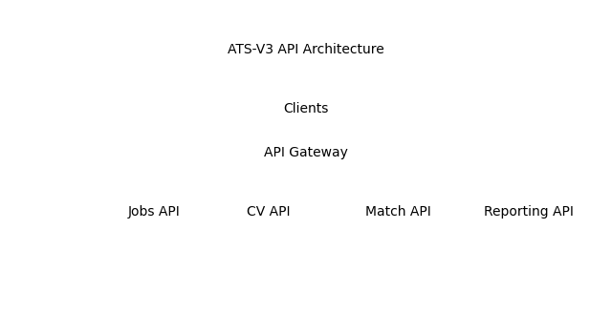

Endpoint Catalogue
Endpoint | Method | Purpose | Auth
/api/jobs | POST | Create Job | Required
/api/cvs | POST | Upload CV | Required
/api/match | POST | Execute Match | Required
/api/reports | GET | Reporting | Required

Sample Request
POST /api/match
{"jobId":1001,"candidateId":5001}

Sample Response
{"score":95,"route":"Main","coverLetterGenerated":true}

Validation Matrix
Tenant Context Required | Authentication Required | Authorization Required | Mandatory Fields Required

Error Catalogue
Code | Name | Description
400 | ValidationError | Request validation failed
401 | Unauthorized | Authentication required
422 | BusinessRuleViolation | Business rule failed

Webhook Catalogue
JobCreated, MatchCompleted, ApplicationSubmitted, OfferCreated

Audit Event Matrix
JobCreated | CVUploaded | MatchExecuted | ApplicationCreated | UserUpdated

Traceability Matrix
FR-007 Execute Match -> API /api/match -> BR-001 -> TC-001

