10-Matching-Engine-Design (Enterprise Edition)

Document Control
Version | 1.0
Status | Enterprise Draft
Owner | AI & Matching Team
Purpose | Authoritative Matching Specification
Audience | Architects, Developers, Product Owners

Executive Summary
Defines how ATS‑V3 evaluates candidate suitability, performs scoring, identifies gaps, generates recommendations and routes outcomes.

Matching Decision Diagram
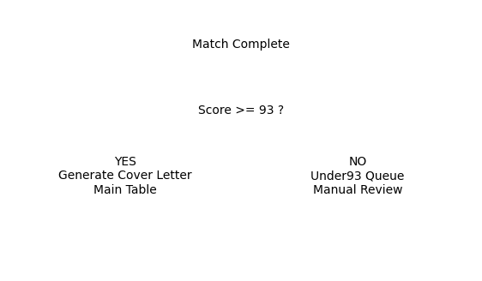

Scoring Matrix
Factor | Weight | Description
Skills | 40% | Required and preferred skills
Experience | 25% | Years and relevance
Certifications | 15% | Required certifications
Education | 10% | Qualification alignment
Bonus Factors | 10% | Industry/domain alignment

Gap Analysis Workflow
Identify missing skills, certifications, experience and qualifications. Produce development recommendations and recruiter guidance.

Recommendation Engine
Generate strengths, weaknesses, suitability summary and ranking recommendations.

Business Rule Mapping
BR-001 93% Cover Letter Rule | BR-002 Under93 Routing Rule | BR-007 Match Eligibility Rule

Decision Table
Score | Route | Cover Letter
95 | Main | Yes
93 | Main | Yes
92 | Under93 | No

Sample Match Record
Candidate: Jane Smith
Job: Senior Software Engineer
Score: 95
Route: Main
Cover Letter: Generated
Missing Skills: Kubernetes

Boundary Test Matrix
92=Under93 | 93=Cover Letter | 94=Cover Letter | Missing Candidate=Validation Failure

Audit Matrix
MatchStarted | MatchCompleted | RecommendationGenerated | CoverLetterGenerated | RouteSelected

Traceability Matrix
BO-002 Improve Match Quality -> FR-007 Execute Match -> BR-001 -> TC-MATCH-001

