ATS-Engine-System-Context-Diagram

Page 1 – Architecture Asset
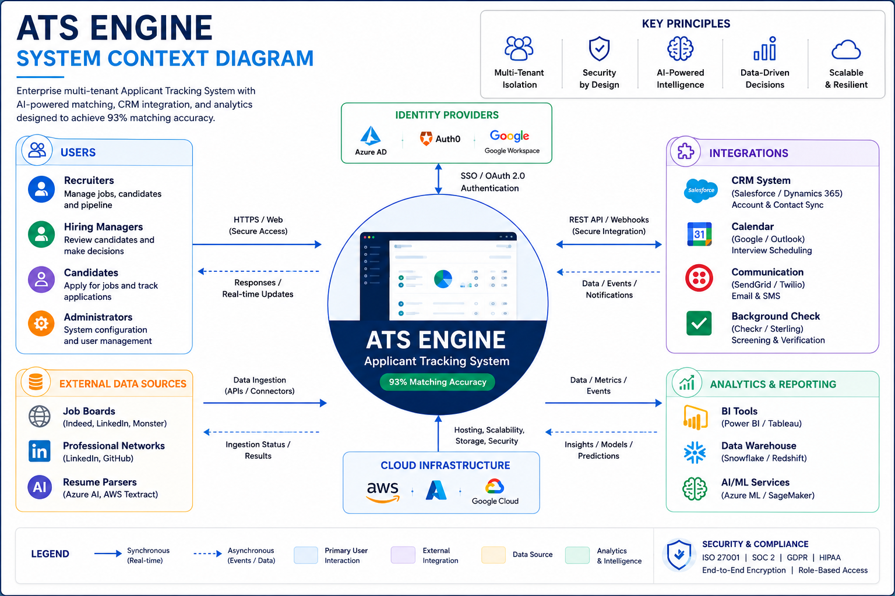

Page 2 – High-Level Description

Purpose
Provide a high-level view of ATS Engine users, external systems, integrations, infrastructure, analytics, and security boundaries.

Scope
Defines the system boundary and major interactions between ATS Engine and external actors.

Internal Actors
Recruiters, Hiring Managers, Administrators, and operational users.

External Actors
Candidates and third-party consumers of ATS Engine services.

Identity Providers
Azure AD, Auth0, Google Workspace and other SSO providers.

External Data Sources
Job boards, professional networks, CV sources and imported datasets.

Integrations
CRM, communications, calendars, background screening and external APIs.

Analytics & Reporting
BI tools, dashboards, AI/ML services and reporting exports.

Infrastructure
Cloud platform, storage, networking, monitoring and operational services.

Security & Compliance
RBAC, tenant isolation, audit logging, encryption and compliance controls.

Key Principles
Security first, audit first, API first, multi-tenant by design and scalable architecture.

Page 3 – Asset Governance & Traceability
Asset ID: ARCH-001
Asset Name:
ATS-Engine-System-Context-Diagram
Status:
Approved
Referenced By:
- ATS-Engine-Architecture-Canon.docx
- ATS-Engine-High-Level-Design.docx
- ATS-Engine-Low-Level-Design.docx
- ATS-Engine-Security-Architecture.docx
Owner:
Architecture Team
Diagram Standard:
DR-001 through DR-016
Purpose:
Authoritative system context view for ATS Engine.

