ATS-Engine-High-Level-Design
Starter enterprise document with embedded ATS Engine assets.

ATS-Engine-Platform-Overview
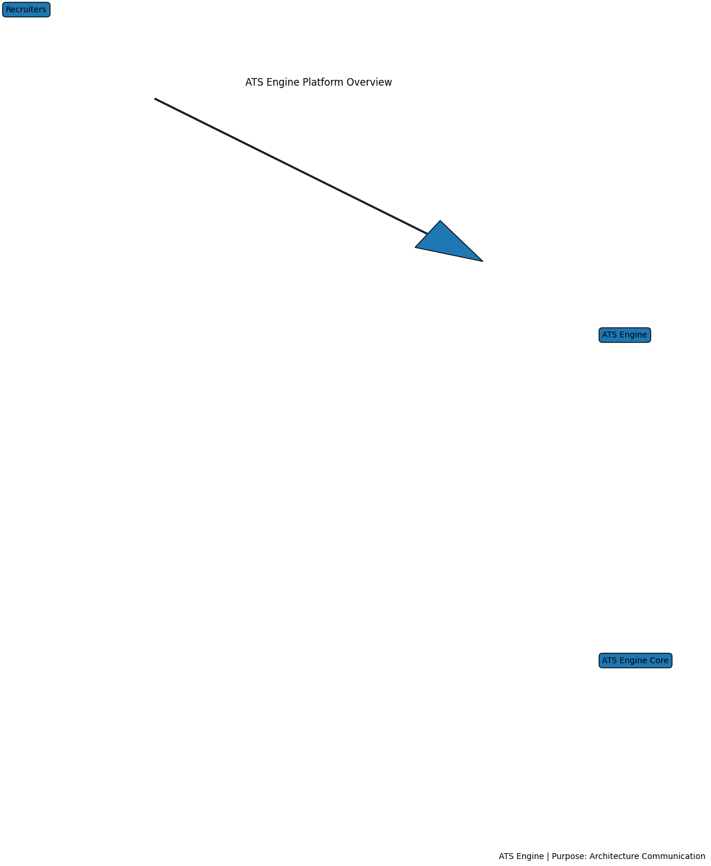
Business Context, Technical Context, Validation Rules, Examples and Test Scenarios to be expanded.

ATS-Engine-System-Context
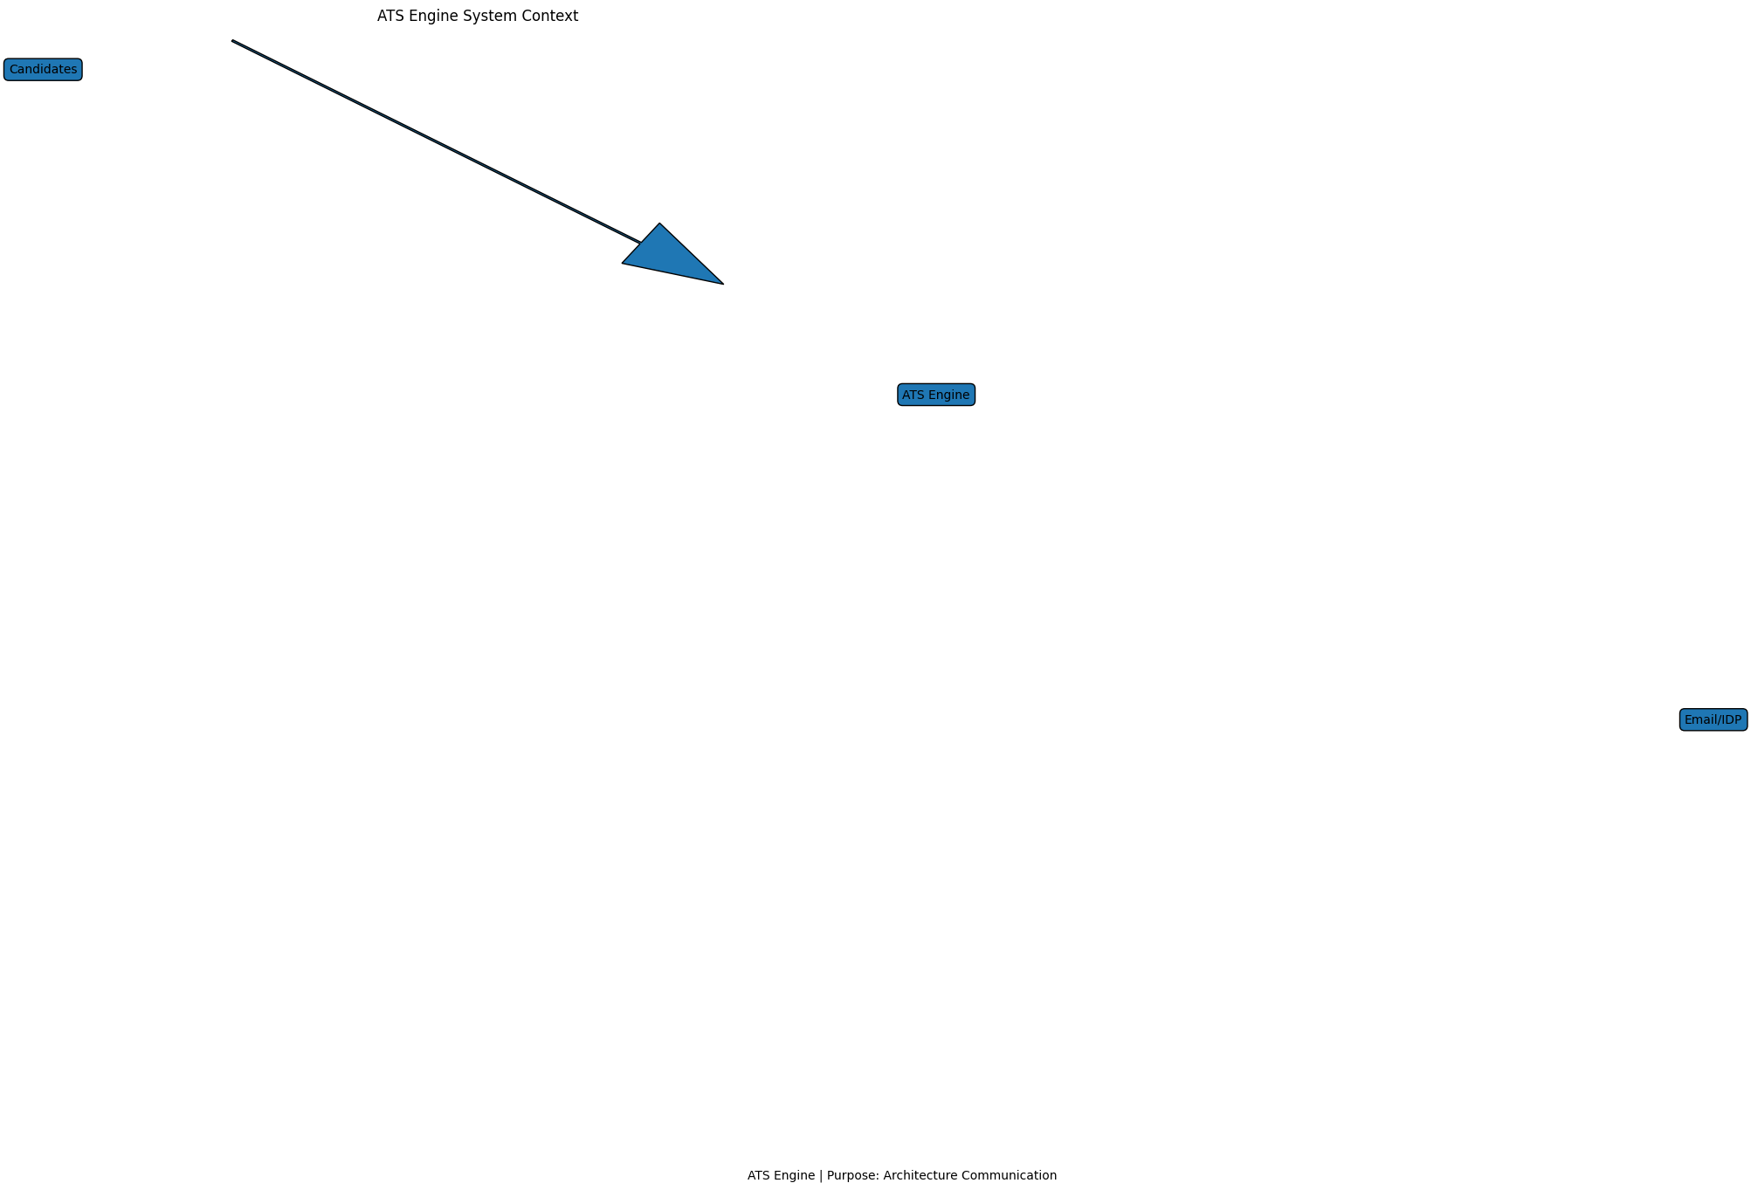
Business Context, Technical Context, Validation Rules, Examples and Test Scenarios to be expanded.

ATS-Engine-Candidate-Journey
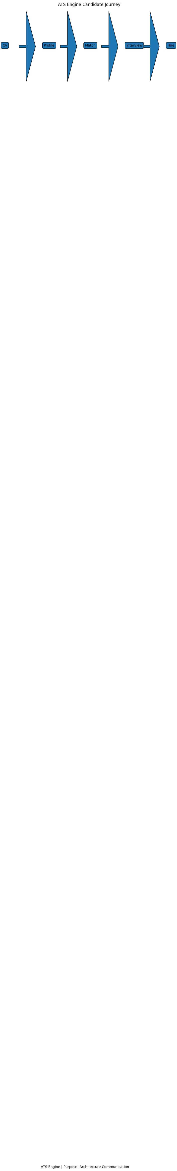
Business Context, Technical Context, Validation Rules, Examples and Test Scenarios to be expanded.

ATS-Engine-93-Percent-Decision-Tree
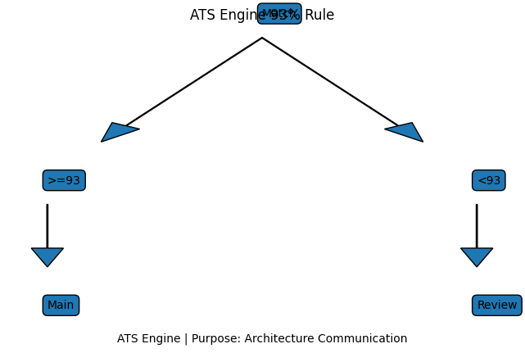
Business Context, Technical Context, Validation Rules, Examples and Test Scenarios to be expanded.

