


COLLATERAL MANAGEMENT AGREEMENT

This collateral agreement is made on this {{DATE}} between the buyer and the seller.
Whereas;
- {{TRANSACTION_SENTENCE}}

It is now agreed as follows;
- The collateral will be stored under a {{BASIS}} custody basis {{LOCATION}}
- That in case of default on the commitments by either party after 7 days of signing of this agreement the aggrieved party will automatically claim right and take possession of the above collateral.

In witness thereof, both parties hereby affix their signatures in the presence of their respective witness on the date and place first above written.

For and behalf of seller For and behalf of buyer

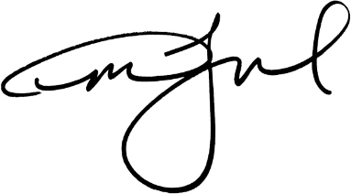
Signature Signature

{{STAMP_DATE}}

