


INVOICE

Invoice No: {{INVOICE_NO}}
Product: Gold
Quantity: {{QUANTITY}}
Date: {{DATE}}

No. | Description | Rate | Amount (USD)
{{ROW_1}}
{{ROW_2}}
{{ROW_3}}
{{ROW_4}}
{{ROW_5}}
{{ROW_6}}
{{ROW_7}}
{{ROW_8}}
{{ROW_9}}
{{ROW_10}}
 | TOTAL AMOUNT PAYABLE |  | {{TOTAL_AMOUNT}}

PAYMENT DETAILS (USD ACCOUNT)
Account Name: Musyoka, Shikumo & Associates Advocates LLP
Account Number: 8702489083000
Bank: Standard Chartered Bank (K) Limited Branch: Chiromo Branch
Bank Code: 02
SWIFT Code: SCBLKENXXX
Currency: USD

Wallet Payment Details: THBUv9Q4hCL7P55z8BkeaaCA2w5QATnrN5
TRC 20

{{STAMP_DATE}}

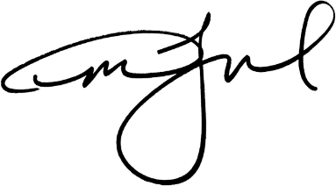
Issued On Behalf of Haq Enterprises LTD

