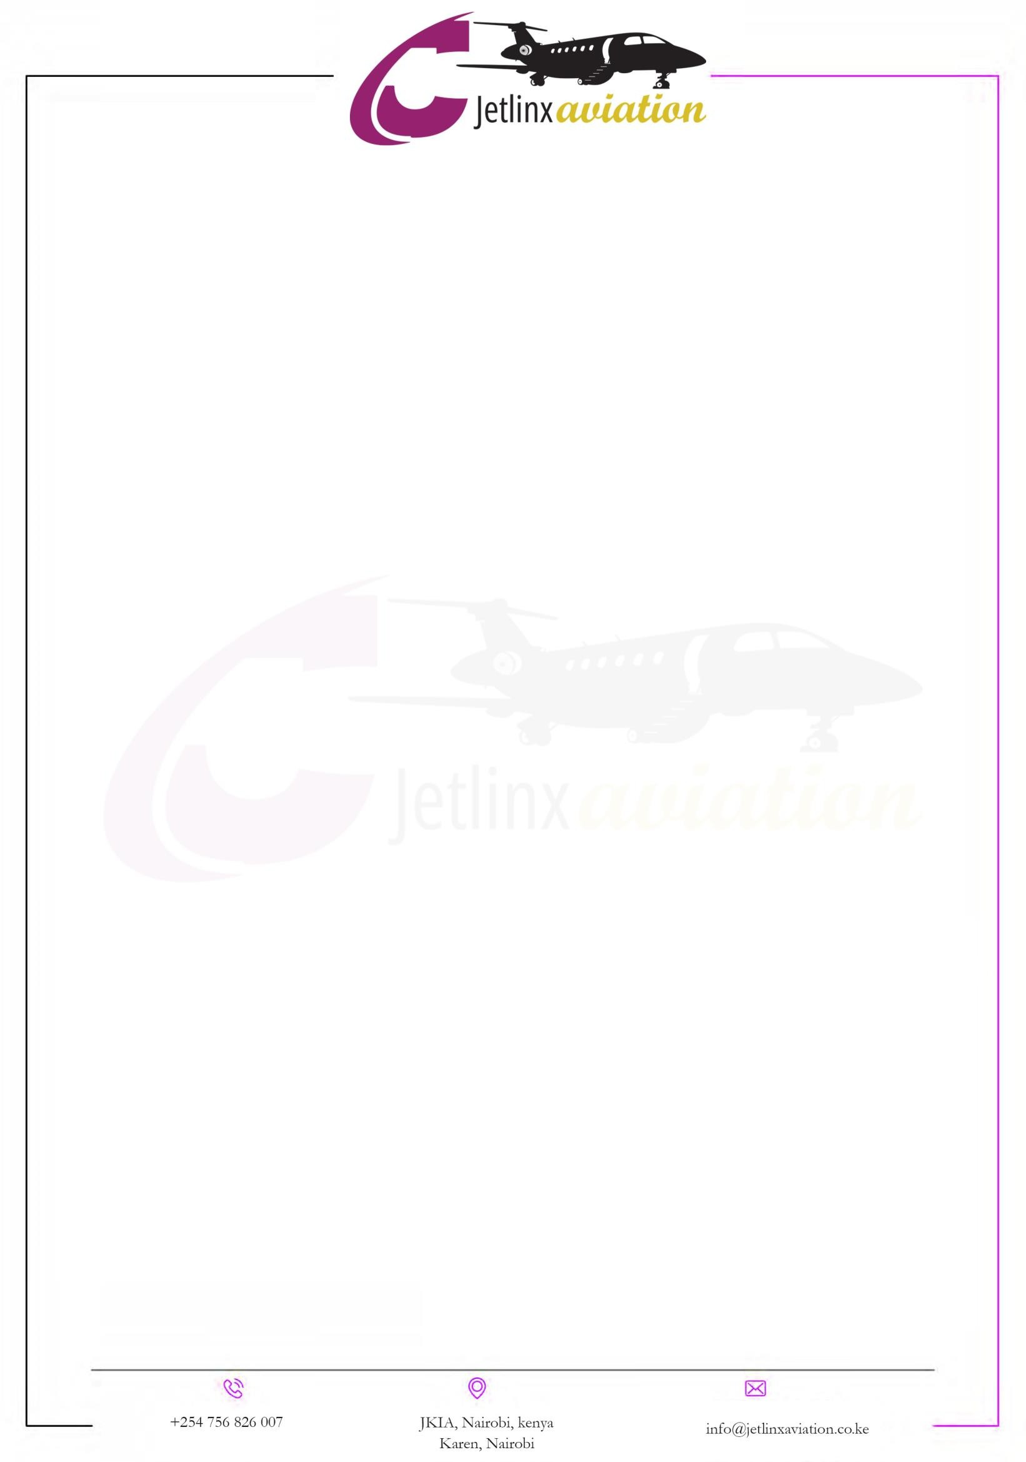
Charter Quote {{CHARTER}}

CLIENT DETAILS AIRCRAFT CHARTER QUOTE

Company: |  | From: | JetLinxaviation
Attention: | END BUYER | Tel: | +254 104 530005
Contact Number |  | Mobile: | +254 104 530005
Email Address: |  | Email Address: | info@jetlinxaviation.co.ke
Date: | {{DATE1}} | 24 Hour Contact | +254 104 530005
Quote Expiry Date: | {{EXPIRY_DATE}} | Email: | info@jetlinxaviation.co.ke
Quotation Reference: {{REF_NO}}

FLIGHT DETAILS
DATE | Cargo Weight | FROM | TO | FLT. TIME | PAX | CREW
{{DATE2}} | {{WEIGHT}} | JOMO KENYATTA  INTERNATIONAL  AIRPORT, NAIROBI(JKIA) | {{TOWN}},  {{COUNTRY}}  ({{CODE}}) | {{FLIGHT_TIME1}} | {{PAX}} | {{CREW}}

Charter Total (USD) | USD: {{TOTAL_AMOUNT}} (VAT Zero Rated)
Subject to: Aircraft availability upon written confirmation | Industry and / or related fuel fluctuations

BENEFICIARY DETAILS:

Account Name | Musyoka, Shikumo & Associates Advocates LLP Account
Bank Name | Standard Chartered Bank (K) Limited
Bank Branch | Chiromo Branch
Account Number | 8702489083000
Account Type | DOLLAR (USD)
Swift Code | SCBLKENXXX
Bank Code | 02

{{ROUTE_MAP}}

KENYA {{COUNTRY}}
NBO {{CODE}}

NAIROBI

Distance
{{DIST_MILES}}miles· ({{DIST_KM}} km)

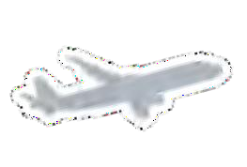
Route
{{TOWN}}

Flight time
{{FLIGHT_TIME2}}

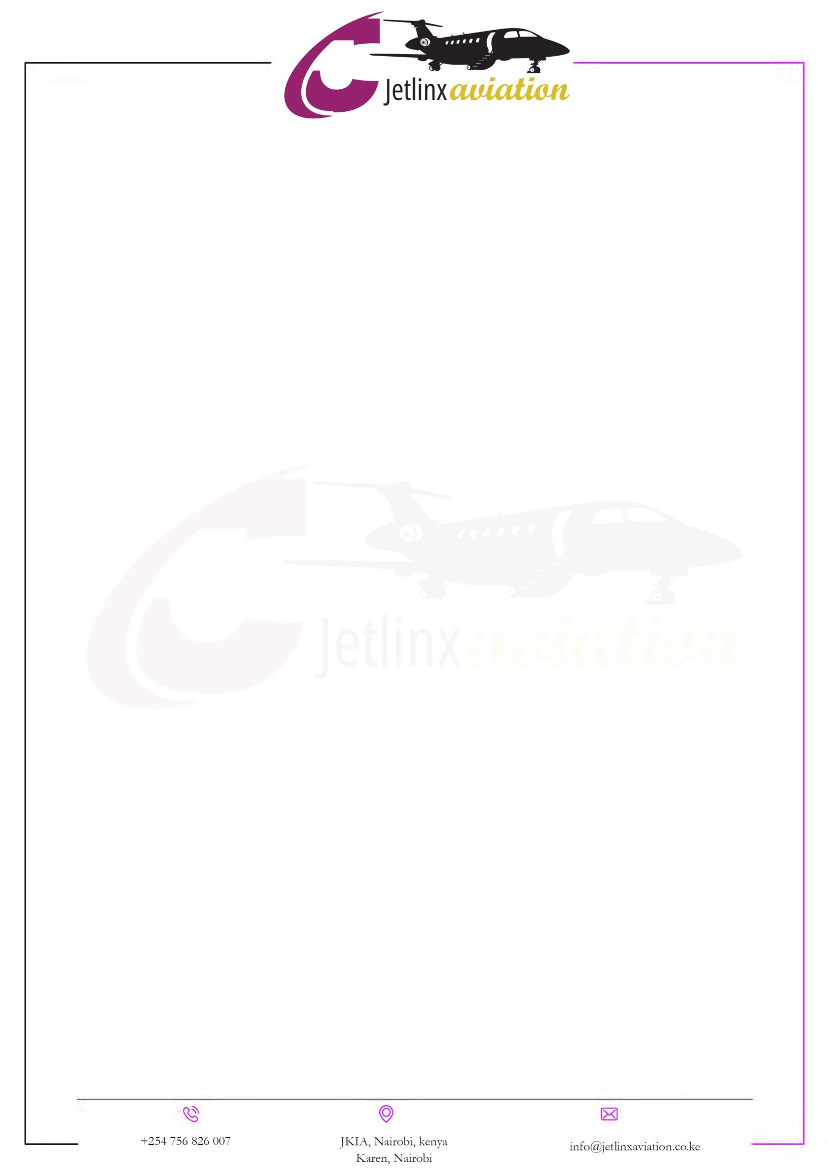

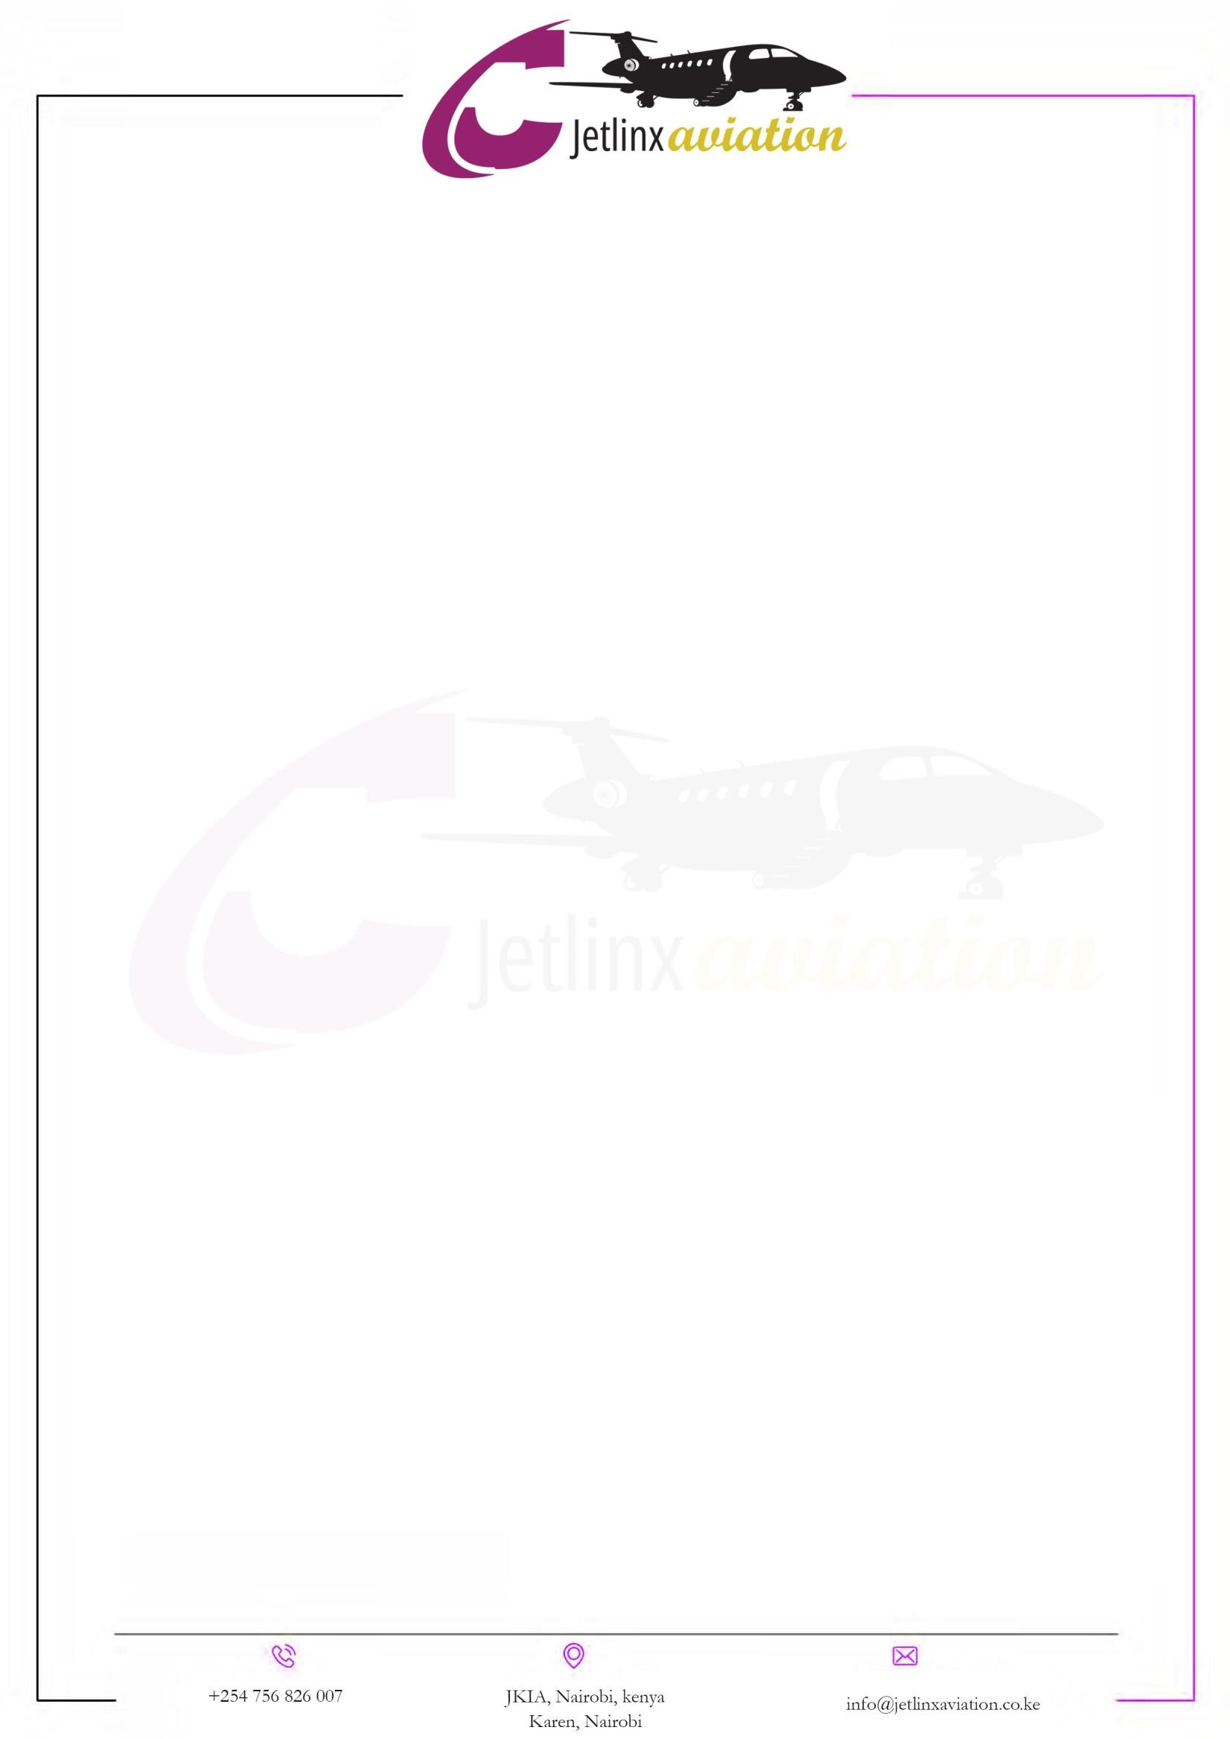
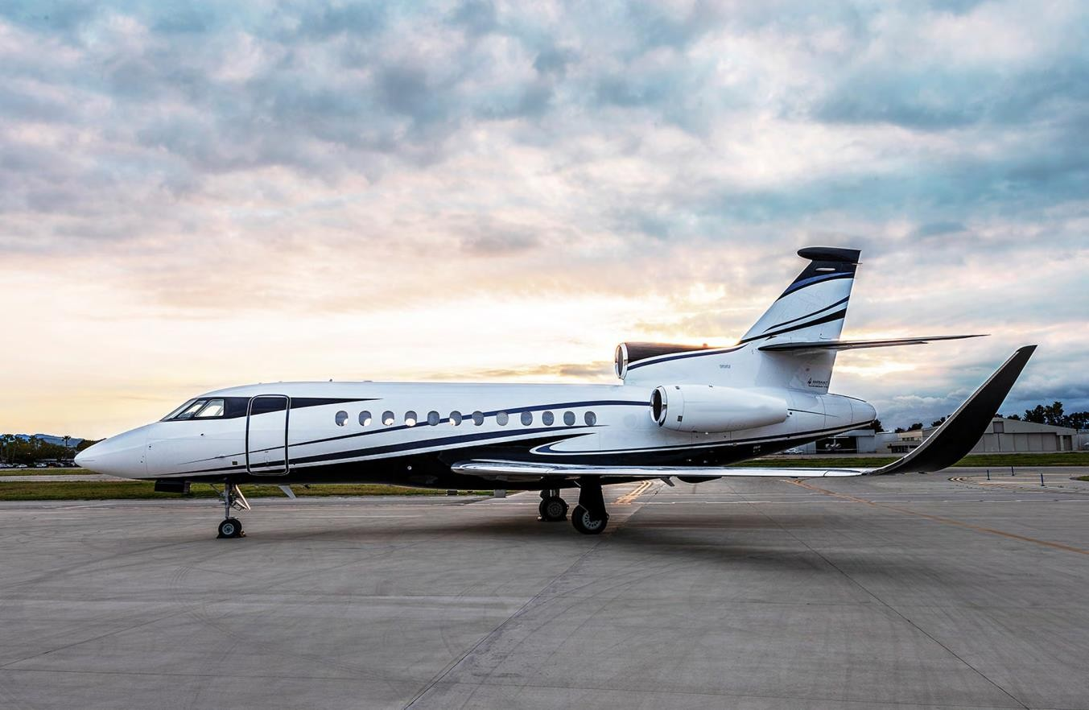

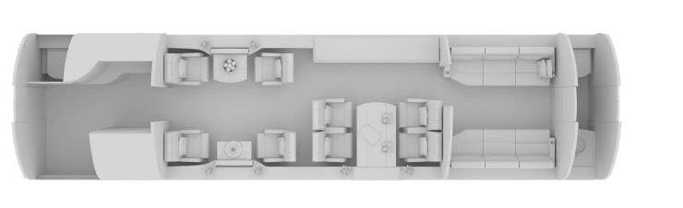


AIRCRAFT PICTURES

{{CHARTER}}

Up to 12* suitcases 3.60m³ - 127ft³
10 pax
*depending on size of suitcases
4500 nm*
*depending on pax, load and weather

Pets allowed | No
DIMENSIONS  Max. length | 10.11 m | 33 ft 2 in
Max. width | 2.34 m | 7 ft 8 in
Max. height | 1.88 m | 6 ft 2 in
DVD Player | No
WIFI | Yes - at additional cost
Satphone/iPhone | Yes
iPad | 2 iPads
Galley | Fully equipped with Microwave, Oven and Coffee Machine.
Aircraft Charter Quotation


{{CHARTER}}
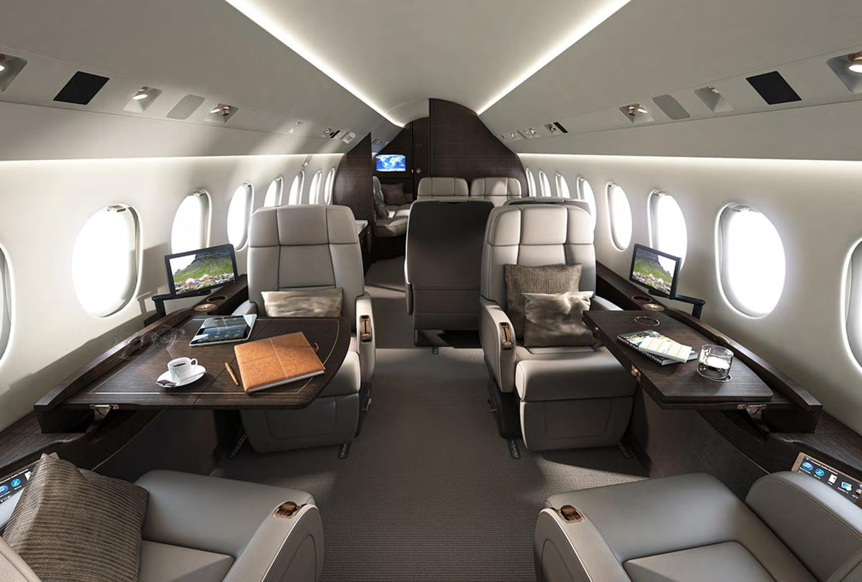
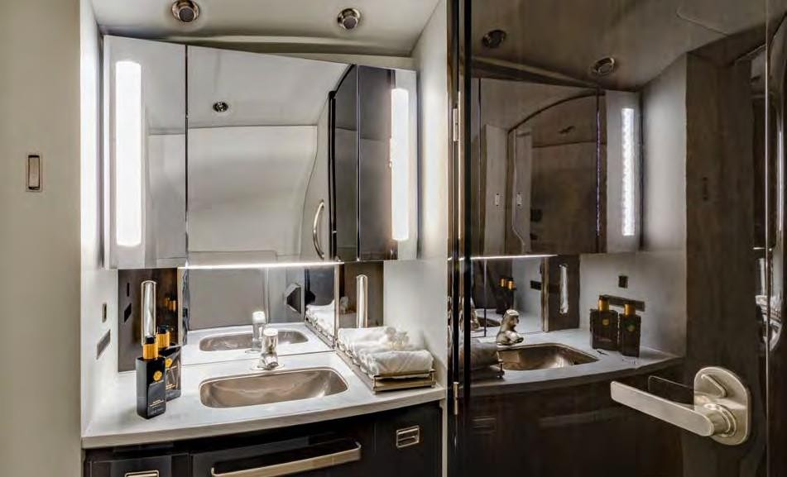

This Quotation Includes
- Airport Fees (Landing, Approach, Parking)
- Passenger Departure Taxes & SARS
- TASP, Air Navigation, en-route and approach charges
- Standard In-flight Catering & Beverages
- Handling fees (If / where required)
- Fuel Surcharges - Should the final bill exceed what was quoted, the additional charge will be billed to the client accordingly.
- Overflight and Landing Permits
- Aircraft cost including crew, fuel and maintenance
- Crew accommodation (full board single room, including road transfers) (Min of 3 Stars Kenyan Standard).
- VIP Lounge
- Wifi Usage

This Quotation excludes the following:
- Crew day room if waiting - period exceeds 3 hours.
- Airport After-Hour Surcharges
- Agent Commission
- Additional insurance surcharges for special coverage not included
- in operator's standard insurance coverage
- Cargo flights: royalties, non-objection, customs, documentation,
- warehouse, terminal handling fees and any loading equipment or crane hire if needed.
- 16% VAT


Charge Description

Description | Unit | Unit Cost (USD) | Total (USD)
Private Jet Charter (NAIROBI -> {{COUNTRY}}) | 1 Flight | {{ROW_AMOUNT1}} | {{ROW_AMOUNT1}}
Aircraft Fuel Surcharge & Handling Fees | Lump Sum | {{ROW_AMOUNT2}} | {{ROW_AMOUNT2}}
Ground Handling & Logistics (loading, AWB, ground handlers) | lump Sum | {{ROW_AMOUNT3}} | {{ROW_AMOUNT3}}
Security Team Deployment (Ricky - Lead Security) | Lump Sum | {{ROW_AMOUNT4}} | {{ROW_AMOUNT4}}
Security Team Deployment (Don - Operations) | Lump Sum | {{ROW_AMOUNT5}} | {{ROW_AMOUNT5}}
Cargo Insurance (All-risk coverage) | Lump Sum | {{ROW_AMOUNT6}} | {{ROW_AMOUNT6}}
Landing Permits, Airport Fees & Clearances | Lump Sum | {{ROW_AMOUNT7}} | {{ROW_AMOUNT7}}
Contingency & Miscellaneous (documentation, permits) | Lump Sum | {{ROW_AMOUNT8}} | {{ROW_AMOUNT8}}
Total Amount {{TOTAL_AMOUNT}}


You acknowledge that this charter may not be performed by Jetlinxaviation itself and this charter may be carried out by an undisclosed principal carrier on behalf of Jetlinxaviation. The terms and conditions agreed herewith will then be in favor of such principal carrier and you hereby waive any claims against Jetlinxaviation.
Kindly take note that the quotes are strictly subject to approval from the Kenyan department of transport (DOT) and are to be approved by Department of International Relations and Cooperation (DIRCO).

CHARTER ACKNOWLEDGMENT AND ACCEPTANCE

I the undersigned hereby accept the Quotation in accordance with your terms and conditions for the amount of $ {{TOTAL_AMOUNT}} (VAT Exclusive). I am duly authorized to sign and accept this quotation.

PERSON NAME RESPONSIBLE FOR PAYMENT
FULLL NAME/S AND SIGNATORY
DESIGNATION | BUYER
QUOTATION REFERENCE NUMBER | {{REF_NO}}
VAT NUMBER OF COMPANY / PERSON RESPONSIBLE FOR
TEL PAYMENT (IF APPLICABLE)
E-MAIL
POSTAL ADDRESS
We look forward to welcoming you and your passengers onboard our Jetlinxaviation.co.ke

For: Jetlinxaviation (Duly Authorized) For
(Duly Authorized)

Name: Michael Delaroi. Name:

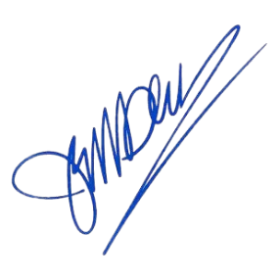
Position: MANAGING DIRECTOR Position:

Signature: Signature:
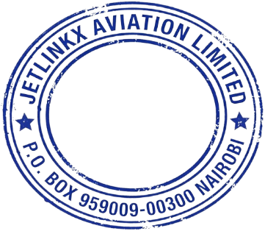

{{STAMP_DATE}}

Stamp: Stamp:

