

Precious Cargo Handlers, Customs Bonded Warehouse, Documentation Processing & Freight Experts

SAFE KEEPING RECEIPT No. {{RECEIPT_NO}}

-Valid only in original-

We, Canary Security Services, an accredited customs security declares with full legal and corporate responsibility, that we have received in our safekeeping the following goods as detailed hereinafter.

Details | Holder / Depositors |  |  | Depositors Reference |  | Date of Receipt {{DATE}}
 | MR. {{HOLDER}} |  |  | Online Tracking Reference Number:
 |  |  |  | {{REF_NO}}
Details Description of Contents |  | Qty | Value (US $) |  | Country of origin
HIGH VALUE CARGO |  | {{QUANTITY}} | Undisclosed |  | {{ORIGIN}}
Nature of deposit  - Valuable items ☐ Others |  |  | Total Value Undisclosed
Type of Deposit  - Documents Samples ☐ Others  - Document Fragile goods☐ Personal  - Precious Minerals |  |  | Depositors Instructions  AS PER CUSTOMS INSTRUCTIONS


Date: {{DATE}} Depositor: MR. {{HOLDER}}

We, Canary Security Services, further confirm that the goods in our safekeeping are legally earned, goods, clean and cleared of non- criminal origin, free on any lies or encumbrances and are freely transferable upon the instructions only of the authorized signatory (the depositor). To track your consignment, please click here to access our website and enter your tracking reference number.

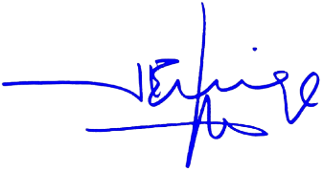

{{STAMP_DATE}}

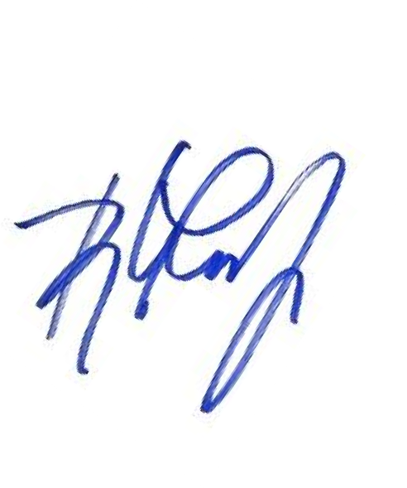
The depositor named is the authorized signatory and is in full control of the goods in our safekeeping, we are prepared to release and/or deliver the deposited goods to the depositor, or his/her associates and heirs, following this safekeeping agreement.


Chief Security Officer MR. {{HOLDER}} Authorized signatory on behalf of
warehouse

