SUBMISSION AND VALIDATION OF STATISTICAL COMPUTATION AND ANALYSES

NUEVA VIZCAYA STATE UNIVERSITY
Bayombong, Nueva Vizcaya

College of Arts and Sciences
MATHEMATICAL MODELING AND STATISTICS CENTER (MMSC)

This is to certify that the statistical computations and analyses presented in this thesis have been reviewed and validated by the Mathematical Modeling and Statistics Center. The results are based solely on the data submitted by {{Author/s}} in connection with their thesis study, titled:

“{{Title}}"

The analyses were carried out using standard statistical methodologies and tools in accordance with the objectives and requirements specified by the researcher. The center guarantees that all computations were performed by Prof. {{Statistician}}, a commissioned statistician of the center.

The interpretation and application of the results are the sole responsibility of the researcher together with their adviser.

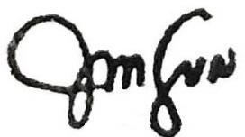
Issued this {{Date}} at the Mathematical Modeling and Statistics Center, Nueva Vizcaya State University.

JULIUS S. VALDERAMA, PhD
Center Director

