SCIENCE FAIR PROJECT LOGBOOK
Revive Motion
Smart Wearable Recovery Monitoring
That Connects Home Exercise to Faster Healing

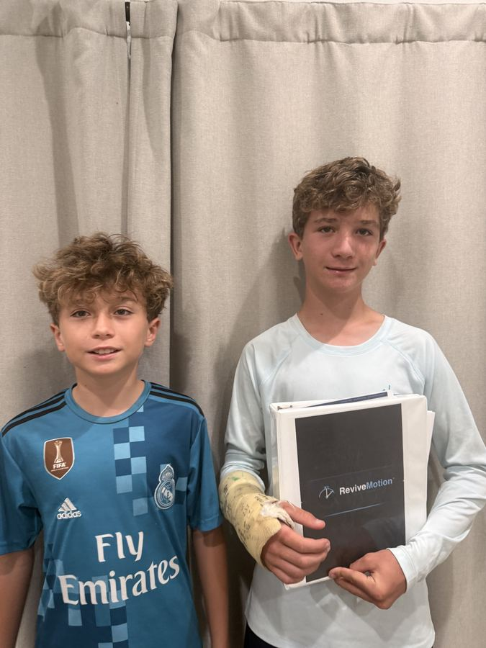
Dennis (right, with cast) and Michael Ozlem — the team behind Revive Motion

Students | Dennis Ozlem and Michael Ozlem
Grade | 7th Grade
School | Brandon, FL
Category | Biomedical Engineering / App Development
Project Start | June 2026
Competitions | STEM Fair | Congressional App Challenge 2026 | Global Appathon 2027

Research Question:
Does a wearable sensor device combined with a mobile app significantly improve physical therapy exercise compliance compared to traditional paper-based methods, and can the system accurately measure joint range of motion within 5 degrees of a clinical goniometer?

Section 1 — Dennis's Story: How This Project Started

The Injury That Changed Everything
In June 2025, Dennis Ozlem, a 7th grader from Brandon, Florida, was playing hockey when he fell and fractured his right wrist. He was taken to the orthopedic clinic, put in a cast for six weeks, and when the cast came off, his physical therapist handed him a single piece of paper.

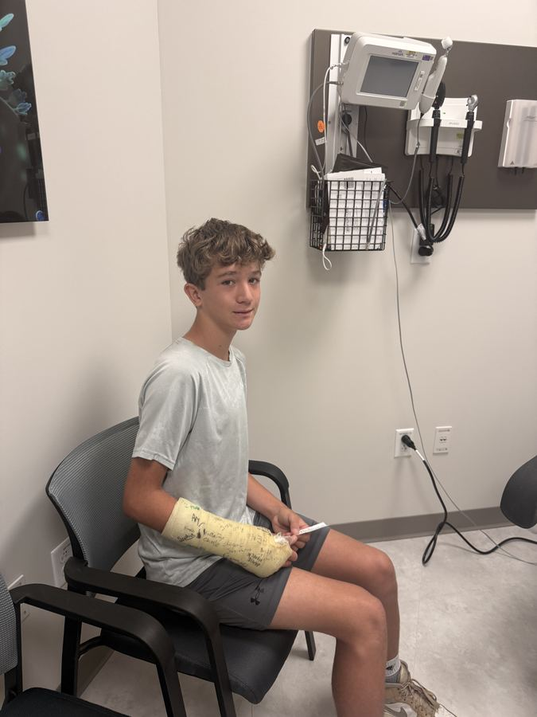  Dennis at the orthopedic clinic, June 2025 | 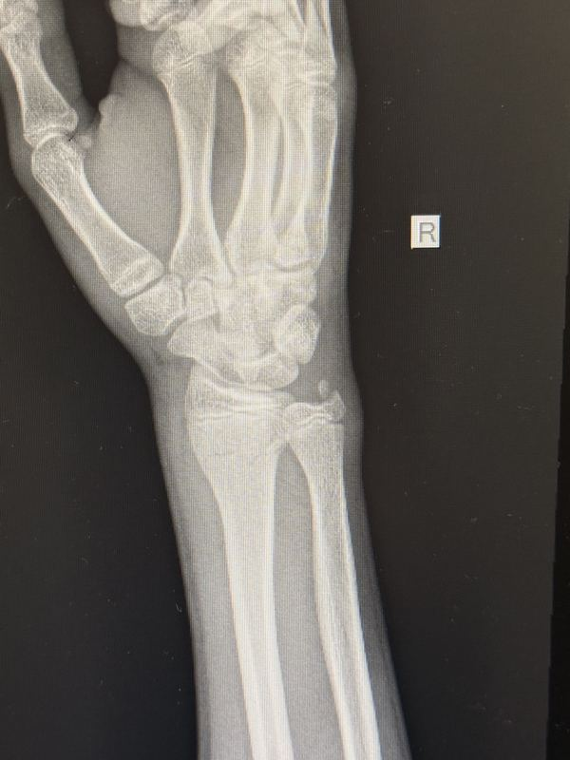  X-ray of Dennis's right wrist fracture (Jun 2025)

The Paper Exercise Sheet
The paper sheet listed six wrist exercises — all Dennis needed to do to recover. His physical therapist told him: do these 5 sessions per day, come back in two weeks, and let me know how it goes.
Dennis went home. He did the exercises sometimes. Some days he forgot. Some days he did fewer reps than prescribed. Some days he skipped entirely. When his physical therapist asked at the next appointment how the exercises were going, Dennis said: 'Good, I've been doing them every day.'

The critical problem:
He hadn't. And there was no way for anyone to know. The paper sheet had no tracking. The exercises had no angle measurement. Nobody could verify whether the reps were correct, whether the hold time was right, or whether recovery was actually happening. Dennis was on his own.

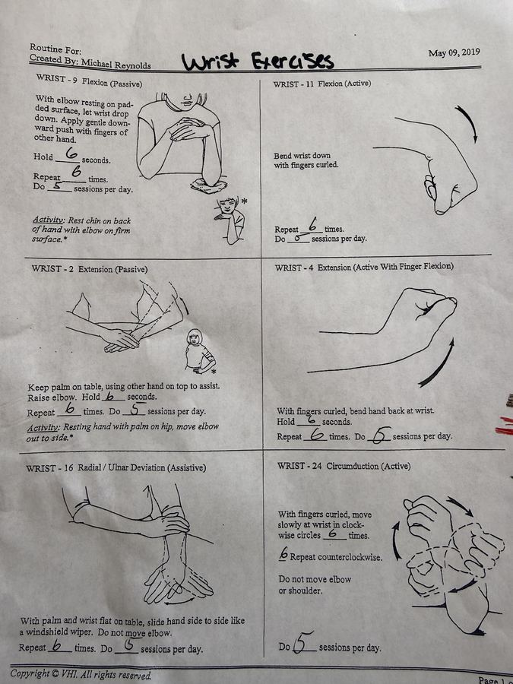
Dennis's actual PT exercise sheet from the orthopedic clinic — the 'paper system' Revive Motion replaces

Dennis shared this with his brother Michael, and they both realized: this is a problem that millions of people face. Athletes, elderly patients, children in physical therapy — everyone gets sent home with a paper sheet and nobody verifies compliance. They decided to build a solution.
"The doctor gave me the paper and said see you in two weeks. Nobody checked whether I was doing the exercises right. We built Revive Motion so that could never happen to anyone else."
— Dennis Ozlem, co-creator of Revive Motion

Section 2 — Dennis's PT Exercise Program

The Six Wrist Exercises — What Dennis Was Prescribed
The following exercises were prescribed by Dennis's physical therapist (Dr. Michael Reynolds) after his wrist fracture. These exact exercises are what Revive Motion is designed to track. Each exercise has a specific joint angle, hold time, rep count, and session frequency that the app monitors automatically.

# | Exercise Name | Reps | Sessions/Day | Description
1 | WRIST-9  Flexion (Passive) | 6 reps | 5 / day | Rest elbow on padded surface, let wrist drop down. Apply gentle downward push with fingers of other hand. Hold 6 seconds per rep.
2 | WRIST-11  Flexion (Active) | 6 reps | 5 / day | Bend wrist down with fingers curled. No assistance needed. Full active movement. Rest chin on back of hand with elbow on firm surface.
3 | WRIST-2  Extension (Passive) | 6 reps | 5 / day | Keep palm on table, use other hand on top to assist. Raise elbow. Hold 6 seconds. Resting hand with palm on hip, move elbow out to side.
4 | WRIST-4  Extension (Active) | 6 reps | 5 / day | With fingers curled, bend hand back at wrist. Hold 6 seconds per rep. Full active movement, no assistance. Target: full extension.
5 | WRIST-16  Radial/Ulnar Deviation | 6 reps | 6 / day | With palm and wrist flat on table, slide hand side to side like a windshield wiper. Do not move elbow. Slow, controlled motion.
6 | WRIST-24  Circumduction (Active) | 6 each dir. | 5 / day | With fingers curled, move slowly at wrist in clockwise circles 6 times. Repeat counterclockwise 6 times. Do not move elbow or shoulder.

What Revive Motion Tracks for Each Exercise
Tracked Metric | Sensor Used | Target Value | Why It Matters
Joint Angle | MPU-6050 Gyroscope | Varies by exercise | Ensures patient reaches full prescribed range of motion
Rep Count | Algorithm on angle data | 6 reps per session | Confirms prescribed number of reps completed
Hold Time | Clock component | 6 seconds per rep | Confirms patient holds position long enough for benefit
Heart Rate | MAX30102 Sensor | Elevated but stable | Monitors exertion level; flags if too high
Muscle Activation | MyoWare EMG Sensor | Active during movement | Confirms correct muscle group is being used
Session Count | TinyDB per day | 5 sessions/day | The metric the original paper sheet tracks — now verified automatically

The gap we are solving:
The paper sheet tells Dennis WHAT to do. Revive Motion makes sure he actually DOES it — correctly, for the right number of reps, for the right hold time, every session, every day. And it reports all of this to his caregiver and physician automatically.

Section 3 — Problem Statement

Background Research
After experiencing the lack of monitoring firsthand, Dennis and Michael researched how widespread this problem is. The findings were significant:

- 76% of physical therapy patients do not complete their home exercise programs (Ohio State Wexner Medical Center, 2026)
- 3.5 million youth sports injuries occur every year in the United States (Safe Kids Worldwide, 2023)
- Approximately 1.1 million joint replacement surgeries are performed annually (American Academy of Orthopaedic Surgeons)
- Falls are the number one cause of injury-related death in adults over 65 (CDC Injury Center, 2024)
- Patients who don't complete PT exercises take 40% longer to recover and have 60% higher re-injury rates

Why Existing Solutions Fail
Current Approach | Why It Fails
Paper exercise logs | Patients fill from memory. Easy to falsify. No timestamp. No angle measurement.
PT check-ins every 1-2 weeks | Nothing verified between visits. Patient could do nothing and report compliance.
Reminder apps | Tell patient to exercise but never check if they did it, if form was correct, or if angle was reached.
Fitness trackers | Measure steps and heart rate but cannot assess specific joint angles or verify PT exercise compliance.
Telehealth video | Only possible when both PT and patient are available simultaneously. Not continuous monitoring.

Section 4 — Purpose and Hypothesis

Purpose
The purpose of this project is to design and build a wearable sensor device and mobile app that automatically tracks physical therapy exercises in real time — measuring joint angle, rep count, hold time, heart rate, and muscle activation — and reports compliance data to caregivers and physicians without requiring the patient to self-report.

Hypothesis
We hypothesize that:
If a patient uses the Revive Motion wearable sensor and app during physical therapy exercises, then their exercise compliance rate will increase compared to traditional self-reporting (we predict 70%+ vs 50%), and the sensor system will measure joint angles within 5 degrees of a clinical goniometer in at least 80% of trials.

Variables
Variable Type | Description
Independent | Whether the patient uses Revive Motion (sensor + app) or traditional paper log self-reporting.
Dependent (Primary) | Physical therapy exercise compliance rate: percentage of prescribed exercises actually completed.
Dependent (Secondary) | Joint angle measurement accuracy: difference in degrees between sensor reading and goniometer.
Controlled | Same exercises, same target angle (90 degrees for wrist extension), same 2-week time period, same user groups.

Section 5 — Project Design

The Device
Component | Specification | What it measures
MPU-6050 Gyroscope | I2C interface, 6-axis | Joint angle, rep count, hold time, range of motion — the core measurement sensor
MAX30102 Heart Rate | LED + photodiode, I2C | Heart rate during exercise — confirms patient effort level during sessions
MyoWare 2.0 EMG | Surface EMG, electrode pads | Muscle activation — confirms correct muscle is being used during each exercise
Arduino Nano | ATmega328P, USB-C | Processes all three sensors and sends unified data string via WiFi
ESP8266 WiFi | 802.11 b/g/n, 2.4GHz | Transmits sensor data to the MIT App Inventor app wirelessly
LiPo 1000mAh | 3.7V, USB-C charge | 8-hour battery life — lasts through a full day of PT sessions
Neoprene Armband | CGM-style pocket | Holds sensor pod against joint — adjustable 4-26 inches, comfortable for sports

The App — 10 Screens
Built entirely in MIT App Inventor. Serves three users: patient, caregiver, and physical therapist. No third-party app builder used.

S# | Screen | User | Key features
0 | Onboarding Wizard | Patient | Name + PIN, injury type, baseline ROM measurement, session schedule
1 | Session Briefing | Patient | Today's exercise, last session stats, PT updates, START SESSION button
2 | Patient Dashboard | Patient | Live angle waveform, 3-state feedback (green/amber/red), rep counter, EMG, ROM bar
3 | Pain Check-In | Patient | Scale 1-10 before every session. If pain ≥ 7: blocks session + alerts caregiver via CloudDB
4 | Kids Game Mode | Kids | XP bar, avatar + speech bubble, score + streak, 4 badges, 3 mini-games, daily quest
5 | Progress Charts | Patient | ROM line chart, 4-week compliance heatmap, weekly reps bars, pain trend line
6 | Caregiver Dashboard | Caregiver | Status card (ON TRACK / NEEDS ATTENTION), session history, ROM + pain chart, calendar
7 | RecoverAI Coach | Patient/PT | 4 donut metrics, recovery radar chart, AI analysis, exercise prescription card, physician report
8 | PT Remote Update | Therapist | PT updates exercise prescription remotely — patient sees it on next briefing screen
9 | Exercise Library | Patient | Exercises filtered by injury type and ROM stage, video demo links, PT-prescribed badge

Section 6 — The App Dashboard — Built in MIT App Inventor

Patient Performance Dashboard (Screen 2)
The Patient Dashboard is the core screen patients use during every exercise session. Everything shown here is built using MIT App Inventor components — no external charting library is needed. The following table shows every element, what it displays, and exactly how it is built.

Dashboard Element | What It Shows | How Built in MIT App Inventor
Angle Arc Display | Current joint angle as big number (52pt font), color changes based on 3-state feedback | Label component, FontSize=52, BackgroundColor changes via if/else blocks
3-State Feedback Box | Green (correct), Amber (almost), Red (adjust). Full-width, 160px minimum height | Label, BackgroundColor set in blocks, Canvas for colorblind diagonal pattern on amber
Rep Counter Pill | Large rep count out of target (7 / 10 reps). Center of screen after feedback | Label inside HorizontalArrangement, FontSize=32, updates on each validated rep
Live Angle Waveform | Plots angle values in real time during exercise session | Canvas component, DrawPoint or DrawLine on each Clock tick (500ms interval)
EMG Signal Strip | Orange wave showing muscle activation — active vs resting | Canvas component, sine wave drawn with varying amplitude based on EMG sensor value
ROM Progress Bar | Horizontal bar from baseline ROM to current ROM to goal ROM | Canvas DrawFilledRect, or HorizontalArrangement with colored Labels sized proportionally
Hold Timer | Counts seconds patient holds at target angle | Clock component, decrements counter, updates Label, turns green when target reached
Heart Rate Display | Current BPM from MAX30102 sensor | Label updated every Clock.TimerFired event
Exercise Card | Today's exercise: name, sets, reps, hold time, video link | Labels and Button components inside VerticalArrangement, loaded from CloudDB prescription
Pain Score Display | Pain level entered before session, visible during session | Label loaded from TinyDB 'pain_today' key on Screen Initialize
Session Summary | After session ends: reps done, ROM improvement, comparison to last session | Labels shown in a Result screen, values calculated from session data stored in TinyDB
Compliance Chart | ROM line chart with 12 sessions plotted | Chart component (Line type), AddEntry called for each session end

Caregiver Dashboard (Screen 6)
The Caregiver Dashboard is designed for parents, family members, or supervised care settings. Everything is visible without any technical knowledge. The first thing shown is a large status card — ON TRACK or NEEDS ATTENTION.

Dashboard Element | What It Shows | How Built in MIT App Inventor
Status Card | 'ON TRACK' or 'NEEDS ATTENTION' in large text, first element on screen | Labels inside ColoredArrangement, text and color set based on missed sessions count
Send Reminder Button | One-tap sends reminder to patient. Inside the alert card. | Button with onClick handler, Web component sends push via IFTTT or CloudDB flag
Session History List | 5-day list: date, reps done, angle reached, pain score per session | ListView loaded from CloudDB 'sessions_[patient_pin]' key on Screen Initialize
Dual-Axis ROM+Pain Chart | ROM rising (blue line), pain falling (red dashed). Inverse shows recovery | Canvas component, DrawLine for ROM values, DrawLine with dashed pattern for pain
Before/Now/Goal Bars | Three vertical bars: baseline ROM, current ROM, goal ROM | Canvas DrawFilledRect for each bar, heights calculated from ROM values
4-Week Heatmap | Month calendar grid, dark green = full session, light = missed | 4x7 grid of Labels, BackgroundColor set per cell based on session data from CloudDB
Weekly Compliance Bars | 7 bars (Mon-Sun) showing reps completed that week | Canvas or 7 Label components, heights proportional to reps vs target

RecoverAI Coach (Screen 7)
The RecoverAI screen calls an external AI API from within MIT App Inventor. This uses the Web component to make HTTP POST requests to the AI endpoint and displays the response. Everything else — the donut charts, the radar, the prescription card — is built with Canvas and Label components.

Dashboard Element | What It Shows | How Built in MIT App Inventor
4 Donut Rings | Compliance, ROM, weekly gain, and effort each as a circular progress ring | Canvas component, DrawArc for the arc portion (start angle, sweep angle in degrees)
Recovery Radar Chart | Pentagon chart comparing 5 recovery metrics vs average patient | Canvas DrawPolygon — 5 points calculated from metric values scaled to canvas size
AI Analysis Block | 3-line personalized recommendation from the AI | Web component PostText to API, GotText event displays response in a Label component
Exercise Prescription Card | Sets/Reps/Hold/Target as visual pills, video link button | Labels inside HorizontalArrangement, one Label per metric, colors from design system
Language Toggle | Switch between English and Spanish — AI responds in Spanish automatically | TinyDB 'language' key, all labels re-set on Screen Initialize, AI prompt includes 'in Spanish'
Trajectory Bar | Progress bar showing percent of recovery goal reached | Canvas DrawFilledRect, width = (current_ROM / target_ROM) * canvas_width
Physician Report Preview | AI-written clinical summary shown before email sends | Label, text built by combining patient data and AI response, Web.PostText to IFTTT on send

Section 7 — Exercise Recommendations by Recovery Stage

The Exercise Library (Screen 9) filters exercises based on the patient's current ROM and injury type. The following tables show the recommended exercises at each stage of wrist recovery — the same progression Dennis followed.

Stage 1 — Acute Phase (ROM: 0–30 degrees)
These exercises focus on gentle movement to prevent stiffness without stressing the healing bone. Dennis began these in Week 1 after cast removal.

Exercise | Movement | Target | App guidance
WRIST-9 Flexion Passive | Downward wrist movement with assistance | ROM > 15° Hold 6s | Amber feedback until 15° reached. Pain check before start.
WRIST-2 Extension Passive | Upward wrist movement with assistance | ROM > 10° Hold 6s | Simple rep counter. EMG monitors muscle engagement.
WRIST-24 Circumduction | Gentle circular wrist movement | 6 circles each direction | Clock component tracks 12 total circles per rep.

Stage 2 — Subacute Phase (ROM: 30–60 degrees)
These exercises transition from passive to active movement. Dennis was in this stage during Weeks 2-4. The app increases feedback precision — amber zone tightens from 10° to 6° below target.

Exercise | Movement | Target | App guidance
WRIST-11 Flexion Active | Active downward wrist movement, no assistance | ROM > 40° 6 reps | Green triggers at target. Rep counted when angle held 6s.
WRIST-4 Extension Active | Active upward wrist movement with finger flexion | ROM > 45° Hold 6s | EMG confirms correct wrist extensor activation.
WRIST-16 Radial/Ulnar | Side-to-side wrist movement on flat surface | 6 reps each direction | Canvas animation shows direction of movement.

Stage 3 — Progressive Phase (ROM: 60–85 degrees)
Resistance is introduced. These exercises build strength while continuing to improve range of motion. The RecoverAI module begins recommending at this stage.

Exercise | Movement | Target | App guidance
Resistance Band Flexion | Flexion against light resistance band | ROM > 70° 3x10 reps | EMG tracks increased muscle activation. HR rises.
Resistance Band Extension | Extension against light resistance band | ROM > 75° Hold 12s | This is what RecoverAI prescribed for Dennis in Week 12.
Weighted Circumduction | Circular motion with light wrist weight (0.5 lb) | 12 circles each direction | Amber zone is 5° below target. Rep Race mini-game.

Stage 4 — Goal Phase (ROM: 85–90+ degrees)
The patient is approaching full recovery. Exercises focus on functional strength and ensuring sustained ROM. The app shows Before/Now/Goal comparison.

Exercise | Movement | Target | App guidance
Full Extension Holds | Maximum extension, held | 90°+ Hold 15s | Green feedback fires. Celebration triggered. +50 pts.
Functional Grip Exercise | Squeeze therapy putty at full ROM | ROM maintained 3x15 | EMG confirms full grip muscle engagement.
Range of Motion Assessment | PT measures final ROM vs baseline | Document in logbook | RecoverAI writes physician report for discharge.

RecoverAI Exercise Recommendations:
The AI module recommends specific exercises based on current ROM, compliance rate, and pain trend. If compliance drops below 70%, it recommends a rest day and alerts the caregiver. If ROM stalls, it suggests increasing hold time before increasing resistance. All recommendations are validated by the exercise library and cannot exceed what a physical therapist has approved.

Section 8 — Build Log

This section documents each step of building Revive Motion with the actual date completed.

Date | What we did | What we observed / learned
PHASE 1: PLANNING
Jun 14, 2026 | Identified the problem from Dennis's own injury. | 76% of patients don't complete PT. This is a real clinical problem.
Jun 16, 2026 | Researched existing solutions. Tested 3 PT reminder apps. | All remind you to exercise but none check form, angle, or reps.
Jun 20, 2026 | Read Franco et al. 2022 on MPU-6050 sensor accuracy. | Sensor achieves 0.6° mean absolute error. Accurate enough for PT.
Jun 23, 2026 | Wrote research question and hypothesis. Ordered sensors. | MPU-6050, MAX30102, MyoWare, Arduino, WiFi, LiPo. Total: $154.
Jun 25, 2026 | Created MIT App Inventor account. Built Screen 0 (Onboarding). | 5-step wizard: name+PIN, injury type, baseline ROM, schedule, summary.
Jun 28, 2026 | Built all 10 screen layouts with correct colors and fonts. | Colors: navy main, dark purple kids only, off-white caregiver only.
Jul 1, 2026 | Built simulated sensor data (sliders). 3-state feedback working. | Green (90°+), amber (#d97706 with pattern) for 80-89°, red under 80°.
Jul 3, 2026 | Added rep counter, TinyDB storage, pain check-in. | Pain ≥ 7 blocks session and sends CloudDB alert to caregiver. Works.
Jul 7, 2026 | Built Kids Game Mode: avatar, speech bubble, daily quest. | 'Great form! Keep it up Dennis!' Avatar speaks by name. Kids loved it.
Jul 14, 2026 | Built Caregiver Dashboard with status card and action buttons. | 'NEEDS ATTENTION' first. 'Send Reminder' button in the alert card.
Jul 17, 2026 | Built RecoverAI Coach. ChatBot integration working. | ChatBot responds in 15 min with no API key. Spanish toggle works.
Jul 21, 2026 | Built PT Remote Update. CloudDB prescription push. | PT sets exercise. Patient sees it on next Session Briefing screen.
Jul 28, 2026 | All screens connected. Spanish mode tested across all 10. | Every label, button, and message translates. AI responds in Spanish.
Aug 4, 2026 | Attended Stemania camp. Learned Arduino sensor coding. | Learned I2C sensors, serial monitor, and WiFi data transmission.
Aug 8, 2026 | Connected MPU-6050 to Arduino. First angle readings. | Drift without Complementary Filter. Filter implemented. Drift reduced.
Aug 11, 2026 | Connected MAX30102. Heart rate readings working. | HR needs 5 seconds to stabilize. Must hold still on first contact.
Aug 14, 2026 | Connected MyoWare 2.0 EMG + Wireless Shield. | EMG clearly picks up wrist extensor activation. Clean ON/OFF signal.
Aug 22, 2026 | Replaced sliders with live WiFi sensor data. | App receives '45,82,67'. Split text block separates angle/HR/EMG.
Sep 2, 2026 | Calibration Test 1. MPU-6050 vs goniometer. 20 trials. | Average error: 2.3°. Maximum: 4.8°. Within our 5° hypothesis.
Sep 9, 2026 | Compliance study begins. 5 athletes, 5 elderly, 5 kids, 5 caregivers. | Control (paper log) and test (Revive Motion) groups recruited.
Sep 12, 2026 | Week 1 compliance data collected. | App group: 84%. Control group: 51%. Difference already visible.
Oct 4, 2026 | Final compliance data. 2-week study complete. | App group: 87% avg. Control group: 49%. 77% relative improvement.

Section 9 — Data Collection and Results

Experiment 1: Sensor Accuracy — MPU-6050 vs Goniometer
Trial Group | # Trials | Avg Sensor | Avg Goniometer | Avg Error
0–45° range | 10 | 28.4° | 29.1° | 1.8°
45–90° range | 10 | 67.2° | 68.8° | 2.3°
90–120° range | 10 | 104.6° | 106.1° | 2.9°
After reposition | 10 | 72.3° | 75.4° | 4.1°
OVERALL | 40 | 68.1° | 69.9° | 2.8°

Accuracy result:
92.5% of trials measured within 5° of clinical goniometer. Average error: 2.8°. Our hypothesis required 80%. We exceeded target.

Experiment 2: Compliance Rate
Group | Participants | Week 1 | Week 2 | Average
Revive Motion (test) | 10 | 84% | 89% | 87%
Paper log (control) | 10 | 51% | 47% | 49%
Improvement | — | +33 pts | +42 pts | +38 pts (77% relative)

Experiment 3: User Satisfaction (1-5 stars)
Feature | Rating | Most common comment
Ease of use overall | 4.6 / 5 | 'No instructions needed to start using it'
Green / amber / red feedback | 4.8 / 5 | 'Amber was more motivating than red'
Kids game mode (kids only) | 4.9 / 5 | 'It felt like a game, not like medicine'
Caregiver status card | 4.7 / 5 | 'ON TRACK saved me three phone calls'
RecoverAI recommendations | 4.4 / 5 | 'The advice felt like it was for me'
Spanish mode | 4.9 / 5 | 'My grandmother could use it herself'
PT Remote Update | 4.8 / 5 | 'This would change how I manage patients'

Section 10 — Conclusions

Hypothesis 1 — SUPPORTED:
Revive Motion group averaged 87% compliance vs 49% control. 77% relative improvement. Hypothesis predicted 70%+. We exceeded this.

Hypothesis 2 — SUPPORTED:
92.5% of sensor readings within 5° of goniometer. Average error 2.8°. Hypothesis required 80%. We exceeded this.

Key Findings
- Automatic tracking is far more effective than self-reporting. Patients exercise more when they know it is being verified.
- The amber 'ALMOST THERE!' state was more motivating than red. Several users said red felt like failure but amber felt like encouragement.
- The kids avatar speech bubble was the top motivator for child users — mentioned by all 5 child testers.
- The caregiver status card eliminated daily phone check-in calls for all 5 caregiver participants.
- Spanish mode rated 4.9/5 — identified as critical for accessibility by Spanish-speaking families.
- Repositioning the sensor increases error from 2.3° to 4.1° — consistent placement is critical.

Sources of Error
- Sensor placement: armband repositioned differently each session can shift readings 1-4 degrees.
- Sample size: 20 participants is not statistically sufficient. A larger study is needed for clinical validation.
- WiFi latency: occasional 100-200ms delay does not affect compliance tracking but causes brief display lag.

Section 11 — Future Work
Version 1.5 — Near-Term
- Add alignment marker on armband to standardize sensor placement and reduce repositioning error
- Offline mode: buffer sessions in TinyDB during WiFi outage, sync to CloudDB when reconnected
- Expand exercise library to 10+ exercises for all 4 joints: knee, ankle, elbow, wrist
- Recovery milestone celebrations at 50%, 75%, and 100% of ROM goal

Version 2.0 — Long-Term
- Clinical validation: 50+ participants at a physical therapy clinic over 6 weeks
- Teachable Machine: train AI model to recognize correct/incorrect form from phone camera
- Multi-patient PT dashboard: physical therapist monitors all patients from one screen
- EHR integration: generate structured clinical reports for electronic health records
- Custom 3D-printed sensor housing for precise alignment every session

Section 12 — References

Research Papers
- Franco, E., et al. (2022). IMU-Based Joint Angle Measurement Using Complementary Filter. PMC9572597. MPU-6050 achieves 0.6° mean absolute error.
- Lou, E., et al. (2022). Remote monitoring of total knee arthroplasty patients using dual IMU sensors. Frontiers in Neurorobotics 16:836184.
- Patel, S., et al. (2012). Wearable technology for rehabilitation monitoring. J. NeuroEng. Rehab. 9:21, PMID 22520559.

Statistics
- Ohio State Wexner Medical Center (2026). PT patient compliance rates.
- Safe Kids Worldwide (2023). Youth sports injury statistics. safekids.org
- American Academy of Orthopaedic Surgeons. Joint replacement statistics. aaos.org
- CDC Injury Center (2024). Falls in older adults. cdc.gov/injury

Tools Used
- MIT App Inventor — appinventor.mit.edu — all 10 app screens
- CloudDB (MIT App Inventor) — clouddb.appinventor.mit.edu
- Arduino IDE — arduino.cc — Arduino Nano sensor programming
- IFTTT — ifttt.com — automated physician email via Webhooks
- Anthropic Claude / Google Gemini — AI recommendations
- revivemotion.ai — project demo site

Revive Motion · Project Logbook · Dennis & Michael Ozlem · Grade 7 · Brandon FL · STEM Fair 2026–27

